Draft Minutes

PCEOCP Matrix Design and Funding (MDF) Sub-Group
September 4, 2008
GMATS, Detroit Airport

Attendance
Bill Buscher, Chris Castanien, Charlie Leverett, Dan Pridemore, David Smith, Dennis Bachelder, Doyle Boese, Gail Evans, Glen Mazzamaro, Gordon Farnsworth, Jerry Wang, Jim Linden, Jo Martinez, John Rosenbaum, John Zalar, Kevin Ferrick, Mike McMillan, Patrick Lai, Ron Romano, Robert Stockwell, Thom Smith, Matthew Ansari, Dan Dotson, Ben Weber, Rich Grunza, Doyle Boese, Mike McMillan, Larry Smith, Scott Lindholm, Bill Lam, Gene Hammerle

Agenda
- Review and approve last meeting minutes
- Review action items
    - Technology selection
    - Base oil selection
    - API funding proposal
- Review report to PCEOCP
- Other business
- Next meeting

Details

The August 11 minutes was approved unanimously.

Jerry Wang reviewed the agenda and there was no change.

Jim Linden reported that 3 technologies had been selected. He would report oil description, test results in pass/fail, and actual fuel economy test results to PCEOCP. Individual additive suppliers selected would be notified after PCEOCP.

Dennis Bachelder reported the two Group IIs and two Group IIIs were selected for the matrix. The quantity needed for the matrix would be donated free of charge.

The group agreed that those oils would be provided to the selected technology suppliers directly for blending. Each technology supplier would perform blend study and feed back data to BOI/VGRA to finalize blend targets. Those technology suppliers would then blend up matrix oils to TMC for distribution.

Kevin Ferrick presented the API funding proposal. Both GM and Ford objected to funding BOI/VGRA. Kevin Ferrick then presented the alternative proposal. Linden indicated the structure was reasonable and the estimated contribution was close to the ILSAC target (based on the 17.6K per test cost estimate from the VID consortium) but he would need to get approval.
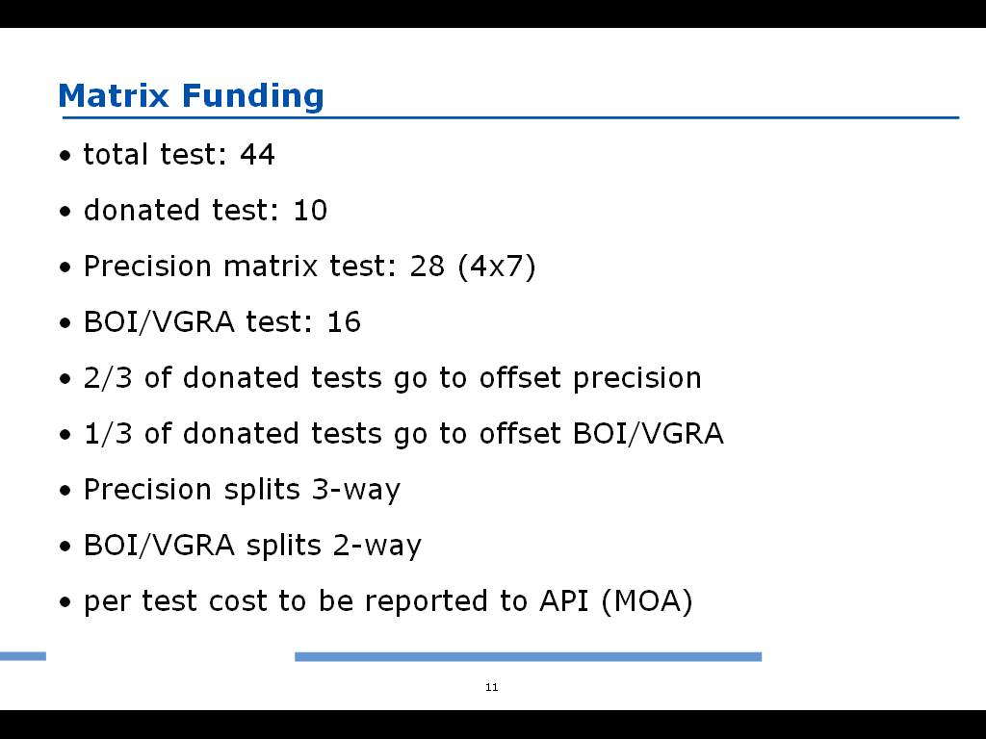
Charlie leveret asked if the reference oils were provided free of charge? John Zalar quoted $3500 per registered test which included oil. Andy Ritchie and Chris Castanien, both representing TMB, believed TMC would not have the flexibility to provide free oil for the matrix testing. That raised the total cost by $154K. Linden asked if the ILSAC contribution could be offset by donated engines. Leverett said the consortium test quote already assumed free engines. Linden indicated difficulty to allocate the expected additional funding (~30K extra from the API alternative proposal) from ILSAC but he didn’t object to moving forward to PCEOCP with the alternative funding structure.

Leverett noted that a Surveillance Panel (SP) meeting was scheduled on Sep 10. He expected a final quote to API from both labs by end of that week.

Linden confirmed to Ferrick that JAMA would be sign as its own trade group but would be considered part of ILSAC for funding estimate.

Leverett also wanted to make sure sufficient quantify was provided to both the matrix and near future so reblend was not necessary soon after the matrix.

The group agreed to request API BOI/VGRA to map the selected base oil and technology to the generic designations currently in the matrix design. The request should be sent to Barbara Dennis copying John Rosenbaum and Kevin Ferrick.

Action: request BOI/VGRA to map oils to designed matrix - Wang

Dan Pridemore wanted to clarify what oils to run in dependent labs given that the final 3 reference oils would not be selected until after step 1 in the matrix. Thom Smith suggested running the all five reference oils. The group advised dependent labs to coordinate oil selection with SP. The group also specified that the last test of all data a non-matrix lab wanted to contribute must start before the end of the matrix step 2 to be considered as part of the precision statement analysis.

Leverett raised a recommendation from the statistician’s group regarding the age of engines to be used in the matrix. Linden pointed out that a new engine was really after 150 hours of break in. The group revised its suggestion to use “new” engines in the matrix to allow the first engine to be less than 400 hours. The second engine in the same lab could be longer than 400 hours pending further SP decision.

Action: decide age limit for the second engine – Seq VI SP

The group then reviewed the slides to be presented to PCEOCP. In addition to the matrix design and the funding structure, the following decisions were also listed:
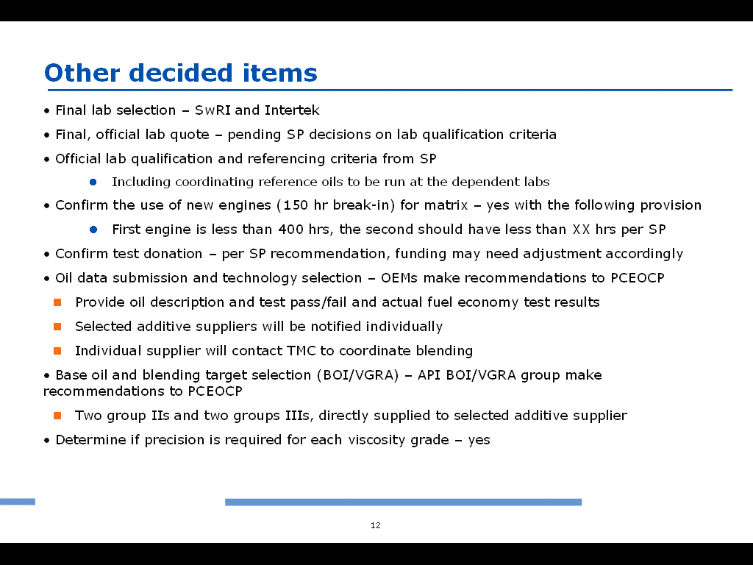

In the last slide, the group recommended the following to PCEOCP.
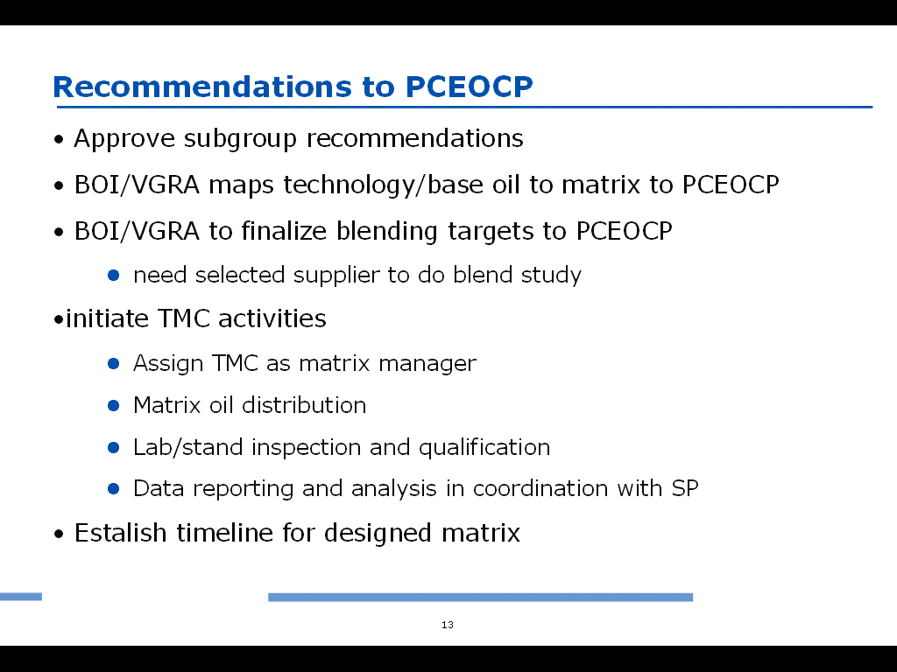
The full presentation was provided to TMC for posting.

With no further discussion, the meeting adjourned at 9:50 am. Given no actions or decisions to follow up, no further meeting was scheduled.

