Draft Minutes

PCEOCP Matrix Design and Funding (MDF) Sub-Group
August 11, 2008
Teleconference

Attendance
Charles Baker, Chris Castanien, Charlie Leverett, Dan Pridemore, David Smith, Dennis Bachelder, Doyle Boese, Gail Evans, Glen Mazzamaro, Gordon Farnsworth, Hannah Murray, Jerry Wang, Jim Linden, Jo Martinez, John Rosenbaum, John Zalar, Kevin Ferrick, Mike McMillan, Patrick Lai, Ron Romano, Robert Stockwell, Thom Smith,

Agenda
- Review and approve last meeting minutes
- Review action items
    - ACC/API combined matrix proposal
    - Oil technology data submission
- Funding estimate/model for proposed matrix
- Other TBD items from records
- Other business
- Next meeting

Details

The July 21 minutes was approved unanimously.

Jerry Wang reviewed the agenda and there was no change.

Dennis Bachelder indicated API LC approved the proposed ACC combined precision/BOI/VGRA matrix.

Jim Linden reiterated the need to get precision earlier. However, ILSAC members agreed to accept the proposal on the basis that recycling an alternative proposal with different test sequence might simply delay the process beyond the extra 4 weeks required by the proposal compared with a prior minimal precision only proposal.

The group voted unanimously to accept this proposal as is (see slides copied below)
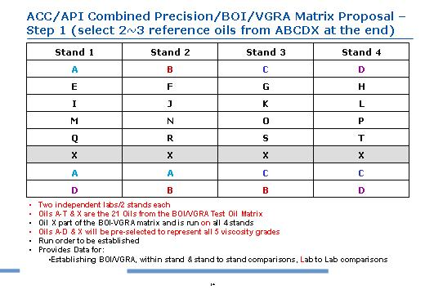
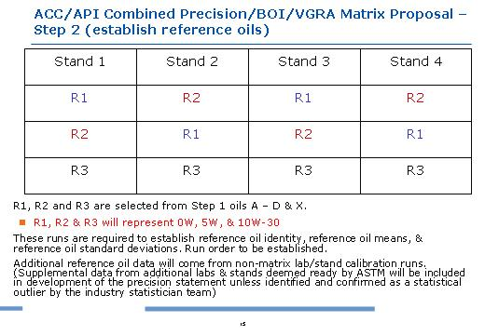

Jerry Wang showed the data submission template which included all current GF-4 and proposed GF-5 tests plus blending data needed by BOI/VGRA. There was no objection or discussion on this template.

Chris Castanien asked for clarification of the technology selection process. Jerry Wang indicated the original proposal was for data submission to John Zalar for coding and for MDF to review data on August 26. Gordon Farnsworn cited the precedence in GF-3 and suggested to let OEMs make the selection on the basis for fuller data disclosure and better data confidentiality (additive companies wouldn’t see each other’s data). Thom Smith preferred the original process so PCEOCP could make the selection by saying the coding process would ensure confidentiality and the industry should be given the opportunity to make selection. The group concluded by agreeing to send all candidate technology (defined as DI+VM) data to Jim Linden by August 21 (end of business day) and ILSAC will make the selection recommendation by September 4 to the PCEOCP meeting for ratification. Thom Smith agreed to the concept that oil data should only show pass/fail when presented in PCEOCP. Two conditions were attached to that decision: the three technologies shall be selected from three different suppliers to maximize differences, and no more than one OEM oil shall be selected by the OEM. The latter was agreed to prevent OEMs from selecting only OEM factory fill oils so GF-5 and other technologies could also be fairly represented in the VID matrix.

Action: submit data to Jim Linden for ILSAC reference oil selection – all technology suppliers
Action: make reference oil technology (DI/VM) selection recommendation to PCEOCP by September 4 - ILSAC

Jerry Wang showed a proposed funding structure based on the matrix design just adopted. It assumed 2 references per stand donated but that would require Seq VI Surveillance Panel approval (scheduled on September 10). It assumed a per test cost which was not an official quote as the independent labs could not provide a final quote without knowing full SP qualification requirements. Jerry Wang said the slide was to get the group to agree on a funding structure as the final cost estimate would have to wait for the labs. Jim Linden said ILSAC agreed to the funding structure. Chris Castanien and Thom Smith said the proposal would need to go through API and ACC review. Kevin Ferrick expected API to review it quickly by August 26.
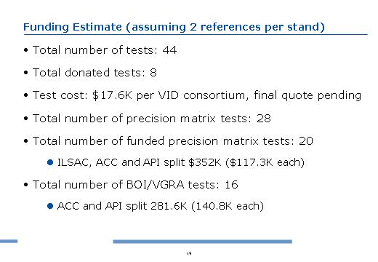
Action: review and approve funding structure by August 26 – ACC and API

Jerry Wang asked what was needed to trigger the signing of the MOU. Kevin Ferrick indicated a draft was already reviewed by API legal. He said lab quote should be directed to him with the MOU only citing the total cost, not lab by lab quotes. He also warned of the time needed for legal review.

Action: provide final quote to API as soon as possible – SwRI and Intertek

Jerry Wang went through the remaining decisions carried over from prior meetings with the updates from the meeting discussion below:
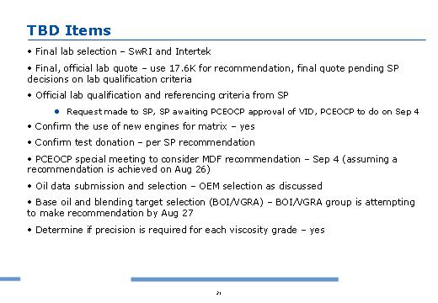

Zalar said TMC was expecting the components for the baseline oil by 2nd week of September. He expected the baseline oil to be available by end of September so wouldn’t causing delay to matrix.

Thom Smith estimated a 2 week ballot period after PCEOCP reviewed the VID and MDF recommendations on September 4 though VID data and MDF recommendation should be circulated as early as possible to facilitate the process.

The meeting adjourned at 12:20 Eastern time. The next meeting is 3 pm, August 26, at Monaco Hotel in San Francisco. All members were encouraged to show up by 2 pm for a possible earlier start.

