**Date: November 1, 2017**

**To: Subcommittee D02.B0 members**

**Technical Contact: Terry Bates, batesterryw@aol.com**

**Work Item #: 54716**

**Ballot Action: New engine oil test method**

**Rationale: This new test method will likely be in the new ILSAC GF-6 engine oil specification**

*Prepared by Terry Bates*

**Standard Test Method for**

**Evaluation of Performance of Automotive Engine Oils in the Mitigation of Low-Speed, Preignition in the Sequence IX Gasoline Turbocharged Direct-Injection, Spark-Ignition Engine**

This standard is issued under the fixed designation X XXXX; the number immediately following the designation indicates the year of original adoption or, in the case of revision, the year of last revision. A number in parentheses indicates the year of last reapproval. A superscript epsilon (ε) indicates an editorial change since the last revision or reapproval.

**INTRODUCTION**

Portions of this test method are written for use by laboratories that make use of ASTM Test Monitoring Center (TMC)[1],[2] services (see Annexes A1 to A4).

The TMC provides reference oils, and engineering and statistical services to laboratories that desire to produce test results that are statistically similar to those produced by laboratories previously calibrated by the TMC.

In general, the test purchaser decides if a calibrated test stand is to be used. Organizations such as the American Chemistry Council require that a laboratory utilize the TMC services as part of their test registration process. In addition, the American Petroleum Institute and the Gear Lubricant Review Committee of the Lubricant Review Institute (SAE International) require that a laboratory use the TMC services in seeking qualification of oils against their specifications.

The advantage of using the TMC services to calibrate test stands is that the test laboratory (and hence the Test Purchaser) has an assurance that the test stand was operating at the proper level of test severity. It should also be borne in mind that results obtained in a non-calibrated test stand may not be the same as those obtained in a test stand participating in the ASTM TMC services process.

Laboratories that choose not to use the TMC services may simply disregard these portions.

1. **Scope** 
   1. This laboratory engine test evaluates the ability of an automotive engine to mitigate preignition in the combustion chambers in gasoline, turbocharged, direct-injection (GTGI) engines under low-speed and high-load operating conditions. This test method is commonly known as the Ford low-speed, preignition (LSPI) test.
      1. In vehicles, equipped with relatively small gasoline GTDI spark-ignition engines, preignition has occasionally occurred when the vehicles are operated under low-speed and high-load conditions. Uncontrolled, preignition may cause destructive engine damage.
   2. The values stated in SI units are to be regarded as standard. No other units of measurement are included in this standard.

1.2.1 *Exceptions—*Where there is no direct SI equivalent such as screw threads, national pipe threads/diameters, tubing size, wire gage, or specified single source equipment.

1.3 *This standard does not purport to address all of the safety concerns, if any, associated with its use. It is the responsibility of the user of this standard to establish appropriate safety and health practices and determine the applicability of regulatory limitations prior to use.*

***2.* Referenced Documents**

**2.1** *ASTM Standards[3]:*

D86 Test Method for Distillation of Petroleum Products and Liquid Fuels at Atmospheric Pressure

D130 Test Method for Corrosiveness to Copper from Petroleum Products by Copper Strip Test

D235  Specification for Mineral Spirits (Petroleum Spirits) (Hydrocarbon Dry Cleaning Solvent)

D323 Test Method for Vapor Pressure of Petroleum Products (Reid Method)

D525 Test Method for Oxidation Stability of Gasoline (Induction Period Method)

D381 Test Method for Gum Content in Fuels by Jet Evaporation

D1298 Test Method for Density, Relative Density, or API Gravity of Crude Petroleum and Liquid Petroleum Products by Hydrometer Method

D1319 Test Method for Hydrocarbon Types in Liquid Petroleum Products by Fluorescent Indicator Adsorption

D2622 Test Method for Sulfur in Petroleum Products by Wavelength Dispersive X-ray Fluorescence Spectrometry

D2699 Test Method for Research Octane Number of Spark-Ignition Engines

D2700 Test Method for Motor Octane Number of Spark-Ignition Engine Fuel

D2709 Test Method for Water and Sediment in Middle Distillate Fuels by Centrifuge

D3120 Test Method for Trace Quantities of Sulfur in Light Liquid Petroleum Hydrocarbons by Oxidative Micrcoulometry

D3231 Test Method for Lead in Gasoline by Atomic Absorption Spectroscopy

D3237 Test Method for Lead in Gasoline by Atomic Absorption Spectroscopy

D4175 Terminology Relating to Petroleum, Petroleum Products, and Lubricants

D5453 Test Method for Determination of Total Sulfur in Light Hydrocarbons, Spark Ignition Engine Fuel, Diesel Engine Fuel, and Engine Oil by Ultraviolet Fluorescence

2.2 *American National Standards Institute Standards[4]*

ANSI MC96.1 Temperature Measurement-Thermocouples

3 **Terminology**

3.1*Definitions:*

3.1.1 *engine oil*, *n*—a liquid that reduces friction or wear, or both, between the moving parts within an engine; removes heat, particularly from the underside of pistons; and serves as a combustion gas sealant for piston rings.

3.1.1.1 *Discussion*—It may contain additives to enhance certain properties. Inhibition of engine rusting, deposit formation, valve train wear, oil oxidation, and foaming are examples. **D4175**

3.1.2 *lubricant test monitoring system (LTMS), n–*an analytical system in which ASTM calibration test data are used to manage test precision and severity (bias). **D4175**

3.1.2 preignition, *n*—*in a spark-ignition engine*, ignition of the mixture of fuel and air in the combustion chamber before the passage of the spark.        **D4175**

3.2  *Definitions of Terms Specific to This Standard:*

3.2.1 *PCM, n*—an engine control unit, most commonly called the powertrain control module (PCM), is an electronic device that instantaneously controls a series of actuators on an internal combustion engine to ensure optimal engine performance.

*3.4 Acronyms and Abbreviations*

3.4.1 AvPIE—-average preignition events

3.4.2 CAN—controller area network

3.4.3 DAC—digital-to-analog converter

3.4.4 DACA—data acquisition and control automation

3.4.5 *ei* —prediction error

3.4.6 ECU—electronic control unit

3.4.7 EEC—Electronic Engine Control

3.4.8 GTDI—gasoline turbocharged direct injection

3.4.9 IBP—initial boiling point

3.4.10 ID—internal diameter

3.4.11 KP_INT—knock interval

3.4.12 LCR—lower compression ring

3.4.13 LTMS—lubricant test monitoring system

3.4.14 LSPI –low speed preignition

3.4.15 MAF—mass air flow

3.4.16 MAP—manifold absolute pressure

3.4.17 MAPT – manifold absolute pressure and temperature

3.4.18 MFB—mass fraction burn

3.4.19 MFB2—mass fraction burn at 2 %

3.420 PCM—powertrain control module

3.4.21 PCV—positive crankcase ventilation

3.4.22 PID —parameter identification

3.4.23 PMAX—maximum pressure

3.4.24 PMAXV—pressure maximum voltage

3.4.25 PMINV—pressure minimum voltage

3.4.26 PP—peak pressure

3.4.27 P/N—part number

3.4.28 UCR—upper compression ring

3.4.29 VCT—variable valve timing

3.4.30 WOT—wide open throttle

3.4.21 *Zi*—exponentially weighted moving average

**4. Summary of Test Method**

4.1 The test procedure is a “flush and run” test, that is the test engine is used for multiple tests and the next test oil is used to flush the previous test oil from the engine.

4.2 The test procedure is conducted in four iterations. Each iteration is 175,000 engine cycles in length.

4.3 Low-engine speed and high-load, steady-state conditions are used to generate preignition events, which are counted throughout each of the four 175,000 engine cycles.

4.4 Combustion pressure is measured directly in each cylinder to provide documentary evidence of the occurrence of preignition events.

**5. Significance and Use**

5.1 This test method evaluates the ability of an automotive engine to mitigate preignition in the combustion chambers in turbocharged, direct injection, gasoline engines under low-speed and high-load operating conditions.

5.2 Varying quality reference oils, with known preignition tendencies, were used in developing the operating conditions of the test procedure.

5.3 The test method has applicability in gasoline engine oil specifications and is expected to be used in specifications and classifications of engine lubricating oils, such as the following:

* + 1. Specification D4485
    2. ILSAC GF-6.
    3. Military Specification MIL-PRF-2104.
    4. SAE Classification J183.

**6. Apparatus (General Description)**

* 1. *Test Engine*—The test engine is a spark ignition, four-stroke, four-cylinder gasoline turbocharged direct injection engine with a displacement of 2.0 L. Features of this engine include variable camshaft timing, dual overhead camshafts driven by a timing chain, four valves per cylinder, and electronic direct-fuel injection. It is based on the Ford Motor Co. 2012 Explorer engine[5],[6].
  2. Configure the test stand to accept the test engine. All special equipment necessary for conducting this test is listed below.
  3. Use appropriate air conditioning apparatus to control the temperature, pressure, and humidity of the inlet air to meet the requirements in Table 6.

6.4 Use an appropriate fuel supply system. A typical system is shown in Fig. 1.

Note 1—The fuel may need to be heated to maintain the fuel temperature in Table 6. As a consequence, heat may buildup in the fuel system during shutdown thereby increasing the pressure in the fuel lines. It is good practice, therefore, to include a pressure relief valve in the fuel line to relieve the pressure and to send the excess fuel back to the tank before the shutoff valve.

6.5 The control and data acquisition system shall meet the requirements listed in Annex A5.

6.6.*Engine Cooling System*:

6.6.1 Use the coolant inlet and outlet system from OH Tecnologies[7],6. Typical plumbing for the external coolant system is shown in Figs. A6.2 and A6.3. Use a coolant flow meter with an accuracy of ± 1 %. Install the flowmeter at either the coolant inlet or coolant outlet sides of the engine. Install the flow control valve in the line running from the engine coolant outlet to the heat exchanger. ITT standard heat exchangers[8],6 have been found suitable. Use 38 mm (1.5 in.) pipe to plumb the coolant system. Minimize the number of elbows in the cooling system. Ensure that the engine coolant flows through the tube side of the heat exchanger.

6.6.2 A radiator cap (Motorcraft RS40 P/N D2YY-8100-A[9]) is used to limit system pressure to 105 kPa. Pressurize the coolant system to 70 kPa ± 10 kPa at the top of the coolant reservoir.

6.6.3 Control the engine-coolant flow rate and outlet temperature to meet the requirements in Table 6.

6.6.4. Prior to running each reference calibration test, inspect and clean the engine-coolant system components external to the engine. The coolant side of the system typically does not need cleaning but the process side may need routine cleaning. While a specific flushing technique is not specified, the technique should employ a commercial descaling cleaner.

6.7*Oil System Components*—All oil system components in the engine are production configuration with the exception of the modified oil pan (Fig. A6.1) and oil filter housing (Fig. A6.12).

6.8 Using the production oil cooler, control the oil temperature by running process water through the water-side of the oil cooler. Locations of oil-temperature thermocouples are shown in Fig. A6.12.

6.9 *Dynamometer*—Use Midwest dynamometer model MW-1014A[10] available from OHT7,**Error! Bookmark not defined.**.

6.10 *Combustion Analysis Equipment—*Use the AVL IndiSmart GigaBit 612 combustion analysis system and the AVL IndiCom combustion analysis software[11],6. For the latter, use the amplifier and pressure settings and the standard results settings given in A11.1.1 and A11.1.2, respectively. Report the channels shown in A11.3.

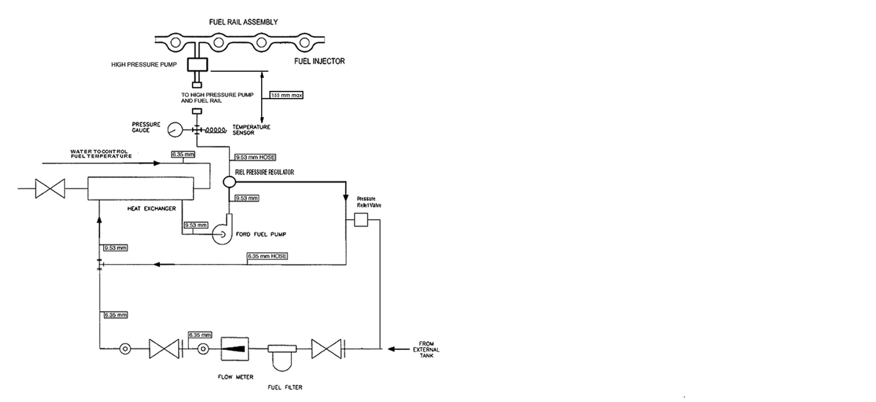 FIG. 1 Typical Fuel Supply System

6.11*Fuel and Fuel System:*

6.11.1 *System Description*—Fig. 1 is a schematic diagram of a typical fuel supply system. Supply an excess volume of fuel to the high-pressure fuel pump and fuel rail at all times. Introduce make-up fuel (that is, fuel used by the engine) into the loop from an external source. Mix the make-up fuel with fuel that is returned from the fuel rail (that is, fuel not used by the engine). Pump the fuel through a mixing chamber, or a small heat exchanger, to mix the two streams and to provide fuel of consistent temperature to the engine. Deliver the fuel to a high-pressure pump (Ford P/N AG9Z-9350-B/AG9E-9D376-AB5,6 that boosts the pressure and supplies the fuel to the fuel rail.

6.11.2 *Controls*—Maintain the fuel temperature to the high-pressure pump at 30 °C ± 0.5 °C. To ensure good atomization of the fuel, maintain the fuel pressure to the high-pressure pump above 450 kPa ± 37 kPa. Maintain constant fuel pressure throughout the test to ensure good speed, power, and air-fuel ratio control.

6.11.3 *Test* *Fuel*—Approximately 340 L of Haltermann HF003 Lube Certificaiton fuel[12],6 are required for each test. (**Warning—**Flammable, health hazard.) A list approved suppliers is listed in X.X.

6.11.4 *Fuel Batch*—Ensure each new batch of fuel is accompanied by a certificate of analysis showing that it meets the requirements shown in Table A7.1.

6.11.4.1 Fuel from a new batch can be added to a laboratory’s fuel tank at anytime provided it meets the requirements in Table A7.1 – see also 6.11.4.2.

6.11.4.2 *Fuel Batch Analysis*—Fuel Batch Analysis—It is the responsibility of the laboratory to analyze a fuel sample every 30 days to verify the value of several key parameters identified in Table A7.1 with an asterisk. The results shall be within the specification band shown in Table A7.1. This comparison will indicate if the fuel batch is contaminated or has aged prematurely. If any results fall outside the tolerances shown in Table A7.1, the laboratory shall contact the TMC and the supplier to determine the suitability of using that batch for this engine test.

7. Apparatus (The Test Engine)

7.1 *SEQUENCE IX Test Engine*—The test engine parts are available from the Ford Motor Company5,6. A detailed listing of all parts and P/Ns is given in Annex A8.

7.2 *Required New Engine Parts*—A new short-block is required when initially referencing a stand and engine combination. This short-block can be re-used provided it remains within service limits and is capable of being referenced. New crush washers and gaskets are required whenever the engine/short-block is disassembled (for example, for pretest measurements or repair). New camshafts and buckets are required when first building a cylinder head. New valves are required when rebuilding a cylinder head.

7.3 *Reusable Engine Parts*—The cylinder head can be used on subsequent short-blocks as long as it remains within the service limits in the workshop manual. The parts listed in Tables A8.2, A8.6, and A8.7 can be used for multiple tests as long as they are in good condition and meet the service limits in the workshop manual.

7.4 *Specially Fabricated Engine Parts*—The following subsections detail the specially fabricated engine parts required in this test method:

7.4.1 *Inlet Air System* (see Fig. A6.8)—Fabricate the inlet air system using the stock 2012 Explorer air cleaner assembly and mass air flow (MAF) sensor as detailed in Table A8.6. Install the fresh-air tube, air-cleaner assembly, and new air filter. Modify the air-cleaner assembly to accept fittings for an inlet-air-temperature thermocouple and pressure tap as shown in Fig. A6.8. Either use the 2012 Explorer fresh-air tubes or fabricate fresh-air tubes so as to provide a separation of 1,040 mm ± 25 mm from the MAF sensor to the turbocharger inlet.

7.4.2 *Oil Pan*—Modify the stock 2012 Explorer oil pan to add an oil drain plug in one of the rear locations shown in Fig. A6.1.

7.4.3 *Cylinder Head*—Use a modified cylinder head that allows the installation of in-cylinder pressure sensors. This engine part is available from TEI[13],6.

7.4.4 *Pressure Sensor Tubes*—Install 3/8 in. OD steel tubing into the pressure sensor sleeves in the cylinder head to allow for installation of the in-cylinder pressure sensors.

7.4.5 *Valve Cover*—Modify the stock valve cover to allow the pressure sensor tubes to protrude through the cover. Seal the location where the tubes protrude through the cover to prevent oil from leaking through the penetrations.

7.4.6 *Coolant Supply Manifold*—To accept the coolant-in thermocouple (Fig. A6.2), use a coolant-inlet purchased from OH Technolgies7,6 in place of the stock coolant inlet.

7.4.7 *Coolant Return Manifold*—To accept the coolant-out thermocouple and provide a coolant return from the turbocharger (Fig. A6.2), use a coolant outlet purchased from OH Technologies**Error! Bookmark not defined.**,6 in place of the stock thermostat housing,

7.4.8. *Oil Filter Housing*—Modify the oil-filter housing to accept a thermocouple on the front side of the housing, facilitating measurement of the oil temperature entering the oil cooler.

7.5 *Special Engine Measurement and Assembly Equipment*—For assembly, use any special tools or equipment shown in the 2012 Explorer Service Manual. Complete any assembly instructions not detailed in Section 7 according to the instructions in the 2012 Explorer Service Manual. Apparatus routinely used in a laboratory or workshop are not included.

7.5.1 *Piston Ring Positioner*—Use the piston-ring positioner to locate the piston rings down from the cylinder-block deck surface by 38 mm. This allows the compression rings to be positioned in a consistent location in the cylinder bore for the ring-gap measurement. Fabricate the positioner according to the details shown in Fig. A6.13.

7.5.2 *Engine Service Tools*—A list of special tools[14] for the test engine is shown in Table A8.8. The tools are designed to aid carrying out several service items, in addition to the specific service items that require special tools to perform the functions indicated (if not self-explanatory).

7.6 *Engine Installation on the Test Stand*:

7.6.1 *General*—Functions that are to be performed in a specific manner or at a specific time in the assembly process are noted here.

7.6.2 *Mounting the Engine on the Test Stand*—Mount the engine on the test stand so that the flywheel friction face is 0.0° ± 0.5° from vertical. Use two motor mounts at the rear of the engine. Quicksilver P/N 6628-A has been found suitable for this purpose. An example of a rear- mount support is shown in Fig. A6.5. Use a rubber mount at the front of the engine attached to the front-cover mount. Examples of front-mount supports are shown in Fig. A6.4. Ensure the engine is at 0.0° ± 0.5° role angle.

7.6.3 *Flywheel*—Obtain the modified flywheel (P/N OHTVH-006-1) from the OH Technologies**Error! Bookmark not defined.**,6. Lightly coat the flywheel bolts with Loctite 565 to prevent any oil from seeping out of the holes. Torque the flywheel to 108 N•m to 115 N•m.

7.6.4 *Clutch and pressure plate*—Obtain the clutch (Sachs P/N K0047-07), the pressure plate (P/N VH006-8-2) and spacer (P/N OVTVH-011-1) from OH Technologies**Error! Bookmark not defined.**,6. Put the flat side on the clutch toward the engine and put the spacer between the flywheel and pressure plate. Torque the pressure plate bolts to 25 N•m to 33 N•m. Replace the clutch and pressure plate with every new engine.

7.6.5 *Driveline*—Grease the driveline every test. The driveline specifications are as follows:

1. Driveline degree: 1.5° ± 0.5°;
2. Installed length from flange to flange: 595 mm ± 13 mm;
3. 1410 series flanges;
4. Pilot: 70 mm (2.75 in.);
5. Bolt circle: 95 mm (3.75 in.);
6. Stub and slip: 90 mm (3.50 in.) and 2.111 mm (0.083 in.), respectively.

7.7 *Exhaust System:*

7.7.1 **Warning—**Exhaust gas is noxious. (Caution: Any leaks in the connections to the sample probes will result in erroneous readings and incorrect air-fuel ratio adjustment.)

7.7.2 A typical exhaust system, with fittings for backpressure probe, oxygen (O2) sensors and thermocouple, is illustrated in Fig. A6.6.

7.7.3 Construct exhaust components from either solid or bellows pipe/tubing. Other flexible pipe type is not acceptable.

7.7.4 Use the backpressure probes until they become unserviceable. If the existing probes are not cracked, brittle, or deformed, clean the outer surfaces and clear all port holes. Check the probes for possible internal obstructions and reinstall the probes in the exhaust pipe.

7.7.4.1 Stainless steel probes are generally serviceable for several tests; mild steel probes tend to become brittle after one test.

7.8 *Fuel Management System:*

7.8.1 *Fuel Injectors*—Inspect the O-rings to ensure they are in good condition and will not allow fuel leaks. Replace if necessary. Install the fuel injectors into the fuel rail and the cylinder head.

7.9 *Powertrain Control Module:*

7.9.1 Use a PCM provided by Ford Motor Company5,6 to run this test. The PCM contains a calibration developed for this test. The PCM calibration number is U502-HBBJ0-v1-7-VEP-371.VBF.

7.9.1.1 The PCM is powered either by a 13.5 V ± 1.5 V battery or an alternative power supply that does not interrupt/interfere with proper PCM operation.

7.9.1.2 Connect the PCM battery/power supply to the engine-wire harness with an appropriate gage wire of the shortest practical length so as to maintain a dc voltage of 12 V to 15 V and minimize PCM electrical noise problems. Ground the PCM ground wire to the engine. From the same ground point, run a minimum 2 gage wire back to the battery negative to prevent interruption/interference of the PCM operation. The power supply can also be used for the lambda (oxygen) sensors.

7.10 *Spark Plugs:*

7.10.1 Use Motorcraft CYFS-12-Y29 spark plugs. Spark plugs come pre-gapped. Torque the spark plugs to 9 N·m to 12 N·m. Do not use anti-seize compounds on spark plug threads.

7.11 *Crankcase-Ventilation System:*

7.11.1 The crankcase-ventilation system is vented to the atmosphere through the port in the valve cover and is not to be connected to the inlet.

7.12 *Water-to-Air Turbocharger Intercooler:*

7.12.1 Use water-to-air intercooler capable of achieving the required air-charge temperatures in Tables 3 to 6 and an average, system-pressure loss less than 3 kPa. Type 5 or Type 52 intercoolers from Frozenboost[15],6 have been found suitable.

When cleaning the intercooler as part of normal maintenance, spray clean the air side of the intercooler with solvent, rinse with hot water and leave to air-dry. Use commercial AquaSafe descaler to clean the water-side.

7.13 *Intercooler Tubing*

7.13.1 Fabricate the inlet-air system with 51 mm internal diameter (ID), stainless steel tubing from the turbocharger to the intercooler, and 64 mm ID, stainless steel tubing from the intercooler to the throttle body. The tubing length is not specified but should be the appropriate length to achieve the required air charge temperature in Tables 3 to 6 and an average system pressure loss less than 3 kPa.

7.13.1.1 Locate the sensor for measuring the manifold absolute pressure and temperature (MAPT) 305 mm ± 25 mm from the intake surface of the throttle body and the intake-air-charge temperature thermocouple 25 mm (1 in.) downstream from the MAPT sensor. Place the probe for measuring the post-intercooler, turbo-boost pressure a minimum of 305 mm upstream from the MAPT sensor. Place the probe for measuring the pre-intercooler, turbo-boost pressure 155 mm ± 25 mm from the turbocharger outlet. The measurements can be seen in Fig. A6.9 and typical installation is shown in Fig. A6.10.

7.14 *External Hose Replacement*

7.14.1 Inspect all external hoses used on the test stand and replace any hoses that have become unserviceable. Check for internal wall separations that could cause flow restrictions. Check all connections to ensure security.

7.15 *Wiring Harness*

7.15.1 There are two wiring harnesses used on the test stand - a dynamometer harness that connects to the stand power and PCM, and an engine harness. Obtain the dynamometer and engine-wiring harnesses from OH Technolgies7,6,. Diagrams of these wire harnesses are shown in Figs A6.16 and A6.17 identifying connections.

7.16 *Electronic Throttle Controller:*

7.16.1 Control the electronic-throttle controller using signals from the simulated, accelerator-pedal position. The dynamometer wiring harness is supplied with an Accelerator Pedal Position jumper cable with un-terminated pigtail leads.

7.16.1.1 Connect the two voltage command signals, Acc Pos Sensor 1 and Acc Pos Sensor 2, to the Accelerator Pedal Position jumper cable. The voltage control ranges for each signal are shown in Table 1. The wiring schematic and pin-out description for this connection are shown in Fig. 2.

7.6.1.2 ACC Pos Sensor 2 shall always equal 50 % of Acc Pos Sensor 1.

7.16.1.3 Run the voltage signals through a voltage isolator otherwise interference will occur between the laboratory digital-to-analog converter (DAC) system and the engine electronic control unit (ECU) leading to erratic throttle control.

TABLE 1 Accelerator Position Sensor Control Ranges

|  |  |  |  |
| --- | --- | --- | --- |
| Command Signal | Operating Range,  V*A* | Min Signal (Idle),  V*A* | Max Signal (WOT)*,*  VA |
| Acc Pos Sensor 1 | 0  to 5.0 | 0.75 (15 %) | 4.25 (85 %) |
| Acc Pos Sensor 2 | 0  to V | 0.375 (15 %) | 2.125 (85 %) |

*A* DC



FIG. 2 Accelerator Position Wiring Schematic

7.17 *Water Pump and Water-Pump Drive*—Install the water pump and pulley, the crankshaft pulley, and the tensioner according to the 2012 Explorer service manual. These are the only components needed to drive the water pump. All other production, front-end, accessory-drive components do not need to be installed. The engine cannot be used to drive any external engine accessory other than the water pump. Pull back the tensioner and install the water-pump drive belt as shown in FIG. 3. Ensure that there is a minimum contact angle of 20° between the drive belt and the water-pump pulley.

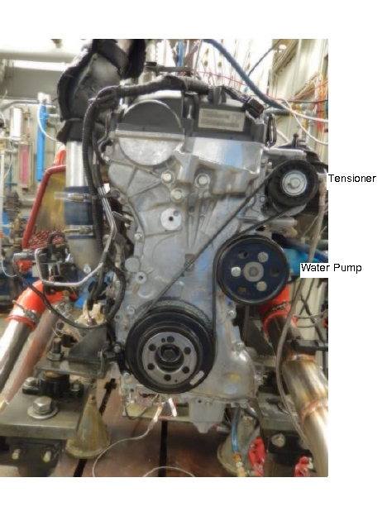

FIG. 3 Water-Pump Drive Arrangement

7.18 *Cylinder-block oil separator*

7.18.1 Install a dummy positive crankcase ventilation (PCV) valve (that is, a PCV valve with the internal components removed) in the oil separator on the side of the engine block. Measure crankcase pressure at this location.

8. Engine Preparation

8.1 *Engine Disassembly*

8.1.1 Disassemble the engine and the cylinder head according to the 2.0 L Ecoboost disassembly procedures in the Ford 2012 Explorer Shop Manual. Note the position of all the engine components to ensure they are returned to the same positions when the engine is reassembled.

8.2 *Cylinder Head Preparation and Cleaning:*

8.2.1 Use a modified cylinder head obtained from TEI13,6.

8.2.2 *New Cylinder Heads:*

8.2.2.1 A new cylinder head that has been modified with pressure-transducer tubes installed, and never used in a previous Sequence IX test, shall be cleaned with Stoddard solvent before assembly. Clean all debris left from the tube installation off the cylinder head.

8.2.3 *Used Cylinder Heads*:

8.2.3.1 For a cylinder head that has been modified with pressure transducer tubes installed, and has been used in a previous Sequence IX test, clean the bare cylinder head, with tubes (but no valve-train components) in an ultrasonic parts cleaner. Tierra Tech Model MOT500NS[16],6 has been found suitable for this purpose. Rinse parts with cleaning soap, NAT-50 or PDN-50[17],6, before putting them into the ultrasonic cleaner. Use Ultrasonic Solution 7 and B16,6 in the ultrasonic parts cleaner.

8.2.3.2 The cleaning procedure is described below:

8.2.3.3 Heat the ultrasonic bath to 60 °C (140 °F). When this temperature is attained (but NOT before), add the ultrasonic cleaning solution. For the Tierra Tech Model MOT500NS with a capacity of 6000 L (158 gal), use 20.8 L of ultrasonic solution 7 and 1.9 L (0.5 gal) of ultrasonic solution B. Change the soap and water solution at least after every 25 h of use.

Note 2—Quantities will be different for a different size unit.

8.2.3.4 After 30 min, remove the parts and immediately spray with hot water, followed by solvent and left to air dry.

8.3 Unless otherwise stated, spray clean the following components with solvent, then blow out with pressurized air, and leave to air dry:

1. Camshafts and all valve train;
2. Intake manifold/throttle body (unseparated);
3. Fuel-pump housing with piston;
4. Vacuum pump and oil screen;
5. Oil screen and the intake and outlet of the turbocharger - wipe lightly, with a rag wet with solvent. (Do not clean the inside of the turbocharger);
6. Carbon build up on the injectors - wipe off; variable vale timining
7. Variable valve timing (VCT) solenoids;
8. Valve cover;
9. Turbocharger oil lines.

8.4 *Engine Measurements:*

8.4.1. *Cylinder Bore and Piston Measurements*—See Table A9.1.

8.4.1.1 Measure and record the piston-to-bore clearances at the top, second, and third ring lands and the piston skirt as shown in Fig. A6.13. Use the bore ladder shown in Fig. A6.14 to determine bore diameter positions. Measure the bore in both the longitudinal and transverse directions. To determining the piston-to-bore clearance, calculate the difference between the particular piston diameter location and the average bore diameter for both the transverse and longitudinal directions.

8.4.1.2 Measure and record ring side clearances for the upper and lower compression rings (UCR, LCR). Determine ring side clearance by taking four measurements 90° apart. Either check clearance with a thickness gauge or by measuring the difference between the thickness of the ring and the height of the corresponding groove.

8.4.1.3 Measure and record ring tension. Obtain ring tension measurements from Test Engineering, Inc.13,**Error! Bookmark not defined.**.

8.4.2  *Cylinder head measurements*—See Table A9.2.

8.4.2.1 To determine the valve stem-to-guide clearance, measure the diameter of the valve stem at 38 mm from the tip of the valve, and the valve guide at 19.5 mm from the top of the valve guide.

8.4.2.2 For the intake and exhaust valve springs, measure and record spring free length and spring tension at a compressed height of 28.7 mm. Verify the compressed spring tension is 460 N ± 21 N. Reject any springs not meeting this criteria.

8.4.3 *Crankshaft Measurements—*See Table A9.3.

8.4.3.1

8.5 *Miscellaneous Engine Components-Preparation*:

8.5.1 *Environment for Engine Buildup and Measurement Areas*—The ambient atmosphere of the engine buildup and measurement areas shall be reasonably free of contaminants. Control the temperature to within ± 3 °C to ensure acceptable repeatability in the measurement of parts dimensions. To prevent moisture forming on cold engine parts that are brought into the buildup or measurement areas, maintain the relative humidity at a nominal maximum of 50  %.

* + 1. *Throttle Body:*
       1. Clean the butterfly and bore of the throttle body with Berryman Chemtool B12[18],6 carburetor cleaner and air-dry before each test. Do not disassemble the throttle body as this will cause excessive wear on the components. The idle-air screw can be removed for the cleaning process. Fully close the idle-air screw during test operation.
       2. There is no specific life for the throttle body. However, the clearance between the bore and the butterfly will eventually increase and render the body unserviceable. When the clearance becomes too great to allow control of speed, torque, and air-fuel ratio, discard the throttle body.

8.6 *Engine Assembly:*

8.6.1 Assemble the engine according to the 2.0 L Ecoboost assembly procedures in the 2012 Explorer Shop Manual, except as noted in section 7. Ensure all components (that is, pistons, rings, bearings, etc.) are replaced in the same positions used originally when assembled at the factory.

* + 1. *Sealing Compounds*—Use a silicon-based sealer, as needed, on the contact surfaces between the rear-seal housing and oil pan and the front cover and cylinder block, cylinder head and oil pan. Use Motorcraft Gasket Maker (TA-16)9,6or equivalent between the 6th intake and exhaust camshaft cap and the cylinder head. Use silicon-based sealer sparingly since it can elevate the indicated silicon content of the used oil.

Note 3—Non-silicon liquid or tape thread sealers may be used on bolts and plugs.

* + 1. *Gaskets and Seals*—Install new gaskets and seals during engine assembly.

8.7 *Cylinder Head Assembly*:

8.7.1 Cylinder heads may be used as long as they remain within service specifications. Refer to the 2012 Explorer Service Manual.

8.7.2 Replace the valves on cylinder heads reused on another engine block,

8.7.3 If a cylinder head is removed from an engine block ahead of schedule due to broken pistons, short-block failure, or lack of test severity, the laboratory may reuse the cylinder head without replacing the valves provided they are within service limit

8.7.4 Assemble the cylinder heads in accordance with the service manual. Lap the valves before installation and install new intake- and exhaust-valve seals. Set the valve lash in accordance with the procedure in the workshop manual and record the valve lash.

8.7.5 Vacuum check the valve ports before use.

8.8 *Engine Installation on Test Stand*—Install the engine onto the stand as described in 7.6.2. Install all engine components external to the long-block according to the 2.0L Ecoboost assembly procedures in the 2012 Explorer Shop Manual, where applicable. Connect the engine to all external laboratory systems identified in Section 6, in accordance with laboratory procedures.

8.9 *Pressure Sensor Installation*—Once the sensor tubes and modified valve cover are installed (see 7.4.4 and 7.4.5), install pressure sensors into the pressure-sensor tube using the sensor-installation tool described in Table A8.8 and torque the sensors to 1.5 N·m.

8.10 *New-Engine Break In*—Once a new engine has been installed on the test stand, perform the eight-hour break-in procedure shown in Table 2 using oil TMC 220[19].

TABLE 2 Sequence IX Eight-Hour, Break-In Procedure

|  |  |  |  |  |
| --- | --- | --- | --- | --- |
| Step | Engine speed, r/min | Engine torque,  N•m | Time per stage, h:min | Total Time, h:min |
| **Install new oil filter and charge engine with 4.2 kg of new oil** | | | | |
| 1 | Idle | 0 | 0:30 | 0:30 |
| **Oil change 1: Shut engine down, drain used oil, and remove oil filter. Allow oil to drain for 20 min. Install new oil filter and add 4.2 kg grams of new oil.** | | | | |
| **Start engine and idle for 5 min** | | | | |
| 2 | 1500 | 38 | 0:30 | 1:00 |
| 3 | 2000 | 72 | 0:30 | 1:30 |
| 4 | 2500 | 111 | 0:30 | 2:00 |
| 5 | 3000 | 135 | 0:30 | 2:30 |
| 6 | 3000 | 150 | 3:15 | 5:45 |
| 7 | 2000 | 72 | 0:15 | 6:00 |
| 8 | 3250 | 155 | 0:15 | 6:15 |
| 9 | 3500 | 155 | 0:15 | 6:30 |
| 10 | 3750 | 155 | 0:15 | 6:45 |
| 11 | 4000 | 155 | 1:15 | 8:00 |
| **Bring engine to idle for 5 min, then shut down** | | | | |
| **Oil change 2: Drain used oil and remove oil filter. Allow oil to drain for 20 min. Install new oil filter and add 4.2 kg new oil.** | | | | |
|  | | | | |

8.10.1 The controlled quantities during the break-in are listed in Table 3. All other controls are left wide open or free flowing. The engine does not produce enough heat in the early steps to reach all target temperatures. All controlled quantities shall be on target at the beginning of Step 4.

Table 3. Sequence IX Controlled Quantities for the Eight-Hour Break-in

|  |  |
| --- | --- |
| Quantity, unit | Controlled value |
| Coolant-out temperature, °C | 85 |
| Oil-gallery temperature, °C | 100 |
| Inlet-air pressure, kPa (gauge) | 0.05 |
| Air-charge temperature, °C | 37 |
| Inlet-air temperature, °C | 30 |
| Humidity, g/kg | 11.4 |
| Fuel pressure, kPa | 450 ± 37 |
| Coolant flow rate | Valve wide open |

8.11 *Temperature Measurements:*

8.11.1 *General:*

8.11.1.1 Temperature measurement locations are specified in 8.11.4.

8.11.1.2 Use thermocouples that can be calibrated with an accuracy of ± 0.5 °C. Use Ford-specified temperature sensors for Electronic Engine Control (EEC) inputs.

8.11.2 *Equipment:*

8.11.2.1 Use premium, sheathed thermocouples in all cases except the intake-air thermocouple which mayA.6.2 be an open-tip type. Use thermocouples with a diameter of 3 mm and a length of 100 mm.

8.11.2.2 Thermocouples, wires, and extension wires shall be matched to perform in accordance with the special limits of error as defined in ANSI MC96.1.

8.11.3 *Calibration*— Refer to table 8.x for calibration interval of thermocouples. The temperature-measurement system shall indicate within ± 0.5 °C of the laboratory calibration standard. The calibration standard shall be traceable to NIST[20].

8.11.4 *Locations for Engine-Temperature Sensors*:

8.11.4.1 *Engine-Coolant Inlet*—Install the sensor in the coolant inlet on the engine (P/N OHTVH-008-1**Error! Bookmark not defined.**,6) perpendicular to the run. Install sensor with the tip in the center of the stream of flow (see Fig. A6.2).

8.11.4.2 *Engine-Coolant Outlet*—Install the sensor in the coolant outlet on the engine (P/N OHTVH-009-1**Error! Bookmark not defined.**,6) perpendicular to the run. Install sensor with the tip in the center of the stream of flow (see Fig. A6.2).

8.11.4.3 *Engine-Oil Gallery*—Install the tip of the sensor at the center of the flow stream in the external, oil-filter adapter (see Fig. A6.12) through the hole for the oil-pressure switch (which is not used). Install a tee to accept this temperature sensor and attach the oil-pressure line.

8.11.4.4 *Engine-Oil-Filter In*—Install the tip of the sensor at the center of the cross fitting attached to the side opposite from the engine-oil-inlet temperature sensor on the oil-filter adaptor. Modify the adapter with a 1/8 NPT hole to access the oil passage (see Fig. A6.12).

8.11.4.5 *Inlet Air*—Install the tip of the thermocouple midstream in the air-cleaner box downstream of the filter (see Fig. A6.8). Insertion depth shall be 37 mm ± 2 mm.

8.11.4.6 *Fuel*—Install the sensor in the low-pressure fuel line no more than 155 mm from the high-pressure pump. Use an appropriate size “T” fitting to ensure the sensor and fitting do not interfere with the fuel flow (see Fig A6.7).

8.11.4.7 *Air Charge*—Install the sensor in the intercooler outlet tube 25 mm± 2 mm downstream from the MAPT sensor (see Fig A6.9).

8.11.4.8 *Exhaust*—Install a sensor 140 mm ± 12 mm downstream on the exhaust flange (see Fig. A6.6).

8.11.4.9 *Oil Sump*—Measurement of oil-sump temperature is optional. If it is measured, install a sensor through the production oil-drain-plug hole. Insertion depth shall be ??

8.12 *Pressure Measurements:*

8.12.1 *General*—Pressure measurement locations are specified in 8.12.4.

8.12.2 *Equipment*—The accuracy and resolution of the pressure-measurement sensors and the complete pressure-measurement system shall meet the requirements of the Data Acquisition and Control Automation II (DACA-II) Task Force Report20. Replace pressure sensors that are part of the EEC system with Ford-specified equipment.

Note 4—Tubing between the pressure-tap locations and the final pressure sensors should incorporate condensate traps, as indicated by good engineering practice. This is particularly important in applications where low, air pressures are transmitted by means of lines which pass through low-lying trenches between the test stand and the instrument console.

8.12.3 *Calibration*—Refer to table 8.x for calibration interval of pressure measurements. Pressure measurement systems shall conform to the guidelines in DACA-II Task Force Report20. The calibration standard shall be traceable to NIST21.

8.12.4 *Locations for Pressure-Measurement Sensors*:

8.12.4.1 *Intake Manifold*—Measure intake manifold pressure at the port downstream of the throttle body on the intake manifold (see Fig. A6.9)

8.12.4.2 *Engine-Oil Gallery*—Measure oil-pump pressure in the external oil-filter adapter (see Fig. A6.11) through the hole for the oil-pressure switch (not used). Install a tee to accept the temperature sensor and attach the oil pressure line.

8.12.4.3 *Coolant Pressure*—Measure engine-coolant-out pressure at the top of the coolant reservoir as shown in Fig. A6.3.

8.12.4.4 *Fuel*—Measure fuel pressure in the lower-pressure fuel line at the exit of the stand fuel pump.

8.12.4.5 *Crankcase*—Measure crankcase pressure at the dummy positive crankcase ventilation (PCV) valve in the cylinder-block oil separator.

8.12.4.6 *Exhaust Back Pressure*—Measure the exhaust back-pressure with the exhaust-gas sampling probe located 76 mm ± 12 mm downstream of the exhaust flange (see Fig. A6.6). A sensor capable of absolute or gauge measurement corrected with barometric pressure reading is recommended. Install a condensate trap between the probe and sensor to accumulate water present in the exhaust gas.

8.12.4.7 *Inlet Air*—Measure inlet air pressure in the air-cleaner box downstream of the air filter (see Fig A6.8).

8.12.4.8 *Pre-Intercooler*—Measure the pre-intercooler pressure with the sampling probe located 155 mm ± 50 mm downstream of the turbocharger flange (see Fig A6.9).

8.12.4.9 *Boost Pressure (Post-Intercooler)*—Measure the boost pressure with the sampling probe located downstream of the intercooler and at least 305 mm upstream of the MAPT sensor (see Fig A6.9).

8.12.4.10. *Cylinder Head Oil*—Measure cylinder-head pressure at the oil gallery plug on the left side of the cylinder head next to the belt tensioner.

8.13 *Flow-Rate Measurements*:

8.13.1 *General*—With the exception of engine coolant, equipment for measuring the flow rate for the four required quantities is not specified. This provides opportunity for adaptation of existing test-stand instrumentation (see X1.4.5 for suitable mass-flow meters).

8.13.2 *Engine Coolant*—Determine coolant-flow rate using a flowmeter with an accuracy of ± 1 % (see Fig. A6.3). A suitable flowmeter is available from the supplier in Appendix X.1.???. Take precautions to prevent air pockets from forming in the lines to the flow meter. Transparent lines or bleed lines, or both, are beneficial in this application. Ensure that the manufacturer’s requirement for orientation and straight sections of pipe are installed immediately up- and downstream of the flowmeter.

8.13.3 *Calibration*— Refer to table 8.x for calibration interval of flow measurements. Calibrate the flowmeters as installed in the system at the test stand with test fluid. Calibrate the flowmeters with a turbine flowmeter or by a volume/time method at Stage 1 and 2 operating conditions.

8.13.4 *Locations for Flow-Rate Measurements:*

8.13.4.1 *Engine Coolant*—Install the flowmeter at either the coolant inlet or outlet sides of the engine.

8.13.4.2 *Fuel*—Measure fuel-flow rate in kg/h on the low-pressure, fuel system before the high-pressure, engine-fuel pump.

8.14 *Humidity*

8.14 *O2 Sensor*

8.15 *In-cylinder pressure sensors*

8.16 *Crank Angle Encoder*

8.17 *Charge Amplifier*

Table 8.x Instrumentation Calibration Table

|  |  |
| --- | --- |
| Instrument Type | Calibration Period |
| Load Cell | Prior to every reference test |
| Thermocouples | Every 3 months. |
| Pressure Sensors |
| Flow Meters |
| In-Cylinder Pressure Sensors |  |
| Crank Angle Encoder |  |
| Charge Amplifier |  |

*Reference sections for each sensor type.*

9. Reagents and Materials

9.1 *Solvents and Cleaners Required*—No substitutions are allowed. (**Warning**—Use adequate safety provisions with all solvents and cleaners.

9.1.1 *Solvent*—Use only mineral spirits (for example, Stoddard Solvent) meeting the requirements of Specification D235, Type II, Class C for volume fraction of aromatics 0 % to 2 %, flash point 61 °C, minimum, and color not darker than +25 on Saybolt Scale or 25 on Pt-Co Scale. (**Warning**—Combustible. Health hazard.) Obtain a Certificate of Analysis for each batch of solvent from the supplier.

9.1.2 *Organic Solvent*—Use Penmul L460[21],6. (**Warning**—Combustible. Health hazard.)

9.1.3 *Ultrasonic Cleaner*—Use Tierratech ultrasonic solution 7 and B16,6.

9.1.4 *Carburetor Cleaner—*BerrymanChemtool B1219,6.

9.2 *Test* *Fuel*—Approximately 340 L of Haltermann HF2021 EPA Tier 3 EEE Emission Certificate test fuel12,6 are required for each test. (**Warning—**Flammable, health hazard.)

9.3 Sealing Compound—Loctite[22] 565[23],6.

9.4 Parts Cleaning Soap, NAT-50 or PDN-50 are acceptable17,6 (**Warning**—Health hazard.)

10. Calibration and Standardization

10.1 *General:*

10.1.1Annex A2 describes calibration procedures using the TMC reference oils, including their storage and conditions of use, the conducting of tests, and the reporting of results. Determine the acceptability of a reference oil according to the Lubricant Test Monitoring System (LTMS).

10.1.2 Annex A3 describes general maintenance activities involving TMC reference oils, including special reference oil tests, special use of the reference oil calibration system, donated reference oil test programs, introducing new reference oils, and TMC information letters and memoranda.

10.1.3 Annex A4 provides general information regarding new laboratories, the role of the TMC regarding precision data, and the calibration of test stands used for non‑standard tests.

10.2 *Activities specific to the Sequence IX* :

10.2.1 Verify the calibration of test stands with reference oils supplied by the TMC (see 10.2.2). Consult Annex A2 prior to attempting calibration of a new stand. Stand calibration tests are normally conducted upon expiration of either the 90 d calibration time period, after completing five non-reference oil tests, or 150 engine hours at start of test. However, calibration time periods may be adjusted by the TMC. Any non-reference oil test started within 90 d of the previous calibration test and with less than 150 engine hours at the start of test is considered within the calibration period, provided the 5 allowed non-reference oil tests that have been completed since the previous calibration test in the stand are not exceeded.

10.2.2  The TMC provides a reference oil sample of 22.4 L for each stand calibration test.

10.3  *Unacceptable Calibration Results:*

10.3.1  It is recognized that a certain percentage of calibration tests fall outside the acceptance limits because of the application of statistics in the development of the acceptance limits. Failure of a reference oil test to meet *ei* (prediction error) or *Zi* (exponentially weighted moving average) control chart limits[24] can be indicative of a false alarm or a stand, laboratory, or industry problem. When this occurs, the laboratory, in conjunction with the TMC, shall attempt to determine the problem source. The TMC may solicit input from industry expertise (other testing laboratories, the test sponsor, ASTM Technical Guidance Committee, Sequence IX Surveillance Panel, and so on) to help determine the cause and extent of a problem. The Sequence IX Surveillance Panel adjudicates industry problems.

10.3.2  If the TMC determines the problem is a false alarm and is stand-related, there is no impact on other non-reference tests running in other stands within the laboratory. If the TMC determines the problem is laboratory-related, non-reference tests run during the problem period shall be considered invalid, unless there is specific evidence to the contrary for each individual test.

10.3.3  The TMC reschedules a calibration test once it is satisfied that no particular problem exists or the problem has been resolved. The laboratory shall provide adequate documentation to support conclusions reached during this process. Attach this documentation to the acceptable calibration test report. It shall provide sufficient information to show how the problem related to other tests operated during the same period.

10.4  *Test Stand Modifications—*A nonstandard test includes any test completed under a modified procedure requiring hardware or controller modifications to the test stand. The TMC determines whether another calibration test is necessary after the modifications have been completed.

10.5  *Test Numbering System:*

10.5.1  *Acceptable Tests—*The test number shall follow the format *AAA-BB-CCCC-DDD* where *AAA* represents the test stand number, *BB* represents the number of tests on the stand, *CCCC* represents the engine number, and DDD represents of tests on the engine. As an example, 6-102-32-5 represents the 102nd test on Stand 6 and the 5th test on engine number 32. Consecutively number all tests on a given stand and engine.

10.5.2  *Unacceptable or Aborted Tests—*If a calibration test is aborted or the results are outside the acceptance limits, the DDD portion of the test number for subsequent calibration test(s) shall include a letter suffix. The completion of any amount of operational time on tests will cause the test number to increase by one.

10.5.3  Re-reference the engines once removed from the test stand and re-installed, even if the test number and time criteria are met by the engine. Laboratories shall inform the TMC with a written explanation when a test engine is removed from a test stand and installed onto another test stand. Calibrate engines moved from one stand into another test stand as a new stand/engine.

11. Test Procedure

11.1 *Oil Flush Procedure*—For each new test, perform two oil flushes using the test oil as detailed below:

11.1.1 Install a new oil filter and charge the engine with 4.2 kg of new oil.

11.1.2 *Warm Up*—Start the engine and operate at 1000 r/min (idle) for 2 min.

11.1.3 Ramp to 2000 r/min and 70 N•m within 2 min. Control to the warm-up conditions listed in Table 4. Maintain conditions for 15 min (including ramp time).

11.1.4 Ramp to 1000 r/min within 2 min and hold at this speed for 2 min (including ramp time).

11.1.5 Shut-down engine.

11.1.6 Drain the oil from the engine for at least 20 min.

11.1.7 Repeat 11.1.1 to 11.1.6 for the second flush.

TABLE 4 Warm Up Conditions

|  |  |
| --- | --- |
| **Controlled Quantity, unit** | **Set Point** |
| Coolant-out temperature, °C | 95 |
| Oil-gallery temperature, °C | 95 |
| Air-charge temperature, °C | 43 |
| Inlet-air temperature, °C | 30 |
| Inlet-air pressure, kPa (absolute) | 0.05 |
| Exhaust back pressure, kPa (absolute) | 104 |
| Humidity, g/kg | 11.4 |
| Fuel pressure, kPa | 450 + 37 |

11.2 *Oil Conditioning Procedure:*

11.2.1 *General—*Prior to initiating the test cycle, condition the test oil as described in this section.

11.2.2 Install a new filter and charge the engine with 4.2 kg of test oil.

11.2.3 *Warm Up*—Start the engine and operate at idle for 2 min.

11.2.4 Ramp to 2000 r/min and 100 N•m in 60 s. Ramp to the warm-up conditions listed in Table 4 and run at these conditions for 15 min.

11.2.5 Ramp to 1750 r/min and 269 N•m in 60 s.

11.2.6 Hold at 1750 r/min and 269 N•m and control to test condition temperatures for 60 min.

11.2.7 Ramp to the cool-down conditions shown in Table 5.

11.2.8 Maintain conditions for 15 min (including ramp times).

11.2.9 Ramp to idle and hold for 2 min.

11.2.10 Shut-down the engine for a minimum of 10 min. Take oil dip and inspect engine and stand for oil leaks and any obvious damage.

TABLE 5. Cool-Down Conditions

|  |  |  |
| --- | --- | --- |
| **Controlled Quantity, units** | **Set Point** | **Ramp time, min** |
| Engine speed, r/min | 2000 | 1 |
| Engine torque, N•m | 50 | 1 |
| Coolant out temperature, °C | 45 | 15 |
| Oil-gallery temperature, °C | 45 | 15 |
| Inlet-air temperature, °C | 30 | N/A*A* |
| Air-charge temperature, °C | 30 | N/A*A* |
| Inlet-air pressure, kPa (absolute) | 0.05 | N/A*A* |
| Exhaust back pressure, kPa (absolute) | 104 | N/A*A* |
| Humidity, g/kg | 11.4 | N/A*A* |
| Fuel pressure. kPa (gauge) | 450 + 37 | N/A*A* |

*A* Not applicable.

11.3 *Test Cycle*—For one complete test, carry out the following test cycle four times. (Each cycle is referred to as one iteration, the four cycles being denoted as iterations A, B, C and D):

11.3.1 *Warm Up*—Start the engine and operate at idle for 2 min.

11.3.2 Ramp to 2000 r/min and 100 N•m in 60 s. Control to the warm-up conditions listed in Table 4 and run at these conditions for 15 min.

11.3.3 Ramp to the test conditions shown in Table 6 and hold for 25 minutes (including ramp time).

~~11.3.4 Hold for 20 minutes~~

~~11.3.5 All these temperatures should be met within a maximum of 20 min. If not, perform a soft shut-down and fix any issue preventing the test conditions from being met. Repeat 11.3.1 to 11.3.4.~~

~~11.3.6 Once the test conditions in Table 6 are met, allow the engine to stabilize for five min.~~

11.3.7 After 25 minutes, record combustion analysis data using AVL Indicom for 175,000 combustion cycles. (See Appendix A11 for combustion analysis settings.)

11.3.8 Ramp to the cool-down conditions shown in Table 5 and maintain these conditions for 15 min (including ramp times).

11.3.9 Ramp to idle r/min and hold for 2 min. During this idle stage, take oil sample as follows:

11.3.9.1 Take a 150mL purge sample followed by a 30 mL sample. Retain the 30 mL oil sample for analysis.

11.3.10 Shut-down the engine and return the 150 mL purge sample. Leave engine down for a minimum of 10 min.

11.3.10.1 Take oil dip and inspect engine and stand for oil leaks and any obvious damage. Oil level should be above the minimum indicator on the dip stick.

11.3.11 Carry out 11.3.1 to 11.3.10.1 for a maximum of eight attempts or until four valid iterations have been recorded, whichever comes first..

Iteration Validity Requirements

* At least 170,000 valid engine cycles per cylinder.
* All controlled parameters have a positive final QI.

11.3.12 Record the operational summary for each iteration A through D on Forms 5 to 8 of the Report Forms (see A12).

TABLE 6 Test Conditions

|  |  |  |
| --- | --- | --- |
| **Controlled Quantity, unit** | **Set Point** | **Ramp times, min** |
| Engine speed, r/min | 1750 + 20 | 1 |
| Torque, N•m | 269 + 5 | 1 |
| Coolant-out temperature, °C | 95 + 0.5 | < 20 |
| Oil-gallery temperature, °C | 95 + 0.5 | < 20 |
| Air-charge temperature, °C | 43 + 0.5 | < 20 |
| Inlet-air temperature, °C | 30 + 0.5 | < 20 |
| Fuel temperature, °C | 30 + 0.5 | N/A*A* |
| Exhaust back pressure, kPa (absolute) | 104 + 2 | N/A*A* |
| Inlet-Air Pressure, kPa (gauge) | 0.05 + 0.02 | N/A*A* |
| Humidity, g/kg | 11.4 + 1 | N/A*A* |
| Fuel Flow Rate*B ,* kg/h | 15.4 | N/A*A* |
| Fuel Pressure, kPa (gauge) | 450 + 37 | N/A*A* |
| Coolant Flow Rate, L/min | 55 + 2 | N/A*A* |

*A* Not applicable.

*B* Fuel flow is a target only.

11.4 *End of Test*—

* Start the engine and operate at 1000 r/min (idle) for 2 min.
* Ramp to 2000 r/min and 70 N•m within 2 min. Control to the warm-up conditions listed in Table 4 until the oil temperature reaches 95 C.
* Ramp to 1000 r/min within 2 min and hold at this speed for 2 min (including ramp time).
* Shut-down engine.
* Turn of Fuel Supply
* Turn of chilled and process water
* Shutoff or remove air intake supply
* Once the engine oil temperature is less than 80 C, drain the oil from the engine for at least 20 min.

12. Determination of Test Results

12.1 *Steps for Calculating Low-Speed Preignition (LSPI) Cycles*

12.1.1 *General:*

12.1.1.1 The AVL combustion analysis equipment and the AVL IndiCom software are used to identify preignition events.

12.1.1.2 The procedure described in this section is intended to be used to evaluate complete test iterations between 170,000 and 175,000 engine cycles. If the test iteration does not contain at least 170,000 engine cycles, the iteration is invalid – see 12.2.1.6.

12.2 *Removal of Invalid Cycles:*

12.2.1 To determine combustion cycle validity, each cylinder is evaluated separately. Invalid combustion cycles are removed from each cylinders data set prior to performing the peak pressure (PP) and mass fraction burn at 2 % (MFB2) LSPI calculations.

Note 5: MFP2 is the measurement of the engine crankshaft angle, in °, when 2 % of the mass fraction of fuel has been burned during a combustion cycle.

12.2.1.1 Use the following criteria to identify invalid cycles:

12.2.1.2 Remove all cycles with a MFB2 < -30°.

12.2.1.3 Remove all cycles with a PP < 2 MPa.

12.2.1.4 After all invalid MFB2 and PP cycles have been removed (sections 12.2.1.2 and 12.2.1.3), remove all cycles with a pressure minimum voltage (PMINV) < [(mean of remaining PMINV) - 0.5 V]. For example, if the mean PMINV of the remaining engine cycles on cylinder 1 is -8.02 V, remove all cycles with PMINV < -8.52 V.

12.2.1.6 Once all invalid cycles are removed, proceed to 12.3 using only the first 170,000 valid engine cycles for each cylinder. If there are fewer than 170,000 valid engine cycles on any cylinder, the iteration is considered invalid. Record the iteration as invalid and report the number of engine cycles run, along with the total number of invalid engine cycles in the test report.

12.3 *Remove abnormal PP Cycles Individually for Each Cylinder:*

12.3.1 Remove obvious outliers.

Note 6—The mathematical method of estimating quantiles decreases in accuracy the further from normality so obvious outliers should be eliminated prior to proceeding.

12.3.1.1 Remove PP > 9MPa (it is assumed that any cycle with PP > 9MPa is an outlier).

12.3.2 Calculate the following quantities for the remaining results:

1. Mean
2. Standard deviation (*S*)
3. Skewness (*s*)
4. Kurtosis (*K*)

12.3.3 Determine the number of standard deviations for the distributions subject to skewness and kurtosis corresponding to the 5 standard deviations that are appropriate for a valid normal distribution.

12.3.3.1 Simultaneously solve for B, C and D in Eqs (1), (2) and (3) using the values for *K* and *s* determined in 12.3.2:

1 = B2 + 2C2 + 6BD + 15D2 (1)

s = 8C3 + 6B2C + 72BCD + 270CD2 (2)

K = 3B4 + 60 B2C2 + 60C4 + 60B3D + 936BC2D + 630B2D2 + 4500C2D2 + 3780BD3 + 10395D4 – 3 (3)

12.3.3.2 Then calculate *F*, an estimate of the quantile corresponding to Z = 5:

F = -C +BZ +CZ2 + DZ3

or

F = -C +B(5) + C(52) + D(53)

Note 7*—F* will generally be on the order of 5 to 10 on the first iteration and 5 to 7 on the last iteration.

12.3.4 Omit those cycles with PP > Mean +*F* x S,which are outliers.

12.3.5 If no outliers are found in 12.3.4, process is complete. If outliers are found in 12.3.4, repeat steps 12.3.3.1 through 12.3.4 until no new outliers are found.

12.3.6 Record the total number of outliers is from 12.3.1.1 and 12.3.4.

*12.4 Remove abnormal MFB2 Cycles Individually for Each Cylinder:*

12.4.1 Remove obvious outliers (see Note 6).

12.4.1.1 Remove MFB2 < 0° (It is assumed that any cycle with a MFB02 < 0° is an outlier.)

12.4.2 Calculate the following quantities for the remaining results:

1. Mean
2. Standard deviation (*S*)
3. Skewness (*s*)
4. Kurtosis (*K*)

12.4.3 Determine the number of standard deviations for the distributions subject to skewness and kurtosis corresponding to the -5 standard deviations that are appropriate for a valid normal distribution.

12.4.3.1 Simultaneously solve for B, C and D in Eqs (1), (2) and (3) using the values for *K* and *s* determined in 12.4.2.

12.4.3.2 Then calculate *F*, an estimate of the quantile corresponding to *Z* = -5.



Note 8*—F* will generally be on the order of -4 to -10 on the first iteration and -4 to -7 on the last iteration.

12.4.4 Omit those cycles with MFB2 < Mean +*F* x S which are outliers .

12.4.5 If no outliers are found in 12.4.4, process is complete. If outliers are found in 12.4.4, repeat steps 12.4.3.1 through 12.4.4 until no new outliers are found.

12.4.6 Record the total number of outliers is from 12.4.1.1 and 12.4.4.

12.5 *Report LSPI Cycles:*

12.5.1 On Form 11 of the Report Forms (see A12), report the following data for each cylinder for each iteration A through D:

12.5.1.1 Total number of combined LSPI cycles. An LSPI cycle is defined as any combustion event containing both PP and MFB2 outliers.

12.5.1.2 Total number of combustion cycles containing only a PP outlier.

12.5.1.3 Total number of combustion cycles containing only a MFB2 outlier.

12.5.1.4 Number of invalid cycles.

12.5.1.5 Final skewness, kurtosis, F values and threshholds for each valid test iteration.

12.6 Record the controlled, monitored and controller area network (CAN) bus data listed in Table 7 at a rate of 1/sec. See Annex A10 for data acquisition addresses for the CAN bus data.

12.6.1 Report CAN bus data for the four iterations A through D (see 11.3), on Forms 9 and 10 of the Report Forms (see A12).

12.7 *Calculation of LSPI Events*—At the end of each 175,000 cycle run, use the following data from the AVL Indicom combustion analysis software to determine iteration validity and calculate the number of LSPI events using the instructions listed in this section.

1. Maximum pressure (PMAX);
2. Mass fraction burn 2 % (MFB2);
3. Pressure minimum voltage (PMINV);

12.7.1 For each iteration A through D, on Forms 12 through 15 of the Report Forms, report cylinder, cycle number, PMAX, MFB2 and type of combustion event for each abnormal combustion cycle identified in sections 12.3 and 12.4.

Abnormal Combustion Designations:

* PP - Peak Pressure Only

MFB2 - Mass Fraction Burn 2% Only

PP&MFB2 - Both Peak Pressure and Mass Fraction Burn 2%

12.8 *Calculation of Average Number of Preignition Events, AvPIE*—Report on Form 4 of the Report Form (see Annex A12) the total number of LSPI events for each iteration A through D (see 11.3). Calculate the average number of events for these four iterations and report as AvPIE.

Table 7. Recorded Test Points

|  |  |  |
| --- | --- | --- |
|  | **Test Point** | **Units** |
|  | Engine Speed | r/min |
|  | Engine torque | N•m |
|  | Coolant-out temperature | ° C |
|  | Oil-gallery temperature | ° C |
|  | Air-charge temperature | ° C |
| **Controlled** | Inlet-air temperature | ° C |
|  | Inlet-air pressure | kPa (gauge (gauge) |
|  | Exhaust back pressure | kPa (absolute) |
|  | Fuel temperature | ° C |
|  | Inlet-air humidity | g/kg |
|  | Coolant flow rate | L/m in |

|  |  |  |
| --- | --- | --- |
|  | Fuel flow rate | kg/h |
|  | Intake-manifold press ure | kPa (absolute) (absolute)A |
|  | Air-charge pressure | kPa (absolute) |
|  | Barometric pressure | kPa (absolute) |
|  | Oil-gallery pressure | kPa (gauge) |
|  | Oil-head pressure | kPa (gauge) |
|  | Oil-filter-In temperature | ° C |
| **Monitored** | Exhaust temperature | ° C |
|  | Crankcase pressure | kPa (gauge) |
|  | Fuel pressure | kPa (gauge) |
|  | Power | kW |
|  | Pre-intercooler air pressure | kPa (absolute) |
|  | Ambient temperature | ° C |
|  | Coolant-in temperature | ° C |
|  | Coolant-out pressure | kPa (gauge) |
|  | Blowby flow rate | L/m in |
|  | Oil-Sump Temperature | ° C |
|  | Coolant flow rate | L/m in |
|  | Equivalence ratio (λ) | unitless |

|  |  |  |
| --- | --- | --- |
|  | Ignition timing advance for #1 cylinder | ° |
|  | Absolute throttle position | % |
|  | Engine-coolant temperature | ° C |
|  | Inlet-air temperature | ° C |
|  | Equivalence ratio (λ) | unitless |
| **PCM CAN bus** | Absolute load value | % |
| **channels** | Intake-manifold pressure | kPa (absolute) |
|  | Fuel-rail pressure | kPa (gauge) |
|  | Accelerator-pedal position | % |
|  | Boost pressure - raw value | kPa (absolute) |
|  | Turbocharger wastegate duty cycle | % |
|  | Actual intake (A) camshaft position | ° |
|  | Actual exhaust (B) camshaft position | ° |
|  | Intake (A) camshaft position actuator duty cycle | % |
|  | Exhaust (B) camshaft position actuator duty cycle | % |
|  | Charge-air-cooler temperature | ° C |
|  | Cylinder 1 knock/combustion performance count | Count |
|  | Cylinder 2 knock/combustion performance count | Count |
|  | Cylinder 3 knock/combustion performance count | Count |
|  | Cylinder 4 knock/combustion performance count | Count |

**13. Report**

13.1  For reference oil results, use the standardized report form set available from the ASTM TMC**Error! Bookmark not defined.** and data dictionary for reporting test results and for summarizing operational data (see Annex A12).

Note 9*—*Report the non-reference oil test results on these same forms if the results are intended to be submitted as candidate oil results against a specification.

13.1.1  Fill out the report forms according to the formats shown in the data dictionary.

13.1.2  Transmit results to the TMC within 5 working days of test completion.

13.1.3  Transmit the results electronically as described in the ASTM Data Communications Committee Test Report Transmission Model (Section 2 — Flat File Transmission Format) available from the ASTM TMC. Upload files via the TMC’s website.

13.2  Report all reference oil test results, whether aborted, invalidated, or successfully completed, to the TMC.

13.3  *Precision of Reported Units—*Use the Practice E29 rounding‑off method for critical pass/fail test result data. Report the data to the same precision as indicated in data dictionary.

13.4  In the space provided, note the time, date, test hour, and duration of any shutdown or off-test condition. Document the outcome of all prior reference oil tests from the current calibration sequence that were operationally or statistically invalid.

13.5  If a calibration period is extended beyond the normal calibration period length, make a note in the comment section and attach a written confirmation of the granted extension from the TMC to the test report. List the outcomes of previous runs that may need to be considered as part of the extension in the comment section.

**14.  Precision and Bias**

14.1  *Precision:*

14.1.1  Test precision is established on the basis of operationally valid reference-oil test results monitored by the TMC.

14.1.2  *Intermediate Precision Conditions—*Conditions where test results are obtained with the same test method using the same test oil, with changing conditions such as operators, measuring equipment, test stands, test engines, and time.

Note 10—Intermediate precision is the appropriate term for this test method, rather than repeatability, which defines more rigorous within-laboratory conditions.

14.1.2.1  *Intermediate Precision Limit (ip)—*The difference between two results obtained under intermediate precision conditions that in the long run, in the normal and correct conduct of the test method, exceed the value shown in Table 8 in only one case in twenty. When only a single test result is available, the intermediate precision limit can be used to calculate a range (test result ± intermediate precision limit) outside of which a second test result would be expected to fall about one time in twenty.

14.1.3  *Reproducibility Conditions—*Conditions where test results are obtained with the same test method using the same test oil in different laboratories with different operators using different equipment.

14.1.3.1  *Reproducibility Limit (R)—*The difference between two results obtained under reproducibility conditions that would, in the long run, in the normal and correct conduct of the test method, exceed the values in Table 8 in only one case in twenty. When only a single test result is available, the reproducibility limit can be used to calculate a range (test result ± reproducibility limit) outside of which a second test result would be expected to fall about one time in twenty.

TABLE 8 Sequence IX Test Precision*A*

|  |  |  |  |  |
| --- | --- | --- | --- | --- |
| Quantity, units | Intermediate  Precision*B* | | Reproducibility*C* | |
| *Sip**D* | *ip* | *SR**D* | *R* |
| Average Number of Preignitions, sqrt(AvPIE+0.5) | 0.2856 | 0.7997 | 0.2856 | 0.7997 |

*A* These statistics are based on 34 tests conducted on eight stand/engine combinations at three laboratories on ASTM reference oils 220, 221, and 223. They were calculated on March 29, 2017.

*B* See 14.1.2.

*C* See 14.1.3.

*D S* is the standard deviation.

14.2  *Bias—*No estimate of bias for this test method is possible because the performance results for an oil are determined only under specific conditions of the test and no absolute standards exist.

aNNEXES

(Mandatory Information)

**A1.  ASTM TEST MONITORING CENTER ORGANIZATION**

A1.1  *Nature and Functions of the ASTM Test Monitoring Center (TMC)**—*The TMC is a non‑profit organization located in Pittsburgh, Pennsylvania and is staffed to: administer engineering studies; conduct laboratory inspections; perform statistical analyses of reference oil test data; blend, store, and ship reference oils; and provide the associated administrative functions to maintain the referencing calibration program for various lubricant tests as directed by ASTM Subcommittee D02.B0 and the ASTM Executive Committee. The TMC coordinates its activities with the test sponsors, the test developers, the surveillance panels, and the testing laboratories. Contact TMC through the TMC Director at:

ASTM Test Monitoring Center

6555 Penn Avenue

Pittsburgh, PA 15206-4489

www.astmtmc.cmu.edu

A1.2  *Rules of Operation of the ASTM TMC**—*The TMC operates in accordance with the ASTM Charter, the ASTM Bylaws, the Regulations Governing ASTM Technical Committees, the Bylaws Governing ASTM Committee D02, and the Rules and Regulations Governing the ASTM Test Monitoring System.

A1.3  *Management of the ASTM TMC—*The management of the Test Monitoring System is vested in the Executive Committee elected by Subcommittee D02.B0. The Executive Committee selects the TMC Director who is responsible for directing the activities of the TMC.

A1.4  *Operating Income of the ASTM TMC—*The TMC operating income is obtained from fees levied on the reference oils supplied and on the calibration tests conducted. Fee schedules are established by the Executive Committee and reviewed by Subcommittee D02.B0.

**A2. ASTM TEST MONITORING CENTER: CALIBRATION PROCEDURES**

A2.1  *Reference Oils—*These oils are formulated or selected to represent specific chemical, or performance levels, or both. They are usually supplied directly to a testing laboratory under code numbers to ensure that the laboratory is not influenced by prior knowledge of acceptable results in assessing test results. The TMC determines the specific reference oil the laboratory shall test.

A2.1.1  *Reference Oil Data Reporting—*Test laboratories that receive reference oils for stand calibration shall submit data to the TMC on every sample of reference oil they receive.  If a shipment contains any missing or damaged samples, the laboratory shall notify the TMC immediately.

A2.2  *Calibration Testing:*

*A2.2.1*  Full‑scale calibration testing shall be conducted at regular intervals. These full‑scale tests are conducted using coded reference oils supplied by the TMC. It is a laboratory's responsibility to keep the on‑site reference oil inventory at or above the minimum level specified by the TMC test engineers.

A2.2.2  *Test Stands Used for Non‑Standard Tests—*If a non‑standard test is conducted on a previously calibrated test stand, the laboratory shall conduct a reference oil test on that stand to demonstrate that it continues to be calibrated, prior to running standard tests.

A2.3  *Reference Oil Storage—*Store reference oils under cover in locations where the ambient temperature is between -10 °C and +50 °C.

A2.4  *Analysis of Reference Oil—*Unless specifically authorized by the TMC, do not analyze TMC reference oils, either physically or chemically. Do not resell ASTM reference oils or supply them to other laboratories without the approval of the TMC. The reference oils are supplied only for the intended purpose of obtaining calibration under the ASTM Test Monitoring System. Any unauthorized use is strictly forbidden. The testing laboratory tacitly agrees to use the TMC reference oils exclusively in accordance with the TMC’s published Policies for Use and Analysis of ASTM Reference Oils, and to run and report the reference oil test results according to TMC guidelines. Additional policies for the use and analysis of ASTM Reference Oils are available from the TMC.

A2.5  *Conducting a Reference Oil Test—*When laboratory personnel are ready to run a reference calibration test, they shall request an oil code via the TMC website.

A2.6  *Reporting Reference Oil Test Results—*Upon completion of the reference oil test, the test laboratory transmits the data electronically to the TMC, as described in Section ?. The TMC reviews the data and contacts the laboratory engineer to report the laboratory's calibration status. All reference oil test results, whether aborted, invalidated, or successfully completed, shall be reported to the TMC.

A2.6.1 All deviations from the specified test method shall be reported.

**A3. ASTM TEST MONITORING CENTER: MAINTENANCE ACTIVITIES**

A3.1  *Special Reference Oil Tests—*To ensure continuous severity and precision monitoring, calibration tests are conducted periodically throughout the year. Occasionally, the majority or even all of the industry’s test stands will conduct calibration tests at roughly the same time. This could result in an unacceptably large time frame when very few calibration tests are conducted. The TMC can shorten or extend calibration periods as needed to provide a consistent flow of reference oil test data. Adjustments to calibration periods are made such that laboratories incur no net loss or gain in calibration status.

A3.2  *Special Use of the Reference Oil Calibration System—*The surveillance panel has the option to use the reference oil system to evaluate changes that have potential impact on test severity and precision. This option is only taken when a program of donated tests is not feasible. The surveillance panel and the TMC shall develop a detailed plan for the test program. This plan requires all reference oil tests in the program to be completed as close to the same time as possible, so that no laboratory/stand calibration status is left pending for an excessive length of time. In order to maintain the integrity of the reference oil monitoring system, each reference oil test is conducted so as to be interpretable for stand calibration. To facilitate the required test scheduling, the surveillance panel may direct the TMC to lengthen and shorten reference oil calibration periods within laboratories such that the laboratories incur no net loss or gain in calibration status. To ensure accurate stand, or laboratory, or both severity assessments, conduct non‑reference oil tests the same as reference oil tests.

A3.3  *Donated Reference Oil Test Programs—*The surveillance panel is charged with maintaining effective reference oil test severity and precision monitoring. During times of new parts introductions, new or re‑blended reference oil additions, and procedural revisions, it may be necessary to evaluate the possible effects on severity and precision levels. The surveillance panel may choose to conduct a program of donated reference oil tests in those laboratories participating in the monitoring system, in order to quantify the effect of a particular change on severity and precision. Typically, the surveillance panel requests its panel members to volunteer enough reference oil test results to create a robust data set. Broad laboratory participation is needed to provide a representative sampling of the industry. To ensure the quality of the data obtained, donated tests are conducted on calibrated test stands. The surveillance panel shall arrange an appropriate number of donated tests and ensure completion of the test program in a timely manner.

A3.4  *Intervals Between Reference Oil Tests—*Under special circumstances, such as extended downtime caused by industry‑wide parts or fuel shortages, the TMC may extend the intervals between reference oil tests.

A3.5  *Introducing New Reference Oils—*Reference oils produce various results. When new reference oils are selected, participating laboratories will be requested to conduct their share of tests to enable the TMC to recommend industry test targets. ASTM surveillance panels require a minimum number of tests to establish the industry test targets for new reference oils.

A3.6  *TMC Information Letters—*Occasionally it is necessary to revise the test method, and notify the test laboratories of the change, prior to consideration of the revision by Subcommittee D02.B0. In such a case, the TMC issues an Information Letter. Information Letters are balloted semi‑annually by Subcommittee D02.B0, and subsequently by D02. By this means, the Society due process procedures are applied to these Information Letters.

A3.6.1   *Issuing Authority—*The authority to issue an Information Letter differs according to its nature. In the case of an Information Letter concerning a part number change which does not affect test results, the TMC is authorized to issue such a letter. Long‑term studies by the surveillance panel to improve the test procedure through improved operation and hardware control may result in the issuance of an Information Letter. If obvious procedural items affecting test results need immediate attention, the test sponsor and the TMC issue an Information Letter and present the background and data supporting that action to the surveillance panel for approval prior to the semiannual Subcommittee D02.B0 meeting.

A3.7  *TMC Memoranda—*In addition to the Information Letters, supplementary memoranda are issued. These are developed by the TMC and distributed to the appropriate surveillance panel and participating laboratories. They convey such information as batch approvals for test parts or materials, clarification of the test procedure, notes and suggestions of the collection and analysis of special data that the TMC may request, or for any other pertinent matters having no direct effect on the test performance, results, or precision and bias.

**A4. ASTM TEST MONITORING CENTER: RELATED INFORMATION**

A4.1  *New Laboratories—*Laboratories wishing to become part of the ASTM Test Monitoring System will be requested to conduct reference oil tests to ensure that the laboratory is using the proper testing techniques. Information concerning fees, laboratory inspection, reagents, testing practices, appropriate committee membership, and rater training can be obtained by contacting the TMC Director.

A4.2  *Information Letters: COTCO Approval—*Authority for the issuance of Information Letters was given by the committee on Technical Committee Operations in 1984, as follows: “COTCO recognizes that D02 has a unique and complex situation. The use of Information Letters is approved providing each letter contains a disclaimer to the affect that such has not obtained ASTM consensus. These Information Letters should be moved to such consensus as rapidly as possible.”

A4.3  *Precision Data—*The TMC determines the precision of test methods by analyzing results of calibration tests conducted on reference oils. Precision data are updated regularly. Current precision data can be obtained from the TMC.

**A5.  CONTROL AND DATA ACQUISITION REQUIREMENTS**

A5.1  *General Description*:

A5.1.1  The data acquisition system shall be capable of logging the operational data in digital format. It is to the advantage of the laboratory that the system be capable of real time plotting of controlled quantities to help assess test validity. The systems shall be capable of calculating real time quality index as this will be monitored throughout the test as designated in A5.4.

A5.1.2  Control capability is not dictated by this procedure. The control system shall be capable of keeping the controlled quantities within the limits specified in Table 6 and maintain the quality index shown in A5.4.

A5.1.3  Design the control and data acquisition system to meet the requirements listed below. Use the recommendations laid out in the Instrumentation Task Force Report and Data Acquisition Task Force Report for any items not addressed in Annex A3.

A5.2  *Digital Recording Frequency*—The maximum allowable time period over which data can be accumulated is 1 s. This data can be filtered, as described in A5.5, and will be considered a reading.

A5.3  *Steady State Operation*:

A5.3.1  Each test interval of 175,000 engine cycles is conducted at steady state operation Calculate the quality index using values reported to the accuracy levels in Table A5.1.

**TABLE A5.1 Accuracy Levels of Data Points to be Used in QI Calculations**

| Quantity | Field Length |
| --- | --- |
| Speed |  |
| Humidity |  |
| Temperature |  |
| Load |  |
| Inlet Air Pressure |  |
| Exhaust Backpressure |  |
| Fuel Flow |  |

**TABLE A5.2 L and U Constants and Over- and Under-Range Values**

|  |  |  |  |  |
| --- | --- | --- | --- | --- |
| Quantity, unit | L | U | Over-range | Under-range |
| Speed, r/min | 1730 | 1770 |  |  |
| Torque, N•m | 264 | 274 |  |  |
| Coolant out temperature, °C | 94.5 | 95.5 |  |  |
| Oil gallery Temperature, °C | 94.5 | 95.5 |  |  |
| Air charge temperature, °C | 42.5 | 43.5 |  |  |
| Inlet air temperature, °C | 29.5 | 30.5 |  |  |
| Fuel temperature, °C | 29.5 | 50.5 |  |  |
| Back pressure, kPa (absolute) | 102 | 106 |  |  |
| Inlet air pressure, kPa (absolute) | 0.03 | 0.07 |  |  |
| Humidity, g/kg | 10.9 | 11.9 |  |  |
| Coolant pressure, kPa (gauge) | 68 | 72 |  |  |
| Coolant flow rate, L/min | 53 | 57 |  |  |

**TABLE A5.3 Maximum Allowable Time Constants**

| Control Quantity | Time Constant, s |
| --- | --- |
| Engine speed, r/min | 0.5 |
| Torque, N•m | 0.7 |
| Engine oil in, °C | 2.4 |
| Engine coolant out, °C | 2.4 |
| Engine coolant flow, L/min | 8.0 |
| Blowby in, °C | 2.4 |
| Inlet air temperature, °C | 2.4 |
| Inlet air pressure, kPa | 1.2 |
| Exhaust back pressure, kPa | 1.2 |
| Engine coolant pressure,kPa | 1.2 |

A5.3.2  The time intervals between recorded readings shall not exceed 1 s. Data shall be recorded throughout the length of each test iteration.

A5.4  *Quality Index Calculation*:

A5.4.1  In accordance with the DACA II Report II calculate the quality index, *QI,* for all controlled quantities for the steady state portion of each test stage throughout the entire test. Ensure missing or bad quality data are accounted for in accordance with the DACA II Report.

A5.4.2  Update the quality index periodically throughout the test to determine the operational validity while the test is in progress. This could indicate if the test operational validity is in question before the test has completed.

A5.4.3  Use the following equation and the values listed in Table A5.2 to calculate the *QI*.



|  |  |  |
| --- | --- | --- |
| where: | | |
| *Xi* | = | values of the quantity measured, |
| *U* | = | allowable upper limit of *X*, |
| *L* | = | allowable lower limit of *X*, and |
| *n* | = | number of measurements taken. |

A5.4.4  Reset data that is greater than the over-range values listed in Table A5.2 (TBD) with the over-range value listed in Table A5.2 (TBD).

A5.4.5  Reset data that is lower than the under-range values listed in Table A5.2 (TBD) with the under-range value listed in Table A5.2 (TBD).

A5.4.6  Round the *Qi* values to the nearest 0.001.

A5.4.7  Report the *Qi* values on Forms 5 to 8 of the test report.

A5.4.8  If the end-of-test Quality index value is below 0.000 for reference oil tests, review the test operations with the TMC. The TMC issues a letter to the laboratory and the test sponsor on its opinion.

A5.4.8.1  The laboratory documents its comments regarding the end-of-test Quality index values less than 0.000 for non-reference oil tests. The laboratory or test sponsor might request TMC review of test operations for non-reference oil tests. The TMC issues a letter to document its opinion.

A5.5  *Time Constants*:

A5.5.1  Filtering can be applied to all control quantites. The amount of filtering applied shall not allow time constants to exceed the values listed in Table A5.3. This time constant shall pertain to the entire system, running from the sensor to the display and data acquisition.

A5.5.2  Maximum allowable system time constants for the controlled quantities are shown in Table A7.3.

**Annex A6. TEMPERATURE, PRESSURE AND OTHER CONTROL SYSTEMS**

**A6.1 See Figs. A6.1 to A6.17.**

|  |  |
| --- | --- |
|  | fig |

**FIG. A6.1 Oil Pan Drain Locations**

|  |  |
| --- | --- |
|  |  |

**FIG. A6.2 Coolant Out And In Connections And Thermocouple Locations**

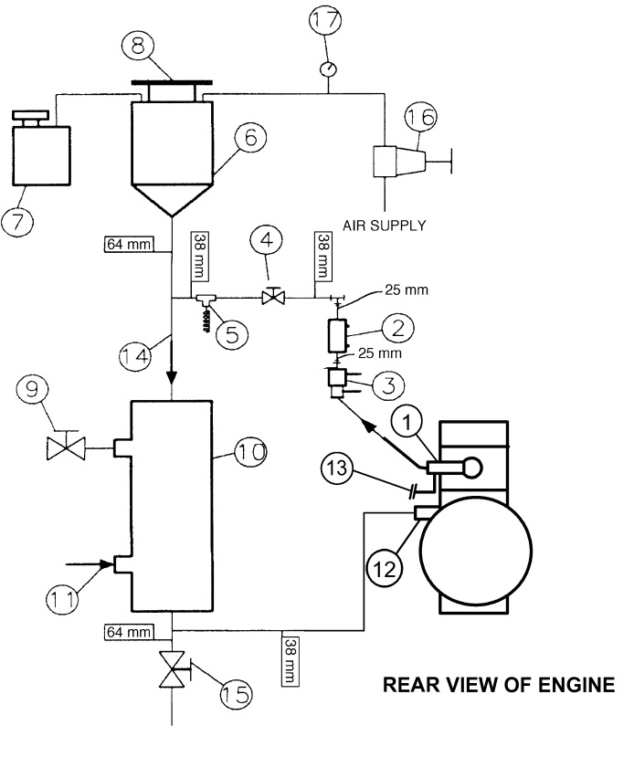

Locate the temperature sensors in the thermostat housing and at water pump inlet as shown in 1 and 12 respectively.

(1) Thermostat housing, coolant out with temperature sensor (P/N OHTVH-009-1)

(2) Sight glass

(3) Flowmeter (can be installed on the inlet or outlet sides of the engine, outlet installation shown here)

(4) Flow control valve

(5) Optional temperature sensor

(6) Fabricated coolant reservoir

(7) Constant full expansion tank

(8) Pressure radiator cap (MOTORCRAFT RS40 P/N D2YY-8100-A)

(9) Process water control valve (regulated by temperature controller with three remote set points)

(10) Heat exchanger (ITT Standard P/N 5-030-06-048-001 TYP.) (Run engine coolant through the tube side)

(11) Process water supply (shell side)

(12) Water pump inlet with temperature sensor (OHTVH-008-1)

(13) Turbocharger coolant return

(14) Engine coolant (tube side)

(15) Coolant system drain valve

(16) Coolant pressure regulator

(17) Coolant pressure

FIG. A6.3  Schematic Showing Components Of A Of Typical Engine Cooling System

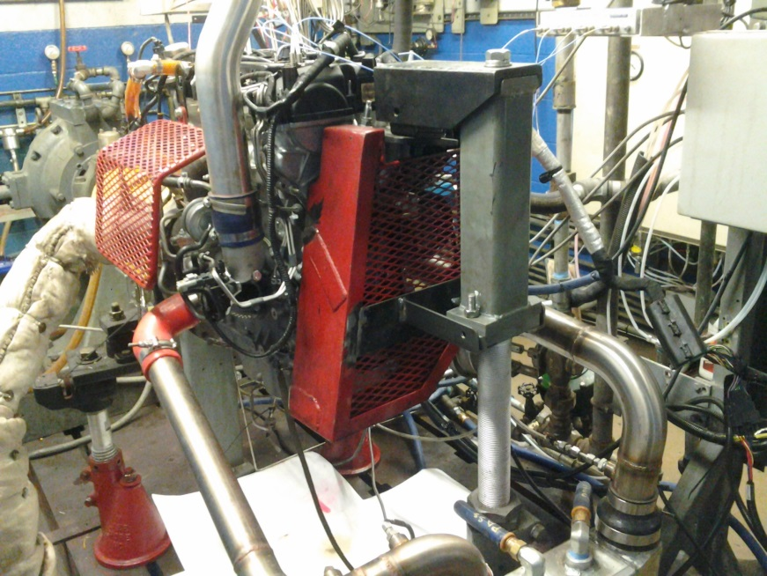 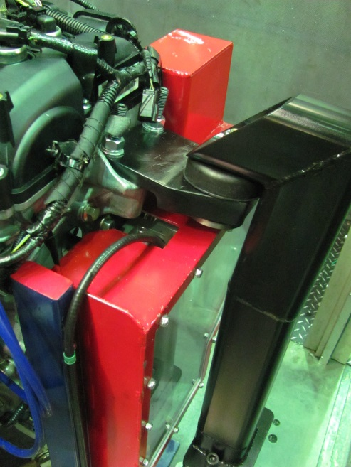

**FIG. A6.4 Motor Mount, Front (Two Options Shown)**

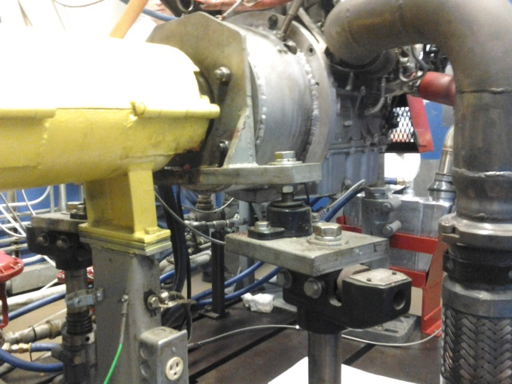 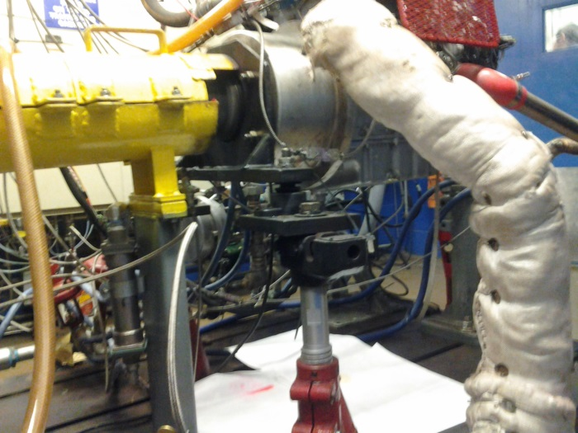

**FIG. A6.5 Motor Mount, Rear**

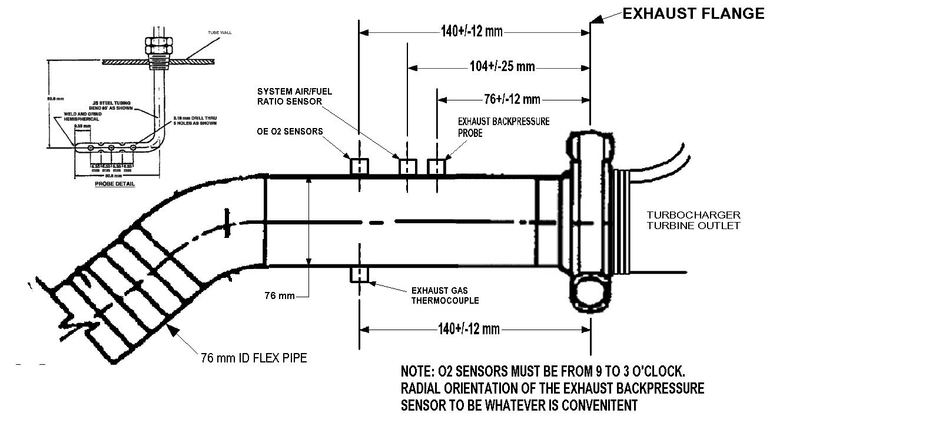

**FIG. A6.6 Exhaust Measurements and Instrumentation**

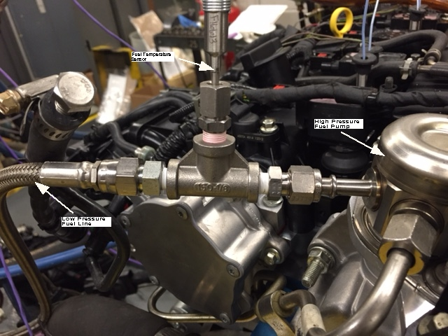

**FIG. A6.7 Location of Fuel-Temperature Sensor**

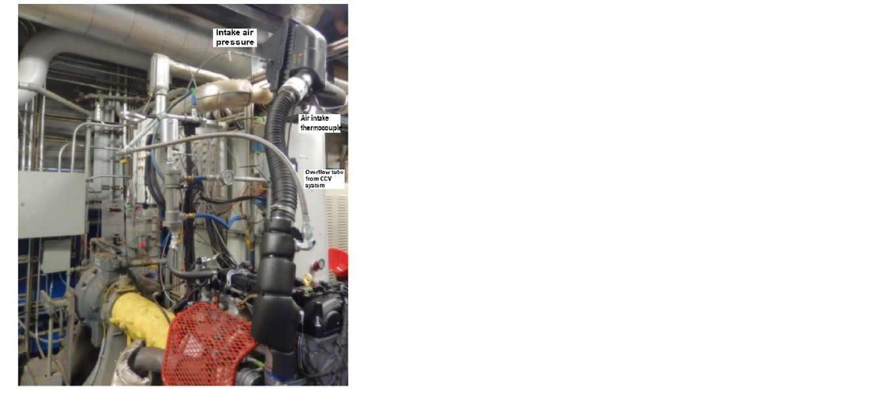

**FIG. A6.8 Typical Air Inlet System**

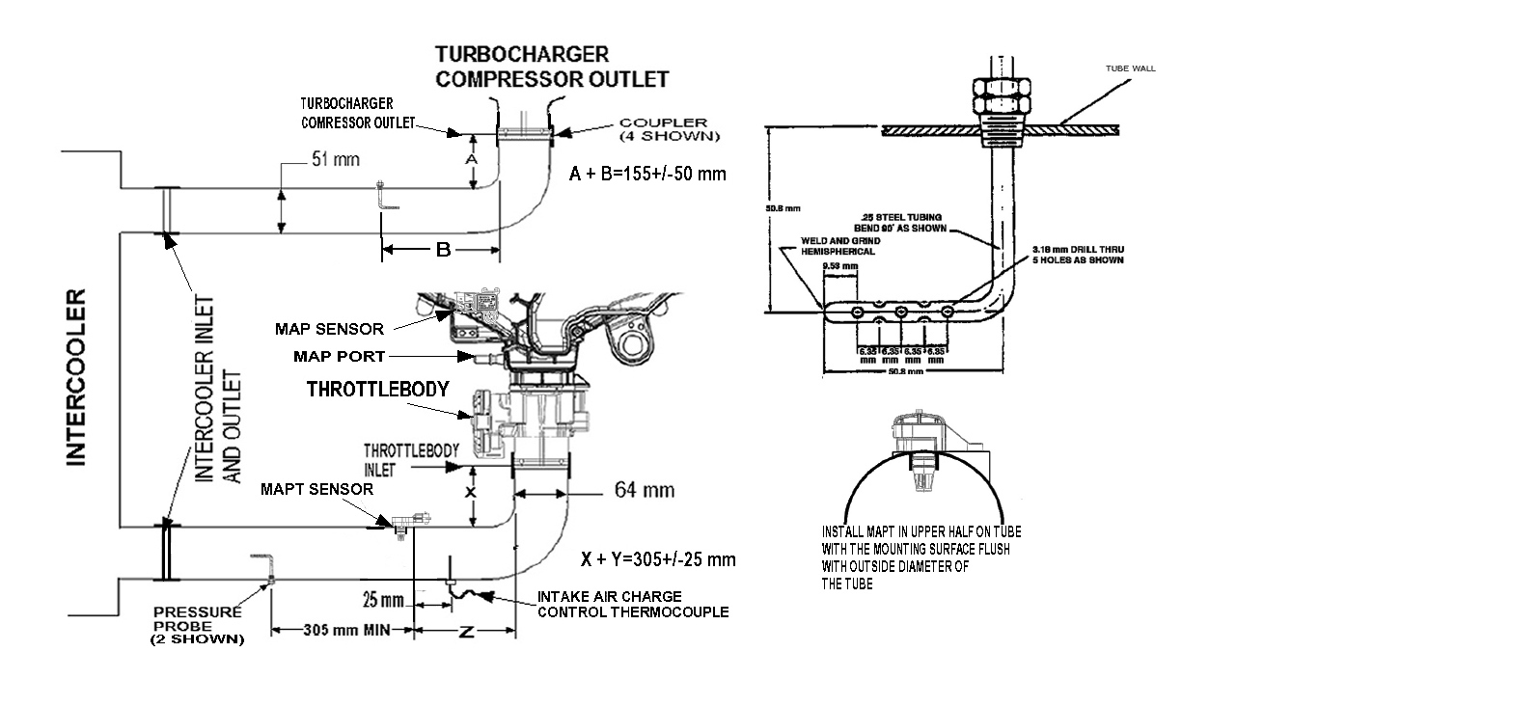

**FIG. A6.9: Intercooler Tubing Measurements and Instrumentation**

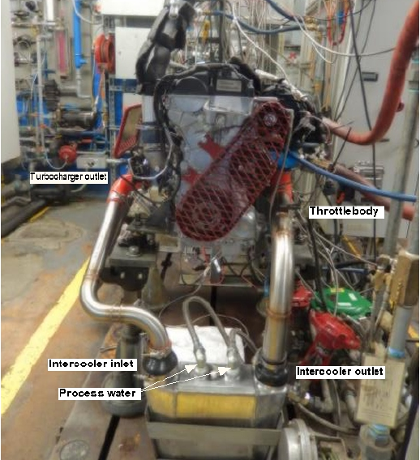

**FIG. A6.10 Typical Intercooler Installation**

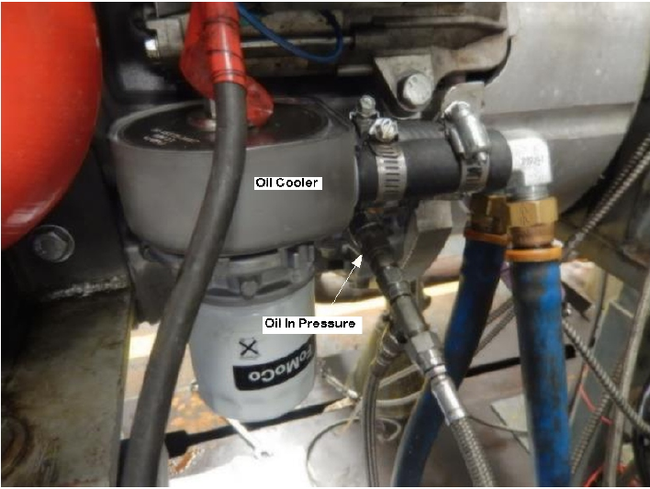

**Fig. A6.11 Oil Cooler Showing Oil Gallery Pressure Sensor Location**

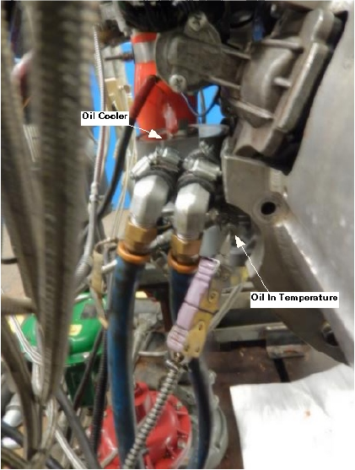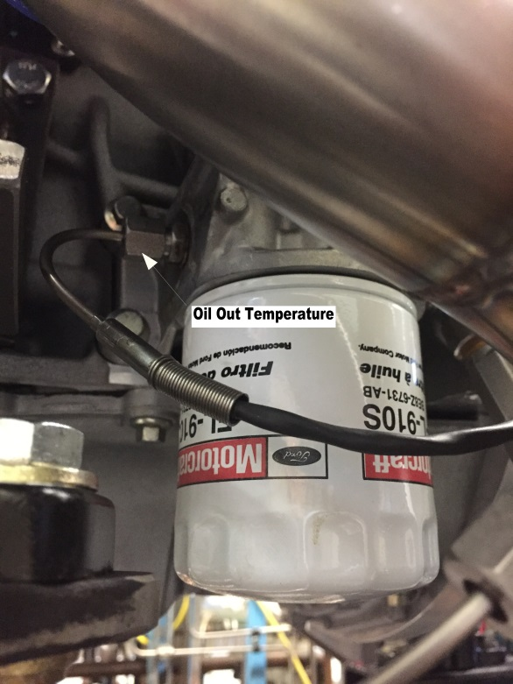

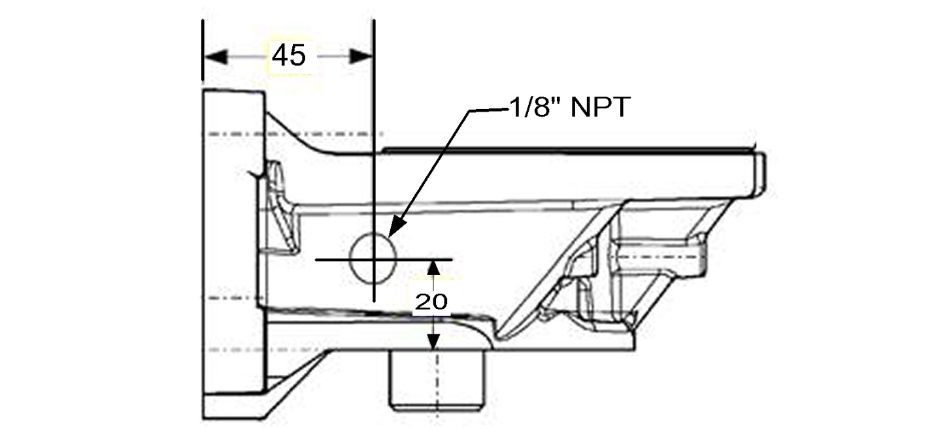

Oil Out temperature location in oil filter adapter

**FIG. A6.12 Oil Cooler Showing Oil Temperature Locations**

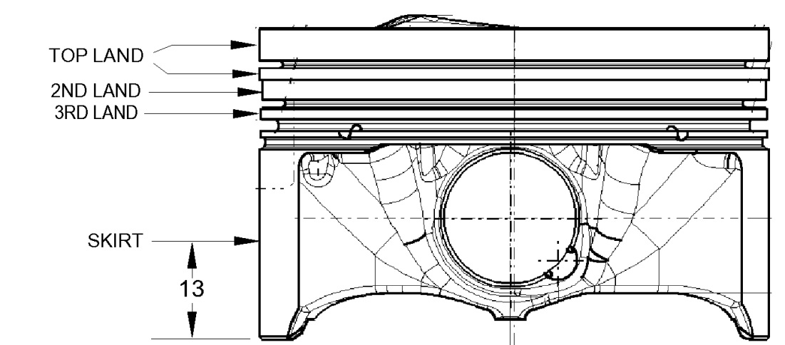

**Fig. A6.13 Piston Diameter Measurements**

A6.14. Bore Ladder



**FIG. A6.15 Vacuum System**

**FIG. A6.16 Dynamometer Wiring Harness**

**FIG. A6.17 Engine Wiring Harness**

**ANNEX A7 TEST FUEL SPECIFICATION**

A7.1 See Table A7.1

**Table A7.1 Test Fuel Specification**

|  |  |  |
| --- | --- | --- |
| Quantity, units | Test method | Specification |
| Research octane number | D2699 | 96.0 to 98.5 |
| Octane number sensitivity | D2700 | 7.5 to 10.5 |
| Lead concentration, mg/L | D3237 | ≤ 2.5 |
| Total sulfur mass fraction, mg/kg | D2622, D3120, D5453 | ≤ 15 |
| Phosphorus concentration, mg/L | D3231 | ≤ 1.3 |
| Copper corrosion (3 h at 50 °C) (dark orange) | D130 | ≤ 1b |
| Oxidation stability, min | D525 | ≥ 1000 |
| Specific gravity, kg/L * | D1298 | 0.734 to 0.744 |
| Hydrocarbon Composition | D1319 |  |
| Aromatics, volume fraction, % |  | 25 to 35 |
| Olefins, volume fraction, % |  | ≤ 10 |
| Saturates, volume fraction, % |  | remainder |
| Gum concentration (washed), mg/100 mL | D381 | ≤ 4 |
| Gum concentration (unwashed), mg/100 mL |  | ≤ 10 |
| Reid Vapor Pressure, kPa * | D323 | 60 to 63 |
| Distillation *  percentages to be evaporated within temperatures shown below: | D86 |  |
| IBP, °C |  | 24 to 35 |
| 10 %, °C |  | 49 to 57 |
| 50 %, °C |  | 93 to 110 |
| 90 %, °C |  | 149 to 163 |
| End Point, °C |  | ≤ 213 |
| Residue volume fraction, % |  | ≤ 2 |
| Water and sediment, % * | D2709 | ≤ 0.01 |
| Odor |  | Shall have the usual characteristic odor of gasoline with no pronounced foreign odor.  Shall have the usual characteristic odor of gasoline with no pronounced foreign odor.  Shall have the usual characteristic odor of gasoline with no pronounced foreign odor |
| Color |  | Red |

**Annex A8. PART NUMBERS FOR ENGINE ASSEMBLY, ENGINE PARTS, FASTENERS, GASKETS, TEST STAND SETUP PARTS, AND SPECIAL PARTS**

A8.1 See Tables A8.1 to A8.8.

**TABLE A8.1 Engine Assembly Part Numbers**

|  |  |  |
| --- | --- | --- |
| **Current Ford Service P/N** | **Current Ford Engineering**  **P/N** | **Description** |
| **BB5Z-6006-A** | **BB5E-6006-AD** | **2.0L ENGINE ASY LB** |
|  | **DA8E-6006-BB** | **2.0L ENGINE ASY LB** |

**TABLE A8.2 Reusable Engine Parts**

|  |  |  |
| --- | --- | --- |
| **Current Ford Service P/N** | **Current Ford Engineering**  **P/N** | **Description** |
| **BB5Z9F593B** | BB5E9F593BA | **INJECTOR ASY** |
| **CJ5Z9D280A** | CJ5E9D280BF | **MANIFOLD ASY - FUEL SUPPLY** |
| **CJ5Z9D440A** | CJ5E9B374BC | **COVER - FUEL PUMP** |
|  |  |  |

**TABLE A8.3 Part Numbers for Fasteners**

|  |  |  |
| --- | --- | --- |
| **Current Ford Service P/N** | **Current Ford Engineering**  **P/N** | **Des cription** |
| **W500033S437** | W500033S437 | **BOLT - FLANGED HEX.** |
| **W500114S442** | W500114S442 | **BOLT** |
| **W500212S437** | W500212S437 | **SCREW** |
| **W500214S437** | W500214S437 | **BOLT ‐ HEX.HEAD** |
| **W500221S437** | W500221S437 | **BOLT - HEX.HEAD** |
| **W500224S437** | W500224S437 | **BOLT** |
| **W500300S437** | W500300S437 | **BOLT** |
| **W500301S437** | W500301S437 | **BOLT** |
| **W500310S437** | W500310S437 | **BOLT - HEX.HEAD** |
| **W500313S437** | W500313S437 | **BOLT** |
| **W500328S437** | W500328S437 | **BOLT** |
| **W500414S442** | W500414S442 | **BOLT** |
| **W503275S437** | W503275S437 | **BOLT - HEX. HEAD - FLANGED** |
| **W505531S442** | W505531S442 | **SCREW** |
| **W506976S442** | W506976S442 | **SCREW** |
| **W520214S440** | W520214S440 | **NUT** |
| **W700115S437** | W700115S437 | **SCREW AND WASHER ASY** |
| **W701183S300** | W701183S300 | **DOWEL - BUS H** |
| **W701219S437** | W701219S437 | **BOLT** |
| **W702426S303** | W702426S303 | **BOLT - HEX.HEAD** |
| **W702492S437** | W702492S437 | **STUD** |
| **W702700S437** | W702700S437 | **STUD** |
| **W703383S437** | W703383S437 | **BOLT** |
| **W703643S430** | W703643S430 | **BOLT** |
| **W703649S300** | W703649S300 | **PIN** |
| **W704474S437** | W704474S437 | **STUD** |
| **W706282S430** | W706282S430 | **BOLT** |
| **W706284S437** | W706284S437 | **BOLT** |
| **W706487S437** | W706487S437 | **BOLT‐OIL COOLER FILTER** |
| **W711261S437** | W711261S437 | **BOLT** |
| **W711574S439** | W711574S439 | **STUD** |
| **W712022S430A** | W712022S430 | **BOLT ‐ HEX.HEAD** |
| **W713095S403** | W713095S403 | **NUT** |
| **W715323S300** | W715323S300 | **WAS HER - COPPER, T/C OIL LINE** |
| **W715638S443** | W715638S443 | **STUD** |
| **W716137S437** | W716137S437 | **BOLT** |
| **W716735S437** | W716735S437 | **BOLT** |
| **W716841S900** | W716841S900 | **PIN, BELL HOUSING** |
| **1L5Z6379AA** | W706161S300 | **BOLT** |
| **1S7Z6A340AA** | 1S7G6K340BC | **BOLT, CRK S HFT PULLEY** |
| **1S7Z6K282AA** | 1S7G6K282AB | **BOLT, CHAIN TEN** |
| **AG9Z6065A** | AG9G6065BA | **BOLT - HEX.HEAD, CYL HEAD** |
| **AG9Z6345A** | AG9G6345AC | **BOLT - BEARING CAP - HEX. HEAD** |
| **BB5Z6214A** | BB5E6214CA | **BOLT - CONNECTING ROD** |
| **CV6Z6279A** | CV6E6279AA | **BOLT, CAMSHAFT** |

**TABLE A8.4 Part Numbers for Test Parts**

|  |  |  |
| --- | --- | --- |
| **Current Ford Service P/N** | **Current Ford Engineering**  **P/N** | **Des cription** |
| **7T4Z9601A** | 7T439601AA | **ELEMENT ASY - AIR CLEANER** |
| **1S7Z6378AA** | 1S7G6378AB | **WAS HER,CRK DIAMOND CRUSH** |
| **6M8Z6278A** | 6M8G6278AA | **WAS HER, CAM, DIAMOND CRUS H** |

**TABLE A8.5 Part Numbers for Gaskets**

|  |  |  |
| --- | --- | --- |
| **Current Ford S ervice P/N** | **Current Ford Engineering**  **P/N** | **Des cription** |
| **CJ5Z6079D** | CJ5E6079AC | **KIT - GASKET** |
| **1S7Z6571EA** | 1S7G6A517BG | **SEAL - VALVE STEM EX** |
| **1S7Z6840AA** | 1S7G6A636AD | **GASKET, OIL FILTER ADPT** |
| **1S7Z6K301BA** | 1S7G6A321AA | **SEAL - CRANKSHAFT REAR OIL** |
| **1S7Z8507AE** | 1S7G8507AF | **GASKET - WATER PUMP** |
| **3M4Z6625AA** | 3M4G6625AA | **GASKET, OIL PMP P/U TUBE** |
| **3M4Z8255A** | 3M4G8K530AB | **GASKET, T/STAT HSG** |
| **3S4Z6571AA** | 3S4G6A517AA | **SEAL - VALVE STEM INT** |
| **9L8Z9E936A** | 9L8E9E936AA | **GASKET, T/B** |
| **AA5Z9E583A** | AA5E9E583AA | **SEAL, FU PUMP** |
| **AG9Z9P431A** | AG9G9P431AA | **GASKET, T/C COOL LINE** |
| **BB5Z2A572B** | BB5E2D224BB | **GASKET - VACUUM PUMP** |
| **BB5Z6584A** | BB5E6K260AB | **GASKET, CAM COVER** |
| **BB5Z6L612A** | BB536L612AA | **GASKET, EXHAUST** |
| **BG9Z9229A** | BG9E9U509AB | **KIT - "O" RING, FU INJ** |
| **BR3Z6C535B** | BR3E6P251BA | **SEAL - VALVE VCT** |
| **CB5Z9276A** | CJ5E9A420BA | **GASKET, FU PUMP CVR** |
| **CJ5Z6051A** | CJ5E6051EC | **GASKET - CYLINDER HEAD** |
| **CJ5Z6N652A** | CJ5E6N652AA | **GASKET, T/C OIL DRAIN LINE** |
| **CJ5Z8255A** | CJ5E8255AA | **SEAL - THERMOSTAT** |
| **CJ5Z9439A** | CJ5E9439AA | **GASKET - INTAKE MANIFOLD** |
| **CJ5Z9448A** | CJ5E9448BA | **GASKET, EX MANIFOLD** |
| **CM5Z6700A** | CM5E6700AB | **SEAL AS Y - CRKS HAFT OIL - FRT** |

**Table A8.6 Test Stand Setup Part Numbers**

|  |  |  |
| --- | --- | --- |
| **Current Ford S ervice P/N** | **Current Ford Engineering**  **P/N** | **Des cription** |
| **AG9Z9D930B** | AG9T9H589BE | **WIRE ASY, FE INJ** |
| **1S7Z12A699BB** | 1S7A12A699BB | **SENS OR - ENGINE KNOCK** |
| **6M8Z6C315AA** | 6M8G6C315AB | **SENS OR - CRANKSHAFT POSITION - CPS** |
| **8F9Z9F472A** | 8F9A9Y460AB | **SENS OR ASY, O2** |
| **8V2Z12B579A** | 8V2112B579AA | **SENS OR ASY, MAF** |
| **9L8Z6G004E** | 9L8A6G004BC | **SENS OR ASY, CYL HD TMP** |
| **AA5Z9A600B** | AA539A600AD | **CLEANER ASY - AIR** |
| **AE5Z6A228A** | AE5Q6A228AA | **PULLEY ASY - TENSION BELT** |
| **AE5Z8620A** | AE5Q6C301AA | **V-BELT** |
| **AG9Z6K679A** | AG9G6K679BC | **PIPE - OIL FEED, T/C** |
| **AG9Z6K868A** | CJ5E6K868AA | **VALVE ASY, ENG PST OIL COOL** |
| **AG9Z6L092A** | AG9G6K677BC | **HOSE - T/C OIL DRAIN** |
| **AG9Z8555A** | AG9G8A506BB | **HOSE - WATER INLET, T/C** |
| **AG9Z9F479A** | AG919F479AB | **SENS OR ASY, MAP** |
| **BV6Z9F479A** | BV619F479AA | **SENS OR ASY, MAPT** |
| **AS 7Z6B288A** | AS7112K073AA | **SENS OR - CAMS HAFT POS ITION** |
| **BB3Z6A642A** | BB3E6A810AA | **KIT ENGINE OIL COOLER** |
| **BB5Z11002C** | BB5T11000AA | **STARTER MOTOR AS Y** |
| **BB5Z5A231A** | BB535A281AA | **CLAMP - HOSE, T/C TO EXH** |
| **BB5Z6C640A** | BB536K863CE | **CONNECTION - AIR INLET T/B END** |
| **BB5Z6C640B** | BB536K863DF | **CONNECTION - AIR INLET, I/C END** |
| **BB5Z6C646C** | BB536C646CD | **DUCT - AIR, TURBO END** |
| **BB5Z6C646D** | BB536C646DF | **DUCT - AIR, INTERCOOLER END** |
| **BB5Z6C683A** | BB5E6L663AA | **FILTER AS Y (T/C SCREEN)** |
| **BB5Z9647A** | BB539647AB | **BRACKET, AIRBOX** |
| **BB5Z9661A** | BB539643AA | **COVER, AIRBOX** |
| **BB5Z9B659B** | BB539F805DE | **HOSE - AIR, TURBO END** |
| **BB5Z9B659E** | BB539F805CG | **HOSE - AIR, AIR BOX END** |
| **BM5Z9F972A** | BM5G9F972BA | **SENS OR - FUEL INJECTOR PRES SURE** |
| **BR2Z9E499A** | BR2E9E499AA | **CONNECTOR, VAC CONTRL, T/C** |
| **CB5Z6K682F** | CB5E6K682BF | **TURBO CHARGER** |
| **CB5Z8592A** | CB5E8592AB | **CONNECTION - WATER OUT, T/C** |
| **CB5Z8K153B** | CB5E8B535AC | **TUBE - WATER OUTLET** |
| **CB5Z9424D** | CB5E9424AF | **MANIFOLD AS Y - INTAKE** |
| **CB5Z9S 468C** | CB5E9S468AF | **HOSE, EMS (VAC HARNESS)** |
| **CJ5Z9J323B** | CJ5E9J323BC | **TUBE AS Y FE PMP TO FE MAN** |
| **CM5Z12029A** | CM5E12A366CA | **COIL ASY - IGNITION** |
| **CP9Z9E926A** | CM5E9F991AD | **THROTTLE BODY AND MOTOR ASY** |
| **D4ZZ7600A** | D4ZA7120AB | **SLEEVE, PILOT BEARING** |
| **DU5Z12A581U** | DU5T12C508UE | **WIRE ASY, ENGINE MAIN** |
| **YS 4Z6766A** | YS4G6766DA | **CAP ASY - OIL FILLER** |
| **5M6Z8509AE** | 5M6Q8509AE | **PULLEY - WATER PUMP** |
| **AG9Z6312B** | AG9E6D334AA | **PULLEY - CRANKSHAFT** |

**TABLE A8.7 Part Numbers for Special Parts**

|  |  |
| --- | --- |
| **DESCRIPTION***A* | **P/N** |
| Housing, flywheel | OHTVH-005-1 |
| Flywheel, modified, 2.0l | OHTVH-006-1 |
| Clutch (Sachs) | K0047-07 |
| Plate, Pressure | VH006-8-2 |
| Harness, Dyno, 2.0l | OHTVH-007-1 |
| Inlet, Coolant | OHTVH-008-1 |
| Clip, Retainer, Sensor, Coolant Inlet | VH008-1 |
| Seal, Coolant Inlet | VH008-2 |
| Outlet, Coolant | OHTVH-009-1 |
| Seal, Coolant Outlet | VH009-6 |
| Spacer (Shim), Clutch Pressure Plate | OHTVH-011-1 |
| Cylinder Head, Instrumented | TEI |
| Mount, Front, Ford 2.0l | OHTVH-004-1 |
| Rubber Isolator, Front Mount | 85 ESCORT |
| Rubber Isolator, Rear Mount | 6628-A |
| Pressure Transducer, | AVL |
|  |  |

*A* All parts are available from OH Technologies, 9300 Progress Pkwy, Mentor, OH 44060.

**Table A8.8 Service Tools**

|  |  |  |  |
| --- | --- | --- | --- |
| **Tool name** | | **Supplier** | **P/N** |
| Camshaft alignment tool | |  |  |
| Timing peg |  |  |  |
| Crankshaft position sensor alignment tool | |  |  |
| Pressure sensor installation tool | |  |  |

A9. ENGINE MEASUREMENTS

A9.1 *Cylinder Bore and Piston Measurements*—See Table A9.1.

Table A9.1 Cylinder Bore and Piston Measurement Record

Block # / Run # : Date: Test Number: Tech:

Cylinder bore measurements without out stress plate

Finish target: Roughness (Ra) 0.225 μm to 0.325 µm Piston to wall clearance: 0.0225 mm to 0.0475 mm

Bore gauge set: 87.5 mm Cylinder cross hatch target: 25° to 35°

Cylinder bore diameter and surfiace finish Piston to Bore Clearance

|  |  |  |  |  |  |
| --- | --- | --- | --- | --- | --- |
| Cylinder  Number | Piston  Diameter | | | Piston  Clearance  Longitudinal, Transverse, | |
| Location | Longitudinal,  mm | Transverse,  mm |
| mm ) | mm |
|  | Top land |  |  |  |  |
| 1 | 2nd land |  |  |  |  |
|  | 3rd land |  |  |  |  |
|  | Skirt |  |  |  |  |
|  | Top land |  |  |  |  |
| 2 | 2nd land |  |  |  |  |
|  | 3rd land |  |  |  |  |
|  | Skirt |  |  |  |  |
|  | Top land |  |  |  |  |
| 3 | 2nd land |  |  |  |  |
|  | 3rd land |  |  |  |  |
|  | Skirt |  |  |  |  |
|  | Top land |  |  |  |  |
| 4 | 2nd land |  |  |  |  |
|  | 3rd land |  |  |  |  |
|  | Skirt |  |  |  |  |

|  |  |  |  |  |
| --- | --- | --- | --- | --- |
| Cylinder  number | Location | Longitudinal  diameter,  mm | Transverse  diameter,  mm | Surface  finish, Ra,  µm |
|  | Top |  |  |  |
| 1 | Middle |  |  |  |
|  | Bottom |  |  |  |
|  | Average |  |  |  |
|  | Top |  |  |  |
| 2 | Middle |  |  |  |
|  | Bottom |  |  |  |
|  | Average |  |  |  |
|  | Top |  |  |  |
| 3 | Middle |  |  |  |
|  | Bottom |  |  |  |
|  | Average |  |  |  |
|  | Top |  |  |  |
| 4 | Middle |  |  |  |
|  | Bottom |  |  |  |
|  | Average |  |  |  |

Use bore ladder Top land is the ring land above upper compression ring

2nd land is the ring land between upper and lower compression rings

3rd land is the ring land between lower compression and oil rings

Skirt is 13 mm to 15 mm up from the bottom of the piston skirt

Ring Gap Ring side clearance

|  |  |  |  |  |  |  |
| --- | --- | --- | --- | --- | --- | --- |
| Cylinder  Number | Clearance, mm | | | Clearance, mm  At 180° At 270° | | Clearance, mm  Average |
| Location | At 0° | At 90° |
|  |  |
|  | UCR |  |  |  |  |  |
| 1 | LCR |  |  |  |  |  |
|  | UCR |  |  |  |  |  |
| 2 | LCR |  |  |  |  |  |
|  | UCR |  |  |  |  |  |
| 3 | LCR |  |  |  |  |  |
|  | UCR |  |  |  |  |  |
| 4 | LCR |  |  |  |  |  |

|  |  |  |
| --- | --- | --- |
| Cylinder  Number | Top  ring, mm | Second  ring, mm |
| Gap 1 |  |  |
| Gap 2 |  |  |
| Gap 3 |  |  |
| Gap 4 |  |  |

Cross Hatch Measurement

|  |  |  |  |
| --- | --- | --- | --- |
| Cylinder  Number | Meas# 1 (degrees) | Meas# 2 (degrees) | AVG Cross Hatch (degrees) |
| 1 |  |  |  |
| 2 |  |  |  |
| 3 |  |  |  |
| 4 |  |  |  |

thickenss and groove height for side clearance calculation

|  |  |  |  |  |  |
| --- | --- | --- | --- | --- | --- |
| Cylinder  Number |  | | | At 180° At 270° | |
| Location | At 0°  mm | At 90°  ( mm ) |
| ( mm ) | ( mm ) |
|  | UCR Thickness |  |  |  |  |
| 1 | LCR Thickness |  |  |  |  |
|  | UCR Groove height, mm mm |  |  |  |  |
|  | LCR Groove height |  |  |  |  |
|  | UCR Thickness |  |  |  |  |
| 2 | LCR Thickness |  |  |  |  |
|  | UCR Groove height |  |  |  |  |
|  | LCR Groove height |  |  |  |  |
|  | UCR Thickness |  |  |  |  |
| 3 | LCR Thickness |  |  |  |  |
|  | UCR Groove height |  |  |  |  |
|  | LCR Groove height |  |  |  |  |
|  | UCR Thickness |  |  |  |  |
| 4 | LCR Thickness |  |  |  |  |
|  | UCR Groove height |  |  |  |  |
|  | LCR Groove height |  |  |  |  |

Ring Tension

|  |  |  |
| --- | --- | --- |
| Cylinder | Top  Ring | Second  Ring |
| 1 |  |  |
| 2 |  |  |
| 3 |  |  |
| 4 |  |  |

Measure the ring side clearance either:

with a thickness gauge between the ring and ring groove with the ring installed;

or by calculating the difference between the thickness

of the ring and the height of the ring groove with the ring uninstalled.

Take four measurements 90° apart.

A9.2 Cylinder Head Measurements—See Table A9.2.

**Table A9.2 Cylinder Head Measurements Record**

Head # Engine #

Head Run # Test #

DATE: Instrument Cntrl # (Valve Guide)

Instrument Cntrl # (Valve Stem)

|  |  |  |  |  |  |  |  |  |
| --- | --- | --- | --- | --- | --- | --- | --- | --- |
|  | Valve guide  diameter  (5.51) mm | Valve stem diameter  (5.5) mm | Clearance  (0.03 to 0.07) mm |  |  | Valve guide  diameter  (5.51) mm | Valve stem diameter  (5.5) mm | Clearance  (0.03 to 0.07) mm |
| 1A intake |  |  |  |  | 1A exhaust |  |  |  |
| 1B intake |  |  |  |  | 1B exhaust |  |  |  |
| 2A intake |  |  |  |  | 2A exhaust |  |  |  |
| 2B intake |  |  |  |  | 2B exhaust |  |  |  |
| 3A intake |  |  |  |  | 3A exhaust |  |  |  |
| 3B intake |  |  |  |  | 3B exhaust |  |  |  |
| 4A intake |  |  |  |  | 4A exhaust |  |  |  |
| 4B intake |  |  |  |  | 4B exhaust |  |  |  |

**Instrument cntrl # (length)** **Instrument cntrl # (tension)**

|  |  |  |  |  |  |  |  |
| --- | --- | --- | --- | --- | --- | --- | --- |
|  | **Spring free length**  **(47 mm)** | **Spring tension**  **(kg @ 28.5 mm)** |  |  |  | **Spring free length**  **(47 mm)** | **Spring tension**  **(kg @ 28.5 mm)** |
| 1A intake |  |  |  |  | 1A exhaust |  |  |
| 1B intake |  |  |  |  | 1B exhaust |  |  |
| 2A intake |  |  |  |  | 2A exhaust |  |  |
| 2B intake |  |  |  |  | 2B exhaust |  |  |
| 3A intake |  |  |  |  | 3A exhaust |  |  |
| 3B intake |  |  |  |  | 3B exhaust |  |  |
| 4A intake |  |  |  |  | 4A exhaust |  |  |
| 4B intake |  |  |  |  | 4B exhaust |  |  |

**Instrument cntrl # (lash)**

|  |  |  |  |  |  |  |
| --- | --- | --- | --- | --- | --- | --- |
| **Intake valve lash measurement**  **(0.19 to 0.31) mm** | |  |  |  | **Exhaust valve lash measurement**  **(0.30 to 0.42) mm** | |
| 1F |  |  |  |  | 1F |  |
| 1R |  |  |  |  | 1R |  |
| 2F |  |  |  |  | 2F |  |
| 2R |  |  |  |  | 2R |  |
| 3F |  |  |  |  | 3F |  |
| 3R |  |  |  |  | 3R |  |
| 4F |  |  |  |  | 4F |  |
| 4R |  |  |  |  | 4R |  |

**Head flatness: Initials:**

A9.3 *Crankshaft Measurements*—see Table A9.3.

**TABLE A9.3 Crankshaft Measurements Record**

**Engine Number: Date:**

**Test Number:** LF

**Instrument Cntrl # (*Journal* ) Instrument Cntrl # (*Bearing* )**

Bore Gauge set to 51.986 mm

|  |  |  |  |  |
| --- | --- | --- | --- | --- |
| **Main Bearing Journals (mm)** | | | | |
| *Diameter: 51.978 mm to 52.002 mm* | | | | |
| Journal  Number | Horizontal  Diameter | Vertical  Diameter | Bearing Inside  Diameter | Clearance  (0.027mm to 0.052mm) |
| **1** |  |  |  |  |
| **2** |  |  |  |  |
| **3** |  |  |  |  |
| **4** |  |  |  |  |
| **5** |  |  |  |  |

**Instrument Cntrl # (*Journal* ) Instrument Cntrl # (*Bearing* )**

Bore Gauge set to 51.986mm

|  |  |  |  |  |
| --- | --- | --- | --- | --- |
| **Rod Bearing Journals (mm)** | | | | |
| *Diameter: 51.978 mm to 52.002 mm* | | | | |
| Journal  Number | Horizontal  Diameter | Vertical  Diameter | Bearing Inside  Diameter | Clearance  (0.027mm to 0.052mm) |
| **1** |  |  |  |  |
| **2** |  |  |  |  |
| **3** |  |  |  |  |
| **4** |  |  |  |  |

**Instrument Cntrl # (Endplay)**

**Crankshaft End Play (0.22 mm to 0.45 mm)**

A10 PCM CANBUS PARAMETER ADDRESSES

A10.1 *CAN Bus Data*—Set up the data acquisition software to record the parameter addresses, as shown in Table A10.1, from the engine’s PCM.

Table A10.2 PCM CANBUS Parameter Identification (PID)

|  |  |  |  |  |  |  |  |  |  |
| --- | --- | --- | --- | --- | --- | --- | --- | --- | --- |
| **Mode** | **PID Number  (Hex)** | **Parameter Description** | **Type** | **Bytes** | **Scale** | **Offset** | **Minimum** | **Maximum** | **Units** |
| 1 | 0E | Ignition Timing Advance for #1 Cylinder | Unsigned Numeric | 1 | 0.5 | -64 | -64 | 63.5 | ° |
| 1 | 11 | Absolute Throttle Position | Unsigned Numeric | 1 | 0.392156862745 | 0 | 0 | 100 | % |
| 1 | 05 | Engine-Coolant Temperature | Unsigned Numeric | 1 | 1 | -40 | -40 | 215 | ° C |
| 1 | 0F | Intake-Air Temperature | Unsigned Numeric | 1 | 1 | -40 | -40 | 215 | º C |
| 1 | 34 | Equivalence Ratio (λ) | Unsigned Numeric | 2 | 0.000030518044 | 0 | 0 | 2 | unitless |
| 1 | 43 | Absolute Load Value | Unsigned Numeric | 2 | 0.392156862745 | 0 | 0 | 25700 | % |
| 1 | 0B | Intake-Manifold Pressure | Unsigned Numeric | 1 | 1 | 0 | 0 | 255 | kPa (absolute) |
| 1 | 23 | Fuel-Rail Pressure | Unsigned Numeric | 2 | 10 | 0 | 0 | 655350 | kPa (gauge) |
| 1 | 49 | Accelerator-Pedal Position | Unsigned Numeric | 1 | 0.392156862745 | 0 | 0 | 100 | % |
| 22 | 033E | Boost Pressure - Raw Value | Unsigned Numeric | 2 | 0.007629394531 | 0 | 0 | 499.992370605469 | kPa (absolute) |
| 22 | 0462 | Turbocharger Wastegate Duty Cycle | Unsigned Numeric | 2 | 0.003051757813 | 0 | 0 | 199.996948274955 | % |
| 22 | 0318 | Actual Intake (A) Camshaft Position | Signed Numeric | 2 | 0.0625 | 0 | -2048 | 2047.9375 | ° |
| 22 | 0319 | Actual Exhaust (B) Camshaft Position | Signed Numeric | 2 | 0.0625 | 0 | -2048 | 2047.9375 | Deg |
| 22 | 0316 | Intake (A) Camshaft Position Actuator Duty Cycle | Unsigned Numeric | 2 | 0.003051757813 | 0 | 0 | 199.996948242188 | % |
| 22 | 0317 | Exhaust (B) Camshaft Position Actuator Duty Cycle | Unsigned Numeric | 2 | 0.003051757813 | 0 | 0 | 199.996948242188 | % |
| 22 | 0461 | Charge Air-Cooler Temperature | Signed Numeric | 2 | 0.015625 | 0 | -512 | 511.984375 | ° C |
| 22 | 05AC | Cylinder 1 Pre-Ignition Counter | Unsigned Numeric | 1 | 1 | 0 | 0 | 255 | Count |
| 22 | 05AD | Cylinder 2 Pre-Ignition Counter | Unsigned Numeric | 1 | 1 | 0 | 0 | 255 | Count |
| 22 | 05AE | Cylinder 3 Pre-Ignition Counter | Unsigned Numeric | 1 | 1 | 0 | 0 | 255 | Count |
| 22 | 05AF | Cylinder 4 Pre-Ignition Counter | Unsigned Numeric | 1 | 1 | 0 | 0 | 255 | Count |

A11. SETTINGS FOR THE AVL INDICOM COMBUSTION ANALYSIS SYSTEM

A11.1 *General—*The AVL IndiCom is a combustion analysis software package that combines data acquisition and evaluation for graphical presentation. The settings applicable to the Sequence IX test are provided below.

A11.1.1 *Amplifier and Pressure Sensor Settings (accessed through the “Sensor” menu):*

|  |  |
| --- | --- |
| Change to 20 KHz |  |
| Amplifier Settings | Pressure Sensor Settings |

|  |
| --- |
|  |
| Pressure Sensor Settings |

A11.1.2 *Standard Results Settings:*

|  |  |
| --- | --- |
|  |  |
| PCYL MAX Settings | |

|  |  |
| --- | --- |
|  |  |
| PCYL MIN Settings | |

|  |  |
| --- | --- |
|  |  |
| PCYL Max Rise Settings | |

|  |  |
| --- | --- |
|  |  |
| PCYL IMEP Settings | |

|  |  |
| --- | --- |
|  |  |
| PCYL Heat Release Settings | |

|  |  |
| --- | --- |
|  |  |
| PCYL Heat Release Settings | |

|  |
| --- |
|  |
| PCYL Single Value Settings |

|  |  |
| --- | --- |
|  |  |
| PCYL Knock (Cylinder Pressure) Settings | |

|  |
| --- |
|  |
| PCYL Knock (Cylinder Pressure) Settings |

|  |  |
| --- | --- |
|  |  |
| PCYL Polytrophic Coefficient Settings | |

|  |  |
| --- | --- |
|  |  |
| IGN1 MAX Settings | |

|  |  |
| --- | --- |
|  |  |
| IGN1 Edge Detection Settings | |

|  |  |
| --- | --- |
|  |  |
| IGN1 Timing Settings | |

|  |
| --- |
|  |
| Speed Settings |

A11.2 *Channels To Record—*Record the following channels:

1. PMAX*
2. MFB2*
3. PMAXV*
4. PMINV*
5. KP_INT*.

**A12. SEQUENCE IX REPORT FORMS AND DATA DICTIONARY**

A12.1 Download the standardized report form set and data dictionary from the ASTM Test Monitoring Center20 or obtain them in hardcopy format from the TMC. The contents of the report form set are as follows:

1. Title / Validity Declaration Page Form 1
2. Table of Contents Form 2
3. Test Results Summary Form 3
4. Summary of LSPI Iterations Form 4
5. Operational Summary – Iteration A   Form 5
6. Operational Summary – Iteration B   Form 6
7. Operational Summary – Iteration C   Form 7
8. Operational Summary – Iteration D   Form 8
9. Operational Summary – CAN BUS, Iterations A and B Form 9
10. Operational Summary – CAN BUS, Iterations C and D   Form 10
11. LSPI Cycle Count and Type Summary   Form 11
12. LSPI Events Summary-Iteration A   Form 12
13. LSPI Events Summary-Iteration B   Form 13
14. LSPI Events Summary-Iteration C   Form 14

15  LSPI Events Summary-Iteration D   Form 15

16  Chemical Analysis   Form 16

17. Hardware Information Form 17

1. Downtime Record Form 18
2. Comment Record Form 19
3. ACC Conformance Form 20

**A13. PROCUREMENT OF TEST PARTS AND MATERIALS**

**A13.1 General**

The following provides sources for test parts and materials:

A13.2 *Test Engine Parts*—The required engine parts for use in the SEQUENCE IX test procedure are from the 2.0L GTDI engine and are supplied by the test sponsor (Ford Motor Company):

Ford Motor Co.

Ford Component Sales

290 Town Center Dr

Dearborn, MI 48126.

A13.3 *Various Materials*:

A13.3.1 Obtain the parts listed in A13.3.1.1 from:

OH Technologies

9300 Progress Pkwy.

Mentor, OH 44060.

A13.3.1.1

1. Coolant inlet and outlet
2. Flywheel
3. Clutch
4. Pressureplate
5. Spacer
6. Bellhousing
7. Dynamometer and engine wire harnesses.

A13.3.2 Obtain the parts listed in A13.3. 2.1 from:

Test Engineering, Inc.

12758 Cimarron Path, Ste. 102

San Antonio, TX 78249-3417.

A13.3.2.1

1. Modified cylinder head
2. Piston ring tension measurement.

A13.4 Obtain Type 5 or Type 52 intercooler from FrozenBoost Inc., www.frozenboost.com.

A13.5 Obtain the powertrain control module (PCM) from Ford Motor Company, attn.: Ron Romano, 313-845-4068, rromano@ford.com.

**APPENDIX**

**(Nonmandatory Information)**

**X1. SOURCES OF INFORMATION AND MATERIALS**

X1.1 **General**

X1.1.1 The following sources are provided for convenience only. This does not represent an exclusive or complete listing of required materials or information sources.

X1.2 **Engine Measurement Record Forms**

X1.2.1 The necessary engine measurement record forms are shown in Figs. A2.24 – A2.26.

X1.3 **Sources Of Information**

X1.3.1 *ASTM Test Monitoring Center*—Direct all communications to the TMC to:

ASTM Test Monitoring Center

6555 Penn Ave.

Pittsburgh, PA 15206-4489.

X1.3.2 *Test Sponsor*—Direct all communications with the test sponsor (Ford Motor Co.) to:

Ford Motor Company

Diagnostic Service Center II

1800 Fairlane Drive,

Room 410

Allen Park, MI 48101.

X1.3.4 *Fuel Information and Availability*—Obtain general information concerning EEE fuel, including availability, from:

Haltermann Products

1201 S. Sheldon Rd.

P.O. Box 249

Channelview, TX 79530-0429.

Halterman Carliss

X1.4 **Sources of Materials**

X1.4.1 *Aeroquip Hose and Fittings*—Obtain from:

Aeroquip Corp.

1225 W. Main

Van Wert, OH 45891.

X1.4.2 *Flowmeter coolant*

X1.4.3 *Intake-Air Humidity Instruments*—Dewpoint meters from the following sources are suitable for measurement of the intake-air specific humidity:

1. Alnor (the Dewpointer)
2. EG & G
3. Foxboro
4. Hy-Cal
5. General Eastern
6. Protimeter.

X1.4.4 *Heat Exchangers*—Obtain ITT Standard Heat Exchangers from:

Kinetics Engineering Corp.

2055 Silber Road, Suite 101

Houston, TX 77055.

X1.4.5 *Fuel Flow Measurement*—Mass fuel flowmeters are available from:

Micro Motion Corp.

7070 Winchester Circle

Boulder, CO 80301.

X1.4.6 *Parts Washer and Chemicals*—A dishwasher type parts cleaner and associated chemicals can be obtained from:

Better Engineering Manufacturing

8361 Town Court Center

Baltimore, MD 21236-4964.

X1.4.7 Crankcase and Intake-Air Pressure Gauges—Obtain from:

Dwyer Instrument Co.

Junction of Indiana State Highway 212 and U.S. Highway 12

P.O. Box 373

Michigan City, IN 46360.

X1.4.8 *Lubricants*—Obtain EF-411 from local distributors of ExxonMobil products.

X1.4.9 *Tygon Hose*—Tygon hose is available through local Cadillac Plastic Co. distributors or the following supplier:

The Norton Co.

12 East Avenue

Tallmadge, OH 44278.

X1.4.10 *Special Tools for the Test Engine*—Special tools to facilitate assembly and disassembly of the engine are available from:

Owatonna Tool Co.

2013 4th St.

NW Owatonna, MN 55060.

X1.4.11 *Ultrasonic Parts Cleaner:* Obtain TierraTech model MOT500NS ultrasonic parts cleaner or similar from:

TierraTech,

Draper Business Park,

12227 South Business Park Drive,

Suite 100,

Draper, UT 84020.

[sales@tierratech.com](mailto:sales@tierratech.com).

X1.4.12 *Ultrasonic Cleaner—*ObtainTierraTech Ultrasonic solution 7 and B cleaner from TierraTech (see X1.4.11).

X1.4.13 *Organic Solvent*—Obtain Penmul L460 from:

Penetone Corp.,

P.O. Box 22006,

Los Angeles, CA 90022.

X1.4.14 *Parts Cleaning Soap*—Obtain NAT-50 and PDN-50f rom:

Better Engineering Manufacturing,

8361 Town Court,

Baltimore, MD 21236.

X1.4.15: *Hatchview Software*—Obtain from: http://digitalmetrology.myshopify.com/products/hatchview

X1.4.16 *USB microscope*—

X1.4.17 *Ford camshaft alignment tool—*Obtain Ford P/N 303-1565 from a Ford or Lincoln dealer.

X1.4.18 *Crankshaft TDC timing peg—*Obtain Ford P/N 303-507 from a Ford or Lincoln dealer.

X1.4.19 *Dynamometer*—Obtain Midwest dynamometer model MW-1014A from: OHT

or from:

Dyne Systems, Inc.,

W209 N17391 Industrial Drive,

Jackson, WI 53037 USA, tel:800-657-0726

or from

Dyno One Inc.,

14671 N 250 W Edinburgh,

IN 46124.

[info@dyno-one.com](mailto:info@dyno-one.com); Tel 812-526-0500

X1.4.20 *Rear Motor Mount—*Obtain Quicksilver P/N 6628-A from:

Quicksilver ???

X1.4.21 *Carburetor Cleaner*—Obtain Chemtool B12 from:

Berryman Products, Inc,

3800 E. Randol Mill Rd,

Arlington, TX 76011.

Tel: +1 800 433 1704; www.berrymanproducts.com.

1. ASTM Test Monitoring Center, 6555 Penn Avenue, Pittsburgh, PA 15206-4489. www.astmtmc.cmu.edu.
2. Until the next revision of this test method, the ASTM TMC will update changes to this method by means of Information Letters. Information Letters may be obtained from the TMC.
3. For referenced ASTM standards, visit the ASTM website, [www.astm.org](http://www.astm.org), or contact ASTM Customer Service at [service@astm.org](mailto:service@astm.org). For *Annual Book of ASTM Standards* volume information, refer to the standard’s Document Summary page on the ASTM website.
4. Available from ANSI, 1899 L Street, NW, 11th Floor, Washington, DC 20036. Tel: +1 202 293 89020; www.ansi.org.
5. The sole source of supply of this component known to the committee at this time is Ford Motor Co., 290 Town Center Dr, Dearborn, MI 48126.
6. If you are aware of alternative suppliers, please provide the information to ASTM International Headquarters. Your comments will receive careful consideration at a meeting of the responsible technical committee which you may attend.
7. The sole source of supply of this part known to the committee at this time is OH Technologies, 9300 Progress Pkwy., Mentor, O 44060, USA.. Tel: +1 440 354 7007. www.ohtech.com.
8. The sole source of supply of this part known to the committee at this time is Kinetics Engineering Corp., 2055 Silber Road, Suite 101, Houston, TX 77055.
9. Available from Ford dealership as well as select auto parts stores.
10. Available from Dyne Systems, Inc. W209 N17391 Industrial Drive, Jackson, WI 53037 USA 800-657-0726; dtnesystems.com and from Dyno One, Inc. 14671 N 250 W Edinburgh, IN 46124, [info@dyno-one.com](mailto:info@dyno-one.com). Tel 812-526-0500.
11. The sole source of supply os this system is AVL Gmbh, Platz 1, A-8020, Graz, Austria. www avl.com.
12. The sole source of supply of this fuel known to the committee at this time is Haltermann Products, 1201 Sheldon Road, P.O. Box 429, Channeview, TX 777530, USA. www.haltermansolutions.com.
13. Test Engineering Inc., 12758 Cimmaron Path, Ste. 102, San Antonio, TX 78249-3417.
14. Available from any Ford dealership or from Owatonna Tools Co., 2013 4th St., NW Owatonna, MN 55060.
15. FrozenBoost Inc., www.frozenboost.com.
16. The sole source of supply of this product known to the committee at this time is TierraTech, Draper Business Park, 12227 South Business Park Drive, Suite 100, Draper, UT 84020. [sales@tierratech.com](mailto:sales@tierratech.com).
17. The sole source of supply of this material known to the committee at this time is Better Engineering Manufacturing, 8361 Town Court, Baltimore, MD 21236.
18. The sole source of supply of this product known to the committee at this time is Berryman Products, Inc, 3800 E. Randol Mill Rd, Arlington, TX 76011. Tel: +1 800 433 1704; www.berrymanproducts.com.
19. Available from the ASTM Test Monitoring Center, 6555 Penn Avenue, Pittsburg, PA 15206-4489, Attention: Administrator.
20. National Institute of Standards and Technology, 100 Bureau Drive, Stop 2300, Gaithersburg, MD 20899-2300. Email: [calibrations@nist.gov](mailto:calibrations@nist.gov). Phone: +1 301 975 2200.
21. The sole source of supply of this product known to the committee at this time is Penetone Corporation, PO Box 22006, Los Angeles, CA 90022.
22. Loctite is a registered trademark of Henkel Corporation.
23. Available from Henkel. Corporation, One Henkel Way, Rocky Hill, CT 06067, USA. www henkelna.com.
24. see LTMS document available from TMC at www.astmtmc.cmu.edu/ftp/docs/ltms/ltms.pdf.