1. Scope

TBD

1. Referenced Documents

TBD

1. Terminology

TBD

1. Summary of Test Method

TBD

1. Significance of Use

TBD

1. Apparatus (General Description)
   1. The test engine is a Ford, spark ignition, four stroke, 4-cylinder gasoline turbocharged direct injection (GTDI) engine with a displacement of 2.0 L. Features of this engine include variable camshaft timing, dual overhead camshafts driven by a timing chain, four valves per cylinder and electronic direct fuel injection. It is based on the Ford Motor Co. 2012 Explorer engine with a displacement of 2.0 L.
   2. Configure the test stand to accept a Ford 2.0L GTDI engine. All special equipment necessary for conducting this test is listed herein.
   3. Use the appropriate air conditioning apparatus to control the temperature, pressure, and humidity of the inlet air to meet the requirements in Table 4.
   4. Use an appropriate fuel supply system. Typical system shown in Figure 1.

Note: Fuel may need to be heated to maintain the fuel temperature in Table 9. Due to heating the fuel, heat may buildup in the fuel system during shutdown and increase the pressure in the fuel lines, therefore it is good practice to include a pressure relief valve in the fuel line to relieve the pressure and send the excess fuel back to the tank before the shutoff valve.

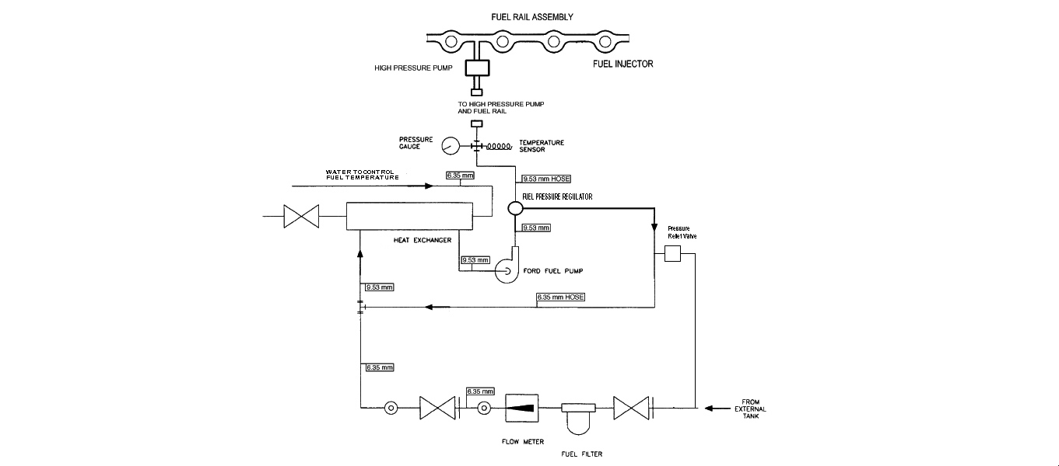

Figure 1. Typical Fuel Supply System

* 1. The control and data acquisition system shall meet the requirements listed in Annex A3.
  2. Coolant Conditioning Equipment
  3. **Engine cooling system** – Use coolant inlet and outlet from the supplier shown in A9.2. Typical plumbing for the external coolant system is shown in Figures A2.2 and A2.3. Use coolant flow meter with and accuracy of +1%. Install the flowmeter and flow control valve in the line running from the engine coolant outlet to the heat exchanger. Use 1.5” pipe to plumb the coolant system. Minimize the number of elbows in the cooling system. Engine coolant should flow through the tube side of the heat exchanger.

6.7.1. A radiator cap is used to limit system pressure to 105 kPa. Pressurize the coolant system to (70 ± 10) kPa at the top of the coolant reservoir

The engine coolant flow rate and outlet temperature are controlled in accordance with the specifications listed in Table 9.

6.7.2. As a minimum, inspect and clean the engine coolant system components, external to the engine,as needed prior to running each reference calibration test. The coolant side of the system typically doesn’t needed cleaning but may need routine cleaning of the process water side . A specific flushing technique is not specified. However, the technique should employ a commercial descaling cleaner.

* 1. **Oil System Components**— All oil system components in the engine are production configuration with the exception of the modified oil pan (Figure A2.1) and oil filter housing (figures A2.16 and A2.17).
  2. Oil Temperature Control – Oil temperature is controlled using the production oil cooler. Process water is run through water side of the oil cooler. Oil temperature thermocouples locations are shown in figure A2.15 and A2.16
  3. Dynamometer - Use Midwest dynamometer model 1014A. The dynamometer can be purchased from the vendor shown in Annex X
  4. The control and data acquisition system shall meet the requirements listed in Annex 3.
  5. Combustion Analysis Equipment AVL IndiSmart Gigabit 612. Details of system setup are shown in Appendix C

1. Apparatus (The Test Engine)
   1. LSPI Test Engine—The test engine parts are available from the Ford Motor Company. A detailed listing of all parts is given in Annex 1.
   2. Required New Engine Parts— A new shortblock is required when initially referencing a stand and engine combination. This shortblock will be used for as many tests as needed as long as it remains within service limits and is able to be referenced. New crush washers and necessary gaskets are required whenever the engine/shortblock is disassembled, ie for pretest measurements or repair. New camshafts and buckets are required when first building a cylinder head. New valves are required when rebuilding a cylinder head. Required new parts are listed in Annex A1.4
   3. Reusable Engine Parts— The cylinder head can be used on subsequent shortblocks as long as it remains within the service limits in the work shop manual. The parts listed in Annex A1.2, A1.6 and A1.7 can be used for multiple tests as long as they are in good condition and meet the service limits in the work shop manual.
   4. Specially Fabricated Engine Parts—The following subsections detail the specially fabricated engine parts required in this test method:
      1. Inlet Air System (see Fig. A2.12) Inlet air system can be fabricated but must use the stock 2012 Explorer air cleaner assembly (A1.6) and MAF sensor. Install the fresh air tube, air cleaner assembly, and new air filter. Modify the air cleaner assembly to accept fittings for inlet air temperature thermocouple and pressure tap as shown in Fig. A2.12. Use the 2012 Explorer fresh air tubes or fresh air tubes can be fabricated but must be 1,040 + 25 mm from the MAF sensor to the turbocharger inlet.
      2. Oil Pan – Modify the stock 2012 Explorer oil pan to add an oil drain plug in one of the rear locations shown in Fig. A2.1.
      3. Cylinder Head – A modified cylinder head must be used that allows for installation of in cylinder pressure sensors. This assembly can be purchased from the supplier listed in Annex 9.
      4. Pressure Sensor Tubes – 3/8” OD steel tubing must be installed into the pressure sensor sleeves in the cylinder head to allow for installation of the in cylinder pressure sensors.
      5. Valve Cover – The stock valve cover must be modified to allow the pressure sensor tubes to protrude through the cover. The location where the tubes protrude through the cover must be sealed to prevent oil from leaking through the penetrations.
      6. Coolant Supply Manifold – a coolant inlet purchased from the supplier in A9.2 is used in place of the stock coolant inlet, to accept the coolant in thermocouple. (Fig A2.2)
      7. Coolant Return Manifold - a coolant outlet purchased from the supplier in A9.2 is used in place of the stock thermostat housing, to accept the coolant out thermocouple and provide a coolant return from the turbocharger. (Fig A2.2)

7.4.8. Oil Filter Housing - The oil filter housing is modified to accept a thermocouple on the front side of the housing, measuring the temperature of the oil entering the oil cooler.

* 1. Special Engine Measurement and Assembly Equipment—Items routinely used in laboratory and workshop are not included. Use any special tools or equipment shown in the 2012 Explorer service manual for assembly. A list of these tools is shown in Annex A1.8. Complete any assembly instructions not detailed in Section 7 according to the instructions in the 2012 Explorer Service Manual.
     1. Piston Ring Positioner—Use the piston ring positioner to locate the piston rings from the cylinder block deck surface by 38 mm. This allows the compression rings to be positioned in a consistent location in the cylinder bore for the ring gap measurement. Fabricate the positioner according to the details shown in Fig. A2.17.
     2. Engine Service Tools—A complete list of special tools for the test engine is shown in Annex A1.8. The tools are available from a Ford dealership. These are designed to aid in performing several service items, in addition to the following specific service items that require special tools to perform the functions indicated (if not self-explanatory).
  2. Engine Installation on the Test Stand—Functions that are to be performed in a specific manner or at a specific time in the assembly process are noted.
     1. Mounting the Engine on the Test Stand—Mount the engine on the test stand so that the flywheel friction face is (0.0 ± 0.5)° from vertical. Two motor mounts are used (Quicksilver part# 6628-A or equivalent) (X2.1.33) at the rear of the engine (Fig A2.5). Use a rubber mount at the front of the engine attached to the front cover mount. An example is shown in Figure A2.4. A drawing showing an example of a rear mount support can be found in Figure A2.6. The engine must be at (0.0 ± 0.5)° role angle.
     2. Flywheel: The flywheel bolts get lightly coated with Loctite 565 to prevent any oil from seeping out of the holes. Torque the flywheel to 108-115 Nm. The flywheel is obtained from the supplier in A9.2
     3. Clutch and pressure plate - The clutch, pressure plate and spacer are obtained from the supplier in A9.2. Put the flat side on the clutch toward the engine. The spacer goes between the flywheel and pressure plate. Torque the pressure plate bolts to 25-33 Nm. The clutch and pressure plate are replaced with every new engine.
     4. Driveline: The driveline is greased every test. Driveline specifications:

Driveline Degree: 1.5 +/- .5 degrees

595 + 13 mm installed length from flange to flange

1410 series flanges

2.75" pilot

3.75" bolt circle

3.50" x .083" stub and slip

* 1. Exhaust System
     1. A typical exhaust system, and fittings for backpressure probe, O2 sensors and thermocouple are illustrated in Figs. A2.8. Exhaust components should be constructed of either solid or bellows pipe/tubing. Other type flexible pipe is not acceptable.
     2. The backpressure probe can be used until they become unserviceable. If the existing probes are not cracked, brittle, or deformed, clean the outer surface and clear all port holes. Check the probes for possible internal obstruction and reinstall the probes in the exhaust pipe. Stainless steel probes are generally serviceable for several tests; mild steel probes tend to become brittle after one test. Exhaust gas is noxious. (Warning—Any leaks in the connections to the sample probe will result in erroneous readings and incorrect air-fuel ratio adjustment.)
  2. Fuel Management System:
     1. Fuel Injectors - Inspect the O-rings to ensure they are in good condition and will not allow fuel leaks, replace if necessary. Install the fuel injectors into the fuel rail and into the cylinder head.
  3. Powertrain Control Module: The engine uses a PCM provided by Ford Motor Company to run this test. The PCM contains a calibration developed for this test. The PCM calibration number is U502-HBBJ0-v1-7-VEP-371.VBF.

(1) The PCM power shall come from a battery (13.5 ± 1.5) V or a power supply that does not interrupt/interfere with proper PCM operation. Connect the PCM battery/power supply to the engine wire harness with an appropriate gage wire of the shortest practical length so as to maintain a dc voltage of (12 to 15) V and minimize PCM electrical noise problems. Ground the PCM ground wire to the engine. From the same ground point, run a minimum two gage wire back to the battery negative to prevent interruption/interference of the PCM operation. The power supply can also be used for the Lambda measuring devices.

* 1. Spark Plugs—Install new Motorcraft CYFS-12-Y2 spark plugs. Spark plugs come pre-gapped. Torque the spark plugs to 9 to 12 N·m. Do not use anti-seize compounds on spark plug threads.
  2. Crankcase Ventilation System— The crankcase ventilation system is vent to the atmosphere through the port in the valve cover and is not to be connected to the inlet.
  3. Water to Air Turbocharger Intercooler - Use water to air intercooler (A9.5) capable of achieving the required air charge temperature (Tables 5-8) and an average system pressure loss less than 3 kPa.
     1. When cleaning the intercooler as part of normal maintenance, the air side of the intercooler must be spray cleaned with Stoddard solvent, rinsed with hot water and left to air dry. Use commercial Aqua Safe descaler to clean the water side.
  4. Intercooler Tubing: Fabricate the inlet air system with 51 mm ID stainless steel tubing from the turbocharger to the intercooler and 64 mm ID stainless steel tubing from the intercooler to the throttle body. The tubing length is not specified but should be the appropriate length achieve the required air charge temperature (Tables 5-8) and an average system pressure loss less than 3 kPa. Locate the MAPT sensor 305+25 mm from the intake surface of the throttle body and the intake air charge temperature thermocouple 1 inch downstream from the MAPT sensor. The post-intercooler turbo boost pressure measurement probe should be placed a minimum of 305 mm upstream from the MAPT sensor. The pre- intercooler turbo boost pressure measurement probe should be placed at 155 +25 mm from the turbocharger outlet. The measurements can be seen in Figure A2.13 and typical installation is shown in Figure A2.14.
  5. External Hose Replacement—Inspect all external hoses used on the test stand and replace any hoses that have become unserviceable. Check for internal wall separations that could cause flow restrictions. Check all connections to ensure security.
  6. Wiring Harness—There are two wiring harnesses used on the test stand, a dynamometer harness that connects to the stand power and PCM and an engine harness. Obtain the dynamometer wiring harness and engine wiring harness from the supplier listed in A9.2. Diagrams of these wire harnesses are shown in Figures A2.20 and A2.21 identifying connections.
  7. Electronic Throttle Controller: Throttle is controlled using simulated accelerator pedal position signals. The dyno wiring harness is supplied with an Accelerator Pedal Position jumper cable with un-terminated pigtail leads. The test laboratory must connect two voltage command signals, Acc Pos Sensor 1 and Acc Pos Sensor 2, to the Accelerator Pedal Position jumper cable. The voltage control ranges for each signal are shown in Table 1.The wiring schematic and pin-out description for this connection is shown in Figure 2. Accelerator Position Wiring Schematic. The voltage signals must be run through a voltage isolator otherwise interference will occur between the lab DAC system and the engine ECU and throttle control will be erratic.

Table 1. Accelerator Position Sensor Control Ranges

|  |  |  |  |
| --- | --- | --- | --- |
| **Command Signal** | **Operating Range** | **Min Signal (Idle)** | **Max Signal (WOT)** |
| Acc Pos Sensor 1 | 0-5.0 VDC | 0.75 VDC (15%) | 4.25 VDC (85%) |
| Acc Pos Sensor 2 | 0-2.5 VDC | 0.375 VDC (15%) | 2.125 VDC (85%) |
| Note: Acc Pos Senor 2 should always equal 50% of Acc Pos Sensor 1. | | | |



Figure 2. Accelerator Position Wiring Schematic

* 1. Water Pump, Water Pump Drive—Install the water pump and pulley, the crankshaft pulley, and tensioner according to the 2012 Explorer service manual. These are the only components needed to drive the water pump. All other production front end accessory drive components do not need to be installed. The engine cannot be used to drive any external engine accessory other than the water pump. Pull back tensioner and install water pump drive belt as shown in Figure 3. Ensure that there is a minimum contact angle of 20° between the drive belt and the water pump pulley.

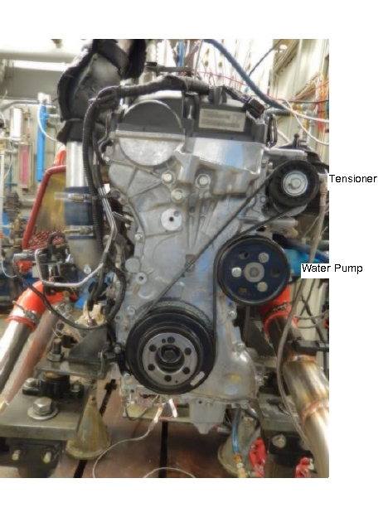

Figure 3 Water Pump Drive Arrangement

* 1. Cylinder block oil separator - Install a dummy PCV valve (PCV valve with the internal components removed) in oil separator on the side of the engine block. This is the location to measure crankcase pressure.

1. Engine Preparation
   1. Engine Disassembly - disassemble the engine and the cylinder head according to the 2.0L Ecoboost disassembly procedures in the Ford 2012 Explorer Shop Manual. Note the position of all the engine components to insure they are returned to the same positions when the engine is reassembled.
   2. Cylinder Head Preparation
      1. Use a modified cylinder head obtained from the supplier in Annex 9.
      2. Cylinder head cleaning:

8.2.2.For a new cylinder head, never run in a test, that has been modified with pressure transducer tubes installed, clean with Stoddard solvent before assembly. Insure all debris, machining chips, etc left from the tube installation have been cleaned off of the cylinder head

8.2.3. For a cylinder head that has been used in a previous LSPI test that is to be re-used, clean the bare cylinder head, with tubes (No valvetrain components) in the Tierra Tech model MOT500NS ultrasonic parts cleaner or similar apparatus. The ultrasonic parts cleaner solution is also provided by Tierra Tech, Ultrasonic solution 7 and B Rinse parts with parts cleaning soap, NAT-50 or PDN-50 before putting into ultrasonic cleaner.

8.2.4. The ultrasonic parts cleaner solution is also provided by Tierra Tech, Ultrasonic solution 7 and B (X2.1.19). The cleaning procedure is described below:

8.2.4.1.Add solution once ultrasonic machine reaches a minimum of 140°F. DO NOT add the degreasers until the ultrasonic machine has reached a temperature of 140°F.

a. 5 ½ gallons of ultrasonic solution 7

b. ½ gallon of ultrasonic solution B

c. Change the soap and water solution at least after every 25 hrs. of use.

*Note: The solution shown above is based upon the MOT-500NS model (158 gallon capacity). Quantities will be different for a different size unit.

After 30 minutes, the parts are removed and immediately sprayed with hot water, then solvent and left to air dry.

* 1. The remaining components are spray cleaned with Stoddard solvent then blown out with pressurized air and left to air dry:

•Camshafts and all valve train.

•Intake manifold/ Throttle body (not being separated)

•Fuel pump housing with piston.

•Vacuum pump and oil screen.

•Intake and outlet of the turbocharger are lightly wiped down with solvent. The oil screen is also cleaned. (Don’t clean the inside of the turbocharger)

•The carbon build up on the injectors is wiped off

•VCT solenoids are sprayed with solvent.

•Valve Cover

•Turbo charger oil lines

* 1. Engine Measurements – Record the following engine measurements
     1. Piston and bore measurements are shown in Table 2.
     2. Record the piston to bore clearances at the top, 2nd and 3rd ring lands and the piston skirt as shown in figure A2.17. Use bore ladder shown in figure A2.18 to determine bore diameter positions. Measure the bore in both the longitudinal and transverse directions. To determining the piston to bore clearance, calculate the difference between the particular piston diameter location and the average bore diameter for both the transverse and longitudinal directions.
     3. Record ring side clearances for the upper and lower compression rings (UCR, LCR). For determining ring side clearance take 4 measurements 90 degrees apart. Either check clearance with a thickness gauge or measuring the difference between the thickness of the ring and the height of the corresponding groove.

8.4.4. Measure ring tension. Ring Tension measurements can be obtained from the supplier in Annex 9

8.4.5.Measure cylinder head dimension shown in Table 3.

8.4.6. For determining the valve stem to guide clearance measure the diameter of the valve stem at 38 mm from the tip of the valve and the valve guide at 19.5 mm from the top of the valve guide.

8.4.7. Measure and record intake and exhaust valve springs, spring free length, and spring load at a compressed height of 28.7 mm. Verify the compressed spring load is 460+21 N. Reject any springs not meeting this criteria.

8.4.8. 1.1.1 Compression Ratio – Measure compression ratio using Whistler P/N KAE-A0250-E

Table 2. Cylinder Bore and Piston Measurements



Table 3. Head Measurements

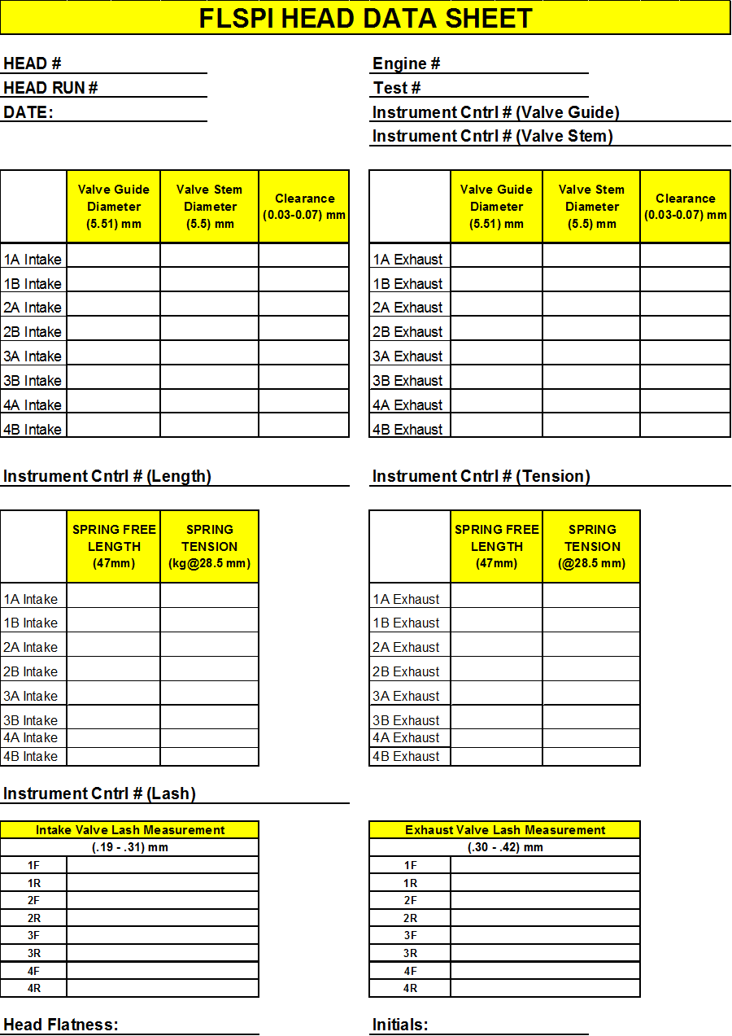

Table 4 Crank Measurements



* 1. Miscellaneous Engine Components-Preparation:
     1. Engine Build-Up and Measurement Area-Environment—The ambient atmosphere of the engine buildup and measurement areas shall be reasonably free of contaminants. A relatively constant temperature (within ± 3 °C) is necessary to ensure acceptable repeatability in the measurement of parts dimensions. To prevent moisture forming on cold engine parts that are brought into the buildup or measurement areas, maintain the relative humidity at a nominal maximum of 50 %.
     2. Throttle Body
        1. Clean the butterfly and bore of the throttle body with carburetor cleaner (Chemtool B12) (X2.1.34) and air-dry before each test. Do not disassemble the throttle body as this will cause excessive wear on the components. The idle air screw can be removed for the cleaning process. Fully close the idle air screw during test operation.
        2. There is no specific life for the throttle body. However, the clearance between the bore and the butterfly will eventually increase and render the body unserviceable. When the clearance becomes too great to allow control of speed, torque, and air-fuel ratio, discard the throttle body
     3. Solvents and Cleaners Required—No substitutions are allowed. (Warning—Use adequate safety provisions with all solvents and cleaners. See Annex X.

8.5.3.1.Solvent—Use only mineral spirits (ie Stoddard Solvent) meeting the requirements of Specification D235, Type II, Class C for Aromatic Content (0 to 2) vol %, Flash Point (61 °C, min) and Color (not darker than +25 on Saybolt Scale or 25 on Pt-Co Scale). (Warning—Combustible. Health hazard.) Obtain a Certificate of Analysis for each batch of solvent from the supplier.

8.5.3.2. Organic Solvent, Penmul L460. (Warning—Combustible. Health hazard.). Annex X2.1.22

8.5.3.3. Ultrasonic Cleaner, Tierra Tech ultrasonic solution 7 and B available from supplier shown in Annex X1.4.

8.5..3.4. Parts Cleaning Soap, NAT-50 or PDN-50 have been found to be acceptable. (Warning—Health hazard.) Annex X

* 1. Engine Assembly – Assemble the engine according to the 2.0L Ecoboost assembly procedures in the 2012 Explorer Shop Manual, except as noted in section 7. Insure all components (ie, pistons, rings, bearings, etc) are put back in the same positions as were originally assembled from the factory.
     1. Sealing Compounds—Use a silicon-based sealer as needed on the contact surfaces between the rear seal housing and oil pan and the front cover and cylinder block, cylinder head and oil pan. Use Motorcraft Gasket Maker between (TA-16) or equivalent between the 6th intake and exhaust camshaft cap and the cylinder head. Use silicon-based sealer sparingly since it can elevate the indicated silicon content of the used oil.
     2. NOTE 1—Non-silicon liquid or tape thread sealers can be used on bolts and plugs.
     3. Gaskets and Seals—Install new gaskets and seals during engine assembly.
  2. Cylinder Head Assembly:
     1. Cylinder heads may be used as long as they remain within service specifications (Refer to 2015 Explorer Service Manual)
     2. When a cylinder head is reused on another engine block, the valves must be replaced.
     3. If a cylinder head is removed from an engine block ahead of schedule due to broken pistons, short block failure, or lack of test severity, the laboratory may reuse the cylinder head without replacing the valves as long as they are within service limit
     4. Assemble the cylinder heads in accordance with the service manual. The valves are lapped before installation and new intake and exhaust valve seals are installed. Set the valve lash per the procedure in the workshop manual and record the valve lash.
     5. Vacuum check the valve ports before use.
  3. Engine Installation on Test Stand - install the engine onto the stand using the equipment shown in section 7. Install all engine components external to the longblock according to the 2.0L Ecoboost assembly procedures in the 2012 Explorer Shop Manual, where applicable. Connect the engine to all external laboratory systems identified in section 6, per laboratory procedures.
  4. Pressure Sensor Installation - once the sensor tubes and modified valve cover are installed (see section 7.4.4 and 7.4.5), install pressure sensors into the pressure sensor tube using the sensor installation tool shown in Table A1.8 and torque sensors to 1.5 Nm.
  5. New Engine Break In - Once a new engine has been installed on the test stand, perform the break-in procedure shown in Table 5. Run LSPI Break-In Procedure, using oil TMC 220.

Table 5. LSPI Break-In Procedure

|  |  |  |  |  |
| --- | --- | --- | --- | --- |
| **Step** | **Speed (RPM)** | **Load**  **(N-m)** | **Time per stage (Hr:Min)** | **Total Time (Hr:Min)** |
| **Charge engine with 4200 grams of  new oil and new oil filter** | | | | |
| 1 | Idle | 0 | 0:30 | 0:30 |
| **Oil Change 1 -Shut engine down and drain used oil and remove oil filter. Allow oil to drain for 20 minutes. Install new oil filter and add 4200 grams of new oil.** | | | | |
| **Start engine and let idle for 5 minutes** | | | | |
| 2 | 1500 | 38 | 0:30 | 1:00 |
| 3 | 2000 | 72 | 0:30 | 1:30 |
| 4 | 2500 | 111 | 0:30 | 2:00 |
| 5 | 3000 | 135 | 0:30 | 2:30 |
| 6 | 3000 | 150 | 3:15 | 5:45 |
| 7 | 2000 | 72 | 0:15 | 6:00 |
| 8 | 3250 | 155 | 0:15 | 6:15 |
| 9 | 3500 | 155 | 0:15 | 6:30 |
| 10 | 3750 | 155 | 0:15 | 6:45 |
| 11 | 4000 | 155 | 1:15 | 8:00 |
| **Bring engine to idle for 5 minutes then shut down** | | | | |
| **Oil Change 2- Drain used oil and remove oil filter. Allow oil to drain for 20 minutes. Install new oil filter and add 4200 grams of new oil.** | | | | |
| **Run one full test per section 13.3 for additional break in. After test is complete drain the oil, remove the oil filter, and proceed to section 13.1.**  During this portion of the break in, the fuel flow must be 15.4+/- 0.4 Kg/Hr. If the fuel flow does not meet these limits the engine cannot be used for LSPI testing and must be replaced. | | | | |

* The controlled parameters during break in are listed in Table 5. All other controls are left wide open/free flowing. The engine does not produce enough heat in the early steps to reach all target temperatures. All controlled parameters are expected to be on target at the beginning of Step 4

Table 6. Sequence Chain Wear 8 Hour Break-in Controlled Parameters

|  |  |
| --- | --- |
| **8 Hour Break In**  **Controlled Parameters** | |
| Coolant Out Temp. | 85 degC |
| Oil Gallery Temp. | 100 degC |
| Inlet Air Pressure | 0.05kPa |
| Air Charge Temp. | 37 deg C |
| Inlet Air Temp. | 30 degC |
| Humidity | 11.4 g/kg |
| Fuel Pressure | 450+37 kPa |
| Coolant Flow | Valve wide open |

9 Measurement Instrumentation

9.1. Temperatures

9.1.1 Equiptment

9.1.1.1 Temperature measurement locations for the six required temperatures are specified. Use thermocouples that are calibratable to 0.5 °C. Use only OEM temperature sensors for EEC inputs.

9.1.1.2 All thermocouples, except the intake-air thermocouple, shall be premium and sheathed. The intake-air thermocouple may be an open-tip type. The diameter and length of the thermocouples shall be 3 mm by 100 mm. Thermocouples, wires, and extension wires should be matched to perform in accordance with the special limits of error as defined in ANSI MC96.1.

9.1.2 Engine Coolant Inlet—Install the sensor in the coolant inlet on the engine (OHTVH-008-1) perpendicular to the run. Install sensor with the tip in the center of the stream of flow. (See Fig. A2.2).

9.1.3 Engine Coolant Outlet—Install the sensor in the coolantoutlet on the engine (OHTVH-009-1) perpendicular to the run. Install sensor with the tip in the center of the stream of flow. (See Fig. A2.2).

9.1.4 Engine Oil Gallery—Install the tip of the sensor at the center of the flow stream in the external oil filter adapter (see Fig. A2.16) through the hole for the oil pressure switch (not used). Install a tee to accept this temperature sensor and attach the oil pressure line.

9.1.5. Engine Oil Filter In—Install the tip of the sensor at the center of the cross fitting attached to the side opposite from the engine oil inlet temperature sensor on the oil filter adaptor. The adapter needs to be modified with a 1/8 NPT hole to access the oil passage (see Fig. A2.16).

9.1.6 Inlet Air—Install the tip of the thermocouple midstream in the air cleaner box downstream of the filter (see Fig. A2.12). Insertion depth shall be (37 ± 2) mm.

9.1.7 Fuel – Install the sensor in the low pressure fuel line no more than 155 mm from the high pressure pump. Use an appropriate size “T” fitting to insure the sensor and fitting doesn’t interfere with the fuel flow. (see Fig A2.9)

9.1.8 Air Charge – Install the sensor in the intercooler outlet tube 25+2 mm downstream from the MAPT sensor. (See fig A2.13)

9.1.9 Exhaust – install a sensor 140+12 mm downstream on the exhaust flange (see Fig. A2.8)

9.1.10 Oil Sump (optional) – Install a sensor through the production oil drain plug hole. Insertion depth shall be ??

9.1.11 Calibration—Calibrate all thermocouples prior to a reference oil test. The temperature measurement system shall indicate within ± 0.5 °C of the laboratory calibration standard. The calibration standard shall be traceable to NIST.

9.2 Pressures:

9.2.1 Equipment— Pressure measurement for each of the eight required parameters is detailed in the following sections. This allows reasonable opportunity for adaptation of existing test stand instrumentation. However, the accuracy and resolution of the pressure measurement sensors and the complete pressure measurement system shall meet the requirements of the DACA-II document. Replace pressure sensors that are part of the EEC system with only Ford specified equipment..

NOTE 5—Tubing between the pressure tap locations and the final pressure sensors should incorporate condensate traps, as indicated by good engineering practice. This is particularly important in applications where low air pressures are transmitted by means of lines which pass through low-lying trenches between the test stand and the instrument console.

9.2.2 Intake Manifold (MAP) – measure the manifold absolute pressure at the port downstream of the throttlebody on the front side of the intake manifold (See Fig 2.13)

9.2.3. Engine Oil Gallery - measure oil pump pressure in the external oil filter adapter (see Fig. A2.16) through the hole for the oil pressure switch (not used). Install a tee to accept the temperature sensor and attach the oil pressure line.

9.2.4 Engine Coolant Out Pressure—Measure engine coolant out pressure at the top of the coolant reservoir as shown in Fig. A2.3.

9.2.5 Fuel – measure fuel pressure in the lower pressure fuel line at the exit of the stand fuel pump.

9.2.6. Crankcase – measure crankcase pressure at the dummy PCV valve in the cylinder block oil separator.

9.2.7 Exhaust Back Pressure - measure the exhaust back pressure with the exhaust gas sampling probe located 76+12 mm downstream of the exhaust flange (see Fig. A2.8). A sensor capable of absolute or gage measurement corrected with barometric pressure reading is recommended. Install a condensate trap between the probe and sensor to accumulate water present in the exhaust gas.

9.2.8 Inlet Air – measure inlet air pressure in the air cleaner box downstream of the air filter. (See Fig A2.12)

9.2.9 Pre-Intercooler – measure the pre-intercooler pressure with the exhaust gas sampling probe located 155+50 mm downstream of the turbocharger flange (See Fig 2.13)

9.2.10 Air Charge (Post-Intercooler) - measure the air charge pressure with the exhaust gas sampling probe located downstream of the intercooler and at least 305 mm upstream of the MAPT sensor. (See Fig 2.13)

9.2.11. Cylinder Head Oil – measure cylinder head pressure at the oil gallery plug on the left side of the cylinder head next to the belt tensioner.

9.2.12 Calibration—Calibrate all pressure measurement sensors prior to a reference oil test. The MAP pressure measurement system shall indicate within 0.1 kPa of the laboratory calibration standard. All other pressure measurement systems shall conform to the guidelines in DACA-II document ?The calibration standard shall be traceable to NIST

9.3 Flow Rates:

9.3.1 Equipment—Flow rate measurement for each of the four required parameters is detailed in the following subsections. With the exception of the engine coolant, measurement equipment is not specified for a given parameter. This allows reasonable opportunity for adaptation of existing test stand instrumentation.

9.3.2 Engine Coolant—Determine the engine coolant flow rate using a flowmeter with an accuracy of +1% (see Fig. A2.3) Flowmeter is available from the supplier in X. Take precautions to prevent air pockets from forming in the lines to the flow meter. Transparent lines or bleed lines, or both, are beneficial in this application. Ensure that the manufacturer’s required for orientation and straight sections of pipe are installed immediately up and down stream of the flowmeter. Install the flowmeter in the line running from the engine coolant outlet to the heat exchanger.

9.3.3 Fuel – measure fuel flow in kg/hr on the low pressure fuel system before the high pressure engine fuel pump.

9.3.3.1 Calibration—Calibrate the flowmeters used in the measurement of both the engine coolant flow rate and blowby heat exchanger coolant flow prior to a reference oil test. Calibrate the flowmeters as installed in the system at the test stand with test fluid. Calibrate the flowmeters with a turbine flowmeter or by a volume/time method at Stage 1 and 2 operating conditions.

1. Calibration
2. Test Procedure
   1. Oil Flush Procedure – For each new test, perform two oil flushes using test oil as detailed below.
3. Charge engine with 4200 grams of new oil and install a new oil filter.
4. Warm Up - Start engine and operate at Idle (900 rpm) for two minutes.
5. Ramp to 2000RPM and 70 N-m within two minutes. Control to warm up conditions listed in Table 7. Maintain conditions for 15 minutes (including ramp time).
6. Ramp to idle within two minutes. Hold at idle conditions for two minutes (including ramp time).
7. Shut down engine.
8. Drain engine oil for 15 minutes.
9. Repeat for second flush.

Table 7. Warm Up Conditions

|  |  |  |
| --- | --- | --- |
| **Controlled Parameter** | **Set Point** | **Units** |
| Coolant Out Temperature | 95 | degC |
| Oil Gallery Temperature | 95 | degC |
| Air Charge Temperature | 43 | degC |
| Inlet Air Temperature | 30 | DegC |
| Inlet Air Pressure | 0.05 | kPaA |
| Exhaust Back Pressure | 104 | kPaA |
| Humidity | 11.4 | g/kg |
| Fuel Pressure | 450+37 | kPa |

* 1. Test Start/Oil Seasoning Procedure:

1. Charge engine with 4200 grams of test oil and install new oil filter.
2. Warm Up - Start engine and operate at Idle (900 rpm) for two minutes
3. Ramp to 2000RPM and 100 Nm in 60 seconds. Control to warm up conditions listed in Table 7. Run at these conditions for 15 minutes.
4. Ramp to 1750RPM and 269 Nm in 60 seconds.
5. Hold at 1750RPM, 269 Nm and control to test condition temperatures for 60 minutes.
6. Ramp to cool down conditions shown in Table 8. Maintain conditions for 15 minutes (including ramp times).

Table 8. Cool Down Conditions

|  |  |  |  |
| --- | --- | --- | --- |
| **Controlled Parameter** | **Set Point** | **Units** | **Ramp times (min)** |
| Engine Speed | 2000 | RPM | 1 |
| Engine Load | 50 | Nm | 1 |
| Coolant Out Temp | 45 | degC | 15 |
| Oil Gallery | 45 | degC | 15 |
| Inlet Air Temp | 30 | degC | N/A |
| Air Charge | 30 | degC | N/A |
| Inlet Air Pressure | 0.05 | kPaA | N/A |
| Exhaust Back Pressure | 104 | kPaA | N/A |
| Humidity | 11.4 | g/kg | N/A |
| Fuel Pressure | 450+37 | kPa | NA |

1. Ramp to idle and hold for 2 minutes.
2. Shut down engine for a minimum of 10 minutes. Take oil dip and inspect engine and stand.
3. Restart Engine to Start Cycle 1
   1. Test Cycle – The following test cycle procedure is conducted four times for one complete test.
4. Warm Up - Start engine and operate at Idle (900 rpm) for two minutes.
5. Ramp to 2000RPM and 100 Nm in 60 seconds. Control to warm up conditions listed in Table 7. Run at these conditions for 15 minutes.
6. Ramp to test conditions listed in Table 9.

Table 9. Test Conditions

|  |  |  |  |
| --- | --- | --- | --- |
| **Test Conditions** | | |  |
| **Controlled Parameter** | **Set Point** | **Units** | **Ramp times (min)** |
| Speed | 1750 +20 | RPM | 1 |
| Load | 269+5 | Nm | 1 |
| Coolant Out Temperature | 95+0.5 | degC | < 20 |
| Oil Gallery Temperature | 95+0.5 | degC | < 20 |
| Air Charge Temperature | 43+0.5 | degC | < 20 |
| Inlet Air Temperature | 30+0.5 | degC | < 20 |
| Fuel Temperature | 30+0.5 | degC | NA |
| Exhaust Back Pressure | 104 +-2 | kPaA | NA |
| Inlet Air Pressure | 0.05 +.02 | kPaG | NA |
| Humidity | 11.4 +1 | g/kg | NA |
| Fuel Flow | 15.4+0.4 | Kg/Hr | NA |
| Fuel Pressure | 450+37 | kPa | NA |
| Coolant Flow | 55+2 | l/min | NA |

1. Hold until the following conditions are true:

* Coolant Out Temp: 95 + 0.5 degC
* Oil Gallery Temp: 95 + 0.5 degC
* Inlet Air Temp: 30 + 0.5 degC
* Air Charge Temp: 43 + 0.5 degC

All the above temperatures should be met within a maximum of 20 minutes. If not, perform soft shut down and fix any issue preventing the test conditions from being met before trying again.

1. Once test conditions are met, allow engine to stabilize for five minutes.
2. After five minute stabilization, begin recording combustion analysis data using AVL Indicom for 175,000 combustion cycles.
3. Ramp to cool down conditions shown in Table 8. Maintain conditions for 15 minutes (including ramp times).
4. Ramp to idle and hold for 2 minutes. Take oil samples during this idle stage. Take 5 fl. oz purge then 1 fl oz sample. Return 5 fl oz purge back into the engine during shutdown.
5. Shut down for a minimum of 10 minutes. Take oil dip and inspect engine and stand
   1. End of Test. Make sure everything is turned off:

* Fuel off
* Coolant pressure off
* Chilled water off
  1. Record the operation and canbus data listed in Table 9. Record test points at a rate of 1/sec.

Table 10. Recorded Test Points







* 1. At the end of each 175,000 cycle run, report the following data from the AVL Indicom combustion analysis software for each engine cycle.
* PMAX
* CA02
* PMAXV
* PMINV
* KP_INT

This data will be used to determine the number of LSPI events for each test run according to the method described in section 13.

1. Determination of Test Results

The LSPI evaluation procedure described in this Appendix is intended to be used to evaluate complete test iterations of at least 170,000 and no more than175,000 engine cycles.

*Note: If the test iteration does not contain at least 170,000 engine cycles, the iteration is invalid. Report the number of engine cycles completed on the report form for this iteration and mark the iteration as “Invalid”.*

For tests containing between 170,000 and 175,000 engine cycles, use the steps listed below to identify LSPI cycles.

**Steps for Calculating LSPI Cycles Adjustmed for Distribution Skewness and Kurtosis**

1. **Remove Invalid Cycles**

Prior to performing the PP and MFB2 LSPI calculations described in this document, remove all invalid combustion cycles from both the PP and MFB2 data set. Use the following criteria to identify invalid cycles.

1. Remove all cycles with a MFB2 < -30 degrees
2. Remove all cycles with a PP < 20 bar.
3. Remove all cycles with a PMINV < 8.5 V

Remove the entire cycle, including PP and MFB2 values, for any cycle that meets the conditions given above. These cycles are considered invalid and are not counted as LSPI cycles. Once all invalid cycles are removed, proceed to the next step using only the first 170,000 valid engine cycles. If there are fewer than 170,000 valid engine cycles, the iteration is considered invalid. Report the number of engine cycles run, along with the total number of invalid engine cyles in the test report.

1. **Remove PP LSPI cycles – (Individually for each cylinder)**
2. Remove obvious outliers. The mathematical method of estimating quantiles decreases in accuracy the further from normality so obvious outliers should be eliminated prior to applying the method.
   1. Remove PP > 90 (I think we all agree that likely anything over 90 is a LSPI)
3. Determine the following statistics on the remaining results. I am assuming that there are built in functions for each of these. If not, I can provide them but we may want to reconsider this approach because the follow steps become increasing more complicated.
   1. Median
   2. Standard deviation (s)
   3. Skewness (S)
   4. Kurtosis (K)
4. Determine the number of standard deviations for our distributions subject to Skewness and kurtosis corresponding to the 5 that is appropriate for a valid normal distribution.
   1. Simultaneously solve for *B*, *C* and *D* in the following three equations (where *S* and *K* are Skewness and Kurtosis, respectively, from Step 2):



Where S = Skewness and K = Kurtosis.

* 1. Then calculate *F*, an estimate of the quantile corresponding to *Z* = 5.



*F* will generally be on the order of 5 to 10 on the first iteration and 5 to 7 on the last iteration.

1. Those cycles with PP > Median +*F* s (where s is the standard deviation) are outliers (LSPI) and should be omitted.
2. If no outliers are found in Step 2, count the LSPI and the process is complete, else return to Step 2. The total number of outliers is from Steps 1a and 4.
3. **Remove MFB02 LSPI Cycles – (individually for each cylinder)**
4. Remove obvious outliers. The mathematical method of estimating quantiles decreases in accuracy the further from normality so obvious outliers should be eliminated prior to applying the method.
   1. Remove MFB02 < 0 (I think we all agree that likely anything under 0 is a LSPI)
5. Determine the following statistics on the remaining results. I am assuming that there are built in functions for each of these. If not, I can provide them but we may want to reconsider this approach because the follow steps become increasing more complicated.
   1. Median
   2. Standard deviation (s)
   3. Skewness (S)
   4. Kurtosis (K)
6. Determine the number of standard deviations for our distributions subject to Skewness and kurtosis corresponding to the -5 that is appropriate for a valid normal distribution.
   1. Simultaneously solve for *B*, *C* and *D* in the following three equations (where *S* and *K* are Skewness and Kurtosis, respectively, from Step 2):



Where S = Skewness and K = Kurtosis.

* 1. Then calculate *F*, an estimate of the quantile corresponding to *Z* = -5.



*F* will generally be on the order of -4 to -10 on the first iteration and -4 to -7 on the last iteration.

1. Those cycles with MFB02 < Median +*F* s (where s is the standard deviation) are outliers (LSPI) and should be omitted.
2. If no outliers are found in step 2, count the LSPI and the process is complete, else return to Step 2. The total number of outliers is from Steps 1a and 4.
3. **Report LSPI Cycles**

Report the following data for each cylinder

1. Total number of combined LSPI cycles (containing both a PP and MFB2 LSPI trigger)
2. Total number of LSPI cycles containing only a PP trigger
3. Total number of LSPI cycles containing only a MFB2 trigger
4. Number of Invalid Cycles
5. Skewness, Kurtosis, and F values for each iteration of the PP and MFB2 analysis
6. PCM CANBUS Parameter IDs
   1. CAN Bus Data –Set up the data acquisition software to record the following Parameter IDs from the engine’s PCM:

Table 11 PCM CANBUS Parameter IDs

|  |  |  |  |  |  |  |  |  |  |
| --- | --- | --- | --- | --- | --- | --- | --- | --- | --- |
| **Mode** | **PID Number  (Hex)** | **Parameter Description** | **Type** | **Bytes** | **Scale** | **Offset** | **Minimum** | **Maximum** | **Units** |
| 1 | 0E | Ignition Timing Advance for #1 Cylinder | Unsigned Numeric | 1 | 0.5 | -64 | -64 | 63.5 | Deg |
| 1 | 11 | Absolute Throttle Position | Unsigned Numeric | 1 | 0.392156862745 | 0 | 0 | 100 | % |
| 1 | 05 | Engine Coolant Temperature | Unsigned Numeric | 1 | 1 | -40 | -40 | 215 | Deg C |
| 1 | 0F | Intake Air Temperature | Unsigned Numeric | 1 | 1 | -40 | -40 | 215 | Deg C |
| 1 | 34 | Equivalence Ratio (Lambda) | Unsigned Numeric | 2 | 0.000030518044 | 0 | 0 | 2 | unitless |
| 1 | 43 | Absolute Load Value | Unsigned Numeric | 2 | 0.392156862745 | 0 | 0 | 25700 | % |
| 1 | 0B | Intake Manifold Absolute Pressure | Unsigned Numeric | 1 | 1 | 0 | 0 | 255 | kPa |
| 1 | 23 | Fuel Rail Pressure | Unsigned Numeric | 2 | 10 | 0 | 0 | 655350 | kPa |
| 1 | 49 | Accelerator Pedal Position | Unsigned Numeric | 1 | 0.392156862745 | 0 | 0 | 100 | % |
| 22 | 033E | Boost Absolute Pressure - Raw Value | Unsigned Numeric | 2 | 0.007629394531 | 0 | 0 | 499.992370605469 | kPa |
| 22 | 0462 | Turbocharger Wastegate Duty Cycle | Unsigned Numeric | 2 | 0.003051757813 | 0 | 0 | 199.996948274955 | % |
| 22 | 0318 | Actual Intake (A) Camshaft Position | Signed Numeric | 2 | 0.0625 | 0 | -2048 | 2047.9375 | Deg |
| 22 | 0319 | Actual Exhaust (B) Camshaft Position | Signed Numeric | 2 | 0.0625 | 0 | -2048 | 2047.9375 | Deg |
| 22 | 0316 | Intake (A) Camshaft Position Actuator Duty Cycle | Unsigned Numeric | 2 | 0.003051757813 | 0 | 0 | 199.996948242188 | % |
| 22 | 0317 | Exhaust (B) Camshaft Position Actuator Duty Cycle | Unsigned Numeric | 2 | 0.003051757813 | 0 | 0 | 199.996948242188 | % |
| 22 | 0461 | Charge Air Cooler Temperature | Signed Numeric | 2 | 0.015625 | 0 | -512 | 511.984375 | Deg C |
| 22 | 05AC | Cylinder 1 Pre-Ignition Counter | Unsigned Numeric | 1 | 1 | 0 | 0 | 255 | Count |
| 22 | 05AD | Cylinder 2 Pre-Ignition Counter | Unsigned Numeric | 1 | 1 | 0 | 0 | 255 | Count |
| 22 | 05AE | Cylinder 3 Pre-Ignition Counter | Unsigned Numeric | 1 | 1 | 0 | 0 | 255 | Count |
| 22 | 05AF | Cylinder 4 Pre-Ignition Counter | Unsigned Numeric | 1 | 1 | 0 | 0 | 255 | Count |

1. AVL Indicom Settings

**Amplifier and Pressure Sensor Settings (accessed through the “Sensor” menu)**

|  |  |
| --- | --- |
| Change to 20 KHz |  |
| Amplifier Settings | Pressure Sensor Settings |

|  |
| --- |
|  |
| Pressure Sensor Settings |

**Standard Results Settings**

|  |  |
| --- | --- |
|  |  |
| PCYL MAX Settings | |

|  |  |
| --- | --- |
|  |  |
| PCYL MIN Settings | |

|  |  |
| --- | --- |
|  |  |
| PCYL Max Rise Settings | |

|  |  |
| --- | --- |
|  |  |
| PCYL IMEP Settings | |

|  |  |
| --- | --- |
|  |  |
| PCYL Heat Release Settings | |

|  |  |
| --- | --- |
|  |  |
| PCYL Heat Release Settings | |

|  |
| --- |
|  |
| PCYL Single Value Settings |

|  |  |
| --- | --- |
|  |  |
| PCYL Knock (Cylinder Pressure) Settings | |

|  |
| --- |
|  |
| PCYL Knock (Cylinder Pressure) Settings |

|  |  |
| --- | --- |
|  |  |
| PCYL Polytrophic Coefficient Settings | |

|  |  |
| --- | --- |
|  |  |
| IGN1 MAX Settings | |

|  |  |
| --- | --- |
|  |  |
| IGN1 Edge Detection Settings | |

|  |  |
| --- | --- |
|  |  |
| IGN1 Timing Settings | |

|  |
| --- |
|  |
| Speed Settings |

**Channels To Report**

* PMAX*
* CA02*
* PMAXV*
* PMINV*
* KP_INT*

Annex 1













Annex 2

|  |  |
| --- | --- |
|  | fig |

Figure A2.1 Oil Pan Drain Locations

|  |  |
| --- | --- |
|  |  |

Coolant out and in connections and thermocouple locations

FIG. A2.2

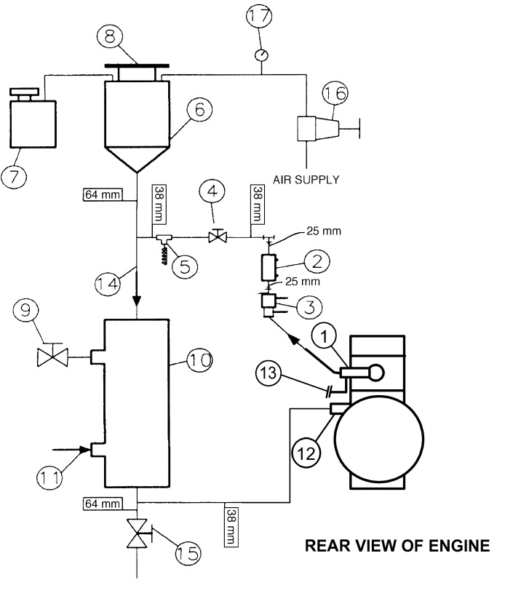

NOTE 1—Observe temperature sensor locations in thermostat housing and at water pump inlet.

NOTE 2—Components of Engine Cooling System—

(1) Thermostat housing, coolant out with temperature sensor (OHTVH-009-1)

(2) Sight glass

(3) Flowmeter

(4) Flow control valve

(5) Optional temperature sensor

(6) Fabricated coolant reservoir

(7) Constant full expansion tank

(8) Pressure radiator cap (MOTORCRAFT RS40 P/N D2YY-8100-A)

(9) Process water control valve (regulated by temperature controller with three remote set points)

(10) Heat exchanger (ITT Standard P/N 5-030-06-048-001 TYP.) (Run engine coolant through the tube side)

(11) Process water supply (shell side)

(12) Water pump inlet with temperature sensor (OHTVH-008-1)

(13) Turbocharger coolant return

(14) Engine coolant (tube side)

(15) Coolant system drain valve

(16) Coolant pressure regulator

(17) Coolant pressure gage

FIG. A2.3  Typical Engine Cooling System Schematic (cont.)

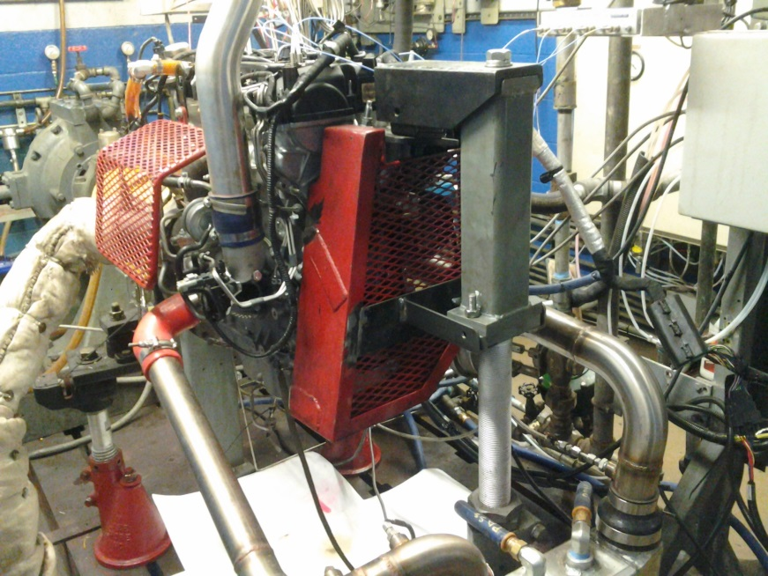 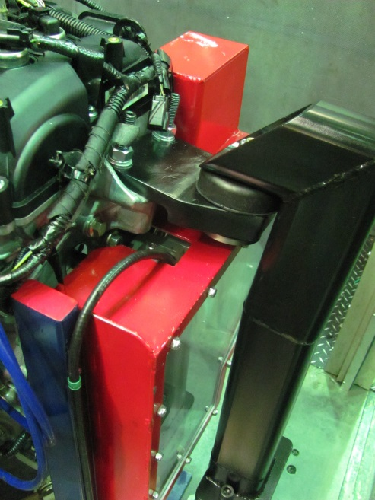

Figure A2.4: Motor Mount, Front (two options)

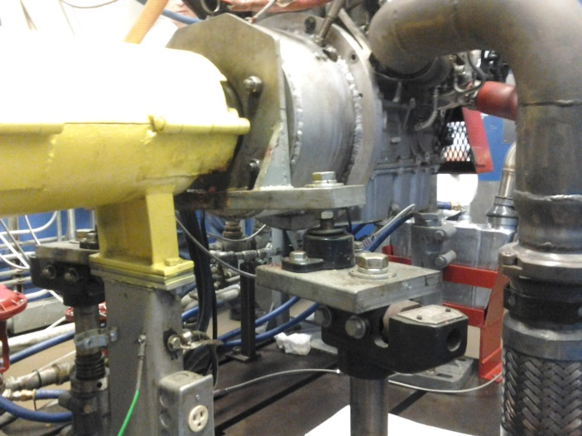 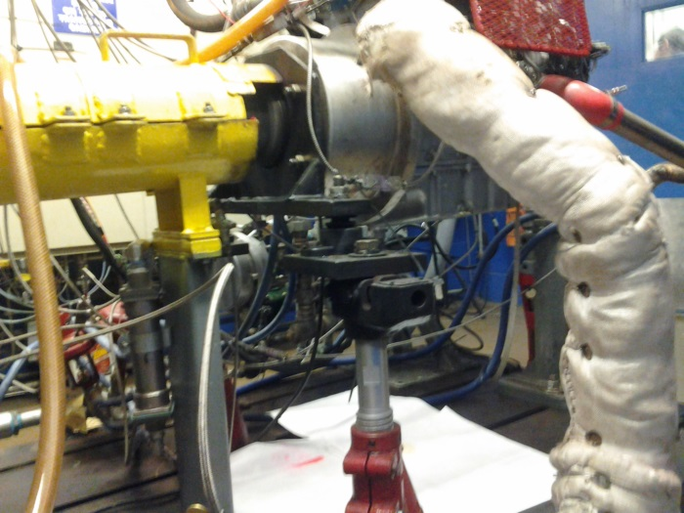

Figure A2.5: Motor Mount,Rear

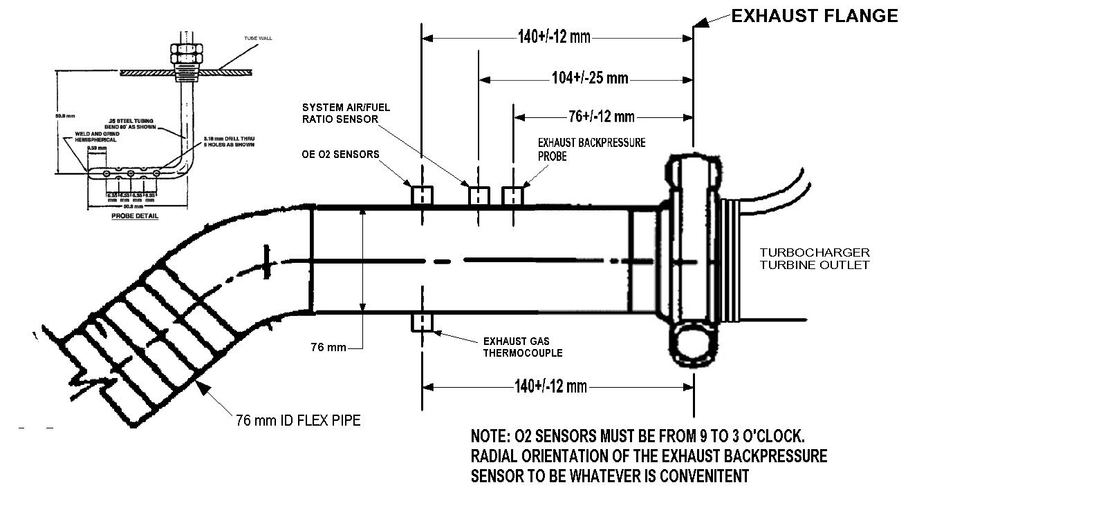

Figure A2.8: Exhaust Measurements and Instrumentation

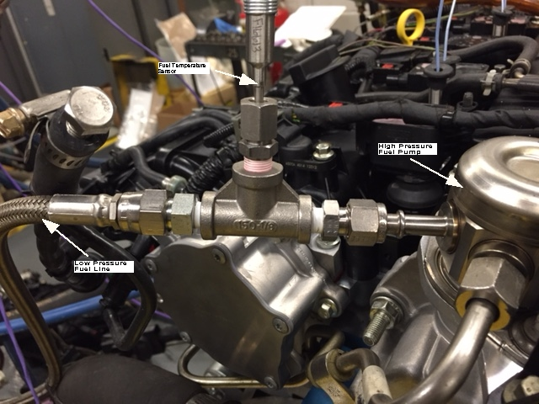

Figure A2.9: Fuel Temperature Sensor Location

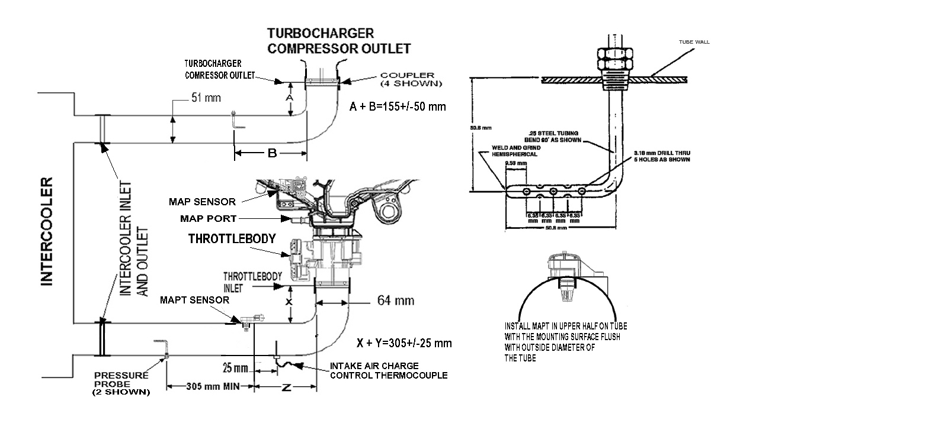

Figure A2.13: Intercooler Tubing Measurements and Instrumentation

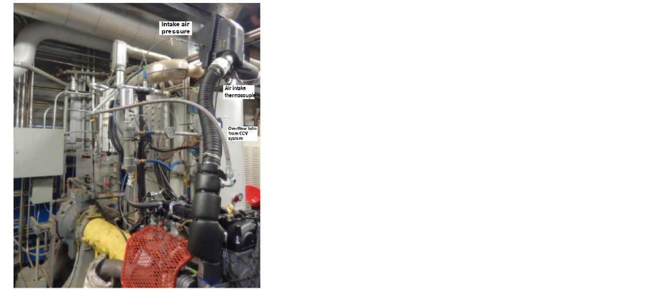

FIG. A2.12 Typical air inlet system

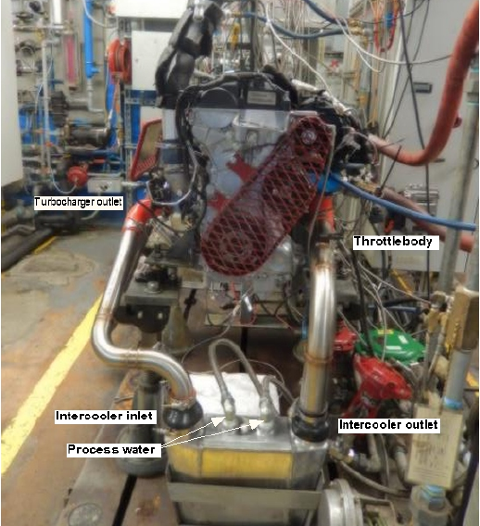

Figure A2.14 Typical intercooler installation

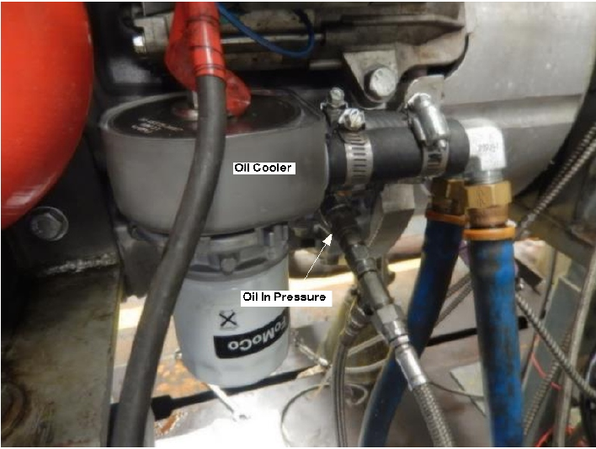

Figure A2.15Oil cooler showing oil gallery pressure location

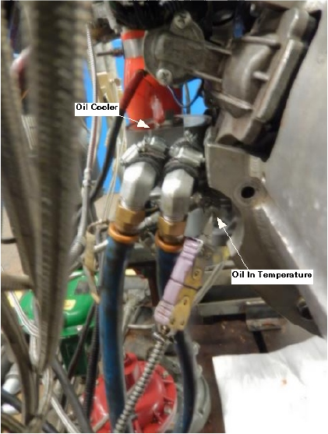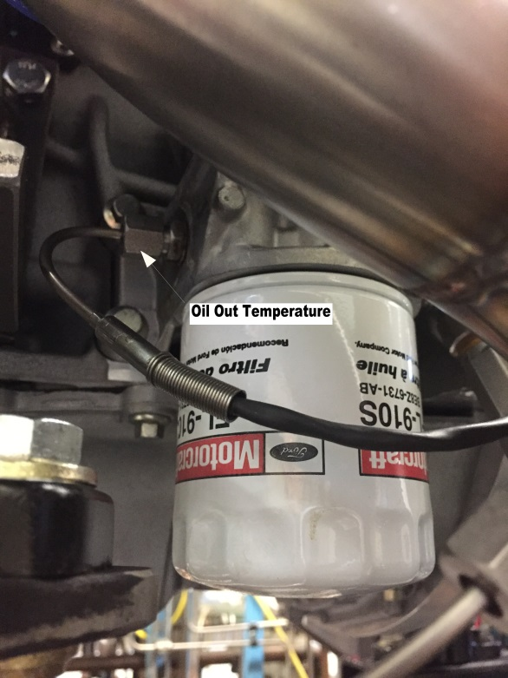

Figure A2.16 Oil cooler showing oil temperature locations

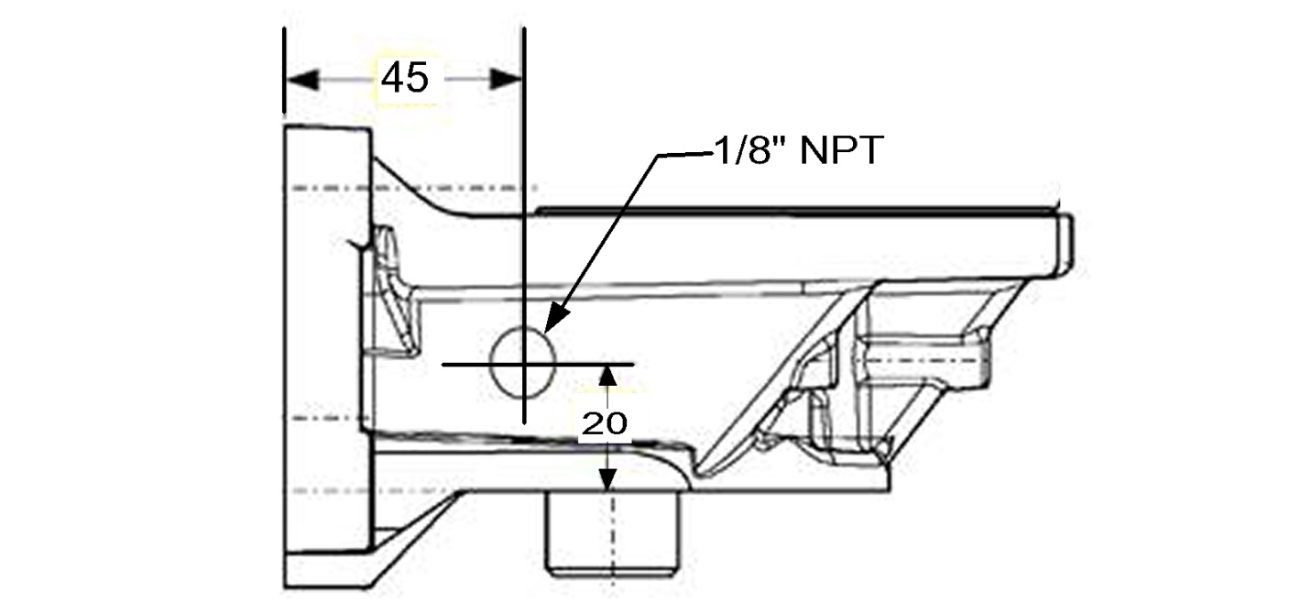

Oil Out temperature location in oil filter adapter

Figure A2.16 Oil cooler showing oil temperature locations

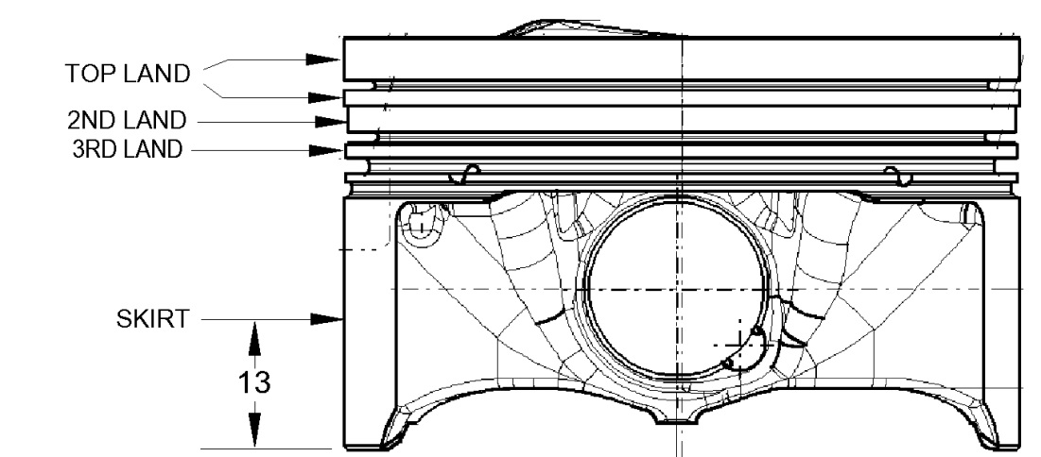

A2.17 Piston diameter measurements

A2.18. Bore Ladder



Vacuum System

Figure A2.19

**A3.  CONTROL AND DATA ACQUISITION REQUIREMENTS**

A3.1  *General Description*:

A3.1.1  The data acquisition system shall be capable of logging the operational data in digital format. It is to the advantage of the laboratory that the system be capable of real time plotting of controlled parameters to help assess test validity. The systems shall be capable of calculating real time quality index as this will be monitored throughout the test as designated in A3.4.

A3.1.2  Control capability is not dictated by this procedure. The control system shall be capable of keeping the controlled parameters within the limits specified in Table 9 and maintain the quality index shown in A3.4.

A3.1.3  Design the control and data acquisition system to meet the requirements listed below. Use the recommendations laid out in the Instrumentation Task Force Report and Data Acquisition Task Force Report for any items not addressed in Annex A3.

A3.2  *Digital Recording Frequency*—The maximum allowable time period over which data can be accumulated is one second. This data can be filtered, as described in A3.5, and will be considered a reading.

A3.3  *Steady State Operation*:

A3.3.1  Each test interval of 175,000 engine cycles is conducted at steady state operation Calculate the quality index using values reported to the accuracy levels in Table A3.1.

**TABLE A3.1 Accuracy Levels of Data Points to be Used in QI Calculations**

| Parameter | Field Length |
| --- | --- |
| Speed |  |
| Humidity |  |
| Temperature |  |
| load |  |
| Inlet Air Pressure |  |
| Exhaust Backpressure |  |
| Fuel Flow |  |

**TABLE A3.2 L and U Constants and Over and Under-Range Values**

|  |  |  |  |  |
| --- | --- | --- | --- | --- |
| Parameter | L | U | Over-Range | Under-Range |
| Speed, r/min | 1730 | 1770 |  |  |
| Load, Nm | 264 | 274 |  |  |
| Coolant Out Temperature, °C | 94.5 | 95.5 |  |  |
| Oil Gallery Temperature, °C | 94.5 | 95.5 |  |  |
| Air Charge Temperature, °C | 42.5 | 43.5 |  |  |
| Inlet Air Temperature, °C | 29.5 | 30.5 |  |  |
| Fuel Temperature, °C | 29.5 | 30.5 |  |  |
| Back Pressure, kPaA | 102 | 106 |  |  |
| Inlet Air Pressure, kPaA | 0.03 | 0.07 |  |  |
| Humidity, g/kg | 10.9 | 11.9 |  |  |
| Coolant Pressure, kPaG | 68 | 72 |  |  |

**TABLE A3.3 Maximum Allowable Time Constants**

| Control Parameter | Time Constant, s |
| --- | --- |
| Engine speed, r/min | 0.5 |
| Torque, Nm | 0.7 |
| Engine oil in, °C | 2.4 |
| Engine coolant out, °C | 2.4 |
| Engine coolant flow, L/min | 8.0 |
| Blowby in, °C | 2.4 |
| Inlet, air, °C | 2.4 |
| Inlet air press, kPa | 1.2 |
| Exhaust back pressure, kPa | 1.2 |
| Engine coolant pressure | 1.2 |
|  |  |

A3.3.2  The time intervals between recorded readings shall not exceed 1 second. Data shall be recorded throughout the length of each test iteration.

A3.4  *Quality Index*:

A3.4.1  Calculate and record the quality index for each controlled parameter for the steady state portion of each test stage throughout the entire test.

A3.4.2  Update the quality index periodically throughout the test to determine the operational validity while the test is in progress. This could indicate if the test operational validity is in question before the test has completed.

A3.4.3  Use the following equation and the values listed in Table A3.2 to calculate the *Qi*.



|  |  |  |
| --- | --- | --- |
| where: | | |
| *Xi* | = | values of the parameter measured, |
| *U* | = | allowable upper limit of *X*, |
| *L* | = | allowable lower limit of *X*, and |
| *n* | = | number of measurements taken. |

A3.4.4  Reset data that is greater than the over-range values listed in Table A3.2 (TBD) with the over-range value listed in Table A3.2 (TBD).

A3.4.5  Reset data that is lower than the under-range values listed in Table A3.2 (TBD) with the under-range value listed in Table A3.2 (TBD).

A3.4.6  Round the *Qi* values to the nearest 0.001.

A3.4.7  Report the *Qi* values on Form ? of the test report.

A3.4.8  If the end-of-test Quality index value is below 0.000 for reference oil tests, review the test operations with the TMC. The TMC issues a letter to the laboratory and the test sponsor on its opinion.

A3.4.8.1  The laboratory documents its comments regarding the end-of-test Quality index values less than 0.000 for non-reference oil tests. The laboratory or test sponsor might request TMC review of test operations for non-reference oil tests. The TMC issues a letter to document its opinion.

A3.5  *Time Constants*:

A3.5.1  Filtering can be applied to all control parameters. The amount of filtering applied shall not allow time constants to exceed the values listed in Table A3.3. This time constant shall pertain to the entire system, running from the sensor to the display and data acquisition.

A3.5.2  Maximum allowable system time constants for the controlled parameters are shown in Table A3.3

Annex 9

A9.1 Test Engine Parts—The required parts for use in the LSPI test procedure are for the 2.0L GTDI engine which are supplied by the test sponsor (Ford Motor Company) through Ford Component Sales:

Ford Motor Co.

290 Town Center Dr

Dearborn, MI 48126

A9.2 Various Materials—

Coolant inlet and outlet, Flywheel

Clutch, pressureplate, spacer, bellhousing

Dynamometer and engine wire harnesses

Are available from the following supplier:

OH Technologies

9300 Progress Pkwy.

Mentor, OH 44060

A9.3 Various Materials—

Modified Cylinder head

Piston ring tension measurement

Are available from the following supplier:

Test Engineering, Inc.

12758 Cimarron Path, Ste. 102

San Antonio, TX 78249-3417

A9.5 Type 5 or Type 52 intercooler from www.frozenboost.com

A9.8 Powertrain Control Module are available from Ford Motor Company, attn.: Ron Romano, 313-845-4068, rromano@ford.com

Annex X

X1. ENGINE MEASUREMENT RECORD FORMS

X1.1 The necessary engine measurement record forms are shown in Figs. A2.24 – A2.26.

X2. SOURCES OF MATERIALS AND INFORMATION

X2.1 The following sources are provided for convenience only. This does not represent an exclusive or complete listing of required materials or information sources.

X2.1.1 Test Engine Parts— LSPI test parts can be purchased through Ford Component Sales and Ford or Lincoln dealers:

Ford Motor Co.

290 Town Center Dr

Dearborn, MI 48126

X2.1.2 ASTM Test Monitoring Center—All communications with the TMC should be directed as follows:

ASTM Test Monitoring Center

6555 Penn Ave.

Pittsburgh, PA 15206-4489

X2.1.3 Test Sponsor—All communications with the test sponsor (Ford Motor Co.) should be directed as follows:

Ford Motor Company

Diagnostic Service Center II

1800 Fairlane Drive,

Room 410

Allen Park, MI 48101

X2.1.4 Aeroquip Hose and Fittings—Aeroquip hose and fittings can be obtained from the following supplier:

Aeroquip Corp.

1225 W. Main

Van Wert, OH 45891

X2.1.5 Fuel Information and Availability—General information concerning EEE fuel, including availability, can be obtained from the following:

Haltermann Products

1201 S. Sheldon Rd.

P.O. Box 249

Channelview, TX 79530-0429

X2.1.6 Flowmeter coolant

X2.1.7 Intake-Air Humidity Instruments—The Alnor Dewpointer, EG & G, Foxboro, Hy-Cal, General Eastern and Protimeter dewpoint meters are suitable for measurement of the intake-air specific humidity.

X2.1.9 Heat Exchangers—ITT Standard Heat Exchangers can be obtained from the following supplier:

Kinetics Engineering Corp.

2055 Silber Road, Suite 101

Houston, TX 77055

X2.1.10 Fuel Flow Measurement—Mass fuel flowmeters are available from the following supplier:

Micro Motion Corp.

7070 Winchester Circle

Boulder, CO 80301

X2.1.12 Parts Washer and Chemicals—A dishwasher type parts cleaner and associated chemicals can be obtained from the following supplier:

Better Engineering Manufacturing

8361 Town Court Center

Baltimore, MD 21236-4964

X2.1.13 Crankcase and Intake—Air Pressure Gages—Gages are available from the following supplier:

Dwyer Instrument Co.

Junction of Indiana State Highway 212 and U.S. Highway 12

P.O. Box 373

Michigan City, IN 46360

X2.1.15 Lubricants—EF-411 is available from local distributors of ExxonMobil products.

X2.1.16 Tygon Hose—Tygon hose is available through local Cadillac Plastic Co. distributors or the following supplier:

The Norton Co.

12 East Avenue

Tallmadge, OH 44278

X2.1.17 Special Tools for the Test Engine—Special tools to facilitate assembly and disassembly of the engine are available from the following supplier:

Owatonna Tool Co.

2013 4th St.

NW Owatonna, MN 55060

X2.1.18 Tierra Tech model MOT500NS ultrasonic parts cleaner or similar Tierra Tech ultrasonic parts cleaner can be obtained from Tierra Tech

X2.1.19: Tierra Tech Ultrasonic solution 7 and B cleaner can be obtained from Tierra Tech

X2.1.22: Penmul L460 can be obtained from Penetone Corp., P.O. Box 22006, Los Angeles, CA 90022

X2.1.23: Parts Cleaning Soap, (NAT-50 or PDN-50) known to the committee at this time is Better Engineering Manufacturing, 8361 Town Court, Baltimore, MD 21236.

X2.1.24: Hatchview Software (<http://digitalmetrology.myshopify.com/products/hatchview>)

X2.1.25: USB microscope.

X2.1.29: Ford camshaft alignment tool (Ford P/N 303-1565) can be obtained from a Ford or Lincoln dealer

X2.1.30: Crankshaft TDC timing peg (Ford P/N 303-507)

X2.1.32 Dyne Systems, Inc. • W209 N17391 Industrial Drive • Jackson, WI 53037 USA • 800-657-0726

Dyno One, Inc. 14671 N 250 W Edinburgh, IN 46124 info@dyno-one.com

Tel 812-526-0500

Fax 812-526-7465

X2.1.33: Quicksilver part# 6628-A

X2.1.34: Chemtool B12