Scope

TBD

Referenced Documents

TBD

Terminology

TBD

Summary of Test Method

TBD

Significance of Use

TBD

Apparatus (General Description)

* 1. The test engine is a Ford, spark ignition, four stroke, 4-cylinder gasoline turbocharged direct injection (GTDI) engine with a displacement of 2.0 L. Features of this engine include variable camshaft timing, dual overhead camshafts driven by a timing chain, four valves per cylinder and electronic direct fuel injection. It is based on the Ford Motor Co. 2012 Explorer engine with a displacement of 2.0 L.
  2. Configure the test stand to accept a Ford 2.0L GTDI engine. All special equipment necessary for conducting this test is listed herein.
  3. Use the appropriate air conditioning apparatus to control the temperature, pressure, and humidity of the intake air to meet the requirements in Table 4.
  4. Use an appropriate fuel supply system (Figure 1).

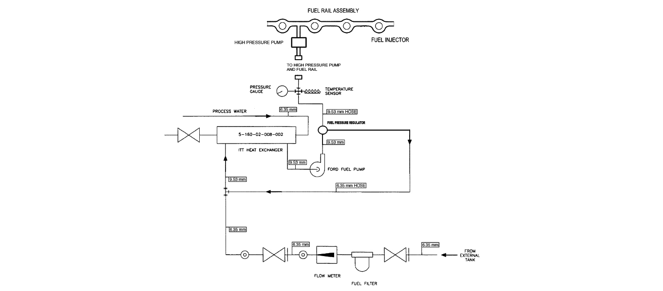

Figure 1. Fuel Supply System

* 1. Coolant Conditioning Equipment
  2. Oil Temperature Control Equipment
  3. Dynamometer
  4. Driveline
  5. Instrumentation
  6. The control and data acquisition system shall meet the requirements listed in Annex XX.
  7. Combustion Analysis Equipment

Apparatus (The Test Engine)

* 1. LSPI Test Engine—The test engine parts are available from the Ford Motor Co. (A1.1, use parts list .xls). A detailed listing of all parts is given in Annex (A1, use parts list .xl).
  2. Required New Engine Parts—.
  3. Reusable Engine Parts—.
  4. Specially Fabricated Engine Parts—The following subsections detail the specially fabricated engine parts required in this test method:
     1. Intake Air System (see Fig. A2.12) Intake air system can be fabricated but must use the stock 2012 Explorer air cleaner assembly (A1.6) and MAF sensor.
     2. Oil Pan – Modify the stock 2012 Explorer oil pan to add an oil drain plug in the location shown in Fig. AX.X.
     3. Driveline—Use the flywheel, clutch, pressure plate, bell housing, clutch spacer listed in Annex (A1.7) from the supplier listed in A9.2.
     4. Cylinder Head – A modified cylinder head must be used that allows for installation of in cylinder pressure sensors. This assembly can be purchased from the supplier listed in A9.2.
     5. Pressure Sensor Tubes – 3/8” OD steel tubing must be installed into the pressure sensor sleeves in the cylinder head to allow for installation of the in cylinder pressure sensors.
     6. Valve Cover – The stock valve cover must be modified to allow the pressure sensor tubes to protrude through the cover. The location where the tubes protrude through the cover must be sealed to prevent oil from leaking through the penetrations.
     7. Coolant Supply Manifold – Purchased from OHT
     8. Coolant Return Manifold - Purchased from OHT
  5. Special Engine Measurement and Assembly Equipment—Items routinely used in laboratory and workshop are not included. Use any special tools or equipment shown in the 2012 Explorer service manual for assembly. A list of these tools is shown in Annex A1.8. Complete any assembly instructions not detailed in Section 7 according to the instructions in the 2012 Explorer Service Manual.
     1. Piston Ring Positioner—Use the piston ring positioner to locate the piston rings from the cylinder block deck surface by 38 mm. This allows the compression rings to be positioned in a consistent location in the cylinder bore for the ring gap measurement. Fabricate the positioner according to the details shown in Fig. A2.17.
     2. Engine Service Tools—A complete list of special tools for the test engine is shown in Annex A1.8. The tools are available from a Ford dealership. These are designed to aid in performing several service items, in addition to the following specific service items that require special tools to perform the functions indicated (if not self-explanatory).

Combustion Analysis Equipment

Engine Preparation

* 1. Engine Disassembly - See Ford 2.0L EcoBoost 2012 Explorer Shop Manual
  2. Engine Measurements – Record the following engine measurements
     1. Piston and bore measurements are shown in Table 1.
     2. Record the piston to bore clearances at the top, 2nd and 3rd ring lands and the piston skirt. Use bore ladder shown in Figure 2 to determine bore diameter positions. Measure the bore in both the longitudinal and transverse directions. To determining the piston to bore clearance calculate the difference between the particular piston diameter and the middle bore diameter.
     3. Record ring side clearances for the upper and lower compression rings (UCR, LCR). For determining ring side clearance take 4 measurements 90 degrees apart. Either check clearance with a thickness gauge or measuring the difference between the thickness of the ring and the height of the corresponding groove.
     4. Measure cylinder head dimension shown in Table 2. For determining the valve stem to guide clearance measure the diameter of the valve stem 1.5 inches from the tip of the valve and the valve guide midway between the top and the bottom of the valve guide.

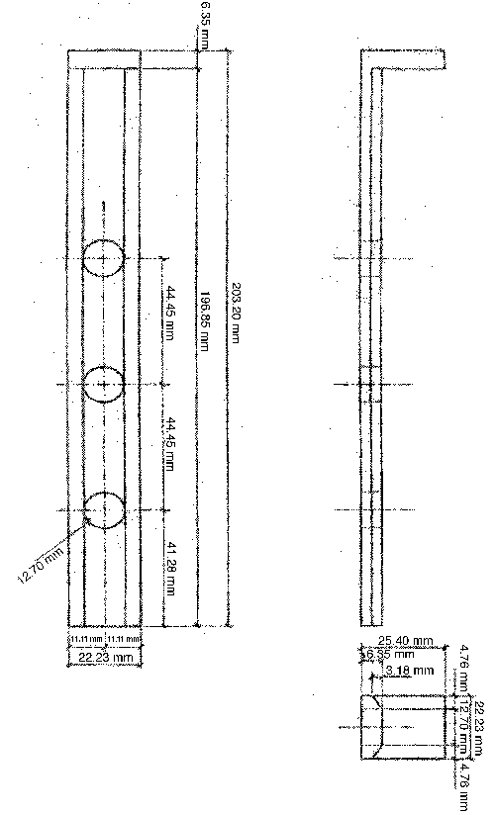

Figure 2. Bore Ladder

Table 1. Cylinder Bore and Piston Measurements



Table 2. Head Measurements



* + 1. Compression Ratio – Measure compression ratio using WhistP/N ###
  1. Engine Assembly – See Ford 2.0L EcoBoost 2012 Explorer Shop Manual
  2. Engine Installation on Test Stand
  3. Pressure Sensor Installation
  4. New Engine Break In - Once a new engine has been installed on the test stand, perform the break-in procedure shown in Table 3, using oil TMC 220.

Table 3. LSPI Break-In Procedure

|  |  |  |  |  |
| --- | --- | --- | --- | --- |
| **Step** | **Speed (RPM)** | **Load**  **(N-m)** | **Time per stage (Hr:Min)** | **Total Time (Hr:Min)** |
| **Charge engine with 4200 grams of  new oil and new oil filter** | | | | |
| 1 | Idle | 0 | 0:30 | 0:30 |
| **Oil Flush 1 -Shut engine down and drain used oil and remove oil filter. Allow oil to drain for 20 minutes. Install new oil filter and add 4200 grams of new oil.** | | | | |
| **Start engine and let idle for 5 minutes** | | | | |
| 2 | 1500 | 38 | 0:30 | 1:00 |
| 3 | 2000 | 72 | 0:30 | 1:30 |
| 4 | 2500 | 111 | 0:30 | 2:00 |
| 5 | 3000 | 135 | 0:30 | 2:30 |
| 6 | 3000 | 150 | 3:15 | 5:45 |
| 7 | 2000 | 72 | 0:15 | 6:00 |
| 8 | 3250 | 155 | 0:15 | 6:15 |
| 9 | 3500 | 155 | 0:15 | 6:30 |
| 10 | 3750 | 155 | 0:15 | 6:45 |
| 11 | 4000 | 155 | 1:15 | 8:00 |
| **Bring engine to idle for 5 minutes then shut down** | | | | |
| **Oil Flush 2- Drain used oil and remove oil filter. Allow oil to drain for 20 minutes. Install new oil filter and add 4200 grams of new oil.** | | | | |
| **Run one full test per section 12.3 for additional break in. After test is complete drain the oil, remove the oil filter, and proceed to section 12.1.** | | | | |

* The controlled parameters during break in are listed in Table 4. All other controls are left wide open/free flowing. The engine does not produce enough heat in the early steps to reach all target temperatures. All controlled parameters are expected to be on target at the beginning of Step 4.

Table 4. Sequence CW Break-in Controlled Parameters

|  |  |
| --- | --- |
| **Break In Controlled Parameters** | |
| Coolant Out Temp. | 85 degC |
| Oil Gallery Temp. | 100 degC |
| Inlet Air Pressure | 0.05kPa |
| Air Charge Temp. | 37 deg C |
| Inlet Air Temp. | 30 degC |

1. Calibration
2. Test Procedure
   1. Oil Flush Procedure – For each new test, perform two oil flushes using test oil as detailed below.
3. Charge engine with 4200 grams of new oil and install a new oil filter.
4. Warm Up - Start engine and operate at Idle (900 rpm) for two minutes.
5. Ramp to 2000RPM and 70 N-m within two minutes. Control to test condition temperatures listed in Table 5. Maintain conditions for 15 minutes (including ramp time).
6. Ramp to idle within two minutes. Hold at idle conditions for two minutes (including ramp time).
7. Shut down engine.
8. Drain engine oil for 15 minutes.
9. Repeat for second flush.

Table 5. Test Temperature Conditions

|  |  |  |
| --- | --- | --- |
| **Controlled Parameter** | **Set Point** | **Units** |
| Coolant Out Temperature | 95 | degC |
| Oil Gallery Temperature | 95 | degC |
| Air Charge Temperature | 43 | degC |
| Inlet Air Temperature | 30 | degC |

* 1. Test Start/Oil Seasoning Procedure:

1. Charge engine with 4200 grams of test oil and install new oil filter.
2. Warm Up - Start engine and operate at Idle (900 rpm) for two minutes
3. Ramp to 2000RPM and 100 Nm in 60 seconds. Control to test condition temperatures listed in Table 5. Run at these conditions for 15 minutes.
4. Ramp to 1750RPM and 269 Nm in 60 seconds.
5. Hold at 1750RPM, 269 Nm and control to test condition temperatures for 60 minutes.
6. Ramp to cool down conditions shown in Table 6. Maintain conditions for 15 minutes (including ramp times).

Table 6. Cool Down Conditions

|  |  |  |  |
| --- | --- | --- | --- |
| **Controlled Parameter** | **Set Point** | **Units** | **Ramp times (min)** |
| Engine Speed | 2000 | RPM | 1 |
| Engine Load | 50 | Nm | 1 |
| Coolant Out Temp | 45 | degC | 15 |
| Oil Gallery | 45 | degC | 15 |
| Intake Air Temp | 30 | degC | N/A |
| Air Charge | 30 | degC | N/A |

1. Ramp to idle and hold for 2 minutes.
2. Shut down engine for a minimum of 10 minutes. Take oil dip and inspect engine and stand.
3. Restart Engine to Start Cycle 1
   1. Test Cycle – The following test cycle procedure is conducted four times for one complete test.
4. Warm Up - Start engine and operate at Idle (900 rpm) for two minutes.
5. Ramp to 2000RPM and 100 Nm in 60 seconds. Control to test condition temperatures listed in Table 5. Run at these conditions for 15 minutes.
6. Ramp to test conditions listed in Table 7.

Table 7. Test Conditions

|  |  |  |  |
| --- | --- | --- | --- |
| **Test Conditions** | | |  |
| **Controlled Parameter** | **Set Point** | **Units** | **Ramp times (min)** |
| Speed | 1750 +15 | RPM | 1 |
| Load | 269+2 | Nm | 1 |
| Coolant Out Temperature | 95+0.5 | degC | < 20 |
| Oil Gallery Temperature | 95+0.5 | degC | < 20 |
| Air Charge Temperature | 43+0.5 | degC | < 20 |
| Inlet Air Temperature | 30+0.5 | degC | < 20 |
| Fuel Temperature | 30 | degC | NA |

1. Hold until the following conditions are true:

* Coolant Out Temp: 95 + 0.5 degC
* Oil Gallery Temp: 95 + 0.5 degC
* Intake Air Temp: 30 + 0.5 degC
* Air Charge: 43 + 0.5 degC

All the above temperatures should be met within a maximum of 20 minutes. If not, perform soft shut down and fix any issue preventing the test conditions from being met before trying again.

1. Once test conditions are met, allow engine to stabilize for five minutes.
2. After five minute stabilization, begin recording combustion analysis data using AVL Indicom for 175,000 combustion cycles.
3. Ramp to cool down conditions shown in Table 6. Maintain conditions for 15 minutes (including ramp times).
4. Ramp to idle and hold for 2 minutes.
5. Shut down for a minimum of 10 minutes. Take oil dip and inspect engine and stand
   1. End of Test. Make sure everything is turned off:

* Fuel off
* Coolant pressure off
* Chilled water off
  1. Record the operation and canbus data listed in table 12.4 at a rate of 1/sec.

Table 8. Recorded Test Points

|  |  |  |
| --- | --- | --- |
|  | **TEST POINT** | **UNITS** |
| **Controlled** | Engine Speed | rpm |
| Engine Load BMEP | bar |
| Coolant Out Temp | deg C |
| Oil In Temp | deg C |
| Intake Manifold Temp | deg C |
| Intake Air Temp | deg C |
| Intake Air Press | kPaG |
| Exhaust Press | kPaA |
| Fuel Temp | deg C |
| Humidity | g/kg |
| **Monitored** | Fuel Flow | kg/hr |
| Intake Manifold Press | kPaA |
| Barometric Press | kPaA |
| Oil Pump Pressure | kPaG |
| Oil Head Pressure | kPaG |
| **PCM CAN BUS Channels** | Ignition Timing Advance for #1 Cylinder | Deg |
| Absolute Throttle Position | % |
| Engine Coolant Temperature | deg C |
| Intake Air Temperature | deg C |
| Equivalence Ratio (Lambda) | NA |
| Absolute Load Value | % |
| Intake Manifold Absolute Pressure | kPa |
| Fuel Rail Pressure | kPa |
| Boost Absolute Pressure - Raw Value | kPa |
| Turbocharger/Supercharger Wastegate Solenoid A Duty Cycle | % |
| Actual Intake (A) Camshaft Position Bank 1 | Deg |
| Actual Exhaust (B) Camshaft Position Bank 1 | Deg |
| Intake (A) Camshaft Position Actuator Duty Cycle Bank 1 | % |
| Exhaust (B) Camshaft Position Actuator Duty Cycle Bank 1 | % |
| Charge Air Cooler Temperature Bank 1 Sensor 1 - Raw | deg C |

* 1. At the end of each 175,000 cycle run, report the following data from the AVL Indicom combustion analysis software for each engine cycle.
* PMAX
* CA02
* PMAXV
* PMINV
* KP_INT

This data will be used to determine the number of LSPI events for each test run according to the method described in section 13.

* 1. CAN Bus Data –Set up the data acquiisiton software to record the following Parameter IDs from the engine’s PCM:

Table 9. PCM Parameter IDs

|  |  |  |  |  |  |  |  |  |  |
| --- | --- | --- | --- | --- | --- | --- | --- | --- | --- |
| **Mode** | **PID Number (Hex)** | **Parameter Description** | **Type** | **Bytes** | **Scale** | **Offset** | **Minimum** | **Maximum** | **Units** |
| 1 | 0E | Ignition Timing Advance for #1 Cylinder | Unsigned Numeric | 1 | 0.5 | -64 | -64 | 63.5 | Deg |
| 1 | 11 | Absolute Throttle Position | Unsigned Numeric | 1 | 0.392156862745 | 0 | 0 | 100 | % |
| 1 | 05 | Engine Coolant Temperature | Unsigned Numeric | 1 | 1 | -40 | -40 | 215 | Deg C |
| 1 | 0F | Intake Air Temperature | Unsigned Numeric | 1 | 1 | -40 | -40 | 215 | Deg C |
| 1 | 34 | Equivalence Ratio (Lambda) | Unsigned Numeric | 2 | 0.000030518044 | 0 | 0 | 2 | Undefined / Not Used |
| 1 | 43 | Absolute Load Value | Unsigned Numeric | 2 | 0.392156862745 | 0 | 0 | 25700 | % |
| 1 | 0B | Intake Manifold Absolute Pressure | Unsigned Numeric | 1 | 1 | 0 | 0 | 255 | kPa |
| 1 | 23 | Fuel Rail Pressure | Unsigned Numeric | 2 | 10 | 0 | 0 | 655350 | kPa |
| 22 | 033E | Boost Absolute Pressure - Raw Value | Unsigned Numeric | 2 | 0.007629394531 | 0 | 0 | 499.992370605469 | kPa |
| 22 | 0462 | Turbocharger/Supercharger Wastegate Solenoid A Duty Cycle | Unsigned Numeric | 2 | 0.003051757813 | 0 | 0 | 199.996948274955 | % |
| 22 | 0318 | Actual Intake (A) Camshaft Position Bank 1 | Signed Numeric | 2 | 0.0625 | 0 | -2048 | 2047.9375 | Deg |
| 22 | 0319 | Actual Exhaust (B) Camshaft Position Bank 1 | Signed Numeric | 2 | 0.0625 | 0 | -2048 | 2047.9375 | Deg |
| 22 | 0316 | Intake (A) Camshaft Position Actuator Duty Cycle Bank 1 | Unsigned Numeric | 2 | 0.003051757813 | 0 | 0 | 199.996948242188 | % |
| 22 | 0317 | Exhaust (B) Camshaft Position Actuator Duty Cycle Bank 1 | Unsigned Numeric | 2 | 0.003051757813 | 0 | 0 | 199.996948242188 | % |
| 22 | 0461 | Charge Air Cooler Temperature Bank 1 Sensor 1 - Raw | Signed Numeric | 2 | 0.015625 | 0 | -512 | 511.984375 | Deg C |
| 22 | 05AC | Cylinder 1 Knock/Combustion Performance Counter | Unsigned Numeric | 1 | 1 | 0 | 0 | 255 | Undefined / Not Used |
| 22 | 05AD | Cylinder 2 Knock/Combustion Performance Counter | Unsigned Numeric | 1 | 1 | 0 | 0 | 255 | Undefined / Not Used |
| 22 | 05AE | Cylinder 3 Knock/Combustion Performance Counter | Unsigned Numeric | 1 | 1 | 0 | 0 | 255 | Undefined / Not Used |
| 22 | 05AF | Cylinder 4 Knock/Combustion Performance Counter | Unsigned Numeric | 1 | 1 | 0 | 0 | 255 | Undefined / Not Used |

Determination of Test Results

Steps for calculating LSPI triggers adjustment for distribution skew and kurtosis:

1. **Remove Invalid Cycles**

Prior to performing the PP and MFB2 LSPI calculations described in this document, remove all invalid combustion cycles from both the PP and MFB2 data set. Use the following criteria to identify invalid cycles.

1. Remove all cycles with a MFB2 < -30 degrees
2. Remove all cycles with a PP < 20 bar.

Remove the entire cycle, including PP and MFB2 values, for any cycle that meets the conditions given above. These cycles are considered invalid and are not counted as LSPI cycles.

1. **Remove PP LSPI cycles – (Individually for each cylinder)**
2. Remove obvious outliers. The mathematical method of estimating quantiles decreases in accuracy the further from normality so obvious outliers should be eliminated prior to applying the method.
   1. Remove PP > 90 (I think we all agree that likely anything over 90 is a LSPI)
3. Determine the following statistics on the remaining results. I am assuming that there are built in functions for each of these. If not, I can provide them but we may want to reconsider this approach because the follow steps become increasing more complicated.
   1. Median
   2. Standard deviation (s)
   3. Skew (S)
   4. Kurtosis (K)
4. Determine the number of standard deviations for our distributions subject to skew and kurtosis corresponding to the 5 that is appropriate for a valid normal distribution.
   1. Simultaneously solve for *B*, *C* and *D* in the following three equations (where *S* and *K* are Skew and Kurtosis, respectively, from Step 2):



Where S = Skew and K = Kurtosis.

* 1. Then calculate *F*, an estimate of the quantile corresponding to *Z* = 5.



*F* will generally be on the order of 5 to 10 on the first iteration and 5 to 7 on the last iteration.

1. Those cycles with PP > Median +*F* s (where s is the standard deviation) are outliers (LSPI) and should be omitted.
2. If no outliers are found in Step 2, count the LSPI and the process is complete, else return to Step 2. The total number of outliers is from Steps 1a and 4.
3. **Remove MFB02 LSPI Cycles – (individually for each cylinder)**
4. Remove obvious outliers. The mathematical method of estimating quantiles decreases in accuracy the further from normality so obvious outliers should be eliminated prior to applying the method.
   1. Remove MFB02 < 0 (I think we all agree that likely anything under 0 is a LSPI)
5. Determine the following statistics on the remaining results. I am assuming that there are built in functions for each of these. If not, I can provide them but we may want to reconsider this approach because the follow steps become increasing more complicated.
   1. Median
   2. Standard deviation (s)
   3. Skew (S)
   4. Kurtosis (K)
6. Determine the number of standard deviations for our distributions subject to skew and kurtosis corresponding to the -5 that is appropriate for a valid normal distribution.
   1. Simultaneously solve for *B*, *C* and *D* in the following three equations (where *S* and *K* are Skew and Kurtosis, respectively, from Step 2):



Where S = Skew and K = Kurtosis.

* 1. Then calculate *F*, an estimate of the quantile corresponding to *Z* = -5.



*F* will generally be on the order of -4 to -10 on the first iteration and -4 to -7 on the last iteration.

1. Those cycles with MFB02 < Median +*F* s (where s is the standard deviation) are outliers (LSPI) and should be omitted.
2. If no outliers are found in step 2, count the LSPI and the process is complete, else return to Step 2. The total number of outliers is from Steps 1a and 4.
3. **Report LSPI Cycles**

Report the following data for each cylinder

1. Total number of combined LSPI cycles (containing both a PP and MFB2 LSPI trigger)
2. Total number of LSPI cycles containing only a PP trigger
3. Total number of LSPI cycles containing only a MFB2 trigger
4. Number of Invalid Cycles
5. Skew, Kurtosis, and F values for each iteration of the PP and MFB2 analysis

**AVL Indicom Settings**

**Amplifier and Pressure Sensor Settings (accessed through the “Sensor” menu)**

|  |  |
| --- | --- |
| Change to 20 KHz |  |
| Amplifier Settings | Pressure Sensor Settings |

|  |
| --- |
|  |
| Pressure Sensor Settings |

**Standard Results Settings**

|  |  |
| --- | --- |
|  |  |
| PCYL MAX Settings | |

|  |  |
| --- | --- |
|  |  |
| PCYL MIN Settings | |

|  |  |
| --- | --- |
|  |  |
| PCYL Max Rise Settings | |

|  |  |
| --- | --- |
|  |  |
| PCYL IMEP Settings | |

|  |  |
| --- | --- |
|  |  |
| PCYL Heat Release Settings | |

|  |  |
| --- | --- |
|  |  |
| PCYL Heat Release Settings | |

|  |
| --- |
|  |
| PCYL Single Value Settings |

|  |  |
| --- | --- |
|  |  |
| PCYL Knock (Cylinder Pressure) Settings | |

|  |
| --- |
|  |
| PCYL Knock (Cylinder Pressure) Settings |

|  |  |
| --- | --- |
|  |  |
| PCYL Polytrophic Coefficient Settings | |

|  |  |
| --- | --- |
|  |  |
| IGN1 MAX Settings | |

|  |  |
| --- | --- |
|  |  |
| IGN1 Edge Detection Settings | |

|  |  |
| --- | --- |
|  |  |
| IGN1 Timing Settings | |

|  |
| --- |
|  |
| Speed Settings |

**Channels To Report**

* PMAX*
* CA02*
* PMAXV*
* PMINV*
* KP_INT*