IVB Golden Stand Installation Manual

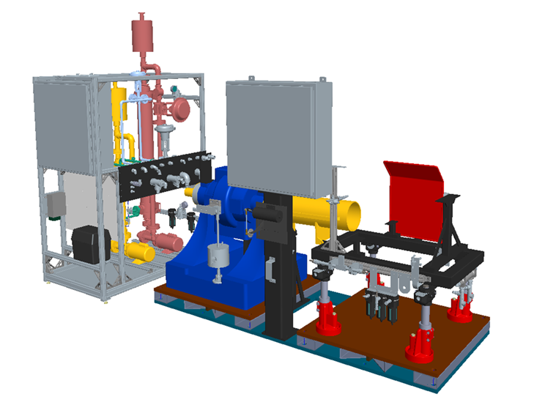

Table of Contents

Laboratory Resources Required for Installation 3
Footprint 3
Power requirements 3
Instrumentation air supply 3
Recyclable cooling water 3
Chilled water mixture 3
Conditioned intake air 3
Bulk fuel supply 3
Exhaust piping 4
Test cell dynamometer 4
Computerized data acquisition and control system 4
Golden Stand Installation 5
Site Selection and Securing the Test Bedplate 5
Dynamometer Installation and Configuration 5
Annex 1 – IVB Golden Stand Layout 8
Annex 2 – Computerized Data Acquisition and Control System 10
Annex 3 - Thermocouple Installation Instructions ……………………………………………………………………16

Laboratory Resources Required for Installation
Prior to installing the IVB Golden Stand, survey the laboratory capabilities to provide the following resources.

Footprint – the baseplate requires a minimum space of 96 inches long by 40 inches wide by 73 inches tall and has provisions for four anchor mounting points. The fluid control rack requires a minimum space of 51 inches long by 33.25 inches wide by 94” tall. The fluid control rack may be mounted at any location provided the supplied interconnect hoses are used as provided. Appendix 1 contains a detailed layout.

Power requirements
- The power distribution box located in the 8020 fluid control rack requires 220 volt 90 amp single phase 60 Hz AC service.
- The dynamometer power controller isolation transformer input requires 220 volt 20 amp single phase 60 Hz service.
- The throttle power controller isolation transformer input requires 120 volt 5 amp single phase 60 Hz service. Additionally, the throttle power controller isolation transformer must be in phase with the dynamometer power controller.

Instrumentation air supply - a 140 kPa instrument-quality air supply meeting ANSI/ISA-S 7.3 specifications.

Recyclable cooling water - treated to prevent deposit accumulation in heat exchangers and associated piping. The cooling water supply will need to be 20 °C to 40 °C with a minimum delivery pressure of 275 kPa. A minimal 135 kPa differential pressure between supply and return is required.

Chilled water mixture - consisting of 50% de-ionized water mixed with either 50% isopropyl alcohol or 50% ethylene glycol that has been cooled between 2 °C and 5 °C with a minimum flow rate of 350 lpm and with a minimum delivery pressure of 300 kPa.

Conditioned intake air - meeting the specifications of 32 ± 2.0 °C, 11.4 ± 0.8 g/kg humidity, and pressurized to 0.05 kPa. Temperature will be controlled by a electrical heating element operating at 220 volts and not to exceed 20 Amps. The test laboratory must provide this electrical heating element as it is not included in the IVB Golden Stand. Pressure will be controlled by a pneumatic control valve that operates in the range of 0 to 105 kPa. The test laboratory must provide the pneumatic control valve as it is not included in the IVB Golden Test Stand. Provisions are included in the IVB Golden test stand for connecting control outputs to these control devices.

Bulk fuel supply – the test consumes approximately 750 liters of the specified fuel. The IVB Golden Stand requires a minimum delivery of 310 kPa pressure at a maximum 10 kg/hr flow rate.

Exhaust piping – an exhaust turn-down pipe is included with the IVB Golden Stand for attachment to the laboratories exhaust system and must be used as provided. The laboratory exhaust system coupled to the exhaust stub section must have minimum diameter of 50 mm and be equipped with an exhaust pressure pneumatically operated valve operating over the range of 0 to 105 kPa that will connect to the IVB Golden Stand instrumentation. The exhaust piping must allow exhaust backpressure to be controlled at 103.5 kPaA ± 1 kPaA when the engine is operated at engine speed of 800 rpm and torque at 25Nm.
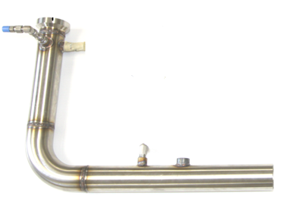
Figure 1 Exhaust Turn-down Pipe

Test cell dynamometer – the dynamometer mounting pallet without dynamometer is supplied as a component of the IVB golden test stand. The required laboratory supplied test cell dynamometer is a Midwest Model 1014A dry gap eddy current dynamometer and is not a component of the IVB Golden Stand package. The dynamometer shall be equipped with the following IVB Golden Stand components which are included with the purchase of an IVB Golden Stand.
- Torque Arms
- Torque Guard
- Dynamometer driveshaft adapter hub
- Load cell linkage
- Load cell heater
- Load cell
- 60 tooth gear with housing and magnetic pickup
- Coolant hoses and coolant header with provisions to monitor dynamometer coolant outlet temperature.

When using a dynamometer reconditioned by third parties, it is permissible to have spacer plates installed between the dynamometer base and the dynamometer mounting pallet providing the centerline distance between center of dynamometer drive shaft and top of dynamometer pallet is maintained to 28 inches ± 1 inch.

Computerized data acquisition and control system - the Sequence IVB Golden Stand test stand requires the use of computerized data acquisition and control for all measured and controlled parameters outlined in this document. The DAC is not supplied as a component of the IVB Golden Stand and must be provided by the test laboratory. The system chosen by individual testing laboratories shall be capable of integrating with the Sequence IVB Golden Stand. A detailed list of the I/O count and type is listed in Annex 2. The system shall also be capable of meeting or exceeding test specific performance requirements for maximum allowable response times and minimum allowable sample rates. In addition to the aforementioned requirements, the system shall also be capable of data logging to test specific archival files for each test parameter at minimum allowable record intervals, that is, no greater than one second intervals between successive logs for each parameter. For items not addressed by this document, please refer to the Data Acquisition and Control Automation II Task Force Report (DACA II).

Golden Stand Installation

Site Selection and Securing the Test Bedplate – select an installation location that meets the criteria discussed in Laboratory Resources Required for Installation section of this document. Using Annex 1 as a reference, stub out supplemental plumbing connections once installation location has been determined. If the installation location has excessive grade, reduce the grade by grouting prior to installing the test bedplate. Prepare the four anchor locations as shown in Figure 7 IVB Golden Stand Anchor Mounting Locations and then move the test bedplate into position. If necessary use leveling shims to ensure the test bedplate is within 0° to 1 ° of horizontal in both the longitudinal and transverse planes before securing the test bedplate with anchors.

Dynamometer Installation and Configuration – the IVB Golden Stand is equipped with a dynamometer mounting pallet for a Midwest 1014A dry gap eddy current dynamometer with tapered rotor shaft and 90 volt excitation coil. New or reconditioned dynamometers may be used. When using none OEM reconditioned dynamometers, the rotor inertia shall be maintained at 15.7 lb ft². The height from the centerline of the dynamometer shaft to the top of the dynamometer mount pedestal shall be maintained at 28 inches ± 0.5 inch. When necessary, spacer blocks are permitted between the bottom face of the dynamometer base and the top face of the dynamometer mounting pallet to achieve the required shaft height.
- Position the dynamometer on the mounting pedestal and secure.
- Assemble load cell mounting components as shown in Figure 2.
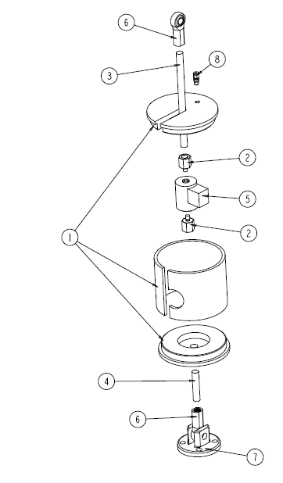
1 | Load Cell Housing
2 | Load Cell Thread Adapter
3 | Threaded Rod 5/8-18 X 10”
4 | Threaded Rod 5/8-18 X 3”
5 | Load Cell
6 | Rod End, 5/8 Female
7 | Load Cell Clevis Bracket
8 | Thermocouple Fitting
9 * | Band Heater
10 * | Band Clamp
11 * | Thermocouple
Table 1 Load Cell Mounting Components
^{* not illustrated}

Figure 2 Load Cell Mounting Components Assembly

- Install the dynamometer accessories as shown in Figure 3.
Item | Description
1 | Torque Guard
2 | Coolant Header
3 | 60 Tooth Gear
4 | Tach Housing
5 | Rear Shaft Guard
6 | Dyno Torque Arm
7 | Actuator Bar
8 | Knife Edge
9 | Load Cell Assembly
10 * | Magnetic Pickup
11 * | Load Cell Assembly
12 * | Coolant Plumbing
13 * | Coolant Hoses
14 * | Coolant Thermocouple
Table 2 1014A Dynamometer Accessories
^{* not illustrated}

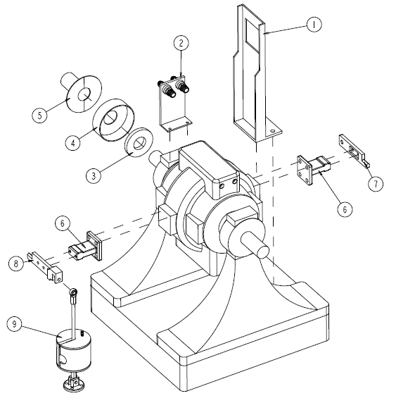
Figure 3 Midwest 1014A with Accessories
Allow use of strainers and other lab related items
Installation of torque arms
Installation of 60 tooth gear and magnetic pickup
Installing load cell and load cell heater assembly

Engine installation
Specified install height for centerline of engine crankshaft 29 inches.

Installing OHT components
Clutch
Bellhousing
Installation of engine speed safety magnetic pickup
Installation of dummy input shaft
Installation of drive shaft adapter
Installation of Engine mounts
Left
Right
Front
Installation of Coolant Adapters
Inlet
Outlet
Test specific throttle body

Test specific intake air filter housing
Intake air thermocouple installation
Allow use of bypass air upstream of inlet to intake air filter housing.
Intake air pressure tap
Install TEI components
Coolant out thermocouple
Remove OEM coolant temperature Sensor
Install pipe fitting hardware
Themocouple installation
Coolant in thermocouple
Install pipe fitting hardware
Themocouple installation
Oil gallery thermocouple
Remove OEM oil pressure sensor
Install pipe fitting hardware
Themocouple installation
Exhaust thermocouple
Install pipe fitting hardware
Themocouple installation
Exhaust pressure tap
Install pipe fitting hardware
Connect pressure sense line to exhaust pressure moisture trap.
Install Horiba AFR sensor
AFR sample tap
Install pipe fitting hardware
Connect sample line to AFR moisture trap
Oil sample and oil pressure sense line
Install
External oil temperature control system
Remote oil filter adapter installation
Oil hose routing
Process water hose connection to oil heat exchanger

Driveline alignment
2 +- 0.5 degrees vertical offset between centerline of engine crankshaft and centerline of dynamometer.
Horizontal offset is 0.
Hose routing
Coolant inlet hose supply from fluid control rack
Coolant outlet hose supply to fluid control rack
Installation of thermocouple extension wire harness
Installation of fuel line connections
From fluid control rack to engine stand
From engine stand to fuel rail
Fuel pressure sense line
Main fuel supply into fluid control rack

Annex 1 – IVB Golden Stand Layout

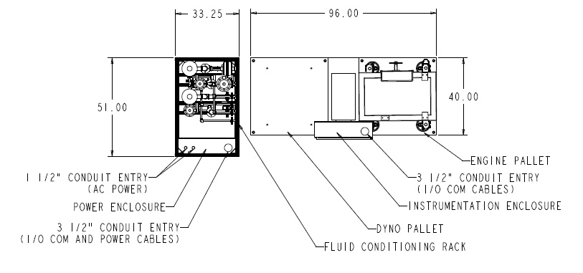
Figure 4 IVB Golden Stand Layout Top View

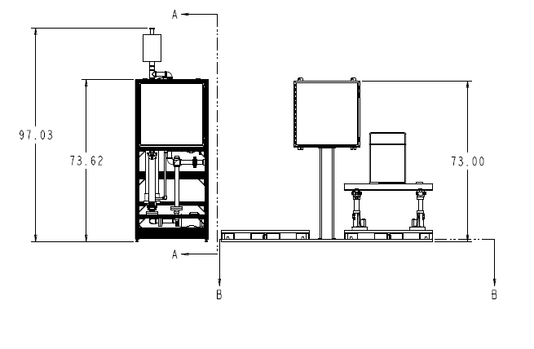
Figure 5 IVB Golden Stand Layout Side View

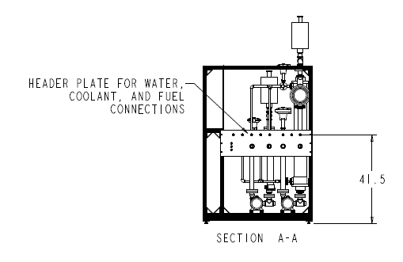
Figure 6 IVB Golden Stand Layout Fluid Connection Port Locations

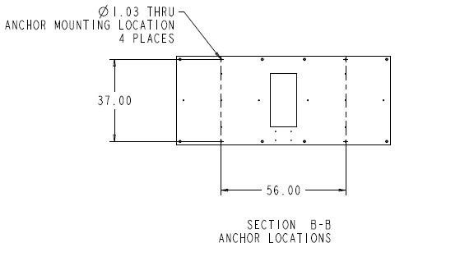
Figure 7 IVB Golden Stand Anchor Mounting Locations

Annex 2 – Computerized Data Acquisition and Control System

The laboratory provided data acquisition and control system shall meet the following requirements:
- Ability to log data at a minimum of 1 Hz continuously.
- 32 channels of A/D with resolution meeting the requirements listed in Table 3 A/D Resolution Requirements.

Table 3 A/D Resolution Requirements
Parameter | Units | Required  Resolution
Engine Speed | r/min | 1
Torque | N·m | 1
Air-to-Fuel Ratio | afr | 0.05
All Temperatures Except Exhaust | °C | 0.1
Exhaust Temperature | °C | 1
All Gauge Pressures | kPaG | 0.1
Barometer | KpaA | 0.1
Humidity | g/kg | 0.01

- 16 channels of D/A with a minimum of 16 bit resolution
- 16 Digital I/O channels control updates at a minimum of 200 kHz.
- Total system time response is the time required for the complete data acquisition system including all filtering, transducer lines, and surge tanks to measure a step change input for a given parameter. Determine system response times by measuring the time required to reach a certain percentage of an imposed step change. The data acquisition system shall meet the system time responses listed in Table 4 System Time Responses.

Table 4 System Time Responses
Parameter | System Time Response
Speed | 0.1 s
Torque | 0.6 s
Intake Air Pressure | 0.75 s
Exhaust Backpressure | 1.2 s
All Temperatures | 2.4 s

- A DyneSystems Non-Interlock 5 is provided as part of the IVB Golden Stand and is the only system permitted to be used for dynamometer excitation and engine throttle control. An operator pendent is required for calibration purposes and is included as part of the IVB Golden Stand.
- The IVB Golden Stand includes a normally open manually activated Emergency Stop button that is connected to a digital I/O channel and also connected across the Key/On line to the ECM. When the switch is engaged, ignition to the engine is immediately terminated and the digital I/O channel goes high to allow the test laboratory’s data acquisition and control system to sense the manual Emergency stop and take action.

Table 5 Golden Stand Provided I/O
I/O Type | Parameter | Source
AD | Dynamometer Speed | 60 tooth gear / magnetic pickup (0-10 kHz input)
AD | Dynamometer Torque | Load Cell 0-500 lbs
AD | Rocker Cover Gas Flow Rate | Sierra Slide Track 0 to 40 lpm (4-20ma Out)
AD | Ignition Voltage | 0 to 15 VDC
AD | Oil Gallery Pressure | 0 to 100 psig transducer (0 to 50 mV)
AD | Intake Manifold Pressure | 0 to 15 psig transducer (0 to 50 mV)
AD | Fuel Pressure | 0 to 100 psig transducer (0 to 50 mV)
AD | Exhaust Gas Pressure | 0 to 15 psig transducer (0 to 50 mV)
AD | Intake Air Pressure | 0 to 1 psig transducer (0 to 50 mV)
AD | Crankcase Gas Pressure | 0 to 1 psig transducer (0 to 50mV)
AD | Engine Coolant Pressure | 0 to 100 psig transducer (0 to 50 mV)
AD | Air Fuel Ratio | 0 to 20 afr (4-20 mA output)
AD | Fuel Flow Rate | 4-20 mA output
DA | Intake Air Pressure Control | 4-20 mA output to 0 to 15 I/P
DA | Coolant Outlet Temp. Control | 4-20 mA output to 0 to 15 I/P
DA | Exhaust Back Pressure Control | 4-20 mA output to 0 to 15 I/P
DA | Oil Gallery Temp. Control | 4-20 mA output to 0 to 15 I/P
DA | Engine Coolant Delta T Control | 4-20 mA output to 0 to 15 I/P
DA | Rocker Cover Cool. Temp Control | 4-20 mA output to 0 to 15 I/P
DA | Fuel Temp Control | 4-20 mA output to 0 to 15 I/P
DA | Torque Control | 4-20 mA output to 0 to 15 I/P
DA | Speed Control | 4-20 mA output to 0 to 15 I/P
DI | Emergency Stop | Digital Input
DI | Test Cell AC Power | Digital Input
DI | Dynamometer Coolant Flow Switch | Digital Input
DO | Ignition | Digital Output
DO | Engine Starter Motor | Digital Output
DO | Intake Air Temp Control | Digital Controller Output
DO | Engine Coolant Heater Control | Digital Controller Output
DO | Coolant Pumps | Digital Output
DO | Exhaust Cooling Fan Motor | Digital Output
DO | Load Cell Heater | Digital Controller Output
DO | Fuel Shutoff | Digital Output

Annex 3 – Thermocouples

Table 5 lists the thermocouples used for the IVB test. Following Table 5 are photographs of the thermocouples installed.

Table 5 Golden Stand Thermocouples
# | Description | Thermocouple Size | Depth (mm) | Depth Reference
1 | Engine Coolant In | E-Type 1/8” x 4” | 78 | Rear of Head
2 | Engine Coolant Out | E-Type 1/8” x 4” | 75 | Coolant Pipe
3 | Engine Oil Gallery | E-Type 1/8” x 4” | 92 | Engine Block
4 | Load Cell | E-Type 1/8” x 4” | 9 | Top of Swage Nut
5 | Intake Air | E-Type 1/8” x 4” | 60 | Adaptor Plate
6 | Test Cell | E-Type 1/8” x 2” | N/A | N/A
7 | Fuel | E-Type 1/8” x 4” | 98 | Center of Tee
8 | Oil Sump | E-Type 1/8” x 3” | 5 | Top of Swage Nut
9 | Rocker Cover Gas Out | E-Type 1/8” x 4” | 39 | Center of Tee
10 | Rocker Cover Coolant In | E-Type 1/8” x 4” | 100 | Center of Tee
11 | Rocker Cover Coolant Out | E-Type 1/8” x 4” | 100 | Center of Tee
12 | Exhaust Gas | E-Type 1/4” x 4” | 21 | Top of Swage Nut
13 | Dynamometer Coolant Out | E-Type 1/8” x 4” | 100 | Center of Tee
14 | Blow-by Gas | E-Type 1/8” x 4” | 100 | Center of Tee
15 | Blow-by Coolant Out | E-Type 1/8” x 3” | 2 | Top of Swage Nut

- Engine Coolant In
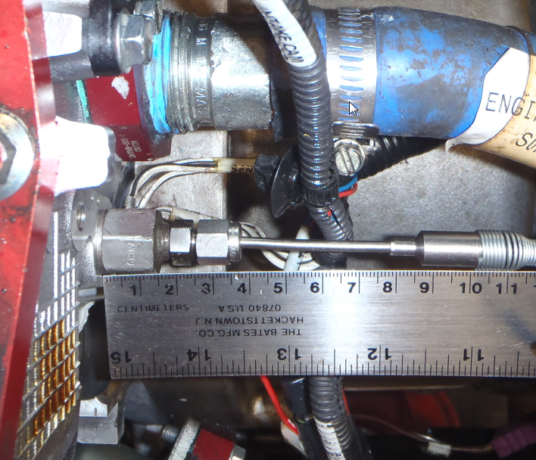

- Engine Coolant Out
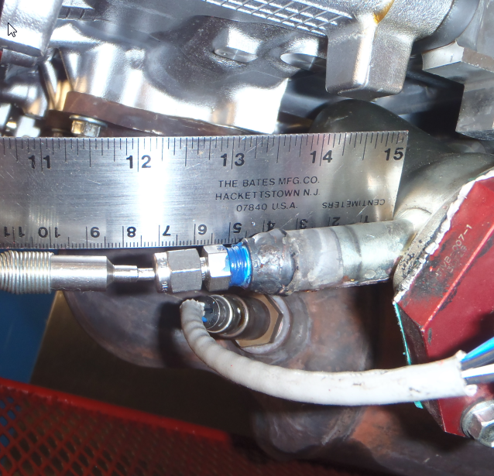

- Engine Oil Gallery

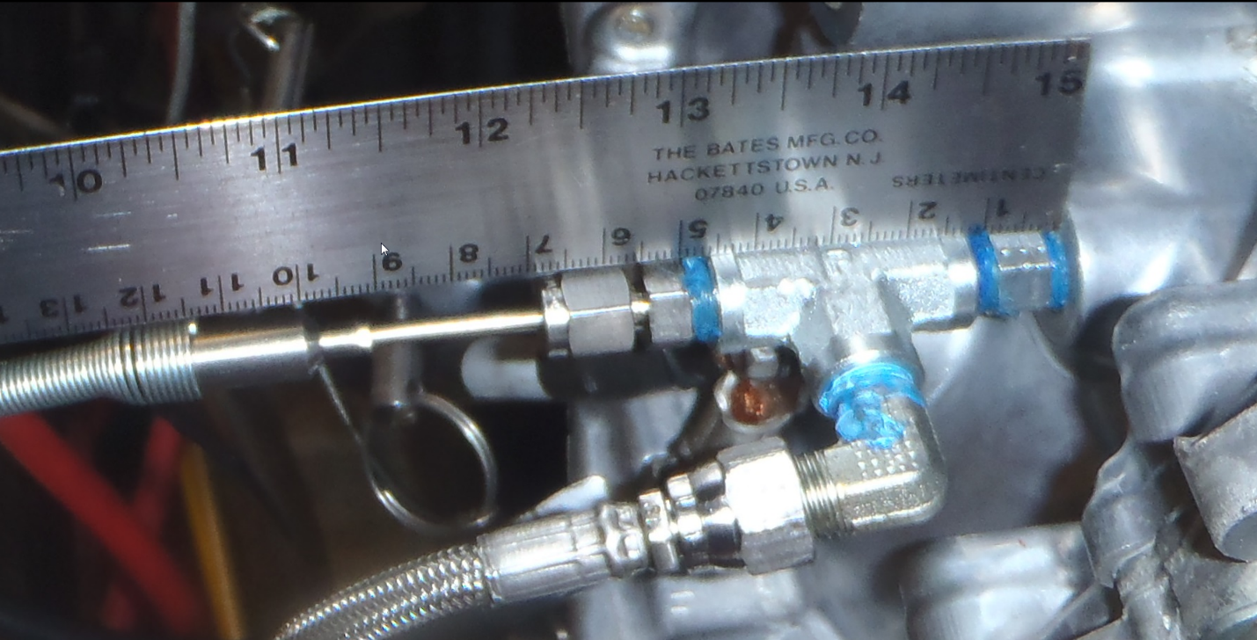

- Load Cell

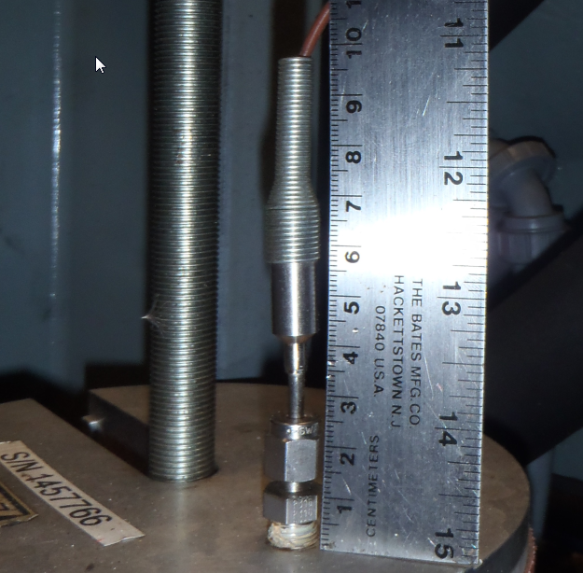

- Intake Air

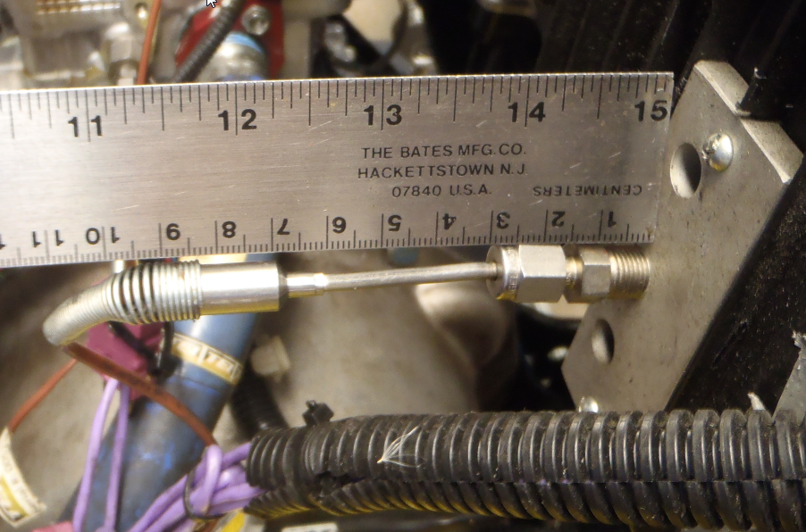

- Test Cell

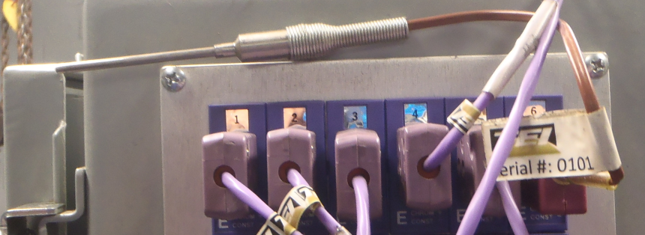

- Fuel

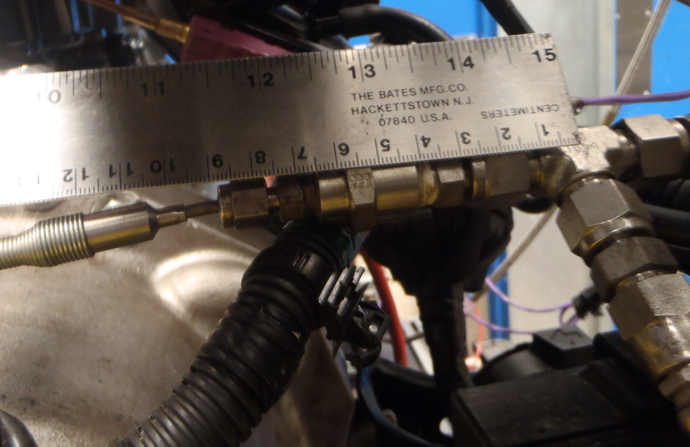

- Oil Sump

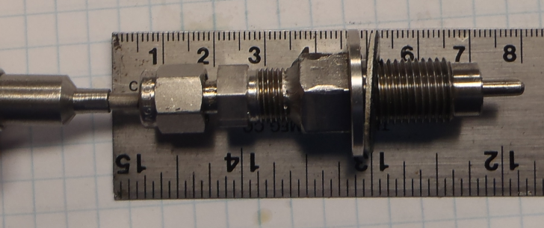

- Rocker Cover Gas Out
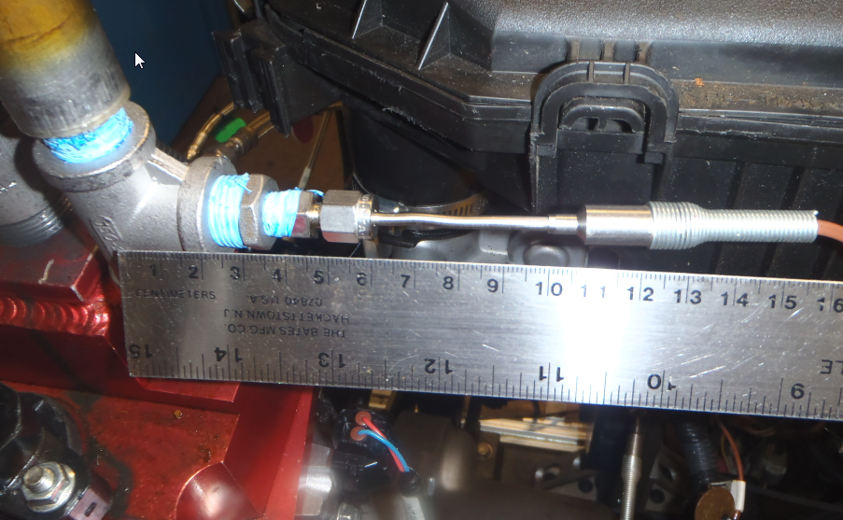

- Rocker Cover Coolant In

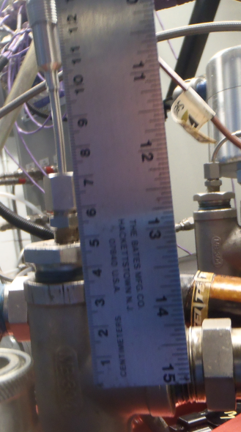

- Rocker Cover Coolant Out

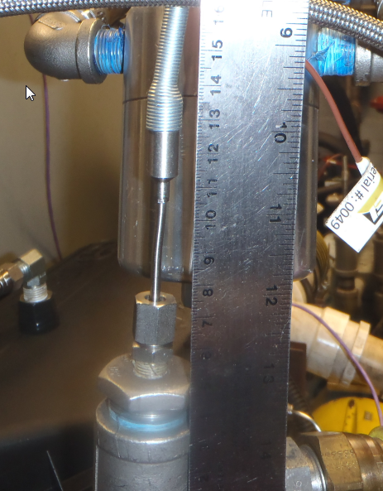

- Exhaust Gas

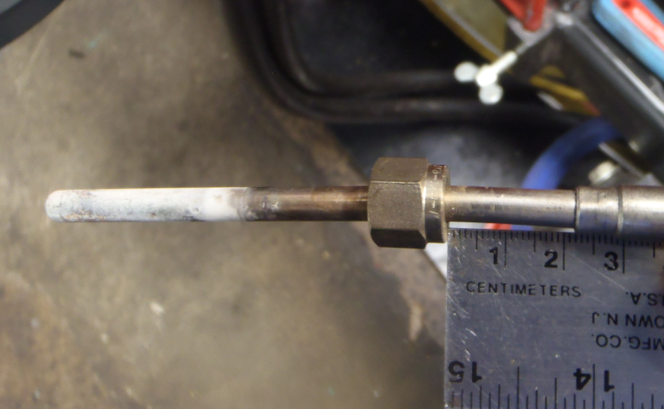

- Dynamometer Coolant Out

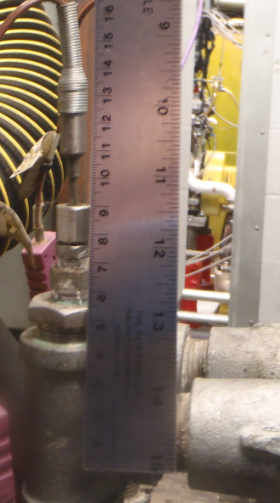

- Blow-by Gas
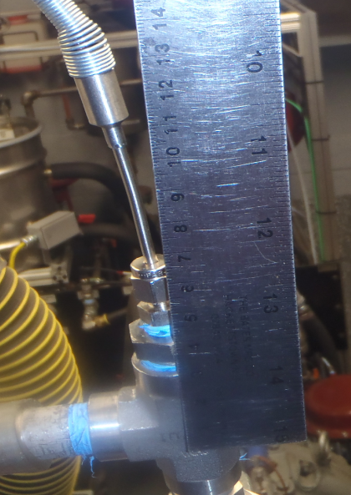

- Blow-by Coolant Out
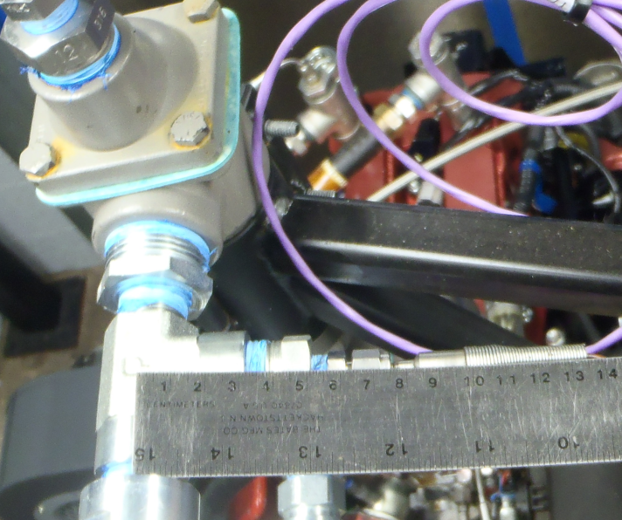

Data Acquisition and Control Automation II Task Force Report, 6/17/97, is available from the ASTM Test Monitoring Center (TMC), 6555 Penn Avenue, Pittsburgh, PA 15206-4489, Attention: Administrator.
The OEM supplier of Midwest 1014A dynamometers is DyneSystems, Inc., W209 N17391 Industrial Drive, Jackson, WI 53037 USA, 800-657-0726. Reconditioned Midwest 1014A dynamometers may be available from other sources.

