Standard Test Method for
Evaluation of Automotive Engine Oils in the Sequence IVB Spark-Ignition Engine

This standard is issued under the fixed designation D6891; the number immediately following the designation indicates the year of original adoption or, in the case of revision, the year of last revision. A number in parentheses indicates the year of last reapproval. A superscript epsilon (ε) indicates an editorial change since the last revision or reapproval.

INTRODUCTION
Portions of this test method are written for use by laboratories that make use of ASTM Test Monitoring Center (TMC)² services (see Annex A1).
The TMC provides reference oils and engineering and statistical services to laboratories that desire to produce test results that are statistically similar to those produced by laboratories previously calibrated by the TMC.
In general, the Test Purchaser decides if a calibrated test stand is to be used. Organizations such as the American Chemistry Council require that a laboratory utilize the TMC services as part of their test registration process. In addition, the American Petroleum Institute and the Gear Lubricant Review Committee of the Lubricant Review Institute (SAE International) require that a laboratory use the TMC services in seeking qualification of oils against their specifications.
The advantage of using the TMC services to calibrate test stands is that the test laboratory (and hence the Test Purchaser) has an assurance that the test stand was operating at the proper level of test severity. It should also be borne in mind that results obtained in a non-calibrated test stand may not be the same as those obtained in a test stand participating in the ASTM TMC services process.
Laboratories that choose not to use the TMC services may simply disregard these portions.

1. Scope

1.1 This test method measures the ability of crankcase oil to control valve-train wear for spark-ignition engines at low operating temperature conditions. This test method is designed to simulate extended engine cyclic vehicle operation. The Sequence IVB Test Method uses a Toyota 2NR-FE water cooled, 4 cycle, in-line cylinder, 1.5 liter engine. The primary result is bucket lifter wear. Secondary results include cam lobe nose wear and measurement of iron wear metal concentration in the used engine oil. Other determinations such as fuel dilution of the crankcase oil, non-ferrous wear metal concentrations, total fuel consumption, and total oil consumption, can be useful in the assessment of the validity of the test results.²
1.2 The values stated in SI units are to be regarded as standard. No other units of measurement are included in this standard.
1.2.1 Exceptions—Where there is no direct SI equivalent such as pipe fittings, tubing, NPT screw threads/diameters, or single source equipment specified.
1.3 This standard does not purport to address all of the safety concerns, if any, associated with its use. It is the responsibility of the user of this standard to establish appropriate safety and health practices and determine the applicability of regulatory limitations prior to use. See Annex AX for specific safety precautions.

2. Referenced Documents

2.1 ASTM Standards:
D235 Specification for Mineral Spirits (Petroleum Spirits) (Hydrocarbon Dry Cleaning Solvent)
D287 Test Method for API Gravity of Crude Petroleum and Petroleum Products (Hydrometer Method)
D323 Test Method for Vapor Pressure of Petroleum Products (Reid Method)
D381 Test Method for Gum Content in Fuels by Jet Evaporation
D445 Test Method for Kinematic Viscosity of Transparent and Opaque Liquids (and Calculation of Dynamic Viscosity)
D525 Test Method for Oxidation Stability of Gasoline (Induction Period Method)
D664 Test Method for Acid Number of Petroleum Products by Potentiometric Titration
D2622 Test Method for Sulfur in Petroleum Products by Wavelength Dispersive X-ray Fluorescence Spectrometry
D3525 Test Method for Gasoline Diluent in Used Gasoline Engine Oils by Gas Chromatography
D4739 Test Method for Base Number of Petroleum Products by Potentiometric Titration
D5185 Test Method for Multielement Determination of Used and Unused Lubricating Oils and Base Oils by Inductively Coupled Plasma Atomic Emission Spectrometry (ICP-AES)
E230 Specification and Temperature-Electromotive Force (EMF) Tables for Standardized Thermocouples
IR 5.8_6.1 Infrared Spectra Oxidation and Nitration Peak Area
2.6 GMNA Standards:
GM6277M Extended Life Automotive, Concentrate – Ethylene Glycol
2.7 Other Standards:
Sequence IVB Assembly Manual
Sequence IVB Keyence VR-3200 Procedure

3. Terminology

3.1 Definitions:
3.1.1 blowby, n—that portion of the combustion products and unburned air/fuel mixture that leaks past piston rings into the engine crankcase during operation.
3.1.2 calibration test stand, n—a test stand on which the testing of reference material(s), conducted as specified in the standard, provided acceptable results. Sub. B Glossary¹⁰
3.1.2.1 Discussion—In several automotive lubricant standard test methods, the ASTM Test Monitoring Center provides testing guidance and determines acceptability.
3.1.3 reference oil, n—an oil of known performance characteristics, used as a basis for comparison.
3.1.3.1 Discussion—Reference oils are used to calibrate testing facilities, to compare the performance of other oils, or to evaluate other materials (such as seals) that interact with oils.
3.2 Definitions of Terms Specific to This Standard:
3.2.1 break-in, n—initial engine operation to reach stabilization of the engine performance after new parts are installed in the engine.
3.2.2 lifter volume loss, n—the difference between the post-test and pre-test volume of a valve-train bucket lifter as measured by a Keyence VR-3000 or later model 3D macroscope.
3.2.5.1 Discussion—The pass fail criteria is the average intake lifter volume loss, the average volume loss of all intake 8 lifters. The average exhaust lifter volume loss is also calculated.
3.2.4 cam lobe wear, n—the difference between pre-test and post-test measurement of a cam lobe from heel to nose in µm.
3.2.5 golden stand, n—Sequence IVA test stand built in accordance with the ASTM DXXXX Sequence IVA test method by the approved supplier(s).
3.2.5 lifter area loss, n
3.2.5 flushing, n—the installation of a fresh charge of lubricant and oil filter for the purpose of running the engine to reduce and eliminate remnants of the previous oil charge.
3.2.5.1 Discussion—Flushing may be carried out in an iterated process to ensure a more thorough process of reducing previous oil remnants.
3.2.6 reference plane, n—The depth above which volume is calculated for Keyence volume measurements.
3.2.7 lifter crown, n—the maximum difference in height measured along to reference axis of the bucket lifters.
3.2.8 cam lobe failure, n—very severe wear of a lobe surface that makes it impossible to complete a test.
3.2.8.1 Discussion—tests that experience cam lobe failure are considered non-interpretable because the phenomenon does not have a repeatable relationship with test oil.
3.2.9 Degreasing Solvent—Mineral spirits meeting the requirements of Specification D235, Type II, Class C for Aromatic Content (0 to 2) vol %, Flash Point (61 °C, min) and Color (not darker than +25 on Saybolt Scale or 25 on Pt-Co Scale).
(Warning-Combustible. Health hazard.) A Certificate of Analysis is required for each batch of solvent.
3.2.10 Keyence VR Macrosscope–A wide area optical 3D measurement device produced by the Keyence Corporation used to generate volume loss wear results for Sequence IVB tests.

4. Summary of Test Method
4.1 Test Numbering Scheme—Use the test numbering scheme shown below:

AAAAA–BBBBB–CCCCC
AAAAA represents the stand number. BBBBB represents the number of tests since the last calibration test on that stand. CCCCC represents the total number of Sequence IVB tests conducted on that stand. For example, 6-10-175 represents the 175th Sequence IVB test conducted on test stand 6 and the tenth test since the last calibration test. Consecutively number all tests. Number the stand calibration tests beginning with zero for the BBBBB field. Multiple-length Sequence IVB tests are multiple runs for test numbering purposes, such as double-length tests which are counted as two runs and triple-length tests which are counted as three runs. For example, if test 1-3-28 is a doubled-length test, number the next test conducted on that stand 1-5-30.
4.2 Test Engine—This procedure uses a Toyota 2NR-FE water cooled, 4 cycle, in-line four cylinder, 1.5 liter engine as the test apparatus. The engine incorporates dual overhead camshafts, four valves per cylinder (2 intake; 2 exhaust), and a direct acting mechanical bucket lifter valve-train design. The critical test parts (camshafts, direct acting mechanical bucket lifters) are replaced prior to each test. A 95 min run-in schedule, followed by a 50 h aging schedule, for Silicon (Si) pacification, is conducted whenever the long block or cylinder head are replaced with new components.
4.3 Test Stand—The complete test stand is available from the Test Engineering Inc. Thermocouples are to be installed by individual test labs at the locations and depths shown in Annex A7. Mount the engine so that there is a 4.5° incline from the exhaust to the intake side and an angle of 0° from front to back. Control the intake air, provided to the engine air filter housing, for temperature, pressure, and humidity. Control the backpressure of the exhaust leaving the engine. Install the engine on a test stand equipped with computer control of engine speed, torque, various temperatures, pressures, flows, and other parameters outlined in the test procedure (see Section 11).
4.4 Test Sequence—After an engine run-in and aging schedule, or after the completion of a previous test, install new test camshafts and bucket lifters. Flush the external oil system with solvent and the oil pan with EF-411 using external pumps and connections. Perform four engine flushes, using fresh oil charges for each flush. After completing the fourth flush, drain and install the fresh test oil charge. Run the test for a total of 200 h, with no scheduled shutdowns. A single test cycle is composed of two 7-s steady-state stages separated by 8-s transitions. This test cycle (two steady-state stages and two transitions) is repeated 24,000 times.
4.5 Analyses Conducted—At the completion of the test, the camshaft lobes are measured for heel-to-toe wear and the bucket lifters are measured for volume loss and mass loss. Use these measurements to determine the summation, average, minimum and maximum wear for the intake and exhaust bucket lifters and the intake and exhaust camshaft lobes. Determine the oil consumption by calculating the difference between the mass of the used drain oil and the mass of the engine’s initial oil charge taking into account oil removed for intermediate oil samples. Analyze the end of test used oil for wear metals, fuel dilution, kinematic viscosity at 40°C, total acid number, total base number, oxidation and nitration by FTIR, and Karl Fischer water content. Retain a final drain sample of 1 L for a minimum of 90 days. Retain the camshafts and bucket lifters for a minimum of 6 months.

5. Significance and Use
5.1 This test method was developed to evaluate automotive lubricant’s effect on controlling camshaft lobe and bucket lifter wear for overhead camshaft engines with direct acting bucket lifters.

Note 1—This test method may be used for engine oil specifications such as ILSAC GF 6.

6. Apparatus

6.1 Test Engine—This test method uses a fired 2011 model Toyota 2NR-FE, in-line 4-cylinder, 16 valve, 4-cycle, water-cooled, port fuel-injected gasoline engine with a displacement of 1.496 L.¹¹ ^{,12} See Annex A6 for a parts lists. Nominal oil sump volume is 3 L. The cylinder block and cylinder head is aluminum. The engine features dual overhead camshafts and direct acting bucket lifters. The engine compression ratio is 10.5 to 1. The engine is rated to 132 N·m of torque at 3000 r/min. The ignition timing and multi-port fuel injection system is electronically controlled by a test-specific ECM.
6.1.1 Engine Buildup and Measurement Area—The ambient atmosphere of the engine buildup and measurement areas shall be reasonably free of contaminants and maintained at a uniform temperature. Maintain the specific humidity at a uniform level to prevent the accumulation of rust on engine parts. Use uniform temperatures and background luminous intensity to ensure repeatable dimensional measurements. Use a Keyence macroscope on a base-plate free of external vibrations.
6.1.2 Engine Operating Area—The laboratory ambient atmosphere shall be reasonably free of contaminants and general wind currents, especially if and when the valve-train parts are installed while the engine remains in the operating area. The temperature and humidity level of the operating area is not specified.
6.1.3 Parts Cleaning Area—This test method does not specify the ambient atmosphere of the parts cleaning area (Warning—Use adequate ventilation in areas while using solvents and cleansers).
6.2 External Engine Modifications—Modify the test engine for the valve-train wear test. Install the modified front cover and oil pan from the approved supplier. Install an oil filter adapter at the location of the stock oil filter housing, as shown in Assembly manual section 1. Install fittings for various temperature and pressure measurements as required by the test method. Replace the Toyota production valve cover with a specially manufactured aluminum jacketed valve cover (part# OHTIVB-002-1). Route the engine coolant through this jacket.
6.3 Test Stand and Laboratory Equipment—This engine-dynamometer test is designed for operation using computer control instrumentation and computer data acquisition. Provide an intake air system for the precise control of engine intake air humidity, temperature, and cleanliness.
6.3.1 Computer Data Acquisition System—The procedure shown in 6.3.1.1 – 6.3.1.3 details the test stand log operational data with a computer data acquisition system using sensor configurations, and is in compliance with Data Acquisition and Control Automation II. Consider a test that has greater than 2 h without data acquisition on any controlled parameter to be operationally invalid.
6.3.1.1 Frequency of Logged Data—Log data at 1 Hz during all 4 stages of all test cycles.
6.3.1.2 Resolution of Logged Data—The laboratory provided data acquisition system must provide 32 analog to digital channels that meet the resolution requirements in Table 1.
6.3.1.3 System Time Response for Logged Data—Do not exceed the controlled operational parameters for system time response for measurement shown in Table 2. The system time response includes the total system of sensor, transducer, analog signal attenuation, and computer digital filtering. Use single-pole type filters for attenuation.

TABLE 1 Data Acquisition Resolution Requirements
Parameter | Units | Required Resolution
Engine Speed | r/min | 1
Torque | N-m | 1
Air-to-Fuel Ratio | afr | 0.05
All Temperatures Except Exhaust | °C | 0.1
Exhaust Temperature | °C | 1
All Gauge Pressures | kPaG | 0.1
Barometer | KpaA | 0.1
Humidity | g/kg | 0.01

TABLE 2 System Time Response
Parameters | Time Response, max  (one time constant)
Temperatures | 2.8 s
Pressures | 1.7 s
Coolant Flow | 2.5 s
Torque | 2.0 s
Speed | 1.8 s

6.3.1.4 Quality Index—The Quality Index (QI) is an overall statistical measure of the variation from test targets of the steady-state operational controlled parameters. The Sequence IVA Surveillance Panel has chosen the QI upper and lower control limits, shown in Table 3.

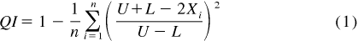

where:
X_{i} | = | values of the parameter measured,
U | = | allowable upper limit of X,
L | = | allowable lower limit of X, and
n | = | number of data points used to calculate QI.

TABLE 3 QI Control Limits
Parameter | U | L
Intake Air Humidity | 12.00 | 11.00
Engine Coolant Out Temperature | 53.5 | 50.5
Exhaust Backpressure * | 107.50 | 101.50
Fuel Rail Temperature | 24.50 | 23.50
Intake Air Pressure | 0.50 | 0.00
Intake Air Temperature | 32.75 | 31.25
Oil Gallery Temperature | 58.00 | 50.00
RAC Coolant Out Temperature | 20.75 | 19.25
Torque | 26.50 | 23.50
Engine Coolant Flow Rate | 80.40 | 79.60
RAC Coolant Flow Rate | 120.75 | 119.25
Blow-by Gas Temperature | 29.50 | 28.50
Load Cell Temperature | 49.00 | 41.00
Engine Coolant Pressure | 80.00 | 60.00
Fuel Rail Pressure | 345.00 | 325.00

Where missing data or Bad Quality Data (BQD), or both, are encountered, calculate the adjusted Quality Index (QI_{ADJ}) using the following equation:

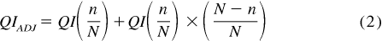

where:
Q | = | QI calculated without missing/BQD,
I | = | points,
n | = | number of data points used to calculate QI, and
N | = | number of data points for a complete data set.

If the QI calculation of a controlled parameter is less than zero, investigate the reason, assess its impact on test operational validity, and document such finding in the final test report. For calibration tests, review the operational validity assessment with the TMC. Annex A2 describes calibration procedures using the TMC reference oil, including their storage and conditions of use, the conducting of tests and the reporting of results.
6.3.2 Test Stand Configuration—Mount the engine on the test stand similar to its vehicle orientation (0° in front; sideways 4.5° up on intake manifold side). This orientation is important to the return flow of oil in the cylinder head, and ensures reproducible oil levels. Directly couple the engine flywheel to the Midwest MW1014A dynamometer through the approved driveshaft.
6.3.3 Dynamometer Excitation and Throttle Control—A DyneSystems Non-Interlock 5 which is provided as part of the golden stand assembly is the only system permitted to be used for dynamometer excitation and throttle control.
6.3.4 Intake-air Supply System—The intake air supply system shall be capable of delivering at least 1000 L/min (2000 L/min preferred) of conditioned and filtered air to the test engine during the 200 h test, while maintaining the intake-air parameters detailed in Table A.2.
6.3.4.1 Induction Air Humidity—Measure the intake air specific humidity in the main system duct or at the test stand. If using a main system duct dew point temperature reading to calculate the specific humidity, verify the dew point periodically at the test stand. Maintain the duct surface temperature above the dew point temperature at all points downstream of the humidity measurement point to prevent condensation and loss of humidity level.
6.3.4.2 Intake Air Filtering—Use the production intake air cleaner assembly with filter, at the engine. Use a snorkel adapter of that fits over the intake air box inlet to connect the controlled air duct to the air cleaner. Ensure that the top of the air cleaner assembly has been modified for installation of the intake pressure sensor line. Refer to 6.3.4.5 for installation position
6.3.4.3 Intake Air Flow—Do not measure for intake airflow.
6.3.4.4 Intake Air Temperature—For final control of the inlet air temperature, install an electric air heater strip within the air supply duct. The duct material and heater elements design shall not generate corrosion debris that could be ingested by the engine.
6.3.4.5 Intake Air Supply Pressure—Locate the pressure sensing tube on the top cover of the air cleaner 190 mm ± 10 mm from the front (straight edge of the top surface) and 65 mm ± 10 mm from the left (viewed from the front of the box). The tube should have a depth of 25 mm ± 4 mm into the air cleaner.
6.3.5 Fuel Supply System—This test method requires approximately 750 L of unleaded Haltermann KA24E Green test fuel per test (24000 cycles). Use a Motorcraft E7T2-9C407-BA fuel pump. The fuel conditioning system is part of the golden stand supplied by Test Engineering Inc.

7. Reagents and Materials

Note 6—Use 12 L and 2600 g and of the non-reference test oil sample to perform the 200 h Valve-train Wear test.
7.1 Coolant for Engine and Rocker Arm Cover— The engine coolant shall have been GM6277M approved (Dexcool (trademark)) mixed 30/70 with demineralized or distilled water.
7.2 Fuel—Use Haltermann KA24E Green test fuel for this test method as shown in Annex AX. (Warning—Flammable. Health hazard.) It is dyed green to preclude unintentional contamination with other test fuels. Use approximately 750 L of fuel for each test (24000 cycles). This fuel has a hydrogen-to-carbon ratio of 1.80 to 1.
7.2.1 Fuel Approval Requirements—The fuel is blended to a sulfur content of 130 ± 10 ppm and the fuel supplier supplier’s requirements. Base the fuel batch acceptance upon the physical and chemical specifications given in Annex AX . Engine validation tests are not necessary for fuel batch acceptance.
7.2.2 Fuel Analysis—Monitor the test fuel using good laboratory practices. Analyze each fuel shipment to determine the value of each parameter for fuel sulfur as described in Test Method D2622, existent gum as described in Test Method D381, RVP as described in Test Method D323, and API Gravity as described in Test Method D287. Compare the results to the original values supplied by the fuel supplier. The analytical results shall be within the tolerances shown in parentheses beside each parameter. This provides a method to determine if the fuel batch is contaminated or has aged prematurely. If any analytical result falls outside the tolerances, the laboratory shall contact the fuel supplier for problem resolution.
7.2.2.1 Fuel Deterioration—Analyze the fuel semiannually to ensure the fuel has not deteriorated excessively or been contaminated in storage.
7.2.2.2 Analyze the fuels using Test Methods D2622, D287, D323, D381, and D525.
7.2.3 Fuel Shipment and Storage—Ship the fuel in containers with the minimum allowable venting as dictated by all safety and environmental regulations, especially when shipment times are anticipated to be longer than one week. Store the fuel in accordance with all applicable safety and environmental regulations. If the run tank has more than one batch of fuel, document the most recent batch in the test report.
7.3 Lubricating Oils:
7.3.1 Break-in Lubricating Oil—An engine break-in procedure (see 11.1.3) is immediately conducted following the replacement of new, major engine components (that is, engine short-block, or cylinder head, or both). Use the proper reference oil, REO 1006-2, from the TMC for the break-in procedure. Use 3 L of this reference oil for each break-in procedure.
7.3.3 Short-block Assembly Lubricant—For engine short-block inspection and reassemble, use EF-411 oil as the assembly lubricant.
7.4 Miscellaneous Materials:
7.4.1 Solvents and Cleansers—No substitutions for 7.4.1.1 – 7.4.1.3 are allowed. Use adequate safety provisions with all solvents and cleaners.
7.4.1.1 Degreasing Solvent—Use only mineral spirits meeting the requirements of Specification D235, Type II, Class C for Aromatic Content ((0 to 2) vol %), Flash Point (61 °C, min) and Color (not darker than +25 on Saybolt Scale or 25 on Pt-Co Scale). (Warning—Combustible. Health hazard.) Obtain a Certificate of Analysis for each batch of solvent from the supplier.
7.4.1.2 Pentane—(Warning—Flammable. Health hazard.) Available from petroleum solvent suppliers.
7.4.1.3 Cylinder Block and RAC Cleaning Detergent—Tri-sodium phosphate and any commercial coolant cleanser. (Warning— Caustic. Health hazard.)
7.4.2 Sealing Compounds—Use a silicone based gasketing compound during engine assembly (for example, oil pan). Use only the silicone gasket shown in Annex AX .

8. Oil Blend Sampling Requirements

8.1 Sample Selection and Inspection—The non-reference oil sample shall be uncontaminated and representative of the lubricant formulation being evaluated.
Note 7—If the test is registered using the American Chemistry Council²⁵ protocols, the assigned oil container formulation number shall match the registration form.
8.2 Non-reference Oil Sample Quantity—Use a minimum of 15 L of new oil to complete the Sequence IVB test, including the oil flushes. Normally the supplier provides a 19 L new oil sample to allow for inadvertent losses.
8.3 Reference Oil Sample Quantity—The TMC provides a 19 L reference oil sample for each stand calibration test.

10. Data Acquisition, Reference Oil Application, and Equipment Calibration and Maintenance

10.1 Data Acquisition:
10.1.1 Computer Data Acquisition—The test stand should log operational data using a computer data acquisition system with sensor configurations process is described in 10.1.2 – 10.1.4.
10.1.2 Frequency of Logged Test Cycle Data—Log the test cycle data at a sampling rate of 1-Hz.
10.1.3 Signal Conditioning—Do not exceed the controlled operational parameters for system time response as shown in Table 1. The system time response includes the total system of sensor, transducer, analog signal attenuation, and computer digital filtering. Use single-pole type filters for attenuation. For temperature sensors only grounded thermocouples are acceptable.
10.1.3.1 Isolated Inputs—Use signal-conditioning modules to provide isolated inputs to the digital computer.
10.2 Reference Oil Application:
Note 9—10.2.6 and 10.2.7 and Annex A1 - 4 describe the involvement of the TMC in respect to calibration procedures and acceptance criteria for a testing laboratory and a test stand, and the issuance of Information Letters and memoranda affecting the test method.
10.2.1 Testing of Reference Oils—Periodically conduct tests on reference oils according to the following:
10.2.1.1 Conduct reference oil tests on each calibrated test stand within a laboratory according to TMC guidelines.
10.2.1.2 Obtain reference oils directly from the TMC. These oils are formulated or selected to represent specific chemical types or performance levels, or both. They are usually supplied directly to a testing laboratory under code numbers to ensure that the laboratory is not influenced by prior knowledge of acceptable results in assessing the test results. The TMC determines which specific reference oil the laboratory shall test.
10.2.1.3 Unless specifically authorized by the TMC, do not analyze reference oils, either physically or chemically. Identification of reference oils by such analyses could undermine the confidentiality required to operate an effective reference oil system. Therefore, reference oils are supplied with the explicit understanding that they will not be subjected to analyses other than those specified in this procedure, unless specifically authorized by the TMC. If so authorized, prepare a written statement of the circumstances involved, the name of the person authorizing the analysis, and the data obtained; furnish copies of this statement to the TMC.
10.2.2 Reference Oil Test Frequency—Conduct reference oil tests according to the following frequency requirements:
10.2.2.1 For a given, calibrated test stand, conduct an acceptable reference oil test after no more than XX test starts have been conducted, or after TBD have elapsed, whichever occurs first.
10.2.2.2 After starting a laboratory reference oil test, non-reference oil tests may be started on any other calibrated test stand.
10.2.2.3 Reference oil test frequency may be adjusted due to the following reasons:
10.2.3 Procedural Deviations—On occasions when a laboratory becomes aware of a significant deviation from the test method, such as might arise during an in-house review or a TMC inspection, the laboratory and the TMC shall agree on an appropriate course of action to remedy the deviation. This action may include the shortening of existing reference oil calibration periods.
10.2.4 Parts and Fuel Shortages—Under special circumstances, such as industry-wide parts or fuel shortages, the Surveillance Panel may direct the TMC to extend the time intervals between reference oil tests. These extensions shall not exceed one regular calibration period.
10.2.5 Reference Oil Test Data Flow—To ensure continuous severity and precision monitoring, calibration tests are conducted periodically throughout the year. There may be occasions when laboratories conduct a large portion of calibration tests in a short period of time. This could result in an unacceptably large time frame when very few calibration tests are conducted. The TMC can shorten or extend calibration periods as needed to provide a consistent flow of reference oil test data. Adjustments to calibration periods are made such that laboratories incur no net loss (or gain) in calibration status.
10.2.6 Special Use of the Reference Oil Calibration System—The Surveillance Panel has the option to use the reference oil system to evaluate changes that have potential impact on test severity and precision. This option is only taken when a program of donated tests is not feasible. The Surveillance Panel and the TMC shall develop a detailed plan for the test program. This plan requires all reference oil tests in the program to be completed as close to the same time as possible, so that no laboratory/stand calibration is left in an excessively long pending status. In order to maintain the integrity of the reference oil monitoring system, each reference oil test is conducted so as to be interpretable for stand calibration. To facilitate the required test scheduling, the Surveillance Panel may direct the TMC to lengthen and shorten reference oil calibration periods within laboratories such that the laboratories incur no net loss (or gain) in calibration status.
10.2.7 Donated Reference Oil Test Programs—The Surveillance Panel is charged with maintaining effective reference oil test severity and precision monitoring. During times of new parts introductions, new or re-blended reference oil additions, and procedural revisions, it may be necessary to evaluate the possible effects on severity and precision levels. The Surveillance Panel may choose to conduct a program of donated reference oil tests in those laboratories participating in the monitoring system, in order to quantify the effect of a particular change on severity and precision. Typically, the Surveillance Panel requests its panel members to volunteer enough reference oil test results to create a robust data set. Broad laboratory participation is needed to provide a representative sampling of the industry. To ensure the quality of the data obtained, donated tests are conducted on calibrated test stands. The Surveillance Panel shall arrange an appropriate number of donated tests and ensure completion of the test program in a timely manner.
10.2.8 Reporting of Reference Oil Test Results—Report the results of all reference oil tests to the TMC according to the following directives:
10.2.8.1 Transmit results to the TMC within five days of test completion by way of electronic data transfer protocol as outlined in the Data Communication Committee, Electronic Test Report Transmission Model (ETRTM). The ETRTM can be obtained from the TMC.
10.2.8.2 If the test was conducted during a time extension permitted by the TMC, so indicate in the Comments section of the test report.
10.2.8.3 For an acceptable reference oil test, conducted following an unacceptable reference oil test, provide sufficient information in the Comments section of the test report to indicate how the problem was identified and corrected, insofar as possible, and how it was related to non-reference oil tests conducted during the period of time that the problem was being solved.
10.2.9 Evaluation of Reference Oil Test Results—The TMC evaluates the reference-oil test results for both operational validity and statistical acceptability. The TMC may consult with the test laboratory in case of difficulty, as follows:
10.2.9.1 Immediately upon receipt of the reference-oil test results from the test laboratory, the TMC evaluates the laboratories decision on operational validity. For operationally valid tests, the TMC then evaluates the pass/fail parameters according to the Sequence IVB Lubricant Test Monitoring System (TBD). If the test is judged acceptable, the reference oil code is disclosed by the TMC to the test laboratory. The TMC conveys to the test laboratory its preliminary findings based on the limited information available to them.
10.2.9.2 Subsequently, upon receipt of the information detailed in XX the TMC reviews all reference-oil test results and reports to determine final test acceptability.
10.2.9.3 In the event the reference oil test is unacceptable, the test laboratory shall provide an explanation of the problem relating to the failure. If the problem is not obvious, all test-related equipment shall be re-checked. Following this re-check, the TMC assigns another reference oil for testing by the laboratory.
10.2.9.4 The TMC decides, with consultation as needed with industry experts (testing laboratories, members of the ASTM Technical Guidance Committee and of the Surveillance Panel, and so forth), whether the reason for any failure of a reference oil test is a false alarm, testing stand, testing laboratory, or industry-related problem. The Sequence IVB Surveillance Panel shall adjudicate all industry problems.
10.2.10 Status of Non-Reference Oil Tests Relative to Reference Oil Tests—Non-reference oil tests may proceed within a given laboratory during reference oil testing based upon the following:
10.2.10.1 During the time of conducting a reference oil test on one test stand, non-reference oil tests may be conducted on other previously calibrated stands. If the reference oil test is acceptable to the TMC, the non-reference oil tests shall be considered to have been run in a satisfactorily calibrated laboratory.
10.2.10.2 If a reference oil test is unacceptable, and it is determined that the problem is isolated to an individual test stand, consider other test stands to remain calibrated, and testing of non-reference oils may proceed on those other stands.
10.2.10.3 If a reference oil test is unacceptable, and it is determined that the problem is laboratory related, non-reference tests running during the problem period shall be considered invalid unless there is specific evidence to the contrary for each test.
10.2.11 Status of Test Stands Used for Non-Standard Tests—If a non-standard test is conducted on a previously calibrated test stand, conduct a reference oil test on that stand to demonstrate that it continues to be calibrated, prior to running standard tests.
10.3 Equipment Calibration:
10.3.1 Instrumentation Calibration—Perform a thorough recalibration adjustment of all instrumentation and transducers, including computer channels, according to the requirements that follow. Perform additional calibration checks whenever operational data indicates an abnormality. Standards used for instrumentation calibration shall be traceable to that country’s specific national standards organization. The accuracy of the standard shall be a minimum of four times better than the accuracy of the test stand instrumentation.
10.3.2 Dynamometer Torque Measurement—Scale the final readout of engine torque (N·m). Calibrate the force measurement and readout system with deadweights. Coolant flow through the dynamometer, reaction forces due to coolant plumbing, and brinnelled trunnion bearings of the dynamometer may affect calibration by temperature excursions of the dynamometer electronic force transducer. When calibrating, ensure the dynamometer coolant flow indicator is in the green (Refer to Figure 10 in Section E) and that the load cell temperature has been stabilized at 45°C ± 1°C for a minimum of one hour. The torque measurement accuracy shall be ± 0.2 N·m. Perform this calibration prior to every test start.
10.3.3 Instrument Calibration—Document all instrument calibrations. Retain all calibration documentation for a minimum of 3 years.
10.3.3 Upon initial stand installation and every 12 months thereafter perform a full instrumentation calibration according to
TABLE 4 Parameters to be Calibrated Every 6 Months
Items
Temperatures
Intake Air Temperature, °C
Engine Oil Gallery Temperature, °C
Engine Oil Sump Temperature, °C
Coolant Temperature Into Engine, °C
Coolant Temperature Out of Engine, °C
Fuel Rail Temperature, °C
Exhaust Gas Temperature, °C
Valve Cover Coolant In Temperature, °C
Valve Cover Coolant Out Temperature, °C
Test Cell Air Temperature, °C
Blow-by Gas Temperature, °C
Blow-by Coolant Temperature, °C
Pressures
Crankcase Gas Pressure, kPa
Oil Gallery Pressure, kPa
Fuel Rail Pressure, kPa
Exhaust Pressure, kPa (absolute)
Intake Air Pressure, kPa
Intake Manifold Pressure, kPa (absolute)
Barometric Pressure, kPa (absolute)
Flows
Air Fuel Ratio, afr
Blowby Flow Rate, sl/min
Fuel Flow Rate, kg/h
Engine Coolant Flow Rate, L/min
Valve Cover Coolant Flow Rate, L/min
General
Intake Air Humidity, grains/kg
Engine Speed, r/min
Engine Torque (N-m)

10.3.4 Humidity of Induction Air Calibration:
10.3.4.1 Calibrate the primary laboratory measurement system at each test stand every 6 months using a hygrometer with a minimum dew point accuracy of ± 0.55 °C at 16 °C. Locate the sample tap on the air supply line to the engine, between the main duct and 1000 mm upstream of the intake air cleaner. The calibration consists of a series of paired humidity measurements comparing the laboratory system with the calibration hygrometer. The comparison period lasts from 20 min to 2 h with measurements taken at intervals of (1 to 6) min, for a total of 20 paired measurements. The measurement interval shall be appropriate for the time constant of the humidity measurement instruments.
10.3.4.2 Verify that the flow rate is within the equipment manufacturer’s specification and that the sample lines are non-hygroscopic. Correct dew point hygrometer measurements to standard conditions (101.12 kPa) using the appropriate equation. Compute the difference between each pair of readings and calculate the mean and standard deviation of the twenty-paired readings. The absolute value of the mean difference shall not exceed 1.43 g/kg, and the standard deviation shall not be greater than 0.714 g/kg. If these conditions are not met, investigate the cause, make repairs, and recalibrate. Maintain calibration records for 2 years.
10.3.5 Profilometer Calibration—Follow the manufacturer’s instruction for calibration and verification checks of the profilometer. Calibrate the profilometer at least annually.
10.3.6 Keyence Measurement Device —Confirm the calibration of the Keyence measurement device at least once every 6 months.

11. Procedure

NOTE 11—When installing a new engine and cylinder head or both, conduct a break-in procedure, see 11.1.4, before running official 200 h tests. After completing the break-in, install the official test valve-train parts as shown in the Sequence IVB Assembly Manual. Then conduct and external system flush, an oil pan flush, and four fired oil-flushes as shown in 11.2.1. After performing the four fired oil-flushes, conduct the 200 h test as shown in 11.2.2.
11.1 Pre-test Procedure:
11.1.1 Pre-test stand cleaning—Clean all pressure traps and the external oil system prior to starting all tests.
11.1.1.1 Remove, spray clean with degreasing solvent, and air dry the exhaust backpressure and crankcase pressure filters. Re-install the filters using new O-rings (part XX).
11.1.1.2 Disconnect the external oil supply and oil return lines from the remote oil filter housing adapter that is mounted on the engine (refer to figure 1).

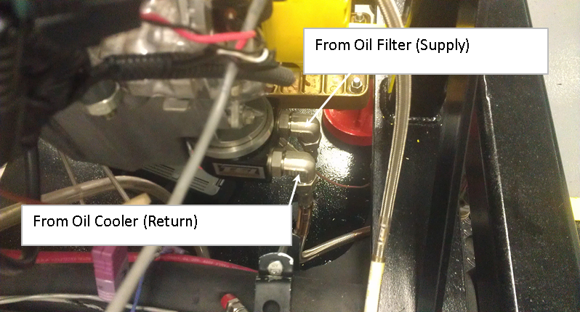
Figure Error! No text of specified style in document..1 Remote Oil Filter Housing Adapter
11.1.1.2 Connect the external oil supply and external oil return lines to a portable oil cleaning flush cart of minimum 1 gallon capacity that is equipped with a circulation pump with a flow capacity of at least 1 gpm. Charge the flush cart with solvent and energize the flush cart pump. Allow the solvent to circulate for one hour.
11.1.1.3 After solvent has circulated for at least one hour, de-energize the flush cart pump and open both heat exchanger drain valves and allow the external oil system to drain.
11.1.1.4 Disconnect the external oil supply and external oil return lines from the flush cart and connect the external oil system to a clean and dry compressed air supply at 15 to 30 psi. Allow the air to flow through the system for at least 15 minutes to dry the system.
11.1.1.5 Disconnect the supply and return lines from the compressed air source and connect the external oil supply and external return lines back to the remote oil filter housing adapter that is mounted on the engine. Close the heat exchanger drain valves.
11.1.1.6 Remove the Oberg oil filter element for cleaning. Clear any debris retained in the Oberg oil filter element with degreasing solvent and air dry. Re-install the Oberg oil filter element in the Oberg filter housing and secure the four retaining bolts.
11.1.1.7 Disconnect the oil pressure sense line between the engine and oil sample valve. Rinse this line using clean degreasing solvent and air dry.
11.1.1.8 Disconnect the oil pressure sense line between the oil sample valve and the oil pressure transducer. Rinse this line using clean degreasing solvent and air dry.
11.1.1.9 Open the oil sample valve and allow any trapped oil to drain. Then close the valve and reconnect both oil pressure/sample lines to their respective locations.
11.1.2 Oil pan flush—Flush the oil pan with EF-411 oil supplied by an external pump prior to all tests.
11.1.2.1 Pour 1 gallon of new EF-411 into a clean oil flush apparatus.
11.1.2.2 The apparatus must include a pump with at least 1 pm of flow, an oil filter, and if pipe fitting are used, they must be black or stainless. A NAPA 1-8429 oil filter adapter, and unused Motorcraft FL 1A oil filter, and GP-201-12L pump are suggested.
11.1.2.3 Connect the apparatus supply to the #8 AN fitting on the side of the modified Sequence IVB oil pan and the return to the rear oil pan drain plug.
11.1.2.4 Run the pump and circulate the EF-411through the oil pan for 10 minutes.
11.1.2.5 Turn off the pump, remove the apparatus, and allow the EF-411 to drain for 5 minutes.
11.1.2.6 Re-install a stainless steel cap on the #8 fitting on the side of the oil pain and re-install the oil pan drain plug.
11.1.3 Blow-by system cleaning—Clean out the blow-by heat exchanger and oil separator before every test.
11.1.3.1 Remove the blow-by heat exchanger and oil separator from the test stand and disassemble the separator.
11.1.3.2 Spray clean the inside of separator and gas side of the heat exchanger with degreasing solvent and air dry.
11.1.3.3 Remove all the short tygon hose sections between the valve cover and external blow-by system heat exchanger and replace them.
11.1.3.4 Reconnect the external blow-by system to the valve cover and blow-by gas filter.
11.1.4 Engine coolant fill procedure—Charge the engine coolant, valve cover coolant, and blow-by heat exchanger coolant tanks with coolant prior to the start of all tests.
11.1.4.1 Pressurize the coolant system to 70 kPa ± 10 kPa.
11.1.5 Dynamometer load cell calibration—Calibrate the load cell in accordance with the specifications in Table 5 below. Dyne Systems part #

TABLE 5 Dynamometer Load Cell Calibration Reference
Calibration Point | Reference Calibration Target Mass, kg | Resulting Reference Torque, N-m | Maximum Error
Zero | 2.535 | 9.94 | 0.5%
Mid-rage | 7.130 | 27.97 | 0.5%
Span | 11.335 | 44.47 | 0.5%

11.1.6 Engine break-in procedure—Conduct the break-in procedure prior to lubricant evaluation testing when installing a new engine block or new cylinder head assembly on a test stand. The break-in allows for monitoring test stand performance and pacification of silicone sealant on the cylinder head, front cover, and oil pan. Use the engine block assembly for XX tests and the head for XX tests. Follow the break in conditions in Table A.1. Use the following break-in steps:
11.1.6.1 Install break-in parts according to Assembly Manual Section 2. Install a stock unmodified Toyota intake camshaft, stock valve springs, and unmeasured bucket lifters for break-in.
11.1.6.2 Install the stock black plastic valve train cover and stock crankcase ventilation setup.
11.1.6.3 Connect the PCV valve in the valve cover to the intake manifold with the stock 19 mm ventilation hose.
11.1.6.4 Connect the valve cover port to the intake air filter housing port with a 15 mm diameter Tygon hose.
11.1.6.5 Connect the braided stainless steel hose from the crankcase pressure transducer to the quick disconnect on the modified oil fill cap.
11.1.6.6 Perform all pre-test procedures, sections 11.1.1 to 11.1.3.
11.1.6.7 Fill the engine with 3.0 L of ASTM REO 1006-2 as break-in oil.
11.1.6.8 Start the engine and begin the break-in schedule provided in Table A.1. Engine load should be achieved within the first 45 s of a step and speed should be achieved within the first 60 s.
11.1.6.9 Control the parameters specified in Table 6 below to constant set-points over the entire course of the break-in procedure.

TABLE 6 Break-in Constant Set-points
Parameter | Set-point
Fuel rail temperature, °C | 24 ± 3
Coolant flow rate, L/min | 80 ± 1
Exhaust backpressure. kPaA | 103.5 ± 1.0
Intake air pressure, kPaA | 0.25 ± 0.3
Intake air temperature, °C | 32 ± 2
Load cell temperature, °C | 45 ± 2

11.1.6.10 Record the values of all the controlled parameters listed in Table 6 and Table A.1 during break-in steps 5 and 8.
11.1.6.11 Following the completion of engine break-in step 8, establish the oil sampling conditions listed in Table 7.

TABLE 7 Oil Sampling Conditions
Engine Speed, rpm | Engine Load, Nm | Gallery Oil Temperature, °C | Coolant Out Temperature, °C
1000 | 10.0 | 50 | 52

11.1.6.12 Once the conditions have been reached, take a 240 ml purge sample followed by a 30 ml oil sample and return the 240 ml purge sample to the oil fill cap.
11.1.6.13 Turn off the engine and allow to rest for 10 minutes prior to checking the oil level with the OHT IVB dipstick (part # IVB022-3) that is located on the valve cover. The intake air hose should always be disconnected when checking the oil level.
11.1.6.14 After checking the oil level, restart the engine and run the aging conditions in Table 7 below for 25 hours.

TABLE 8 Engine Aging Conditions
Engine Speed, rpm | Engine Load, Nm | Gallery Oil Temperature, °C | Coolant Out Temperature, °C
3000 | 50.0 | 80 | 88

11.1.6.15 After 25 hours, turn off the engine and allow to rest for 10 minutes prior to checking the oil level with the OHT dipstick that is located on the valve cover.
11.1.6.16 After checking the oil level, restart the engine and run the aging operating conditions for a final 25 hours.
11.1.6.17 After the 25 hours, return to oil sampling conditions and take a final 240 ml purge sample followed by a 30 ml oil sample and return the 240 ml purge sample to the oil fill cap.
11.1.6.18 Turn off the engine and allow to rest for 10 minutes prior to checking the oil level with the OHT dipstick that is located on the valve cover. This concludes engine break-in.
11.7 Engine silicone pacification—Conduct the engine silicone pacification procedure when a used engine that has been reassembled is installed on a test stand. Removal and re-installation of an oil pan or front cover is considered reassembly.
11.7.1 Perform all pre-test procedures, sections 11.1.1 to 11.1.3.
11.7.2 Fill the engine with 3.0 L of ASTM REO 1006-2 as break-in oil.
11.7.3 Perform engine oil aging, sections 11.1.6.13 to 11.1.6.18.
11.2 Test Procedure:
11.2.1 Engine flushes—Conduct four fired flushes with 3000 ml of test evaluation oil at the conditions listed in Table 8.
11.2.1.1 Conduct the 1st engine flush by filling the engine with 3000 ml and operating at the Table 8 conditions for 6 minutes.
11.2.1.2 After the first flush, turn the engine off and conduct a compression and leakdown test and record these values. Engine oil is required for the leakdown test
11.2.1.3 Drain the flush oil from the oil pain drain plug and the two external oil system heat exchanger drain valves for 30 minutes. Retain an oil sample for analysis.
11.2.1.4 Conduct the 2nd flush by filling the engine with 3000 ml and operating at the Table 8 conditions for 38 minutes.
11.2.1.5 Drain the flush oil from the oil pain drain plug and the two external oil system heat exchanger drain valves for 30 minutes. Retain an oil sample for analysis.
11.2.1.6 Repeat steps 11.2.1.4 and 11.2.1.5 for the 3rd flush.
11.2.2 Test Operation—Conduct a 200 hour test consisting of 24000 thirty second 4-stage cycles under the conditions specified by Table 2, Table A.2 and Table A.3.
11.2.2.1 Remove the external oil system, 28 µm Oberg filter screen (part # OHT6A-013-2), clean with degreasing solvent, and air dry.
11.2.2.1 Weight out a 2600 g test charge and fill the engine.
11.2.2.2 Operate the engine at stage 1 idle conditions for 10 minutes then shutdown the engine and wait 10 minutes before measuring the oil level using the modified Sequence IVB dipstick that inserted into the side of the oil pan.
11.2.2.3 Start the engine in stage 1 conditions and remain there for at least 10 minutes and until reaching a coolant temperature of at least 45°C, an oil gallery temperature of at least 45 °C.
11.2.2.4 Begin first cycle of test operations.
11.2.2.4.1 Intermediate oil samples are required at 25, 50, 75, 100, 125, 150, and 175 test hours. 60 ml oil samples are taken at every 25 hour interval.
11.2.2.4.2 The 0 hour sample should be analyzed with methods D5185, D445, D664, and D4739.
11.2.2.4.3 All 60 ml oil samples and the EOT oil sample should be analyzed with methods D5185, D445, D664, D4739, D3525, and IR 5.8_6.1.
11.2.2.5 At oil sampling intervals, operate the engine at stage 1 conditions. Remove a 240 ml purge sample and return it followed by the oil sample.
11.2.2.6 After both purges, take the volume of oil sample specified by the test hour and the instructions in step 11.2.2.4.
11.2.2.7 After 200 hours, which should be approximately 24000 cycles, the test is concluded.
11.2.3 Shutdowns and test resumes—In the event of a non-end-of-test shutdown, prior to restarting the engine, ensure stage 1 conditions for oil gallery temperature test set-point and blow-by temperature test set-point are met.
11.2.3.1 If a test shutdowns due to cam lobe failure(s), that test cannot be resumed and is deemed non-interpretable.
11.2.3.2 Any engines that experience lobe failure must be removed from service for full inspection of bearing and cylinder liner surfaces. A full rebuild with new main and rod bearings must be conducted in accordance with Assembly Manual Section 4 before an engine can be returned to service.
11.3 Post-test procedures
11.3.1 Oil level— After 200 hours of test operation, allow the engine to run at stage 1 conditions for 10 minutes before shutting down. Let the engine rest turned off for 10 minutes and then measure the end-of-test oil level using the OHT IVB dipstick inserted into the side of the oil pan.
11.3.2 Check the engine’s compression and leakdown.
11.3.3 Oil consumption— Drain the test oil from the oil pain drain plug and the two external oil system heat exchanger drain valves for 30 minutes. Retain an at least 60 ml final oil sample for analysis
11.3.3.1 Weigh the drained test oil and calculate the oil consumption for the test by finding the difference between the initial charge and final drain and then subtracting the mass of the intermediate oil samples from that value. The initial 2600 g oil charge is considered to be equivalent to 3000 ml and that mass to volume ratio is used to calculate the mass of the intermediate 60 ml oil samples. Therefore, the final oil consumption would be calculated by the formula: oil consumption = (3000 g – final oil drain mass) – (7 samples x 60 ml/per sample x 2600 g / 3000 ml)
11.3.4 Fuel consumption— Note how much fuel was consumed over the course of the test.
11.3.5 Post-test wear measurements:
11.3.5.1 All volume loss measurements are to be conducted with a Keyence 3D macroscope in accordance with the IVB Keyence VR-3200 Procedure.

Table 9 Engine Oil Flush Operating Parameters
Parameter | Setpoint
Engine Speed | 1500 rpm
Torque | 10 N*m
Engine Coolant Out Temperature | 52 °C
Engine Oil Gallery Temperature | 49°C
Exhaust Back Pressure | 103.5 kPaa
Intake Air Pressure | 0.25 kPag
Intake Air Temperature | 32°C
Fuel Temperature | 24°C
Rocker Cover Outlet Temperature | 20°C
Coolant Flow Rate (Engine) | 80 L/min
Coolant Flow Rate (Rocker Arm Cover) | 120 L/min
Load Cell Temperature | 45°C
Blowby Gas Temperature | 29°C
Coolant Temperature Heater | Heater OFF

12. Keywords

12. Precision and Bias

ANNEXES
(Mandatory Information)
A.1 ASTM TEST MONITORING CENTER ORGANIZATION
A1.1 Nature and Functions of the ASTM Test Monitoring Center (TMC)—The TMC is a non-profit organization located in Pittsburgh, Pennsylvania and is staffed to: administer engineering studies; conduct laboratory inspections; perform statistical analyses of reference oil test data; blend, store, and ship reference oils; and provide the associated administrative functions to maintain the referencing calibration program for various lubricant tests as directed by TMC Subcommittee D02.B0 and the ASTM Executive Committee. The TMC coordinates its activities with the test sponsors, the test developers, the surveillance panels, and the testing laboratories. Contact TMC through the TMC Director at:
ASTM Test Monitoring Center
6555 Penn Avenue
Pittsburgh, PA 15206-4489
www.astmtmc.cmu.edu
A1.2 Rules of Operation of the ASTM TMC—The TMC operates in accordance with the
ASTM Charter, the ASTM Bylaws, the Regulations Governing ASTM Technical Committees, the Bylaws Governing ASTM Committee D02, and the Rules and Regulations Governing the ASTM Test Monitoring System.
A1.3 Management of the ASTM TMC—The management of the Test Monitoring System is vested in the Executive Committee elected by Subcommittee D02.B0. The Executive Committee selects the TMC Director who is responsible for directing the activities of the TMC.
A1.4 Operating Income of the ASTM TMC—The TMC operating income is obtained from fees levied on the reference oils supplied and on the calibration tests conducted. Fee schedules are established by the Executive Committee and reviewed by Subcommittee D02.B0.
A2. ASTM TEST MONITORING CENTER: CALIBRATION PROCEDURES
A2.1 Reference Oils—These oils are formulated or selected to represent specific chemical, or performance levels, or both. They are usually supplied directly to a testing laboratory under code numbers to ensure that the laboratory is not influenced by prior knowledge of acceptable results in assessing test results. The TMC determines the specific reference oil the laboratory shall test.
A2.1.1 Reference Oil Data Reporting – Test laboratories that receive reference oils for stand calibration shall submit data to the TMC on every sample of reference oil they receive. If a shipment contains any missing or damaged samples, the laboratory shall notify the TMC immediately.
A2.2 Calibration Testing:
A2.2.1 Full-scale calibration testing shall be conducted at regular intervals. These full-scale tests are conducted using coded reference oils supplied by the TMC. It is a laboratory's responsibility to keep the on-site reference oil inventory at or above the minimum level specified by the TMC test engineers.
A2.2.2 Test Stands Used for Non-Standard Tests—If a non-standard test is conducted on a previously calibrated test stand, the laboratory shall conduct a reference oil test on that stand to demonstrate that it continues to be calibrated, prior to running standard tests.
A2.3 Reference Oil Storage—Store reference oils under cover in locations where the ambient temperature is between -10 °C and +50 °C.
A2.4 Analysis of Reference Oil—Unless specifically authorized by the TMC, do not analyze TMC reference oils, either DXXXX
17

physically or chemically. Do not resell ASTM reference oils or supply them to other laboratories without the approval of the TMC. The reference oils are supplied only for the intended purpose of obtaining calibration under the ASTM Test Monitoring System. Any unauthorized use is strictly forbidden. The testing laboratory tacitly agrees to use the TMC reference oils exclusively in accordance with the TMC’s published Policies for Use and Analysis of ASTM Reference Oils, and to run and report the reference oil test results according to TMC guidelines. Additional policies for the use and analysis of ASTM Reference Oils are available from the TMC.
A2.5 Conducting a Reference Oil Test—When laboratory personnel are ready to run a reference calibration test, they shall request an oil code via the TMC website.
A2.6 Reporting Reference Oil Test Results—Upon completion of the reference oil test, the test laboratory transmits the data electronically to the TMC, as described in Section 13. The TMC reviews the data and contacts the laboratory engineer to report the laboratory's calibration status. All reference oil test results, whether aborted, invalidated, or successfully completed, shall be reported to the TMC.
A2.6.1 All deviations from the specified test method shall be reported.
A3. ASTM TEST MONITORING CENTER: MAINTENANCE ACTIVITIES
A3.1 Special Reference Oil Tests—To ensure continuous severity and precision monitoring, calibration tests are conducted periodically throughout the year. Occasionally, the majority or even all the industry’s test stands will conduct calibration tests at roughly the same time. This could result in an unacceptably large time frame when very few calibration tests are conducted.
The TMC can shorten or extend calibration periods as needed to provide a consistent flow of reference oil test data. Adjustments to calibration periods are made such that laboratories incur no net loss or gain in calibration status.
A3.2 Special Use of the Reference Oil Calibration System—The surveillance panel has the option to use the reference oil system to evaluate changes that have potential impact on test severity and precision. This option is only taken when a program of donated tests is not feasible. The surveillance panel and the TMC shall develop a detailed plan for the test program. This plan requires all reference oil tests in the program to be completed as close to the same time as possible, so that no laboratory/stand calibration status is left pending for an excessive length of time. To maintain the integrity of the reference oil monitoring system, each reference oil test is conducted to be interpretable for stand calibration. To facilitate the required test scheduling, the surveillance panel may direct the TMC to lengthen and shorten reference oil calibration periods within laboratories such that the laboratories incur no net loss or gain in calibration status. To ensure accurate stand, or laboratory, or both severity assessments, conduct non-reference oil tests the same as reference oil tests.
A3.3 Donated Reference Oil Test Programs—The surveillance panel is charged with maintaining effective reference oil test severity and precision monitoring. During times of new parts introductions, new or re-blended reference oil additions, and procedural revisions, it may be necessary to evaluate the possible effects on severity and precision levels. The surveillance panel may choose to conduct a program of donated reference oil tests in those laboratories participating in the monitoring system, to quantify the effect of a particular change on severity and precision. Typically, the surveillance panel requests its panel members to volunteer enough reference oil test results to create a robust data set. Broad laboratory participation is needed to provide a representative sampling of the industry. To ensure the quality of the data obtained, donated tests are conducted on calibrated test stands. The surveillance panel shall arrange an appropriate number of donated tests and ensure completion of the test program in a timely
manner.
A3.4 Intervals Between Reference Oil Tests—Under special circumstances, such as extended downtime caused by industry-wide parts or fuel shortages, the TMC may extend the intervals between reference oil tests.
A3.5 Introducing New Reference Oils—Reference oils produce various results. When new reference oils are selected, participating laboratories will be requested to conduct their share of tests to enable the TMC to recommend industry test targets. ASTM surveillance panels require a minimum number of tests to establish the industry test targets for new reference oils.
A3.6 TMC Information Letters—Occasionally it is necessary to revise the test method, and notify the test laboratories of the DXXXX
18

change, prior to consideration of the revision by Subcommittee D02.B0. In such a case, the TMC issues an Information Letter. Information Letters are balloted semi-annually by Subcommittee D02.B0, and subsequently by D02. By this means, the Society due process procedures are applied to these Information Letters.
A3.6.1 Issuing Authority—The authority to issue an Information Letter differs according to its nature. In the case of an Information Letter concerning a part number change which does not affect test results, the TMC is authorized to issue such a letter. Long-term studies by the surveillance panel to improve the test procedure through improved operation and hardware control may result in the issuance of an Information Letter. If obvious procedural items affecting test results need immediate attention, the test sponsor and the TMC issue an Information Letter and present the background and data supporting that action to the surveillance panel for approval prior to the semiannual Subcommittee D02.B0 meeting.
A3.7 TMC Memoranda—In addition to the Information Letters, supplementary memoranda are issued. These are developed by the TMC and distributed to the appropriate surveillance panel and participating laboratories. They convey such information as batch approvals for test parts or materials, clarification of the test procedure, notes and suggestions of the collection and analysis of special data that the TMC may request, or for any other pertinent matters having no direct effect on the test performance, results, or precision and bias.
A4. ASTM TEST MONITORING CENTER: RELATED INFORMATION
A4.1 New Laboratories—Laboratories wishing to become part of the ASTM Test Monitoring
System will be requested to conduct reference oil tests to ensure that the laboratory is using the proper testing techniques. Information concerning fees, laboratory inspection, reagents, testing practices, appropriate committee membership, and rater training can be obtained by contacting the TMC Director.
A4.2 Information Letters: COTCO Approval—Authority for the issuance of Information
Letters was given by the committee on Technical Committee Operations in 1984, as follows: “COTCO recognizes that D02 has a unique and complex situation. The use of Information Letters is approved providing each letter contains a disclaimer to the affect that such has not obtained ASTM consensus. These Information Letters should be moved to such consensus as rapidly as possible.”
A4.3 Precision Data—The TMC determines the precision of test methods by analyzing results of calibration tests conducted on reference oils. Precision data are updated regularly. Current precision data can be obtained from the TMC.

TABLE A.1 Engine Break-in Schedule
Break-in Step # | Duration, min | Engine Speed, rpm | Engine Load, N-m | Gallery Oil Temperature, °C | Coolant Out Temperature, °C
1 | 10 | 800 | 6.3 | 50 | 50
2 | 10 | 1600 | 6.3 | 55 | 50
3 | 10 | 200 | 25.0 | 60 | 55
4 | 10 | 2400 | 25.0 | 65 | 60
5 | 10 | 2400 | 46.9 | 70 | 65
6 | 15 | 2800 | 46.9 | 75 | 70
7 | 15 | 3200 | 46.9 | 80 | 75
8 | 15 | 3200 | 46.9 | 85 | 80

TABLE A.2 Summary of Sequence IVB Test Operating Conditions
Parameter | Units | Ramp to Stage 1 | Stage 1 | Ramp to Stage 2 | Stage 2
Duration | s | 8 | 7 | 8 | 7
Engine Speed | Rpm | 4300 to 800 | 800 | 800 to 4300 | 4300
Engine Torque | N-m | 25 ± 1.5 | 25 ± 1.5 | 25 ± 1.5 | 25 ± 1.5
Coolant Out Temperature | °C | 52 ± 1.5 | 52 ± 1.5 | 52 ± 1.5 | 52 ± 1.5
Coolant Flow (Engine) | L/min | 80 ± 0.4 | 80 ± 0.4 | 80 ± 0.4 | 80 ± 0.4
Coolant Flow (RAC) | L/min | 120 ± 0.75 | 120 ± 0.75 | 120 ± 0.75 | 120 ± 0.75
Oil Gallery Temperature | °C | 54 ± 5 | 54 ± 5 | 54 ± 5 | 54 ± 5
RAC Coolant Out Temperature | °C | 20 ± 0.75 | 20 ± 0.75 | 20 ± 0.75 | 20 ± 0.75
Fuel Rail Temperature | °C | 24 ± 0.5 | 24 ± 0.5 | 24 ± 0.5 | 24 ± 0.5
Load Cell Temperature | °C | 45 ± 4 | 45 ± 4 | 45 ± 4 | 45 ± 4
Intake Air Temperature | °C | 32 ± 0.75 | 32 ± 0.75 | 32 ± 0.75 | 32 ± 0.75
Blowby Gas Temperature | °C | 29 ± 0.5 | 29 ± 0.5 | 29 ± 0.5 | 29 ± 0.5
Intake Air Pressure | kPa | 0.25 ± 0.25 | 0.25 ± 0.25 | 0.25 ± 0.25 | 0.25 ± 0.25
Intake Air Humidity | g/kg | 11.5 ± 0.5 | 11.5 ± 0.5 | 11.5 ± 0.5 | 11.5 ± 0.5
Exhaust Pressure | kPaA | - | - | - | 104.5 ± 3
Engine Coolant Pressure | kPa | 70 ± 10 | 70 ± 10 | 70 ± 10 | 70 ± 10
Fuel Rail Pressure | kPa | 335 ± 10 | 335 ± 10 | 335 ± 10 | 335 ± 10
Air-to-Fuel Ratio (Not Controlled) | :1 | Record | 14.5 ± 0.5 | Record | 14.5 ± 0.5

TABLE A.3 RPM Setpoints and QI Control Limits
Cycle Time, s | Setpoint, rpm | U, rpm | L, rpm
1 | 800 | 950 | 650
2 | 800 | 900 | 700
3 | 800 | 875 | 725
4 | 800 | 850 | 750
5 | 800 | 850 | 750
6 | 800 | 850 | 750
7 | 800 | 850 | 750
8 | 927 | 1077 | 777
9 | 1357 | 1607 | 1107
10 | 1888 | 2288 | 1488
11 | 2300 | 2700 | 1900
12 | 2731 | 3131 | 2331
13 | 3168 | 3568 | 2768
14 | 3610 | 4010 | 3210
15 | 4041 | 4441 | 3641
16 | 4300 | 4400 | 4200
17 | 4300 | 4375 | 4225
18 | 4300 | 4350 | 4250
19 | 4300 | 4325 | 4275
20 | 4300 | 4325 | 4275
21 | 4300 | 4325 | 4275
22 | 4300 | 4325 | 4275
23 | 4136 | 4236 | 4036
24 | 3734 | 3984 | 3484
25 | 3283 | 3683 | 2883
26 | 2829 | 3229 | 2429
27 | 2382 | 2782 | 1982
28 | 1946 | 2346 | 1546
29 | 1523 | 1923 | 1123
30 | 1116 | 1516 | 716

A7. THERMOCOUPLES

A7.1 This annex This annex illustrates the locations and depths of the required IVB thermocouples which are supplied by Test Engineering Inc.

TABLE A7 Thermocouple List
# | Description | Thermocouple Size | Depth (mm) | Depth Reference
1 | Engine Coolant Out | E-Type 1/8” x 4” | 78 | Rear of Head
2 | Engine Coolant In | E-Type 1/8” x 4” | 75 | Coolant Pipe
3 | Engine Oil Gallery | E-Type 1/8” x 4” | 92 | Engine Block
4 | Load Cell | E-Type 1/8” x 4” | 9 | Top of Swage Nut
5 | Intake Air | E-Type 1/8” x 4” | 60 | Adaptor Plate
6 | Test Cell | E-Type 1/8” x 2” | N/A | N/A
7 | Fuel | E-Type 1/8” x 4” | 98 | Center of Tee
8 | Oil Sump | E-Type 1/8” x 3” | 5 | Top of Swage Nut
9 | Valve Cover Gas Out | E-Type 1/8” x 4” | 39 | Center of Tee
10 | Valve Cover Coolant In | E-Type 1/8” x 4” | 100 | Center of Tee
11 | Valve Cover Coolant Out | E-Type 1/8” x 4” | 100 | Center of Tee
12 | Exhaust Gas | E-Type 1/4” x 4” | 21 | Top of Swage Nut
13 | Dynamometer Coolant Out | E-Type 1/8” x 4” | 100 | Center of Tee
14 | Blow-by Gas | E-Type 1/8” x 4” | 100 | Center of Tee
15 | Blow-by Coolant Out | E-Type 1/8” x 3” | 2 | Top of Swage Nut

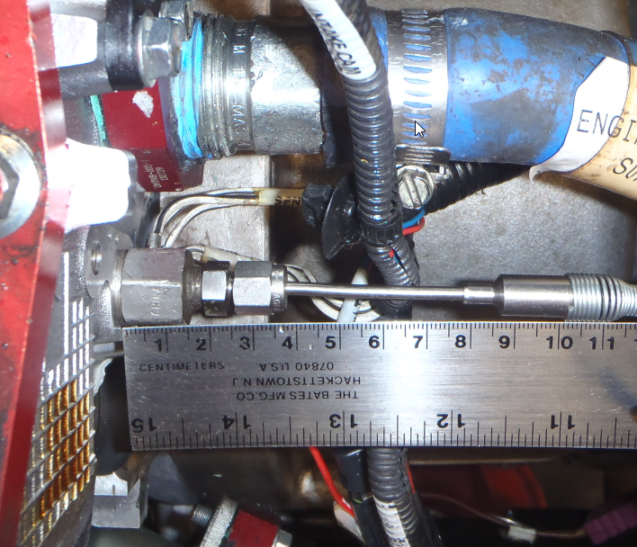

Figure A7. 1 Engine Coolant Out

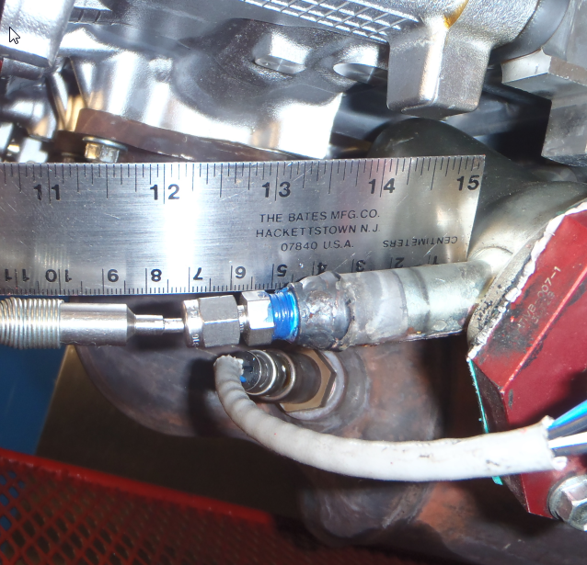

Figure A7. 2 Engine Coolant In

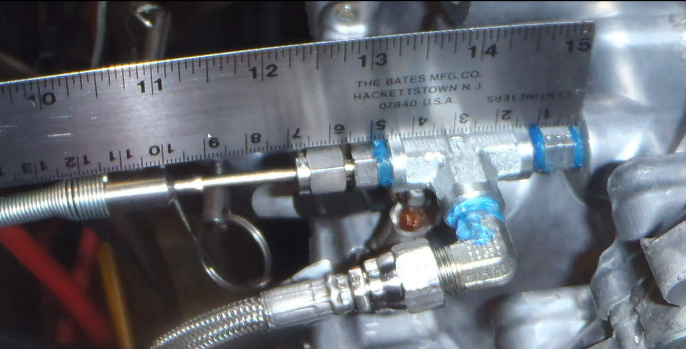

Figure A7. 3 Engine Oil Gallery

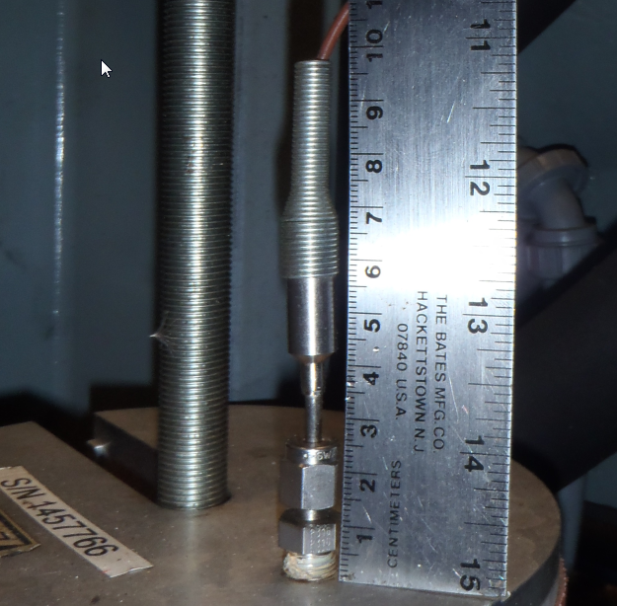

Figure A7. 4 Load Cell

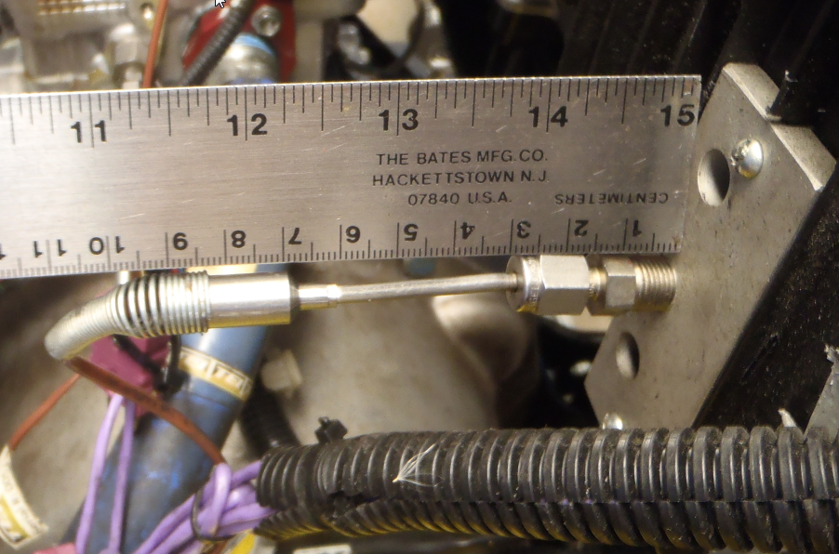

Figure A7. 5 Intake Air

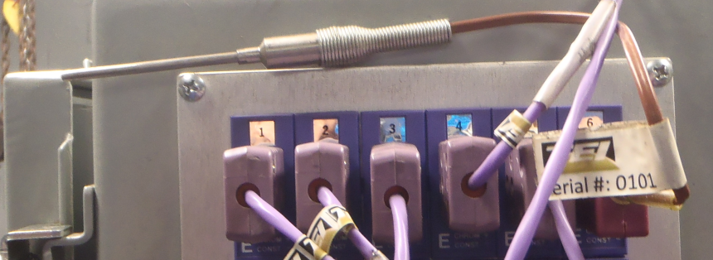

Figure A7. 6 Test Cell

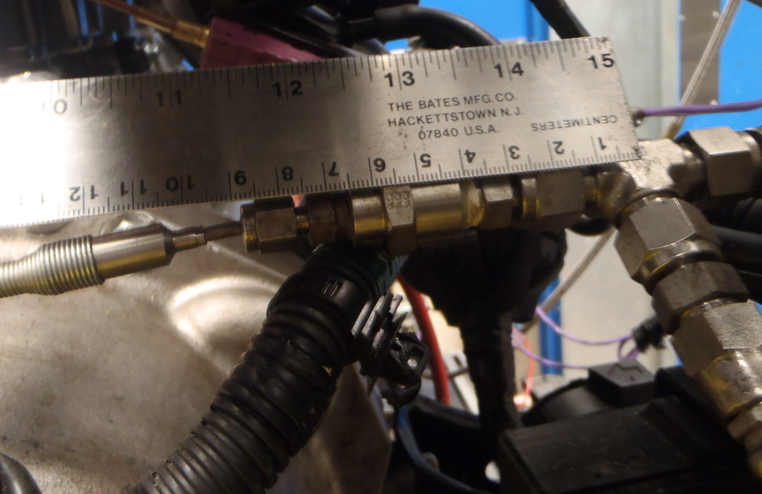

Figure A7. 7 Fuel

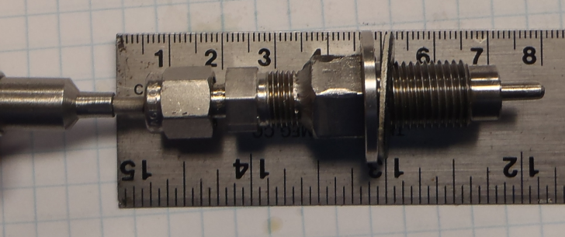

Figure A7. 8 Oil Sump

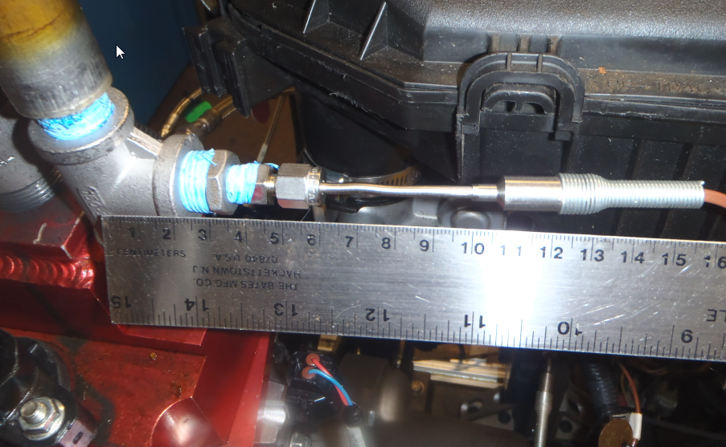

Figure A7. 9 Valve Cover Gas

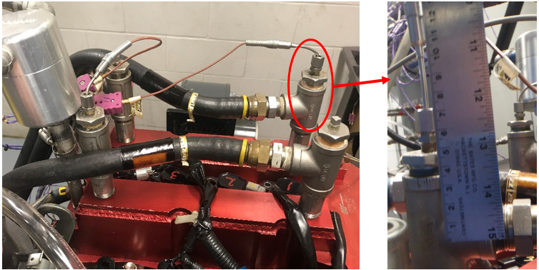
Figure A7. 10 Valve Cover Coolant In

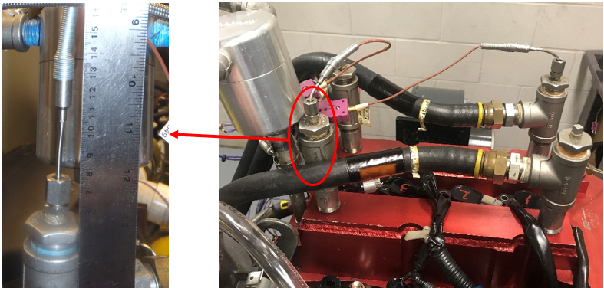
Figure A7. 11 Valve Cover Coolant Out

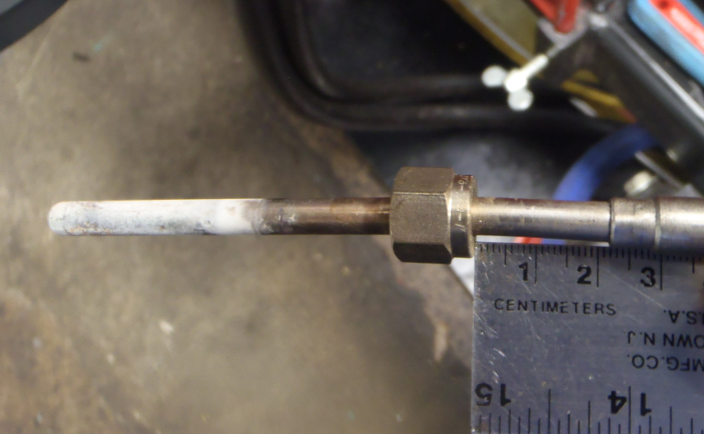

Figure A7. 12 Exhaust Gas

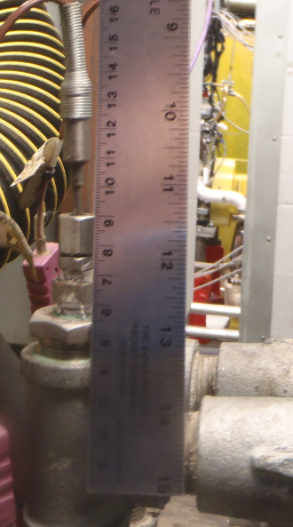

Figure A7. 13 Dynamometer Coolant Out

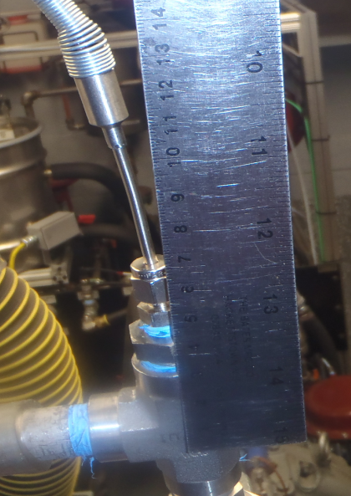

Figure A7. 14 Blow-by Gas

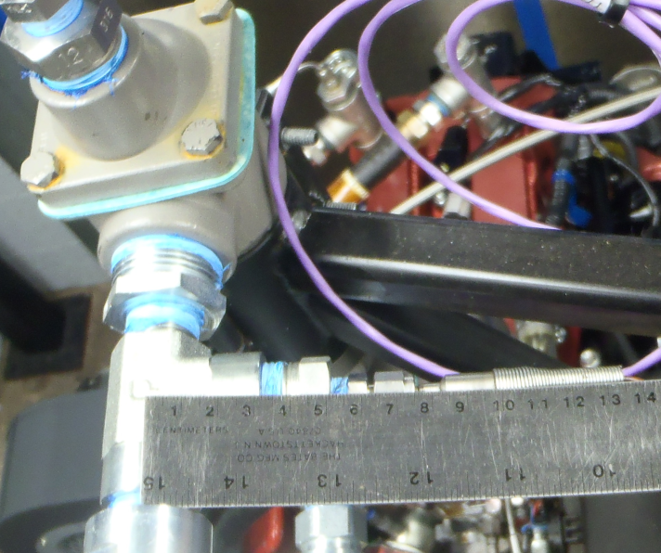

Appendix
Figure A7. 15 Blow-by Coolant Out

(Non-mandatory Information)

X1. Useful Information

X1.1 General Communications Concerning Sequence IVB Reference Tests, Procedural Questions and Non-Reference Tests:
ASTM Test Monitoring Center
Attention: Administrator
6555 Penn Avenue
Pittsburgh, PA 15206-4489
Telephone: (412) 365-1005
X1.2 Reference Oils and Calibration Oils:
Purchase reference oils and calibration oils by contacting:
ASTM Test Monitoring Center
Attention: Operations Manager
6555 Penn Avenue
Pittsburgh, PA 15206-4489
Telephone: (412) 365-1010

X1.3 Test Engine:
Sequence VIE engines, part 2012 GM (HFV6) OHT6E-001-1
OH Technologies, Inc.
9300 Progress Parkway

P.O. Box 5039
Mentor, OH 44061-5039
Telephone: (440) 354-7007
Fax (440) 354-7080
X1.4 Dynamometer:
A Midwest Model 758 (50-hp) dry gap dynamometer may be ordered from:
Midwest Dynamometer Engineering Company
3100 River Road
River Grove, IL 60171
Telephone: (708) 453-5156
Fax: (708) 453-5171
X1.5 Dynamometer Load Cell:
The recommended load cell is a Lebow Model 3397 which may be ordered from:
Honeywell
2080 Arlingate Lane
Columbus, OH 43228-4112
Telephone: (800) 867-3888
X1.6 Cooling System Pressure Cap:
A satisfactory coolant system pressure cap (100 kPa, normally closed cap) is available through local distributors.
X1.7 Cooling System Pump (P-1):
The specified cooling system pump may be obtained from:
Gould Pumps, Inc.
240 Fall Street
Seneca Falls, NY 13148
X1.8 Coolant Heat Exchanger (HX-1):
ITT (Model 320-20)
ITT Standard
175 Standard Parkway
Buffalo, NY 14227
or
Bell & Gossett (BP 75H-20 or BP 420-20)
Bell & Gossett ITT
8200 N. Austin Avenue
Morton Grove, IL 60053
X1.9 Coolant Orifice Plate (Differential Pressure):
Flowell
8308 South Regency Drive
Tulsa, OK 74131
Telephone: (918) 224-6969
X1.10 Coolant Control Valves (TCV-104, FCV-103 and TCV-101):
Badger Meter, Inc.
P.O. Box 581390
Tulsa, OK 74158
Telephone: (918) 836-8411
X1.11 Differential Pressure Transducer (DPT-1):
The recommended transducers are Viatran Model 274 or Model 374, Validyne Model DP15, and Rosemount model 1151 which may be ordered from:
Viatran Corp.
300 Industrial Drive
Grand Island, NY 14072
Telephone: (716) 773-1700
or
Validyne Engineering Corp.

8626 Wilbur Ave.
Northridge, CA 91324
Telephone: (818) 886-2057
or
Rosemount Inc.
4001 Greenbriar Street 150B
Stafford, Texas 77477
Telephone: 1-800 999-9307
X1.12 Water Pump Plate:
The water pump block off plate OHT6D-005-1 may be purchased from:
OH Technologies, Inc.
9300 Progress Parkway
P.O. Box 5039
Mentor, OH 44061-5039
Telephone: (440) 354-7007
Fax (440) 354-7080
X1.13 Oil Scavenge Pump (P-3):
Houdaille Industries, Inc.
Viking Pump Division
George and Wyeth Street
Cedar Falls, IA 50613
Telephone: (319) 266-1741
X1.14 Thermocouples:
www.omega.com
Telephone: (888) 826-6342
X1.15 Oil Circulation Pump (P-4):
Houdaille Industries, Inc.
Viking Pump Division
George and Wyeth Street
Cedar Falls, IA 50613
Telephone: (319) 266-1741
X1.16 External Oil System Solenoid Valves (FCV-150A, FCV-150C, FCV-150D, FCV-150E and FCV-150F):
Burkert Contromatic Corp.
1091 N. Batavia Street
Orange, CA 92667
Telephone: (714) 744-3230
Fax: (714) 639-4998
X1.17 External Oil System Control Valves (TCV-144 and TCV-145):
Badger Meter, Inc.
P.O. Box 581390
Tulsa, OK 74158
Telephone: (918) 836-8411
X1.18 Oil Heat Exchanger (HX-6):
ITT (Model 310-20):
ITT Standard
175 Standard Parkway
Buffalo, NY 14227
or
Bell & Gossett (Model BP 25-20 or BP 410-020):
Bell & Gossett ITT
8200 N. Austin Avenue
Morton Grove, IL 60053
X1.19 Electric Oil Heater Housing (EH-5):
TEST ENGINEERING, INC. (TEI)

12718 Cimarron Path
San Antonio, TX 78249
Telephone: (210) 690-1958
Fax: (210) 690-1959
X1.20 Oil Filter Housing Assembly OHT6A-012-2 and Filters (Screen) (FIL-2)
Racor 28 micron screen OHT6A-013-3:
OH Technologies, Inc.
9300 Progress Parkway
P.O. Box 5039
Mentor, OH 44061-5039
Telephone: (440) 354-7007
Fax: (440) 354-7080
X1.21 Modified Oil Filter Adapter Plate OHT6D-003-1:
OH Technologies, Inc.
9300 Progress Parkway
P.O. Box 5039
Mentor, OH 44061-5039
Telephone: (440) 354-7007
Fax: (440) 354-7080
X1.22 External Oil System Hose and Quick Disconnect Fittings:
Aeroquip products are available through local distributors or:
Aeroquip Corporation
Industrial Division
1225 W. Main Street
Van Wert, OH 45891
Telephone: (419) 238-1190
X1.23 Modified Oil Pan and Modified Oil Pick-Up Tube OHT6D-001-1:
The oil pan and oil level blocking plate may be purchased from:
OH Technologies, Inc.
9300 Progress Parkway
P.O. Box 5039
Mentor, OH 44061-5039
Telephone: (440) 354-7007
Fax: (440) 354-7080
X1.24 Fuel Flow Measurement Mass Flow Meter:
MicroMotion, Inc.
7070 Winchester Circle
Boulder, CO 80301
Telephone: (303) 530-8400 or (800) 522-6277
Fax: (303) 530-8209
X1.25 AFR Analyzer:
The recommended AFR analyzers are a Horiba MEXA 110, 700, 730 or ECM AFM1000 which may be ordered from:
Horiba Instruments, Inc.
17671 Armstrong
Irvine Industrial Complex
Irvine, CA 92623
Telephone: (714) 250-4811
Or
Engine Control and Monitoring (ECM)
Los Altos, CA
Telephone: (403) 734-3433
X1.26 ECU (Engine Control Unit) Revision 3, OHT6D-012-4:
OH Technologies Inc.
9300 Progress Parkway

P.O. Box 5039
Mentor, OH 44061-5039
Telephone: (440) 354-7007
Fax: (440) 354-7080
X1.27 Engine Wiring Harness Without Interface OHT6D-011-2:
OH Technologies Inc.
9300 Progress Parkway
P.O. Box 5039
Mentor, OH 44061-5039
Telephone: (440) 354-7007
Fax: (440) 354-7080
X1.28 Modified Coolant Inlet:
The coolant inlet may be purchased from:
OH Technologies Inc.
9300 Progress Parkway
P.O. Box 5039
Mentor, OH 44061-5039
Telephone: (440) 354-7007
Fax: (440) 354-7080
X1.29 Organic Solvent (Penmul L460):
Penetone Corporation
74 Hudson Avenue
Tenafly, NJ 07670
X1.30 Degreasing Solvent:
Available from local suppliers.
X1.31 Damper drivelines may be purchased from:
Machine Service Inc.
http://www.machineservice.com/contact.htm
American VULKAN Corporation
2525 Dundee Road,
Winterhaven, FL 33884
(863)-324-2424
X1.32 Engine Mounts:
OH Technologies Inc.
9300 Progress Parkway
P.O. Box 5039
Mentor, OH 44061-5039
Telephone: (440) 354-7007
Fax: (440) 354-7080
X1.33 Test Fuel:
Haltermann Products
1201 South Sheldon Road
PO BOX 429
Channelview, TX 77530-0429
Telephone: 281-457-2768
X1.34 Order parts specified as “available from CPD” from:
OH Technologies Inc.
9300 Progress Parkway
P.O. Box 5039
Mentor, OH 44061-5039
Telephone: (440) 354-7007
X1.35 Paxton Fuel Pressure Regulator
Can be obtained from Summit Racing
960 East Glendale Avenue
Sparks, NV 89431
www.summitracing.com

ASTM International takes no position respecting the validity of any patent rights asserted in connection with any item mentioned in this standard. Users of this standard are expressly advised that determination of the validity of any such patent rights, and the risk of infringement of such rights, are entirely their own responsibility.
This standard is subject to revision at any time by the responsible technical committee and must be reviewed every five years and if not revised, either reapproved or withdrawn. Your comments are invited either for revision of this standard or for additional standards and should be addressed to ASTM International Headquarters. Your comments will receive careful consideration at a meeting of the responsible technical committee, which you may attend. If you feel that your comments have not received a fair hearing you should make your views known to the ASTM Committee on Standards, at the address shown below.
This standard is copyrighted by ASTM International, 100 Barr Harbor Drive, PO Box C700, West Conshohocken, PA 19428-2959, United States. Individual reprints (single or multiple copies) of this standard may be obtained by contacting ASTM at the above address or at 610-832-9585 (phone), 610-832-9555 (fax), or service@astm.org (e-mail); or through the ASTM website (www.astm.org). Permission rights to photocopy the standard may also be secured from the ASTM website (www.astm.org/COPYRIGHT/).

This test method is under the jurisdiction of ASTM Committee D02 on Petroleum Products, Liquid Fuels, and Lubricants and is the direct responsibility of Subcommittee D02.B0 on Automotive Lubricants. Current edition approved May 1, 2014. Published June 2014. Originally approved in 2003. Last previous edition approved in 2013 as D6891 – 13a. DOI: 10.1520/D6891-14.
The ASTM Test Monitoring Center will update changes in this test method by means of Information Letters. Information letters may be obtained from the ASTM Test Monitoring Center (TMC), 6555 Penn Ave., Pittsburgh, PA 15206-4489, Attention: Administrator. www.astmtmc.cmu.edu. This edition incorporates all Information Letters through No. 13–1.
For referenced ASTM standards, visit the ASTM website, www.astm.org, or contact ASTM Customer Service at service@astm.org. For Annual Book of ASTM Standards volume information, refer to the standard’s Document Summary page on the ASTM website.
Available from from IHS Markit, 25 Ropemaker St., London, EC2Y 9LY, United Kingdom
ASTM TMC Technical Guidance Committee Report available referenced on www.asmtmc.cmu.edu
American Chemistry Council, 1300 Wilson Boulevard, Arlington, VA 22209.

