**Mack T-13 Sensor Placement**

8.6 *Measurements:*

8.6.1 *Calibrations*—Calibrate thermocouples, pressure

gages, speed, torque and fuel flow measuring equipment prior to each

reference oil test or at any time readout data indicates a need.

Conduct calibrations with at least two points that bracket the

normal operating range. Make these calibrations part of the

laboratory record. During calibration, connect leads, hoses and

readout systems in the normally used manner and calibrate

with necessary standards. For controlled temperatures, immerse

thermocouples in calibration baths. Calibrate standards

with instruments traceable to the National Institute of Standards

and Technology on a yearly basis.

8.6.2 *Temperatures:*

8.6.2.1 *General*—Measure temperatures with thermocouples

and conventional readout equipment or equivalent. For

temperatures in the (0 to 150) °C range, calibrate temperature

measuring systems to + 0.5 °C for at least two temperatures

that bracket the normal operating range. Insert all thermocouples

so that the tips are located midstream of the flow unless

otherwise indicated.

8.6.2.2 *Ambient Air*—Locate thermocouple in a convenient,

T_ROOM

well-ventilated position from the engine and hot accessories.

8.6.2.3 *Coolant*—Locate the coolant-out thermocouple in

T_ENG_COOLANT_OUT

the water elbow flange after the thermostat housing. Locate it in

the center of the water stream. Refer to Fig. A1.1. Locate the

T_ENG_COOLANT_IN

coolant-in thermocouple near the connection to the engine,

as shown in Fig. A1.2.

8.6.2.4 *Oil Gallery*—Locate thermocouple on the left gallery of

T_OIL_GALLERY

the engine (intake side), as shown in Fig. A1.3. Insertion depth

of 64.2 mm (2.5265”) from face of engine block.

8.6.2.5 *Oil Sump Temperature*—Using a front oil pan

T_OIL_SUMP

configuration, locate a thermocouple on the intake side of the

oil pan, 158.8 mm (6.25”) from the front of the pan and

254 mm (10.00”) from the top of the pan rail. Insertion depth shall be 76.2-127 mm (3-5”) from the inside wall of the oil pan. Refer to Fig. A1.4.

8.6.2.6 *Inlet Air Temperature*—Locate the inlet air thermocouple

T_INLET_AIR

in the center of the air stream leading to the turbocharger inlet, as shown

in Fig. A1.5. It is not necessary to control inlet air humidity, but measurement is required.

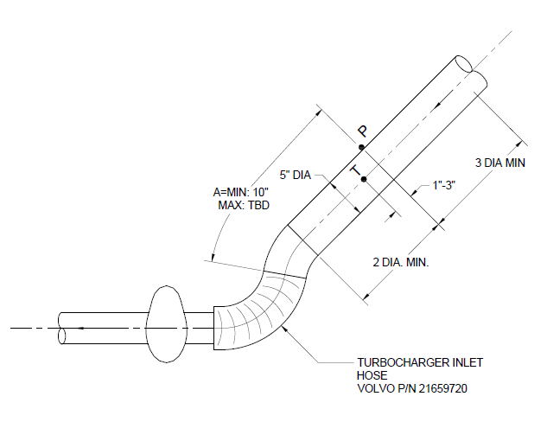

8.6.2.7 *Fuel In*—Locate thermocouple at connection of

T_FUEL_IN

fuel inlet fitting on the intake side of the engine, as

shown in Fig. A1.6.

8.6.2.8 *Exhaust Tailpipe*—Locate a thermocouple in the

T_EXHAUST_TAILPIPE

exhaust pipe downstream of the exhaust back pressure tap

and CO2 probe. Refer to Fig. A1.7.

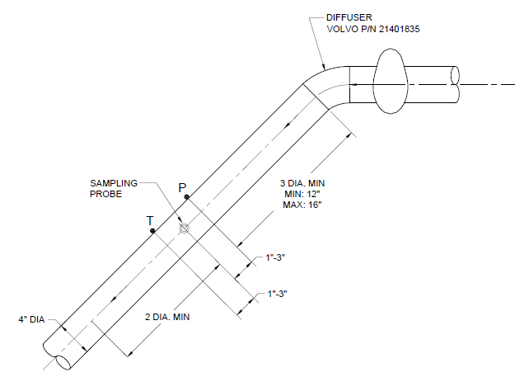

8.6.2.9 *Intake Manifold*—Locate a thermocouple at the

T_INTAKE_MAN

tapped fitting on the intake air manifold as shown in Fig. A1.8.

8.6.2.10 *EGR Cooler Outlet*—Locate thermocouple as

T_EGR_OUT

shown in Fig. A1.9.

8.6.2.11 *Intercooler Outlet*—Locate the thermocouple

T_INTERCOOLER_OUT

downstream of the cooler outlet and prior to the EGR mixer,

as shown in Fig A1.10.

8.6.2.12 *Oil Jet*—Locate the thermocouple on the oil filter

T_OIL_JET

housing, as shown in Fig A1.11. Insertion depth of 78.5 mm

(3.0925”) from face of oil filter housing.

8.6.2.13 *Fuel Gallery*—Locate the thermocouple in the fuel

T_FUEL_GALLERY

gallery as shown in Fig A1.12. Insertion depth of 50.8 mm

(2.00”) from face of cylinder head.

8.6.2.14 *Dewpoint*—Locate the sensor to record the

T_DEWPOINT

dewpoint temperature before the air filter, as shown in Fig A1.13.

8.6.2.15 *Compressor Discharge*—Locate the thermocouple

T_COMP_OUT

between the compressor outlet and the intercooler, as shown

in Fig A1.14. Locate the thermocouple downstream of the

compressor outlet pressure tap.

8.6.2.16 *Cylinder Ports*—Locate thermocouples in each

T_CYL_1 to T_CYL_6

cylinder port as shown in Fig A1.15 and Fig A1.16.

8.6.2.17 *Oil From Cooler*—Locate the thermocouple on the

T_OIL_FROM_COOLERR

oil filter housing, as shown in Fig A1.17. Insertion depth of

24.1 mm (0.950”) from face of oil filter housing.

8.6.3 *Pressures*:

P_OIL_GALLERY

8.6.3.1 *After Oil Filter (Main Oil Gallery)*—Locate the

pickup on the left side of the engine (intake side).

Refer to Fig. A1.18.

8.6.3.2 *Pre-Turbine Exhaust*—Locate the pickup on the

P_R_EXH_MAN

P_F_EXH_MAN

exhaust manifold, see Fig. A1.19. This measurement is

not mandatory, but it is recommended for diagnostic purposes.

P_INTAKE_MAN

8.6.3.3 *Intake Manifold (Air Boost)*—Take the measurement

at the tapped fitting provided on the intake manifold as

illustrated in Fig. A1.20.

8.6.3.4 *Intake Air Pressure (Intake Air Restriction)*—

P_INLET_AIR

Measure it with a static port (pressure tap hole) located

upstream of Inlet Air Temperature (see Fig. A1.5).

8.6.3.5 *Exhaust Back Pressure*—Measure exhaust back

P_EBP

pressure in a straight section of pipe upstream of the exhaust

tailpipe thermocouple, with a pressure tap hole as shown in

Fig. A1.7. Do not locate the tap downstream of either the temperature thermocouple or the

CO2 probe.

8.6.3.6 *Crankcase Pressure*—Locate the pickup on the valve

P_CRANKCASE

cover between cylinder 3 and cylinder 4. Refer to Fig A1.21.

P_COMP_OUT

8.6.3.7 *Compressor Discharge*—Locate the pickup as shown

in Fig A1.14. Locate the pressure tap upstream of the

compressor outlet thermocouple.

8.6.3.8 *Coolant System*—Locate the pickup at the top of the

P_COOL­_TANKTANK

coolant system expansion tank, as shown in Fig A1.22.

8.6.3.9 *Air Cleaner­*—Locate pickups to read the pressure

P_AIR_CLEANER

differential for both the high and low sides across the air cleaner,

as shown in Fig A1.23 and Fig A1.24.

P_COOLANT_PUMP

8.6.3.10 *Coolant Pump*—Locate the pickup on the right side

cover, as shown in Fig A1.25.

8.6.3.11 *Intercooler Outlet*—Locate the pickup at the outlet

P_INTERCOOLER_OUT

of the intercooler, as shown in Fig A1.10. Locate the pressure

tap upstream of the intercooler outlet thermocouple.

8.6.3.12 *Fuel Gallery*—Locate the pickup in the fuel gallery,

P_FUEL_GALLERY

as shown in Fig A1.26.

8.6.3.13 *Oil Jet*—Locate the pickup on the oil filter housing,

P_OIL_JET

as shown in Fig A1.27.

8.6.3.14 *Cylinder Head Oil*—Locate the pickup in the

P_OIL_CYL_HEAD

cylinder head, as shown in Fig A1.1.

8.6.4 *Carbon Dioxide Measurements*:

8.6.4.1 *General*—Calibrate the sensors prior to each measurement

taken during the course of the test. The CO2 levels for

the calibration span gases are specified. The intake span gas

shall be (2 to 4) % CO2. The exhaust span gas shall be (10 to 15)

% CO2. The blend quality for all span gases shall be Primary

Standard ± 1%. The intake and exhaust CO2 samples shall have

a dew point no greater than 5 °C.

8.6.4.2 *Exhaust Carbon Dioxide Probe*—Measure the exhaust

Exhaust Probe

CO2. Locate the probe downstream of the exhaust back-pressure tap.

Use a 6.4 mm probe that meets the Code of Federal Regulations,

Title 40 Part 86.310-79. The probe diameter is not to exceed the sample line diameter. Refer

to Fig. A1.7.

Intake Manifold Probe

8.6.4.3 *Intake Manifold Carbon Dioxide Probe*—Locate the probe

in the intake manifold, as shown in Fig A1.28. Use a 6.4 mm probe

that meets the Code of Federal Regulations, Title 40 Part 86.310-79.

The probe diameter is not to exceed the sample line diameter.