Mack T-13 Appendix A1
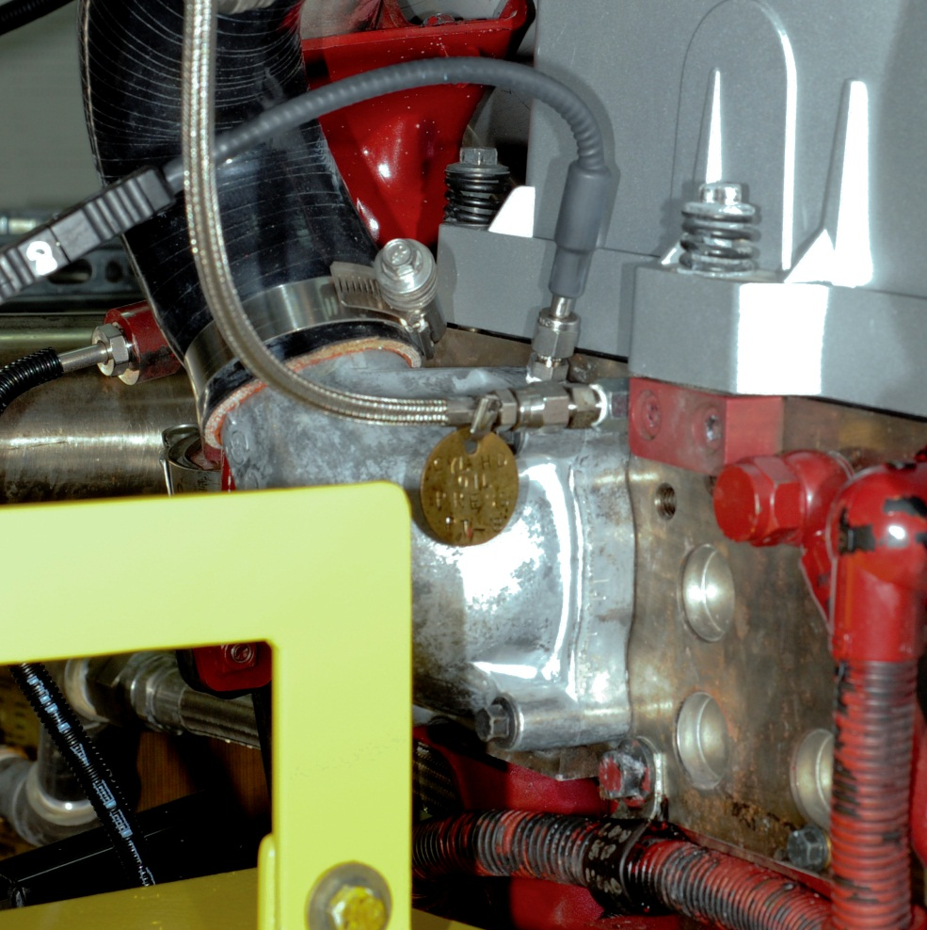
P_OIL_CYL_HEAD
T_ENG_COOLANT_OUT
FIG. A1.1 Engine Coolant Out Temperature and Cylinder Head Oil Pressure
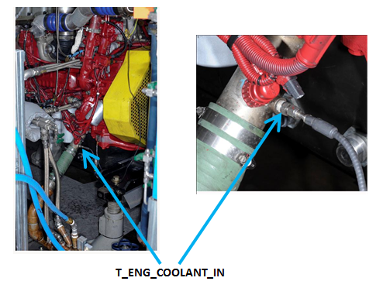
FIG. A1.2 Engine Coolant In Temperature

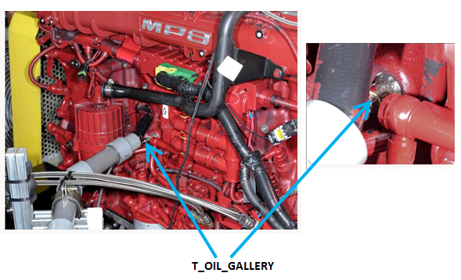
FIG. A1.3 Oil Gallery Temperature

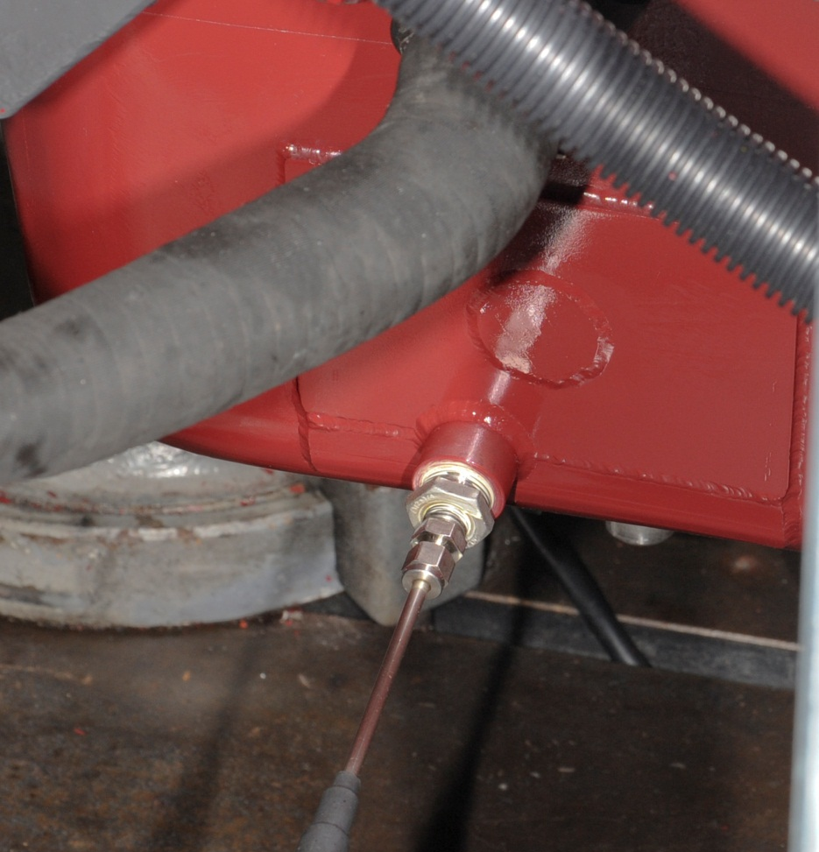
FIG. A1.4 Oil Sump Temperature
T_OIL_SUMP

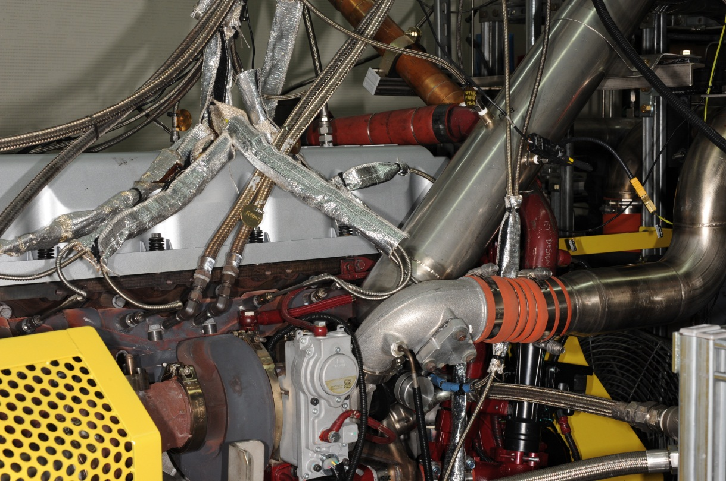
T_INLET_AIR
FIG. A1.5 Intake Air Temperature and Pressure
P_INLET_AIR

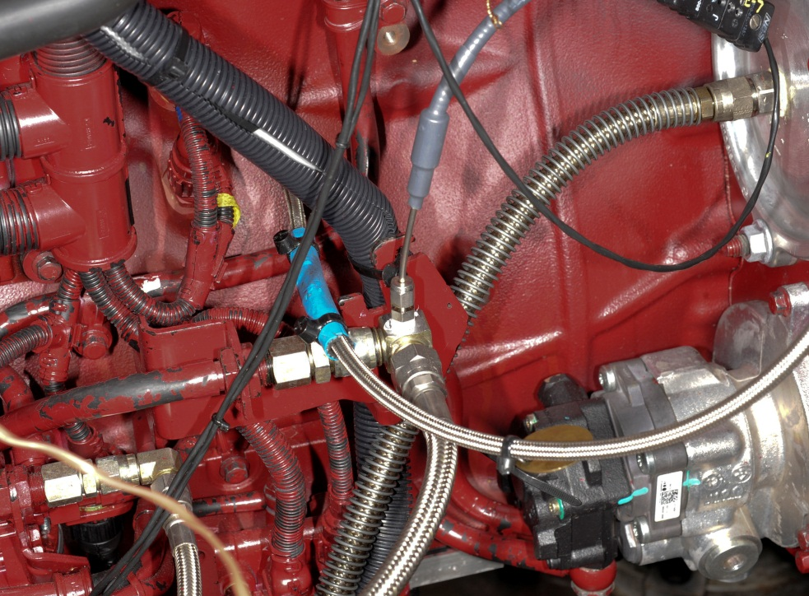
FIG. A1.6 Fuel In Temperature
T_FUEL_IN

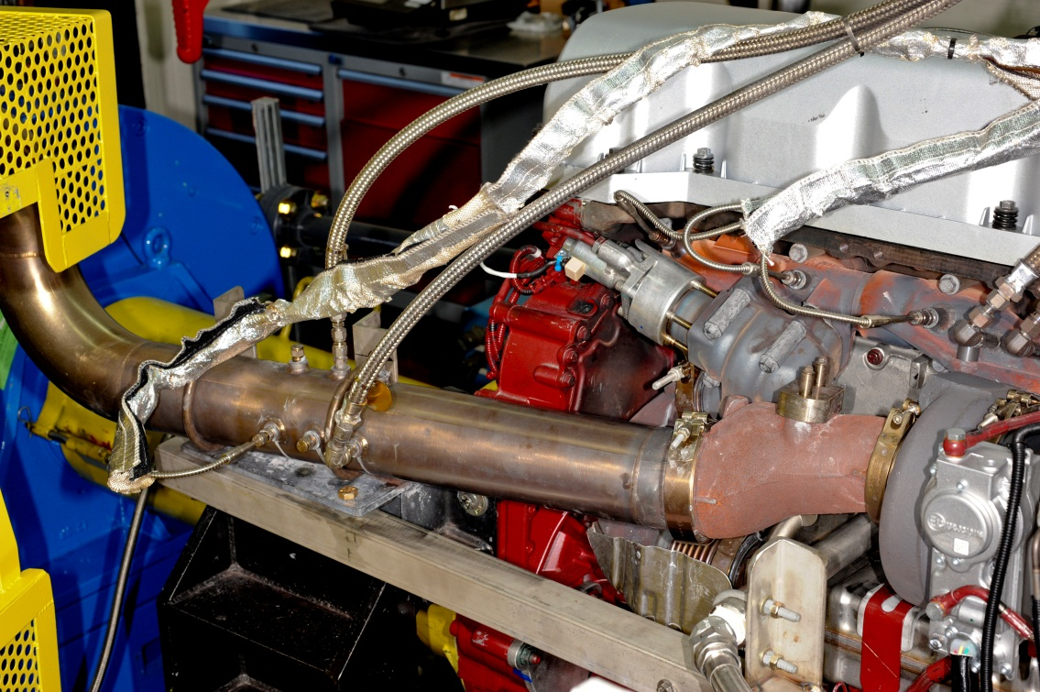
T_EXHAUST_TAILPIPE
EXHAUST PROBE
P_EBP
FIG. A1.7 Exhaust Tailpipe Temperature, Exhaust Back-Pressure and Exhaust probe

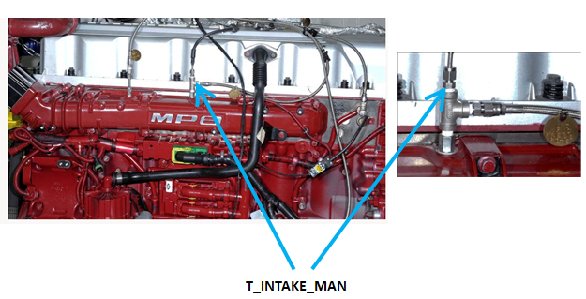
FIG. A1.8 Intake Manifold Temperature

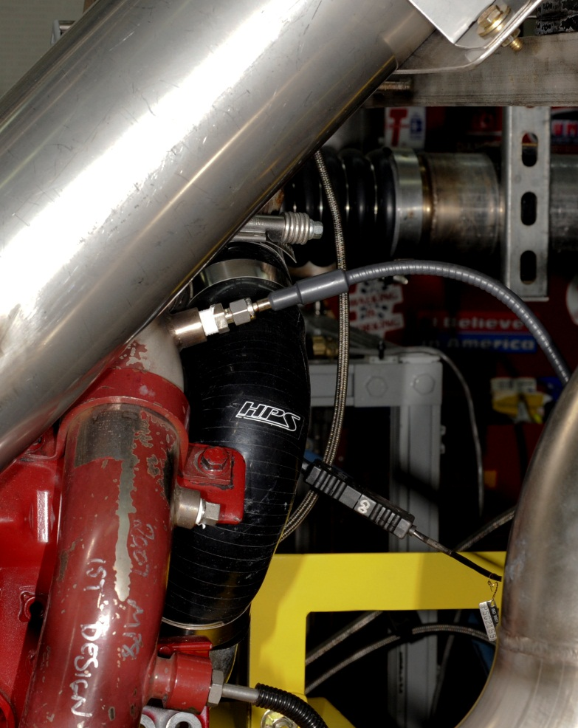
T_EGR_OUT
FIG. A1.9 EGR Gas Out Temperature

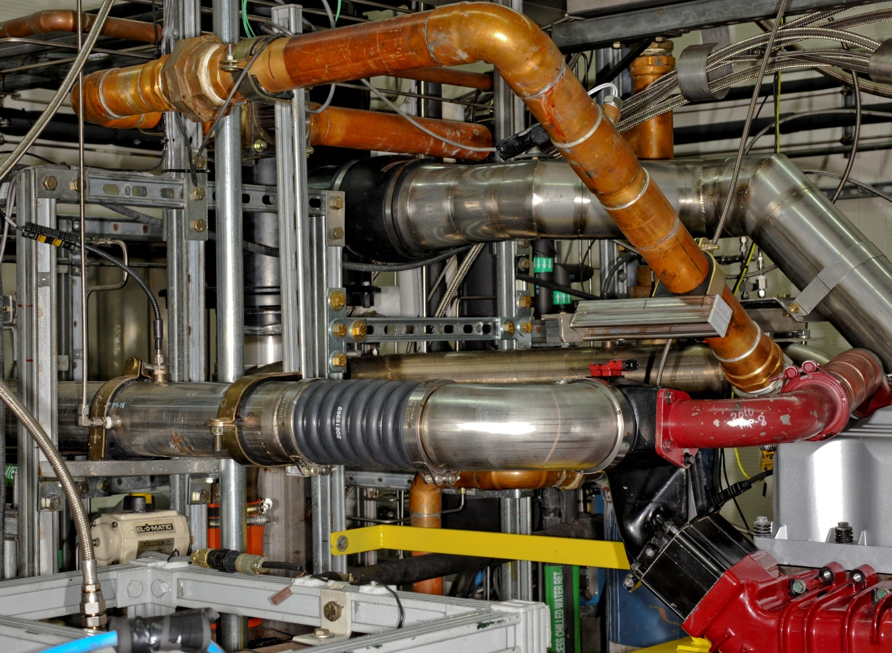
P_INTERCOOLER_OUT
T_INTERCOOLER_OUT
FIG. A1.10 Intercooler Outlet Temperature and Pressure
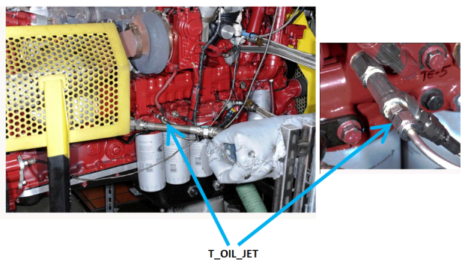
FIG. A1.11 Oil Jet Temperature
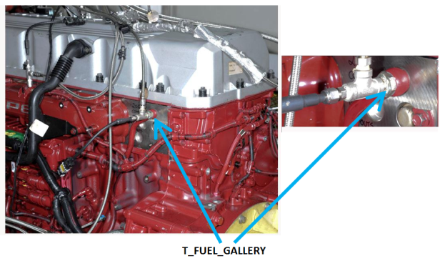
FIG. A1.12 Fuel Gallery Temperature

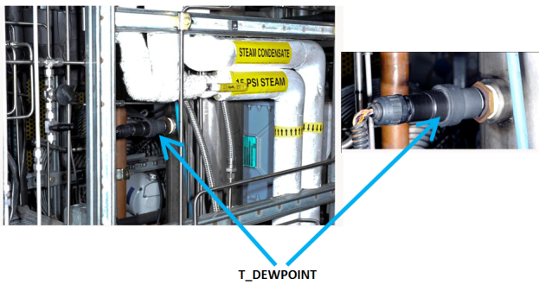
FIG. A1.13 Dewpoint Temperature

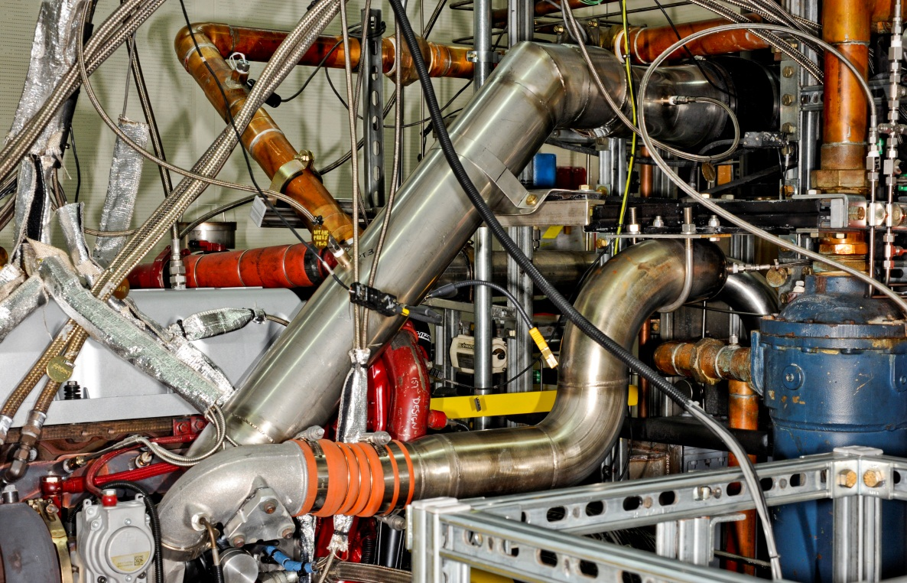
P_COMP_OUT
T_COMP_OUT
FIG A1.14 Compressor Outlet Temperature and Pressure
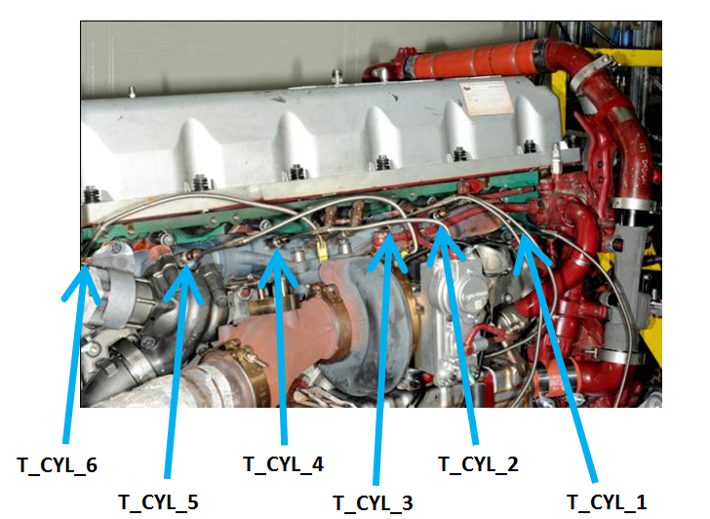
FIG A1.15 Cylinder Port Temperatures

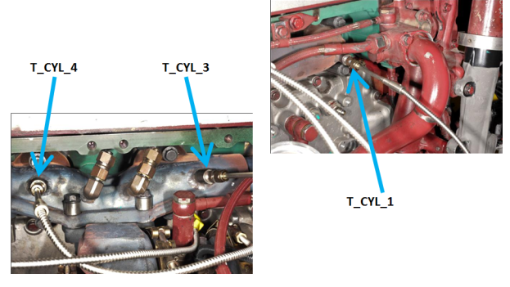
FIG A1.16 Cylinder Port Temperatures (Close View)

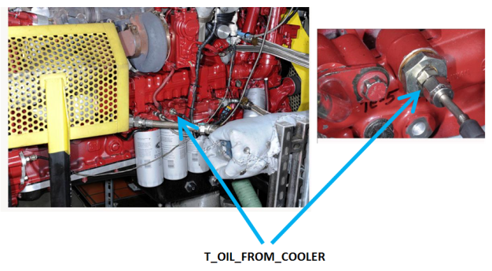
FIG A1.17 Oil Temperature From Cooler
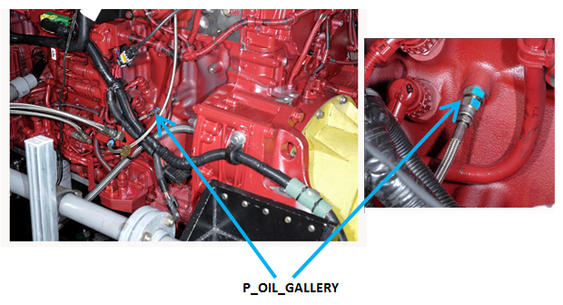
FIG A1.18 Oil Gallery Pressure

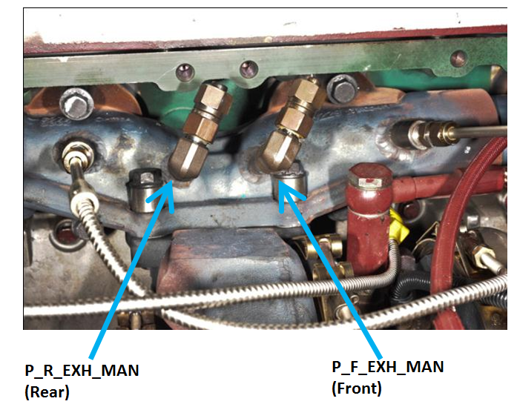
FIG A1.19 Exhaust Manifold Pressures
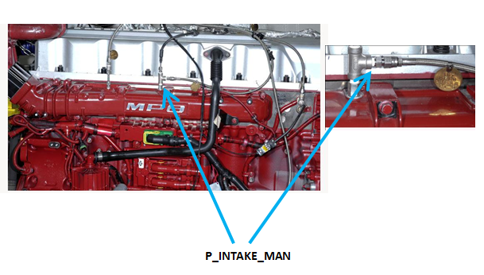
FIG A1.20 Intake Manifold Pressure
VENT LINE
P_CRANKCASE

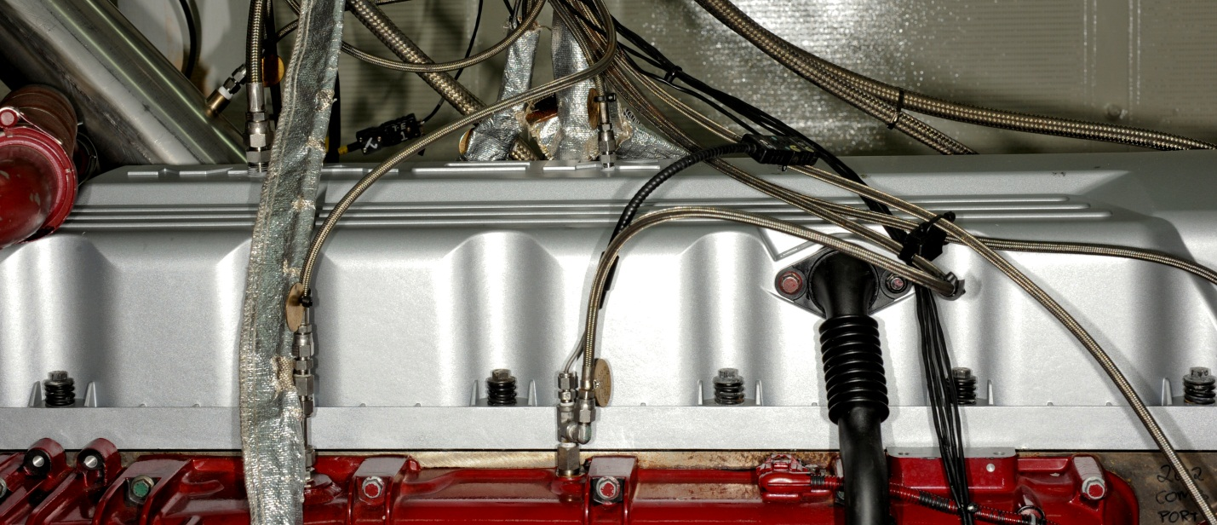
FIG A1.21 Crankcase Pressure and Vent of External Oil Vessel

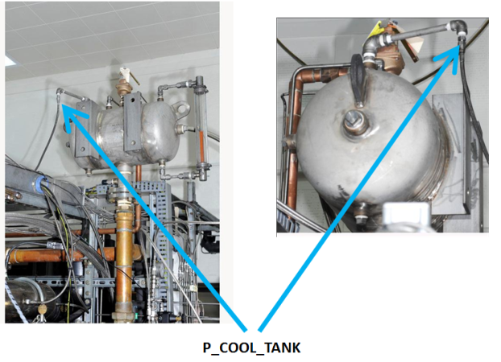
FIG A1.22 Coolant Expansion Tank Pressure

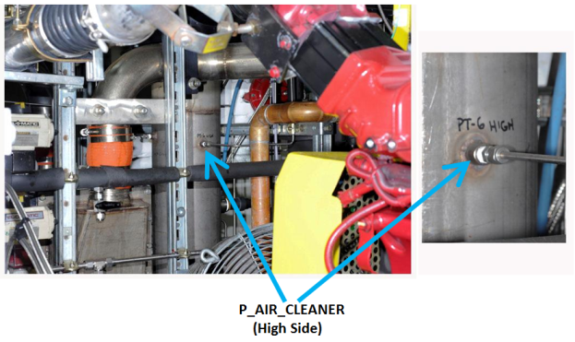
FIG A1.23 Air Cleaner Pressure Differential (High Side)

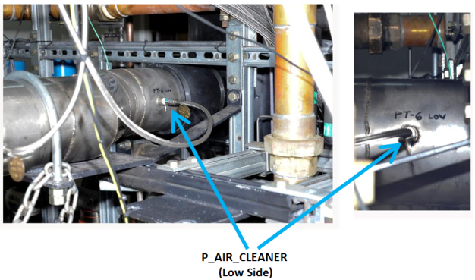
FIG A1.24 Air Cleaner Pressure Differential (Low Side)
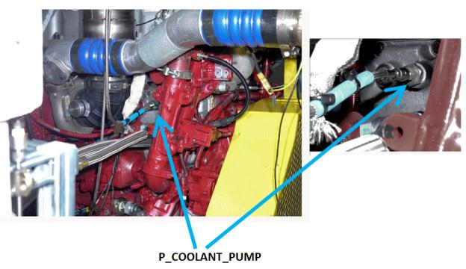
FIG A1.25 Coolant Pump Pressure

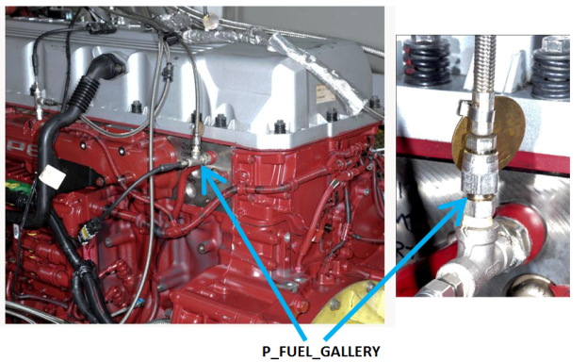
FIG A1.26 Fuel Gallery Pressure

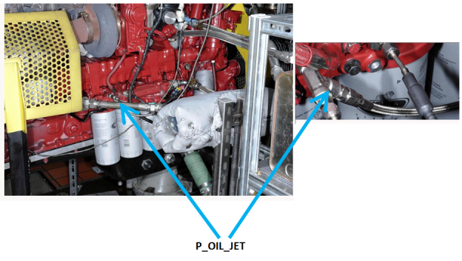
FIG A1.27 Oil Jet Pressure

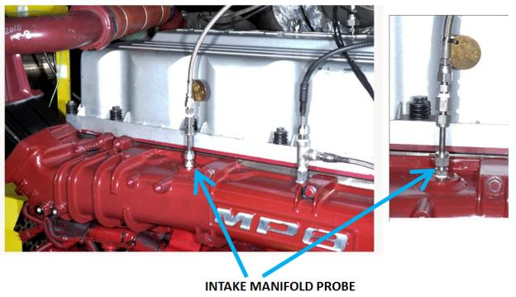
FIG A1.28 Intake Manifold Probe

