Mack T-8A, 8, and 8E Fuel Requirements
The Mack T-8A, 8, and 8E Tests (hereafter referred to as T-8) shall use a fuel meeting the PC-9-HS specification located on the TMC website, and that has been approved for use through the process defined by the Mack/Volvo Surveillance Panel for acceptance.
For a fuel to be approved for the Mack T-8 test, the fuel supplier shall demonstrate, through chemical analyses and engine testing, that the fuel provides the same performance as a currently approved fuel. The supplier shall provide a Certificate of Analysis documenting that the fuel meets the current PC-9-HS fuel specification, as well as conducting a prove-out program.
Due to the high level of sulfur content compared to the majority of fuel commercially available in the marketplace and the T-8’s historic sensitivity to fuel, only suppliers that have been approved through the panel’s process are considered acceptable for use. Since the PC-9-HS sulfur requirement of 400-500ppm, it is expected that fuel for the test will be produced as a batch process rather than a continuous production stream. The fuel supplier shall conduct a full COA analysis for each batch produced.
An individual lab may not bring a new fuel supplier into use, even following the criteria noted in the approval process, without the notification and review of the Surveillance Panel.
Prove-Out Program – The prove-out program is to be run entirely on a single test stand in a single test laboratory. The chosen test stand must have a history of at least three (3) successful calibration tests in the last four years, the first LTMS appearance for the stand being over one year prior to the start of the prove-out program, and not had a current lapse in calibration of greater than one calibration time period. The engine will be rebuilt immediately prior to beginning the prove-out program, with no rebuilds during the program. The intent is to conduct all tests without replacement of major internal or external hardware. The prove-out program will be run using reference oil 1005-5 (or subsequent approved oil re-blends). The alternate fuel will be evaluated based on results Viscosity increase at 3.8% soot, the 50% shear viscosity increase at 4.8% soot and the 100% shear viscosity increase at 4.8% soot.
First, the chosen stand shall conduct a calibration test on oil 1005-5 on currently approved fuel. The test must meet all LTMS calibration acceptance criteria. Based on the results of the test, determine the new stand-level exponentially weighted moving average, or Zi value, for each of the three soot parameters. Zi is as defined in the LTMS document. The Zi value calculated for each parameter immediately after the calibration test will be referred to as $Z_{cal}$ in the subsequent sections. Also calculate the average front and rear exhausts manifold temperatures, average power, and average injection timing of the calibration test.
Next, the same stand shall immediately conduct two (2) tests on oil 1005-5 using the alternate fuel. For each test, calculate the difference between the standardized test result Yi and the previously determined $Z_{cal}$ value for each parameter. This difference is the prediction error, or Ei value. That is, Ei = Yi – $Z_{cal}$. Note that because of the use of $Z_{cal}$ instead of $Z_{i-1}$, this is slightly different than the definition of Ei in the LTMS document. Here Y_{i} is defined as in the LTMS document:

$$Y_{i}=\frac{R_{i}-M}{S}$$
where:
$Y_{i}$ = standardized test result at test order i
$R_{i}$= actual reference oil test result at test order i,
M = reference oil target mean from LTMS, and
S = reference oil target standard deviation from LTMS.
Similar to the calibration tests, calculate the average front and rear exhausts temperatures, average power, and average injection timing.
The results of the prove-out testing must meet the following criteria:
For viscosity increase at 3.8% soot, 50% shear viscosity increase, and 100% shear viscosity increase at 4.8% soot, the calculated Ei value must be within +/- 1.734 for both tests.
?, the calculated Ei value must be within +/- 2.066 for both tests.
The average front and rear exhaust temperature for both tests shall be within +/- 15 deg. C of the calibration test.
The average power for each test shall be within +/- 10 kW of the calibration test.
The average injection timing shall be – Soot Drift shall be ???
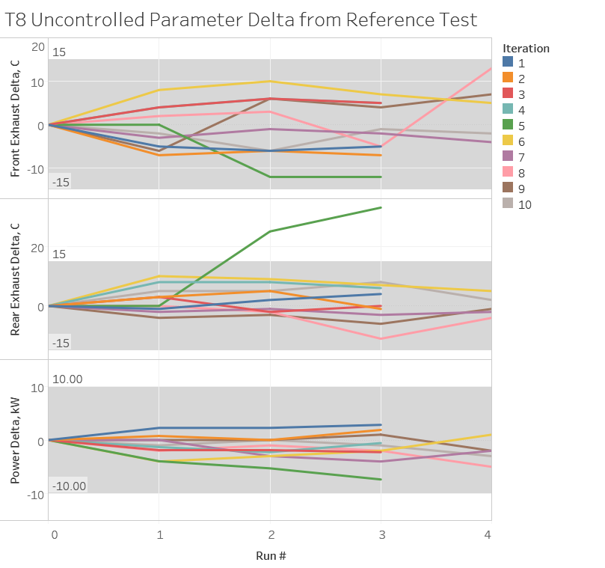

Both alternate fuel tests shall be operationally valid with no controlled parameters outside of prescribed average limits.
The Surveillance Panel will approve the fuel for use following confirmation of these results. If the supplier believes the fuel is providing equivalent performance to the current approved fuel without meeting the criteria listed above, they may petition the surveillance panel to conduct an additional review. At this point, the actions taken by the Surveillance Panel to accept or reject the fuel will vary depending on the results and judgement of the panel members.

A list of approved fuel suppliers for the T-8 test is maintained on the TMC website.

Introduction of a Surveillance Panel Approved Fuel - A lab may utilize any fuel that has been approved by the Surveillance Panel for use with the T-8 with a single calibration test that meets all validity requirements and no Level 2 Ei alarms. The fuel must have previously conducted a full “Prove-Out Program” and been approved for use at the Surveillance Panel. A new fuel for a lab is one that has never previously completed an acceptable calibration test in that lab. The Test Monitoring Center should be notified when a calibration oil is requested that a new fuel supplier will be utilized. In the case that a level 2 Ei alarm is exceeded, a second test may be run and the stand considered calibrated as long as the second test also falls within the level 3 Ei alarm limits.
Once a lab has successfully calibrated with the new fuel, lab severity adjustments will be recalculated and applied to all candidate tests across all stands until the next calibration test. For a lab with multiple stands it is permissible for multiple fuels to be in use simultaneously until the previously calibrated fuel is depleted. A fuel that has been approved for use by the panel and has successfully calibrated in one stand in a lab is automatically approved for candidate tests in any other lab/stand combinations within the lab. A particular lab/stand combination can only transition from the previously calibrated fuel to the most recently calibrated fuel, and not back to the previous fuel once the new fuel has been utilized until the next successful calibration test. The intent is to not alternate fuels within a reference interval for candidate tests.
Transition Between Approved Fuels - Transitioning between two fuels that have previously been approved for use in a particular lab can occur with no additional requirements outside of those listed in the LTMS for the calibration of an existing stand.
Fuel Supply Tanks - The fuel tank located at a laboratory and supplying fuel to the test stand must be addressed in one of two ways prior to being loaded with a new fuel source. If the tank was previously filled with an unapproved fuel for the Mack T-8 test, the tank should be fully drained and cleaned. If an approved fuel was in the tank, the overall capacity of the tank must be below 5% prior to refilling with enough volume to complete a T-8E test (approximately 5,900 gallons).
Fuel should also be flushed through all lines connecting the supply tank to the test cell. Due to variation in line volumes from lab/stand combinations, a set volume is not defined here. Enough fuel should be flushed to ensure that the entire line volume has been changed over to the new fuel.

