Date: <Enter Date>
To: Subcommittee <AXX.XX> or Main Committee <AXX> members (both for concurrent ballots)
Tech Contact: <Contact Name, email address/phone number>
Work Item #: <Enter Work Item number>
Ballot Action: Revision of <Enter Standard Designation/Title>
Rationale: <Enter reasons for proposed ballot action. Include an update on previous ballot history, if applicable>

Standard Test Method for

Evaluation of Automotive Engine Oils for Soot-Viscosity Performance in a Cummins ISB Medium-Duty Diesel Engine

This standard is issued under the fixed designation D7484; the number immediately following the designation indicates the year of original adoption or, in the case of revision, the year of last revision. A number in parentheses indicates the year of last reapproval. A superscript epsilon (ε) indicates an editorial change since the last revision or reapproval.
INTRODUCTION
Any properly equipped laboratory, without outside assistance, can use the procedure described in this test method. However, the ASTM Test Monitoring Center (TMC) provides reference oils and an assessment of the test results obtained on those oils by the laboratory. By these means, the laboratory will know whether its use of the test method gives results statistically similar to those obtained by other laboratories. Furthermore, various agencies require that a laboratory utilize the TMC services in seeking qualification of oils against specifications. For example, the U.S. Army imposes such a requirement in connection with several Army engine lubricating oil specifications.
Accordingly, this test method is written for use by laboratories that utilize the TMC services. Laboratories that choose not to use these services may simply ignore those portions of the test method that refer to the TMC.
This test method may be modified by means of information letters issued by the TMC.² In addition, the TMC may issue supplementary memoranda related to the method.
ASTM International policy is to encourage the development of test procedures based on generic equipment. It is recognized that there are occasions where critical/sole-source equipment has been approved by the technical committee (surveillance panel/task force) and is required by the test procedure. The technical committee that oversees the test procedure is encouraged to clearly identify if the part is considered critical in the test procedure. If a part is deemed to be critical, ASTM encourages alternative suppliers to be given the opportunity for consideration of supplying the critical part/component providing they meet the approval process set forth by the technical committee.
An alternative supplier can start the process by initiating contact with the technical committee (current chairs shown on ASTM TMC website). The supplier should advise on the details of the part that is intended to be supplied. The technical committee will review the request and determine feasibility of an alternative supplier for the requested replacement critical part. In the event that a replacement critical part has been identified and proven equivalent the sole-source supplier footnote shall be removed from the test procedure.

1. Scope *

1.1 This test method, commonly referred to as the Cummins ISB Viscosity Test, covers the utilization of a modern, 5.9 L, diesel engine equipped with exhaust gas recirculation and is used to evaluate oil performance with regard to valve-train wear.
1.2 The values stated in SI units are to be regarded as standard. No other units of measurement are included in this standard.
1.2.1 Exceptions—SI units are provided for all parameters except where there is no direct equivalent such as the units for screw threads, National Pipe Threads/diameters, tubing size, or where there is a sole source of supply equipment specification.
1.2.2 See also A7.1 for clarification; it does not supersede 1.2 and 1.2.1.
1.3 This standard does not purport to address all of the safety concerns, if any, associated with its use. It is the responsibility of the user of this standard to establish appropriate safety, health, and environmental practices and determine the applicability of regulatory limitations prior to use. See Annex A1 for general safety precautions.
1.4 Table of Contents:

 | Section
Scope | 1
Referenced Documents | 2
Terminology | 3
Summary of Test Method | 4
Significance and Use | 5
Apparatus | 6
Engine Fluids and Cleaning Solvents | 7
Preparation of Apparatus | 8
Engine/Stand Calibration and Non-Reference Oil Tests | 9
Test Procedure | 10
Calculations and Test Validity | 11
Report | 12
Precision and Bias | 13
Annexes
Safety Precautions | Annex A1
Intake Air Aftercooler | Annex A2
The Cummins ISB Engine Build Parts Kit | Annex A3
Sensor Locations and Special Hardware | Annex A4
External Oil System | Annex A5
Cummins Service Publications | Annex A6
Specified Units and Formats | Annex A7
Oil Analyses | Annex A8
Alternate Fuel Approval Process | Annex A9
1.5 This international standard was developed in accordance with internationally recognized principles on standardization established in the Decision on Principles for the Development of International Standards, Guides and Recommendations issued by the World Trade Organization Technical Barriers to Trade (TBT) Committee.

2. Referenced Documents

2.1 ASTM Standards:³
D86 Test Method for Distillation of Petroleum Products and Liquid Fuels at Atmospheric Pressure
D93 Test Methods for Flash Point by Pensky-Martens Closed Cup Tester
D97 Test Method for Pour Point of Petroleum Products
D130 Test Method for Corrosiveness to Copper from Petroleum Products by Copper Strip Test
D235 Specification for Mineral Spirits (Petroleum Spirits) (Hydrocarbon Dry Cleaning Solvent)
D445 Test Method for Kinematic Viscosity of Transparent and Opaque Liquids (and Calculation of Dynamic Viscosity)
D482 Test Method for Ash from Petroleum Products
D524 Test Method for Ramsbottom Carbon Residue of Petroleum Products
D613 Test Method for Cetane Number of Diesel Fuel Oil
D664 Test Method for Acid Number of Petroleum Products by Potentiometric Titration
D976 Test Method for Calculated Cetane Index of Distillate Fuels
D1319 Test Method for Hydrocarbon Types in Liquid Petroleum Products by Fluorescent Indicator Adsorption
D2274 Test Method for Oxidation Stability of Distillate Fuel Oil (Accelerated Method)
D2500 Test Method for Cloud Point of Petroleum Products and Liquid Fuels
D2622 Test Method for Sulfur in Petroleum Products by Wavelength Dispersive X-ray Fluorescence Spectrometry
D2709 Test Method for Water and Sediment in Middle Distillate Fuels by Centrifuge
D3338 Test Method for Estimation of Net Heat of Combustion of Aviation Fuels
D4052 Test Method for Density, Relative Density, and API Gravity of Liquids by Digital Density Meter
D4175 Terminology Relating to Petroleum Products, Liquid Fuels, and Lubricants
D4294 Test Method for Sulfur in Petroleum and Petroleum Products by Energy Dispersive X-ray Fluorescence Spectrometry
D4739 Test Method for Base Number Determination by Potentiometric Hydrochloric Acid Titration
D5185 Test Method for Multielement Determination of Used and Unused Lubricating Oils and Base Oils by Inductively Coupled Plasma Atomic Emission Spectrometry (ICP-AES)
D5186 Test Method for Determination of the Aromatic Content and Polynuclear Aromatic Content of Diesel Fuels By Supercritical Fluid Chromatography
D5453 Test Method for Determination of Total Sulfur in Light Hydrocarbons, Spark Ignition Engine Fuel, Diesel Engine Fuel, and Engine Oil by Ultraviolet Fluorescence
D5967 Test Method for Evaluation of Diesel Engine Oils in T-8 Diesel Engine
D6078 Test Method for Evaluating Lubricity of Diesel Fuels by the Scuffing Load Ball-on-Cylinder Lubricity Evaluator (SLBOCLE) (Withdrawn 2021)⁴
D6838 Test Method for Cummins M11 High Soot Test (Withdrawn 2019)⁴
D6975 Test Method for Cummins M11 EGR Test (Withdrawn 2019)⁴
D7156 Evaluation of Diesel Engine Oils in the T-11 Exhaust Gas Recirculation Diesel Engine
E29 Practice for Using Significant Digits in Test Data to Determine Conformance with Specifications
E178 Practice for Dealing With Outlying Observations

3. Terminology

3.1 Definitions:
3.1.1 blind reference oil, n—a reference oil, the identity of which is unknown by the test facility.
3.1.1.1 Discussion—This is a coded reference oil that is submitted by a source independent from the test facility.
D4175
3.1.2 blowby, n—in internal combustion engines, that portion of the combustion products and unburned air/fuel mixture that leaks past piston rings into the engine crankcase during operation.
3.1.3 calibrate, v—to determine the indication or output of a device (for example, thermometer, manometer, engine) with respect to that of a standard.
3.1.4 candidate oil, n—an oil that is intended to have the performance characteristics necessary to satisfy a specification and is to be tested against that specification. D4175
3.1.5 crosshead, n—an overhead component, located between the rocker arm and each intake-valve and exhaust-valve pair, that transfers rocker arm travel to the opening and closing of each valve pair.
3.1.5.1 Discussion—Each cylinder has two crossheads, one for each pair of intake valves and exhaust valves.
D6838
3.1.6 exhaust gas recirculation (EGR), n—a method by which a portion of engine's exhaust is returned to its combustion chambers via its inlet system. D6975
3.1.7 heavy-duty, adj—in internal combustion engine operation, characterized by average speeds, power output and internal temperatures that are close to the potential maximums. D4175
3.1.8 non-reference oil, n—any oil other than a reference oil, such as a research formulation, commercial oil or candidate oil. D4175
3.1.9 non-standard test, n—a test that is not conducted in conformance with the requirements in the standard test method; such as running in an uncalibrated test stand or using different test equipment, applying different equipment assembly procedures, or using modified operating conditions. D4175
3.1.10 overhead, n—in internal combustion engines, the components of the valve-train located in or above the cylinder head. D6838
3.1.11 reference oil, n—an oil of known performance characteristics, used as a basis for comparison.
3.1.11.1 Discussion—Reference oils are used to calibrate testing facilities, to compare the performance of other oils, or to evaluate other materials (such as seals) that interact with oils.
D4175
3.1.12 sludge, n—in internal combustion engines, a deposit, principally composed of insoluble resins and oxidation products from fuel combustion and the lubricant, that does not drain from engine parts but can be removed by wiping with a cloth. D4175
3.1.13 test oil, n—any oil subjected to evaluation in an established procedure. D4175
3.1.14 valve-train, n—in internal combustion engines, the series of components such as valves, crossheads, rocker arms, push rods and camshaft, that open and close the intake and exhaust valves. D6838
3.1.15 wear, n—the loss of material from a surface, generally occurring between two surfaces in relative motion, and resulting from mechanical or chemical action or a combination of both. D4175
3.2 Definitions of Terms Specific to This Standard:
3.2.1 lug, v—in internal combustion engine operation, to run the engine in a condition characterized by a combined mode of relatively low-speed and high-power output, with the potential to cause hesitation.
3.2.2 ramp, v—to change an engine condition at a prescribed rate when changing from one set of operating conditions to another set of operating conditions.
3.2.2.1 Discussion—When ramping the engine speed down to a condition such that the engine lugs, the speed is forced down by increasing the torque in a such a way that the speed comes to idle before zero torque condition is reached.
3.2.3 tappet, n—in internal combustion engines, a valve-train component, located between the camshaft and push rod, that transfers cam lobe travel to the rocker arm, opening and closing a pair of intake or exhaust valves.

4. Summary of Test Method

4.1 This test method uses a Cummins ISB diesel engine with 5.9 L displacement, equipped with exhaust gas recirculation and featuring an EPA 2004 emissions configuration. Two oil flushes, each for 30 min, are followed by a test at constant speed and fuel flow conditions. The duration of the test is dependent upon the performance level desired from the non-reference oil. This is followed by a post-test flushing process.
4.2 Take oil samples periodically and analyze for viscosity increase and soot content.
4.3 Engine rebuilds may be necessary as indicated by degradation of test parameters and are left to the discretion of the test laboratory. The main parameter to necessitate a rebuild is loss of oil consumption control.
4.4 The test stand is equipped with the appropriate instrumentation to control engine speed, fuel flow and other operating parameters.
4.5 Oil performance is determined by assessing the viscosity of the oil at specified soot levels.

5. Significance and Use

5.1 This test method was developed to evaluate the viscosity increase and soot concentration (loading) performance of engine oils in turbocharged and intercooled four-cycle diesel engines equipped with EGR. Obtain results from used oil analysis.
5.2 The test method can be used for engine oil specification acceptance when all details of the procedure are followed.

6. Apparatus

6.1 Test-Engine Configuration:
6.1.1 Test Engine—The Cummins ISB is an in-line, six-cylinder, diesel engine with a displacement of 5.9 L. It is turbocharged, aftercooled, and has an overhead valve configuration. It features a 2004 emissions configuration with electronic control of fuel metering and common rail fuel injection. Obtain the test engine and the engine build parts kit from the Central Parts Distributor (CPD) or an OEM distributor where appropriate. , The components of the engine build parts kit are shown in Table A3.1.
6.1.2 Remote Oil Heat Exchanger and Bypass Plate—Remove the stock oil heat exchanger from the engine and replace with a bypass plate (part number ISB-OCBP)⁵ ^{,6} shown in Fig. A4.1. Attach a remote bypass (part number 149-0118-00)⁶ , to the filter head, as shown in Fig. A4.2. The bypass allows control of the oil temperature by directing the oil to flow through a 76 mm × 102 mm dual-pass, remote oil heat exchanger (part number SN16-003-014-004)⁶ , as shown in Fig. A4.3. The oil lines to and from the remote oil heat exchanger and filter head shall not be greater than 1000 mm long and shall be 19.3 mm nominal outer diameter tubing (Aeroquip “-12” or equivalent).
6.1.3 Oil Pan Modification—Modify the oil pan as shown in Fig. A4.4.
6.1.4 Engine Control Module (ECM)—Obtain the ECM from the CPD.⁵ ^{,6} Information about the ECM is given in a Cummins publication.0 , 1 Use a Cummins engineering tool¹¹ to retard injection timing in order to increase soot generation. Verify that the 2004 EPA calibration is used. Some engine protection protocols have been disabled to ensure that the test is run according to the procedure. Obtain prior authorization and instructions from Cummins Inc.2 on how to disable the engine protection protocols and the use of Cummins engineering tools.
6.1.5 Air Compressor—The engine-mounted air compressor is not used for this test method. Remove the air compressor and cover the opening by a plate (part number 3954567).¹¹
6.1.6 Engine Inlet Air Heater—Remove the internal heating elements from the housing of the engine inlet air heater. Remove the lower, factory-installed, electrical terminal. Drill and tap this hole (¹/₈ in. NPT) for the inlet manifold pressure fitting.
6.2 Test-Stand Configuration:
6.2.1 Engine Mounting—Install the engine so that it is upright and the crankshaft is horizontal, with minimal block distortion. Due to the nature of the test, a driveline coupling damper is recomended.¹³
6.2.2 Intake Air System—The configuration is shown in Fig. A4.6. Use a cobra elbow (part number 3037625).⁵ ^{,11} Connect to the cobra elbow using straight, 100 mm diameter tubing with a minimum length of 300 mm. Use an air filter typical of those used in diesel engine testing applications. Install the intake air tube (Fig. A4.6) at the intake of the turbocharger compressor. Construct the system to minimize airflow restriction. Install methods for controlling the intake air temperature and pressure.
Note 1—Difficulty in achieving or maintaining intake manifold pressure or intake manifold temperature, or both, could be indicative of insufficient or excessive restriction.
6.2.3 Aftercooler—Use an appropriately sized aftercooler for cooling boost air to the required temperature. Instructions for obtaining an aftercooler that has been found adequate are listed in A2.1. An example installation photograph is shown in Fig. A4.10.
6.2.4 Exhaust System—Install a long-radius, 90°-elbow, exhaust tube (see Fig. A4.11) at the discharge flange of the turbocharger housing, followed by a sufficient length of straight tubing to allow the temperature and pressure sensors to be located 152 mm downstream of the elbow weld seam. Use good engineering practice in establishing the total length and diameter of the tube downstream of the sensors. Install a method of controlling exhaust back pressure.
6.2.5 Exhaust Gas Recirculation System—The components for the exhaust gas recirculation system are installed by the manufacturer. Replacement parts are available.⁵ ^{,11}
6.2.6 Fuel Supply—The laboratory fuel supply and filtration systems are not specified. Determine the fuel-consumption rate by measuring the rate of fuel flowing into the day tank. Install a method of controlling the fuel temperature. Ensure the fuel-inlet restriction and return restrictions adhere to the requirements specified in the Cummins Service Manual.¹¹ ^{,14}
6.2.7 Coolant System—The coolant system configuration is not specified. A typical configuration consists of a non-ferrous-core heat exchanger, a reservoir (expansion tank), and a temperature-control valve. Pressurize the system by regulating air pressure at the top of the expansion tank. Install a sight glass to detect air entrapment.
Note 2—Caution: Although the system volume is not specified, an excessively large volume can increase the time required for the engine fluid temperatures to attain specification. A system volume that has been found satisfactory is 35 L or less (including engine).
6.2.7.1 Block the engine thermostat wide open.
6.2.8 Pressurized Oil-Fill System—The oil-fill system is not specified. A typical configuration includes an electric pump, a 20 L reservoir and transfer hose.
6.2.9 External Oil System—Configure the external oil system according to Fig. A5.1, using an external reservoir with a volume between 4 L and 8 L. Use Viking Pump (model number SG041825)5 for the external pumps with a nominal pump-motor speed of 1140 r/min. A three-way valve system similar to that used in the ISB wear test (D7484) is permissible, however is not required for this test. The location of the three-way valve is not specified (location shown in Fig. A5.1 is for example only).
6.2.9.1 Oil-Sample Valve Location—Locate the oil-sample valve on the return line from the remote oil heat exchanger system to the engine. It is recommended that the valve be located as shown in Fig. A4.9.
6.2.9.2 Do not use brass or copper fittings in the external oil system because such metals can influence wear-metals analyses of the used oil.
6.2.10 Crankcase Aspiration—Vent the blowby gas at the port located at the left rear of the flywheel housing, as shown in Fig. A4.5. Ensure the vent line proceeds in a downward direction into the collection bucket and that the collection bucket has a minimum volume of 19 L.
6.2.11 Blowby Rate—The flow-rate device and system configuration are not specified. Install the system according to good engineering practice and operate the flow-rate device according to the manufacturer's guidelines.
6.3 System Time Responses—Table 1 shows the maximum allowable system time responses. Determine system time responses in accordance with the Data Acquisition and Control Automation II (DACA II) Task Force Report.¹⁶

TABLE 1 Maximum Allowable System Time Responses
Measurement Type | Time Response, s
Speed | 2.0
Torque | 2.0
Temperature | 3.0
Pressure | 3.0
Flow | 45.0
6.4 Oil-Sample Containers—High-density polyethylene containers are recommended for oil samples. (Warning—Glass containers may break and may cause injury or exposure to hazardous materials, or both.)

7. Engine Fluids and Cleaning Solvents

7.1 Test Oil—Approximately 60 L of test oil are required to complete the test.
7.2 Test Fuel—Approximately 3800 L of PC-9HS, low-sulfur, diesel fuel from an approved supplier are required to complete the test. The TMC maintains a list of approved fuel suppliers. The fuel shall have the properties and tolerances shown in the “PC-9HS Fuel Specification” section of the “TMC-Monitored Test Fuel Specifications” document maintained by the TMC.¹⁷
7.3 Engine Coolant—Use 50:50 pre-mixed Fleetguard Compleat PG.¹¹
7.4 Solvents and Cleaners Required—(Warning—Use adequate safety precautions with all solvents and cleaners.)
7.4.1 Solvent—Use mineral spirits meeting Specification D235, Type II, Class C requirements for aromatic content (0 % to 2 % vol), flash point (61 °C), and color (not darker than +25 on Saybolt Scale or 25 on Pt-Co Scale). Obtain a Certificate of Analysis for each batch of solvent from the supplier. (Warning—Combustible. Health hazard.)
7.4.2 Pentane—Used for rinsing and cleaning components before measurement. (Warning—Flammable. Health hazard.)
7.4.3 Degreasing Solvent—EnSolv,8 a proprietary n-propyl bromide based solvent used for cleaning the tappets. (Warning—Health hazard.)

8. Preparation of Apparatus

8.1 Cleaning of Parts:
8.1.1 General—This section describes the preparation of test engine components specific to the Cummins ISB Viscosity test. Use the Cummins service publications listed in Annex A6 for the preparation of other engine components. Take precautions to prevent rusting of iron components.
8.1.2 Engine Block—The engine block is a parent bore type. When performing a rebuild, it is permissible to replace components at the discretion of the lab.
8.1.3 Rocker Cover and Oil Pan—Clean the rocker cover and oil pan with solvent (see Warning in 7.4.1) between runs. Use a brush as necessary to remove deposits.
8.1.4 External Oil System—Flush the internal surfaces of the oil lines and the external reservoir with the appropriate flush oil during the post-test flush process.
8.2 Engine Assembly:
8.2.1 General—Except as noted in this section, use the procedures indicated in the Cummins service publications (see Annex A6).
8.2.2 Parts Reuse and Replacement—Except as directed in 8.2.5, engine components may be reused or replaced at the discretion of the laboratory (Cummins Critical Parts List, CPL #8123). The engine block may be reused provided that it meets the serviceability requirements defined in the Cummins Service Manual.¹¹
8.2.3 Build-Up Oil—Use a Cummins-branded oil meeting Cummins Engineering Standard 20086.¹¹
8.2.4 Coolant Thermostat—Lock the engine coolant thermostat open to close off the bypass passage in the engine block.
8.2.5 New Parts—Each test will utilize a series of new oil filters. No other hardware changes are mandated between tests, however labs may follow preventative maintenance practices to replace external components as needed.
8.2.5.1 Oil Pan Gasket—It is permissible to utilize an aftermarket, single piece, oil pan gasket to add in the installation process between runs.
8.2.6 The entire engine may be rebuilt at the discretion of the lab. If power cylinder hardware is replaced the engine must complete the 80 h, new-engine, break-in cycle specified in 10.1 and results in the termination of a reference interval.
8.3 Operational Measurements:
8.3.1 Units and Formats—See Annex A7. Record operational parameters in accordance with the minimum resolutions given in Table A7.1.
8.3.2 Instrumentation Calibration:
8.3.2.1 Calibration of the Fuel Consumption Rate Measurement System—Calibrate the fuel consumption rate measurement system before every reference oil test. Volumetric systems shall be temperature-compensated and calibrated against a mass flow device. The flow meter located on the test stand shall indicate within 0.2 % of the calibration standard. The calibration standard shall be traceable to the National Institute for Standards and Technology (NIST).²⁰
8.3.2.2 Calibration of the Temperature Measurement Systems—Calibrate the temperature measurement systems before every reference oil test sequence. Each temperature measurement system shall indicate within ±0.5 °C of the laboratory calibration standard. The calibration standard shall be traceable to NIST.²⁰
8.3.2.3 Calibration of the Pressure Measurement Systems—Calibrate the pressure measurement systems before every reference oil test sequence. The calibration standard shall be traceable to NIST.²⁰
8.3.3 Temperature Measurements:
8.3.3.1 Measurement Location—This section specifies the temperature measurement locations. The measurement equipment is not specified. Install the sensors such that the tip is located midstream of the flow unless otherwise indicated. Follow the guidelines detailed in the DACA II Task Force Report¹⁶ for the accuracy and resolution of the temperature measurement sensors and the complete measurement system.
8.3.3.2 Coolant-Out Temperature—Install the sensor as shown in Fig. A4.15(a).
8.3.3.3 Coolant-In Temperature—Install the sensor on the right side of the engine on the inlet pipe to the coolant pump intake housing, as shown in Fig. A4.15(b).
8.3.3.4 Fuel-In Temperature—Install the sensor in the fuel pump inlet fitting, as shown in Fig. A4.13. The maximum allowable sensor size is 4.8 mm diameter. Install the sensor to the center of the banjo fitting.
8.3.3.5 Oil Gallery Temperature—Install the sensor at the metric, straight-thread hole on the left front of the engine, near the ECM, as shown in Fig. A4.12.
8.3.3.6 Intake Air Temperature—Install the sensor as shown on Fig. A4.6. Locate the sensor upstream of the cobra elbow 150 mm to 200 mm; ensure that there is straight tubing upstream of the sensor of at least 150 mm in length. Do not install the sensor upstream of the intake air pressure tap.
8.3.3.7 Intake Manifold Temperature—Install the sensor at the top of the aluminum snorkel on the air inlet tube, as shown in Fig. A4.7. The insertion depth from the outside surface of the aluminum snorkel shall be 114 mm.
8.3.3.8 Exhaust Temperature—Install the sensor as shown in Fig. A4.11.
8.3.3.9 Oil Sump Temperature—Install the sensor from the outside pan boss, identified as the Factory/OEM metric-threaded hole, as shown in Fig. A4.4(a), at an insertion depth of 60 mm.
8.3.3.10 Additional Temperature Measurements—Monitor any additional temperatures that the laboratory considers beneficial.
Note 3—Measurement of the EGR cooler gas inlet and outlet, and coolant inlet and outlet temperatures is recommended. Additional exhaust temperature sensor locations, such as the exhaust ports and pre-turbine (front and rear), are also recommended. The detection of changes in exhaust temperature(s) is an important diagnostic in terms of satisfactory engine operation.
8.3.4 Pressure Measurements:
8.3.4.1 Measurement Location and Equipment—This section specifies the pressure measurement locations. The measurement equipment is not specified. Follow the guidelines detailed in the DACA II Task Force Report¹⁶ for the accuracy and resolution of the pressure measurement sensors and the complete measurement system.
Note 4—It is beneficial to install a condensation trap at the lowest elevation of the tubing between the pressure measurement location and the final pressure sensor for crankcase pressure, intake air pressure, and exhaust pressure. Route the tubing to avoid intermediate loops or low spots before and after the condensation trap.
8.3.4.2 Oil Gallery Pressure—Measure the pressure at the metric, straight-thread fitting on the left front of the engine, located near the ECM, as shown in Fig. A4.12.
8.3.4.3 Oil Filter Inlet Pressure—Measure the pressure at the ¹/₈ in. NPT port located on the remote oil filter assembly, as shown in Fig. A4.9.
8.3.4.4 Oil Filter Outlet Pressure—Measure the pressure at the ¹/₈ in. NPT port located on the remote oil filter assembly, as shown in Fig. A4.9.
8.3.4.5 Intake Manifold Pressure—Measure the pressure at the ¹/₄ in. NPT port located in the air heater block at the top-front of the intake manifold, as shown in Fig. A4.8.
8.3.4.6 Crankcase Pressure—Measure the pressure at the dipstick port located on the left side of the test engine, as shown in Fig. A4.12.
8.3.4.7 Intake Air Pressure—Measure the pressure on the intake air tube, as shown in Fig. A4.6. Locate the pressure tap upstream of the cobra elbow 150 mm to 200 mm; ensure that there is straight tubing upstream of the sensor of at least 150 mm in length.
8.3.4.8 Exhaust Back Pressure—Measure the static pressure through a hole in the exhaust tube, as shown in Fig. A4.11.
8.3.4.9 Fuel Pressure—Measure the pressure on the engine-mounted outlet of the fuel filter, as shown in Fig. A4.14.
8.3.4.10 Coolant Pressure—Measure the pressure on top of the expansion tank.
8.3.4.11 Additional Pressure Measurements—Monitor any additional pressures considered to be beneficial.
8.3.5 Flow Rate:
8.3.5.1 Flow-Rate Location and Measurement Equipment—The flow-rate measurement locations are specified in this section. The equipment or type of system for the blowby and fuel flow rates is not specified. Follow the guidelines detailed in the DACA II Task Force Report¹⁶ for the accuracy and resolution of the flow-rate measurement system.
8.3.5.2 Blowby Flow Rate—Use engineering judgment and the manufacturer's guidelines concerning the installation and use of the blowby flow-rate measurement device.
8.3.5.3 Fuel Flow Rate—Determine the fuel consumption rate by measuring the fuel flowing to the day tank.
8.3.6 Carbon Dioxide Sensors:
8.3.6.1 Intake Measurement—Measure the intake manifold Carbon Dioxide from the same location that the manifold pressure is monitored.
8.3.6.2 Exhaust Measurement—Measure the exhaust Carbon Dioxide from a port located XX mm from the weld flange on the exhaust pipe.
Note 5—This section is addressed to those laboratories that choose to utilize the services of the TMC² in maintaining calibration of the test stand.

9. Engine/Stand Calibration and Non-Reference Oil Tests

9.1 General—Calibrate the test engine and the test stand by conducting a test with a blind reference oil.² Submit the results to the TMC² for determination of acceptance according to the Lubricant Test Monitoring System (LTMS).
9.1.1 Because the Cummins ISB engine is used for both a wear and viscosity test with the same general stand set-up, there may be cases that a stand is dual-referenced for both test methods. For a stand referenced as such, the same engine must be used for ISB Viscosity testing, but may be removed from the stand and wear tests run without invalidating the viscosity reference status. The same engine that calibrated for the viscosity test must be reinstalled in the stand for the reference interval to continue.
9.2 New Test Stand—A new test stand is defined as a stand that has never been successfully calibrated before. Perform a calibration as described in 9.1 to introduce a new test stand into the system.
9.3 Stand Calibration Period:
9.3.1 A test stand calibration test is carried out 12 months or 12 operationally valid non-reference oil tests, whichever comes first, following the completion of the last successful calibration test.
9.3.2 Last Start Date—A non-reference oil test can be completed provided the pre-test flushes are started prior to the expiration of the calibration period.
9.4 Stand Modification and Calibration Status—Modification of the test stand control systems or the conducting of any non-standard test, or both, can invalidate the calibration status. A non-standard test includes any test conducted under a modified procedure, non-procedural hardware, controller set-point modifications, or a combination thereof. This does not include tests run according to ASTM D7484 in the stand. Contact the TMC² to determine if any such proposed modifications will affect the calibration status.
9.5 Test Numbering System:
9.5.1 General—The test number has four parts, W-X-Y”V”-Z: W represents the test stand number, X represents the run number for that stand (and has a XXX format), Y represents the eight-digit serial number for that engine followed by the letter “V” indicating its use for viscosity testing, and Z represents the number of test hours completed by that engine block since the calibration test started and has a format XXXX. The value for the number of test hours on the engine, Z, does NOT include the 80 h break-in time (see 10.1) nor does it include time for warm-up and cool-down run times. As an example, test number 64-002-57216596V-0312 indicates stand number 64, test number 002 for that stand, engine serial number 57216596, it is being used for Viscosity testing, and the engine has 0312 test hours prior to starting this test, one reference and one test at 156 hours each. Every test start (reference oil and non-reference oil) increments X by one.
9.5.2 Reference Oil Tests—The sequential stand run number remains unchanged for reruns of aborted, invalid, or unacceptable calibration tests. However, follow the sequential stand run number by a letter suffix (A for the first rerun, B for the second, and so forth).
9.5.3 Non-Reference Oil Tests—Do not add a letter suffix to X for aborted or operationally invalid, non-reference oil tests.
9.6 Reference Oil Test Acceptance:
9.6.1 Reference oil test acceptance is determined in accordance with the LTMS.²
9.7 Reference Oil Accountability:
9.7.1 Laboratories shall provide a full accounting of the identification and quantities of all reference oils used. With the exception of the oil analyses required in 11.4, perform no physical or chemical analyses of reference oils without written permission from the TMC. In such an event, include the written confirmation and the data generated in the reference oil test report.
9.7.2 Retain used reference oil samples for 90 days from the End of Test (EOT) date.
9.8 Donated Reference Oil Test Programs—The ASTM D02.B0.02 Cummins Surveillance Panel is charged with maintaining effective reference oil test severity and precision monitoring. During times of new parts introductions, new or re-blended reference oil additions, and procedural revisions, it may be necessary to evaluate the possible effects on severity and precision levels. The Surveillance Panel may choose to conduct a program of donated reference oil tests in those laboratories participating in the monitoring system, in order to quantify the effect of a particular change on severity and precision. Typically, the Surveillance Panel requests its panel members to volunteer enough reference oil test results to create a robust data set. Broad laboratory participation is needed to provide a representative sampling of the industry. To ensure the quality of the data obtained, donated tests are conducted on calibrated test stands. The Surveillance Panel shall arrange an appropriate number of donated tests and ensure completion of the test program in a timely manner.
9.9 Adjustments to Reference Oil Calibration Periods:
9.9.1 Procedural Deviations—On occasions when a laboratory becomes aware of a significant deviation from the test method, such as might arise during an in-house review or a TMC inspection, the laboratory and the TMC shall agree on an appropriate course of action to remedy the deviation. This action may include the shortening of existing reference oil calibration periods.
9.9.2 Parts and Fuel Shortages—Under special circumstances, such as industrywide parts or fuel shortages, the Surveillance Panel may direct the TMC to extend the time intervals between reference oil tests. These extensions shall not exceed one regular calibration period.
9.9.3 Reference Oil Test Data Flow—To ensure continuous severity and precision monitoring, calibration tests are conducted periodically throughout the year. There may be occasions when laboratories conduct a large portion of calibration tests in a short period of time. This could result in an unacceptably large time frame when very few calibration tests are conducted. The TMC can shorten or extend calibration periods as needed to provide a consistent flow of reference oil test data. Adjustments to calibration periods are made such that laboratories incur no net loss (or gain) in calibration status.
9.9.4 Special Use of the Reference Oil Calibration System—The Surveillance Panel has the option to use the reference oil system to evaluate changes that have potential impact on test severity and precision. This option is only taken when a program of donated tests is not feasible. The Surveillance Panel and the TMC shall develop a detailed plan for the test program. This plan requires all reference oil tests in the program to be completed as close to the same time as possible, so that no laboratory/stand calibration is left in an excessively long pending status. In order to maintain the integrity of the reference oil monitoring system, each reference oil test is conducted so as to be interpretable for stand calibration. To facilitate the required test scheduling, the Surveillance Panel may direct the TMC to lengthen and shorten reference oil calibration periods within laboratories such that the laboratories incur no net loss (or gain) in calibration status.
9.9.5 Non-Reference Oil Test Result Severity Adjustments—This test method incorporates the use of a Severity Adjustment (SA) for non-reference oil test results. A control chart technique, described in the LTMS, has been selected for identifying when a bias becomes significant for average camshaft wear and average tappet mass loss. When calibration test results identify a significant bias, determine a SA in accordance with LTMS. Report the SA value on the appropriate form, Test Results Summary, in the space for SA. Add this SA value to non-reference oil test results, and enter the adjusted result in the appropriate space. The SA remains in effect until a new SA is determined from subsequent calibration test results. Calculate and apply SAs on a stand basis.

10. Test Procedure

10.1 New Engine Break-In—The engine break-in procedure consists of a sequence of 15 min cycles run for a total of 80 h (see Table 2). With the exception of Step 6 in Table 2, perform changes in torque and speed at a rapid rate. This break-in cycle is only required for engines built with new power cylinder components. The original equipment (OE) oil cooler may be left installed as received; the OE fuel filter and peripherals are also allowed.

TABLE 2 15 min Break-in Cycle
Step | Torque,  N·m | Speed,  r/min | Time,  s
1 | 0 %^{A} | 800 | 144
2 | 800^{B} | 1600 | 36
3 | 800^{B} | 2600 | 360
4 | 0 %^{A} | 3000 | 36
5 | 800^{B} | 2600 | 144
6 | 800^{B} | Ramp down from  2600 to 1600 | 36
7 | 800^{B,C} | 1600 | 108
8 | 0 %^{A} | 3000 | 36

^{A} No excitation on the dynamometer.
^{B} Nominal.
^{C} During step 7, turbocharger surge conditions may occur in the induction system requiring torque to be reduced by about 3 % to 8 %.

10.1.1 Oil Charge for Break-In—Install a non-test oil filter (part number LF3970) and pressure charge the engine with 14.5 kg of Cummins branded CES 20086 oil.¹¹ This amount includes oil in the filter.
10.1.2 Break-In Cycle—Run the break-in cycle, as detailed in Table 2, for 80 h.
10.1.3 Post Break-In—Drain the break-in oil. The engine may now be used for testing and is ready to be equipped and assembled as detailed in sections 6.1 and 8.
10.2 Pretest Procedure:
10.2.1 Pretest Oil Charge 1—Install a new oil filter (part number LF3970¹¹ ) and pressure charge the engine with 14.5 kg of test oil. This amount includes oil in the filter.
10.2.3 Engine Warm-Up Procedure—Perform all engine start-ups as directed in this section, changing set points in a step-wise fashion.
10.2.3.1 Run the engine at 1300 r/min and no torque for 2 min. Start the auxiliary oil pump.
10.2.3.2 Increase torque to 200 N·m for 5 min.
10.2.3.3 Increase torque to 400 N·m for 5 min.
10.2.3.4 Increase speed to 2600 r/min and torque to 600 N·m for 5 min.
10.2.4 Pretest Oil Flush 1—Operate the engine at 1600 r/min and 440 N·m for 15 min. Shutdown the engine as directed in 10.2.5 and drain the oil for 30 min.
10.2.4.1 Replace the non-test oil filter with another LF3970 filter. Repeat the pretest oil charge (10.2.1) and the engine warm-up (10.2.3), and operate the 1600 r/min and 440 N·m flush condition for 15 min. Shutdown the engine (10.2.5) and drain the oil for 30 min.
10.2.5 Engine Shutdowns—Perform all non-emergency shutdowns as directed in this section, changing set points in a step-wise fashion.
10.2.5.1 From Test Condition (see Table 3):

TABLE 3 Test Conditions
Test Parameter | Test
Time, h | 156
Engine speed, r/min | 1600
Torque, N·m | Resultant
Fuel Rate, kg/h | 20.0
Coolant-out temperature, °C | 66
Coolant pressure, kPa | 99 to 107
Intake manifold pressure, kPa | XX to XX
Intake manifold temperature, °C | 68
Inlet-air temperature, °C | 30
Oil Gallery temperature, °C | 88
Intake-air restriction, kPa | 2
Exhaust back pressure, kPa | 7
Fuel temperature, °C | 40
Fuel lift pump pressure, kPa | Record
Intake Carbon Dioxide | XXXX
Exhaust Carbon Dioxide | XXXX

(1) Decrease engine speed to 1300 r/min and torque to 440 N·m for 1 min.
(2) Decrease torque to 200 N·m for 1 min.
(3) Run engine at low idle and no torque for 2 min.
10.2.5.2 Downtime Limits - Do not exceed ten shutdowns for all operationally valid tests. Additionally, all operationally valid tests should not exceed 150 h of downtime. Conduct an engineering review if either condition is exceeded.
10.3 156 h, Test Cycle:
10.3.1 Test-Oil Charge—Install a new LF3970 oil filter and pressure charge the engine with 16.0 kg of test oil. This amount includes oil in the filter.
10.3.2 Test Conditions—Warm-up the engine as directed in 10.2.3 and run the test conditions shown in Tables 3. The use of the procedure in various qualification specifications may dictate test length, however the default duration is 156 hours if not otherwise specified. At the conclusion of the test, shut down the engine as directed in 10.2.5.

10.3.3 Oil Samples—Every 12 h from 0 h to the end of testing take 120 mL oil samples from the sample valve (see Fig. A4.9). A purge, 120 mL minimum, shall be taken prior to taking the sample. If extended line lengths are required to route the sample valve to a location remote from the engine due to safety concerns, ensure a purge volume greater than three times the volume of the line is taken. Return the purge to the auxiliary oil reservoir.
10.3.4 Test Conditions Details:
10.3.4.1 Run at retarded injection timing to generate soot to the targets noted below. Use Cummins engineering tool¹¹ to change final timing as indicated on engineering tool display.
10.3.4.1.1 Soot level at 84 hours: 3.60% to 4.20%
10.3.4.1.2 Soot level at 156 hours: 6.75% to 7.75%
10.3.4.1.3 A test laboratory should terminate a test that fails to meet the 84 hour soot window.
10.3.4.2 Oil Addition/Drain—There are no oil additions made during this test.
10.3.4.3 Data Collection Minima for Testing—Take snapshot readings of all operational data at a minimum of every 6 min. More frequent logging is permissible.
10.4 Post-Test:
10.4.1 Drain the test oil for 30 min. Remove the test oil filter.
10.4.2 Remove the oil pan and valve cover, solvent wash and dry. Once dry, reinstall on the engine.
10.4.3 Install a non-test oil filter. Charge the engine with 14.5 kg of Cummins-branded CES 20086 oil.¹¹
10.4.3 Table 4 describes the Post-Test Flush cycle. The maximum duration of the cycle is 28 s. Repeat this cycle for 4 hours. This has been found to help reduce deposit formation on the pistons and extend the engines life with respect to oil consumption.

TABLE 4 Post-test Flushing, 28 s, Test Cycle
Step | Step  Timer,  s | Accumulated  Time,  s | Operation | Engine Throttle  Position,  % | Speed,  r/min | Torque,^{A}  N·m
0 | 0 | 0 | Idle | 0 | 750 to 850 | No torque  (zero excitation)
1 | 2.5 | 2.5 | Accelerate to step 2 conditions | 100 | Ramp up | Ramp up
2 | 6.0 | 8.5 | Rated speed | 100 | 2600^{B} | 800
3 | 2.0 | 10.5 | Lug^{C} to step 4 conditions | 0 | Ramp down | Ramp down
4 | 1.0 | 11.5 | Idle | 0 | 750 to 850 | No torque  (zero excitation)
5 | 2.5 | 14.0 | Accelerate to speed & within 1.5 s | 75^{D} | Peak 1600 to 1750 for min 0.5 s | 550 to 750
6 | 2.0 | 16.0 | Lug^{C} to step 7 conditions | 0 | Ramp down | Ramp down
7 | 1.0 | 17.0 | Low Idle | 0 | 750 to 850 | No torque  (zero excitation)
8 | 2.5 | 19.5 | Accelerate to speed & torque within 1.5 s | 75^{D} | Peak 1600 to 1750 for min 0.5 s | 550 to 750
9 | 2.0 | 21.5 | Lug^{C} to step 10 conditions | 0 | Ramp down | Ramp down
10 | 1.0 | 22.5 | Idle | 0 | 750 to 850 | No torque  (zero excitation)
11 | 2.5 | 25.0 | Accelerate to speed & torque within 1.5 s | 75^{D} | Peak 1600 to 1750 for min 0.5 s | 550 to 750
12 | 2.0 | 27.0 | Lug^{C} to step 13 conditions | 0 | Ramp down | Ramp down
13 | 1.0 | 28.0 | Idle | 0 | 750 to 850 | No torque  (zero excitation)

^{A} This is the nominally observed torque.
^{B} Engine speed average (over 6 s) shall be 2600 r/min ± 50 r/min. An initial overshoot between 2650 r/min and 2800 r/min is allowed.
^{C} Engine speed shall come to idle before reaching a no torque condition, i.e., the torque forces the speed down.
^{D} Approximate throttle position to reach specified speed and torque.

11. Calculations and Sample Analysis

11.1 Oil Inspection:
11.1.1 Analyze each oil sample for viscosity at 100 °C in accordance with Test Method D5967, Annex A3. Determine viscosity increase using the 90-pass DIN shear viscosity, see 11.1.5, as the minimum viscosity. To maintain accuracy and precision conduct all viscosity measurements at a TMC-calibrated laboratory.
11.1.2 Analyze each oil sample for soot content in accordance with Test Method D5967, Annex A4. To maintain accuracy and precision conduct all soot measurements at a TMC-calibrated laboratory. Report soot to two decimals.
11.1.3 Every 24 h, starting with the 12 h oil sample and including new and EOT samples, determine base number in accordance with Test Method D4739; determine acid number in accordance with Test Method D664; determine oxidation using integrated IR.
11.1.4 Every 24 h, starting with the 24 h oil sample and including new and EOT samples, determine iron, lead, copper, chromium, aluminum, silicon, tin, and sodium levels in accordance with Test Method D5185.
11.1.5 For the new oil sample only, determine the 30-pass DIN shear viscosity in accordance with Test Method D6278 or D7109. Also for the new oil sample, determine the 90-pass DIN shear viscosity in accordance with Test Method D7109.
11.1.6 For the 108 hour oil sample, determine MRV viscosity at –20 °C in accordance with Test Method D6896. As part of the MRV measurement procedure, be sure to prepare the sample in accordance with A4.3, Annex A4 of Test Method D5967. The maximum reported result is 400,000 mPa·s. Use this value if the results are too viscous to measure.
11.1.7 For the 36 h, 96 h, and EOT oil samples, determine fuel dilution in accordance with Test Method D3524.
11.1.8 Conduct all oil analyses as soon as possible after sampling.
11.2 Fuel Inspections—Use fuel purchase inspection records to ensure conformance to the specifications listed in Table 1 for the last batch of fuel used during the test. In addition, perform the following inspections on new (0 h) and EOT (156 h) fuel samples: API Gravity at 15.6 °C, Test Method D287 or D4052 Total Sulfur, mass percent, Test Method D5453 (Test Method D2622 or D4294 can be substituted). Use one 1 L sample for inspections.
11.3 Oil Consumption Calculation:
11.3.1 Using the oil mass measurements logged, see 10.3.4.3, determine the oil consumption, in grams per hour, by performing linear regression on the data starting from 13 h and ending at 156 h or when the auxiliary oil sump runs dry. The oil consumption is the slope of the regression line.
11.3.1.1 Following any shutdowns, exclude 1 h of oil mass data from the regression to account for the stabilizing of the oil scale.
11.3.1.2 The auxiliary oil sump is considered to have run dry when the oil mass curve shows a significant flattening which indicates that the oil mass is no longer decreasing.
11.3.1.3 Report oil consumption for the test on the appropriate form.
11.4 Oil Filter ΔP Calculation:
11.4.1 The reported oil filter ΔP is the maximum oil filter ΔP that occurs as a result of the test.
Calculate the oil filter ΔP as follows:

11.4 Assessment of Test Validity—To be valid, tests shall complete the run time required by the specification results are to be used for, meet the operational validation requirements of Annex A8, meet the soot windows outlined in 10.3.4.1, and have an oil consumption rate less than XXXX.

12. Report

12.1 Reporting Reference Oil Test Results—For TMC reference oil tests, use the standardized report form set and data dictionary for reporting test results and for summarizing operational data. Report forms and the data dictionary are available from the TMC.² Fill out the report forms according to the formats shown in the data dictionary. When transmitting data electronically, a Header Data Dictionary shall precede the data dictionary. The latest version of this Header Data Dictionary can be obtained from the TMC.² Report test results in the units and with the significant digits shown in Table A7.2. Round the data in accordance with Practice E29.
12.1.1 During the test, if the engine is shut down or operated out of test limits, record the test hours, time, and date on the appropriate form. In addition, note all prior reference oil tests that were deemed operationally or statistically invalid in the comment section.
12.1.2 When reporting reference oil test results, transmit the test data electronically by utilizing the ASTM Data Communications Committee Test Report Transmission Model (see Section 2, Flat File Transmission Format) which is available from the TMC.
12.1.2.1 For test acceptance determination, transmit the data within five days of test completion.
12.2 Deviations from Test Operational Limits—Report all deviations from specified test operational limits on the appropriate form.

13. Precision and Bias

13.1 Precision—Test precision is established on the basis of operationally valid reference oil test results monitored and updated by the TMC periodically. Contact the TMC² for current industry data. Table 5 summarizes the reference oil precision from operationally valid tests through DATE TBD.

TABLE 5 Test Precision^{A}
Measured Units
Test Result | Intermediate  Precision, i.p. | Reproducibility,  R
Average Crosshead Mass Loss, mg | 2.66 | 2.66

^{A} These statistics were obtained from the TMC.² They are based on results obtained in five laboratories on TMC Reference Oils 830-2, 831-1, 831-2, and 821 over the period October 2005 through July 10, 2015.

13.1.1 Intermediate Precision Conditions—Conditions where test results are obtained with the same test method using the same test oil, with changing conditions such as operators, measuring equipment, test stands, test engines, and time.
Note 6—The Intermediate precision is the appropriate term for the method rather than repeatability which defines more rigorous within-laboratory conditions.
13.1.2 Intermediate Precision Limit (i.p.)—The difference between two results obtained under intermediate precision conditions that would, in the long run, in the normal and correct conduct of the test method, exceed the values shown in Table 5 in only one case in twenty. When only a single test result is available, the Intermediate Precision Limit can be used to calculate a range (test result ± Intermediate Precision Limit) outside of which a second test result would be expected to fall about one time in twenty.
13.1.3 Reproducibility Conditions—Conditions where test results are obtained with the same test method using the same test oil in different laboratories with different operators using different equipment.
13.1.4 Reproducibility Limit (R)—The difference between two results obtained under reproducibility conditions that would, in the long run, in the normal and correct conduct of the test method, exceed the values shown in Table 5 in only one case in twenty. When only a single test result is available, the Reproducibility Limit can be used to calculate a range (test result ± Reproducibility Limit) outside of which a second test result would be expected to fall about one time in twenty.
13.2 Bias—No estimate of bias for this procedure is possible, as the behavior of an oil is determined only under the specific conditions of the test and no absolute standards exist.

14. Keywords

14.1 diesel engine oil; heavy-duty engine oil; ISB medium-duty diesel engine; lubricants; valve-train wear
ANNEXES
(Mandatory Information)
A1. SAFETY PRECAUTIONS
A1.1 The operating of engine tests can expose personnel and facilities to safety hazards. Personnel trained and experienced with engine testing should perform the design, installation, and operation of test stands.
A1.2 Install guards (shields) around all external moving, hot, or cold components. Design the guard to contain the energy level of a rotating component should the component break free. Fuel, oil, coolant, and electrical wiring should be properly routed, guarded, grounded and kept in good order.
A1.3 Keep the test stand free of oil and fuel spills and tripping hazards. Do not permit containers of oil or fuel, or both, to accumulate in the testing area. Fire fighting equipment should be immediately accessible. Observe normal precautions whenever using flammable solvents for cleaning purposes.
A1.4 Safety masks, glasses, or hearing protection, or a combination thereof, should be worn by personnel working on the test stand. No loose or flowing clothing, including long hair or other accessory to dress, should be worn near rotating equipment. Caution personnel against working alongside the engine and driveline while the engine is running.
A1.5 Interlocks should automatically shutdown the engine when an anomaly in any of the following occur: engine or dynamometer coolant temperature, engine oil pressure, dynamometer field current, engine speed, exhaust temperature, excessive vibration, or when the fire protection system is activated. The interlock should include a method to cut off the fuel supply to the engine at the injector pump (including the return line). A remote fuel cut off station (external to the test stand) is recommended.
A1.6 Employ other safety precautions as required by regulations.
A2. INTAKE AIR AFTERCOOLER
A2.1 Obtain the Modine aftercooler (part number 1A012865) from one of the following sources:

Central Parts Distributor (CPD)⁵ ^{,6}
Kraft Power Corporation, 1229 Nessley Road, Lancaster, PA 17601
Local Mack Trucks Inc. (www.macktrucks.com) dealer

Note A2.1—When ordering via a local Mack Trucks Inc. dealer, use part number 5424 03 928 031. This is a non-stocked part in the Mack Parts Distribution System and will appear as an invalid part number. Instruct the dealer to expedite via a Ship Direct purchase order. The aftercooler will then be shipped from Modine directly, bypassing the normal Mack Parts Distribution System.
A3. THE CUMMINS ISB ENGINE BUILD PARTS KIT
A3.1 Unlike the D7484 ISB Wear test, the ISB Viscosity test does not use a build kit for each test. Which a lab elects to rebuild an engine, the wear test build kit may be used as a starting point for some components, or they may

A4. SENSOR LOCATIONS AND SPECIAL HARDWARE
A4.1 The following lists the various engine modifications and the relevant figures that detail the changes and sensor locations.
A4.1.1 Oil Heat Exchanger Bypass Plate—See Fig. A4.1.

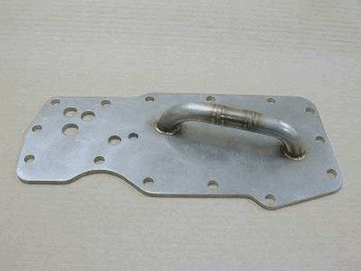

FIG. A4.1 Oil Heat Exchanger Bypass Plate
A4.1.2 Remote Filter Head Bypass—See Fig. A4.2.

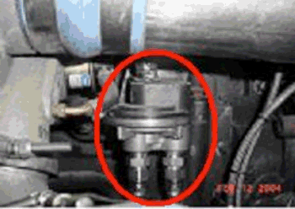

FIG. A4.2 Remote Filter Head Bypass
A4.1.3 Remote Oil Heat Exchanger—See Fig. A4.3.

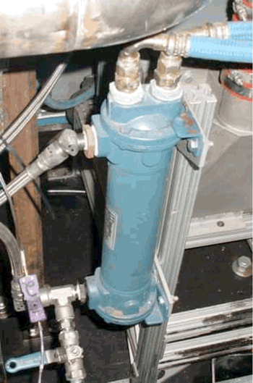

FIG. A4.3 Remote Oil Heat Exchanger
A4.1.4 Oil Pan Modifications—See Fig. A4.4.

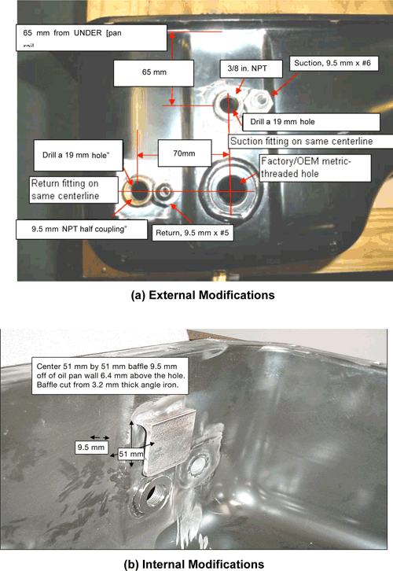

FIG. A4.4 Oil Pan Modifications
A4.1.5 Blowby Elbow to Blowby Barrel—See Fig. A4.5.

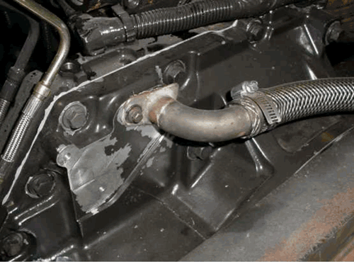

FIG. A4.5 Location of the Elbow for Venting the Blowby Gas
A4.1.6 Intake Air System—See Figs. A4.6-A4.8.

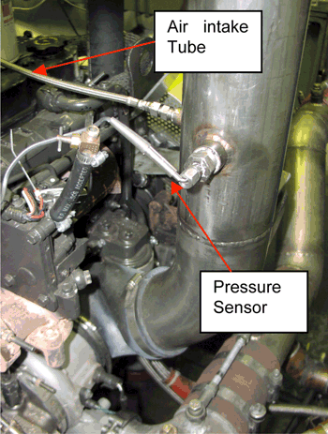

FIG. A4.6 Configuration of the Intake Air System

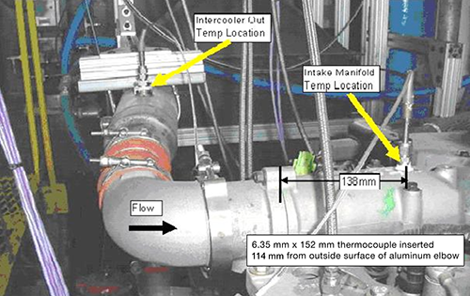

FIG. A4.7 Location of Sensor for Intake Manifold Temperature Measurement

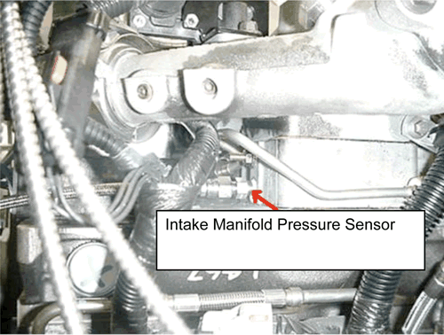

FIG. A4.8 Location of Sensor for Intake Manifold Pressure Measurement
A4.1.7 Remote Oil Filter—See Fig. A4.9.

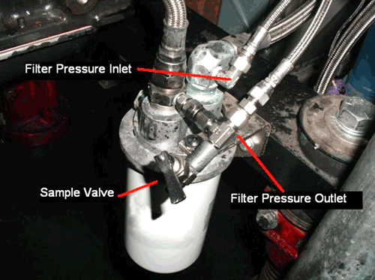

FIG. A4.9 Remote Oil Filter Showing Location of Sensors for Inlet and Outlet Pressure and the Recommended Location of the Oil Sample Valve
A4.1.8 Aftercooler Installation—See Fig. A4.10.

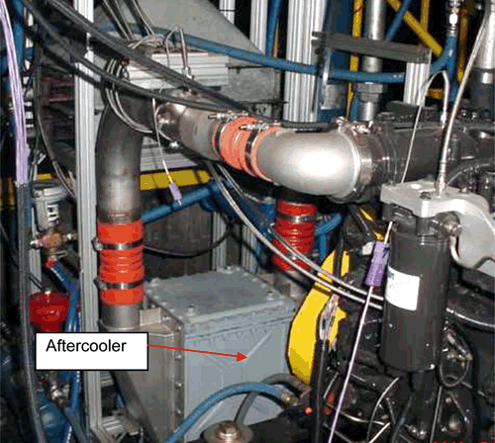

FIG. A4.10 Aftercooler Installation
A4.1.9 Exhaust System—See Fig. A4.11.

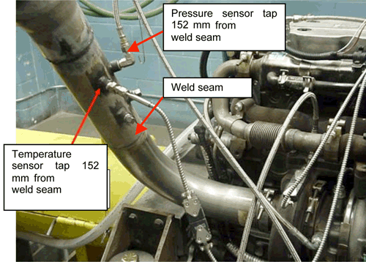

FIG. A4.11 Exhaust System Showing Location of Taps for Temperature and Pressure Sensors
A4.1.10 Oil-Gallery Temperature and Pressure—See Fig. A4.12.

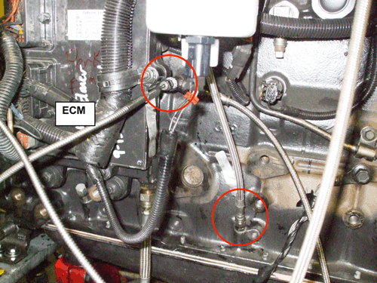

FIG. A4.12 Location of Sensors for Oil Gallery Temperature and Pressure and Crankcase-Pressure Measurement
A4.1.11 Crankcase-Pressure Measurement Point—See Fig. A4.12.
A4.1.12 Fuel-Temperature Measurement—See Fig. A4.13.

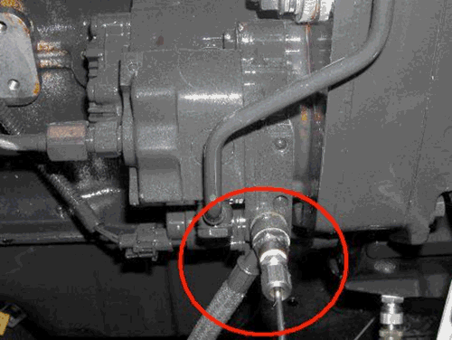

FIG. A4.13 Location of Sensor for Fuel-in Temperature Measurement
A4.1.13 Fuel-Pressure Measurement—See Fig. A4.14.

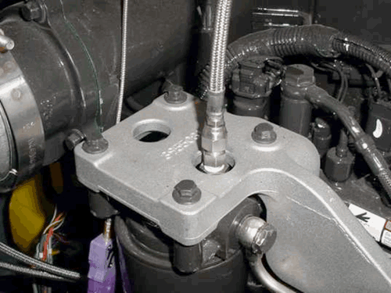

FIG. A4.14 Location of Sensor for Fuel-Pressure Measurement
A4.1.14 Coolant-Temperature Outlet and Inlet Measurement—See Fig. A4.15.

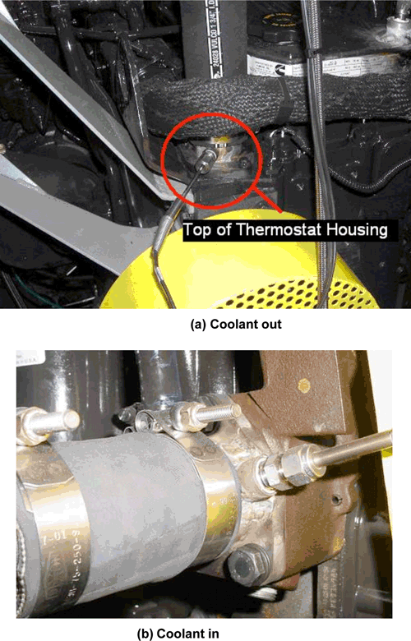

FIG. A4.15 Location of Sensors for Coolant-Temperature Measurement
A5. EXTERNAL OIL SYSTEM
A5.1 See Fig. A5.1.

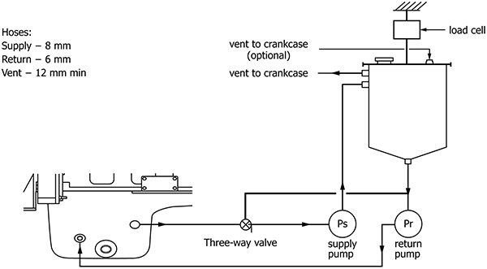

FIG. A5.1 External Oil System
A6. CUMMINS SERVICE PUBLICATIONS
A6.1 General preparation techniques, as well as, engine specifications, component specifications and torque values for Cummins ISB engines are detailed in the Cummins publication entitled Troubleshooting and Repair Manual ISB^{e} and ISB (Common Rail Fuel System) Series Engines, Bulletin Number 4021271, June 30, 2004. The manual is available from Cummins Parts Distributors.
A6.2 The following Cummins publication also contains information relevant to the ISB engine: Troubleshooting and Repair Manual ISB, ISB^{e}, QSB 4.5, QSB 5.9, QSB 6.7, ISC, QSC 8.3, ISL and QSL 9 Engines, CM 850 Electronic Control System Engines, Bulletin Number 4021416.
A7. SPECIFIED UNITS AND FORMATS
A7.1 Specified Units:
A7.1.1 The parameters in this test method are specified in SI units except for pipe fittings, tubing, and tubing fittings. These are available worldwide and are not interchangeable with Sl-sized equivalents because of differences in thread dimensions. As a consequence, no SI conversion is stated. The ports are standard straight thread and are not interchangeable with Sl-sized equivalents.
A7.1.2 Test Report—Record operational parameters according to Table A7.1. Report test results in the units and with the significant digits shown in Table A7.2. Round test results in compliance with Practice E29.

TABLE A7.1 Minimum Resolution of Recorded Measurements
Parameter | Record Data  to Nearest
Speed | 1 r/min
Power | 1 kW
Torque | 1 N·m
Fuel Flow | 0.1 kg/h
Coolant In Temperature | 0.1 °C
Coolant Out Temperature | 0.1 °C
Fuel In Temperature | 0.1 °C
Oil Gallery Temperature | 0.1 °C
Intake Air Temperature | 0.1 °C
Exhaust (Tailpipe) Temperature | 1 °C
Intake Manifold Pressure | 0.1 kPa
Crankcase Pressure | 0.01 kPa
Exhaust Pressure | 0.1 kPa

TABLE A7.2 Significant Digits for Test Results
Viscosity Increase (cSt) | 0.00 cSt
A7.1.3 Measurements and Conversions—With the exceptions noted in A7.1.1, all parameters have been specified in SI units. The intent of this test method is to measure all parameters directly in SI units. If parameters are measured in inch-pound units, then the laboratory shall be able to demonstrate to the TMC that the measurements are within the tolerance after conversion to SI units.
Note A7.1—Caution: Significant error can occur due to rounding or tolerance stacking, or both, when converting from inch-pound units to SI units.
A7.2 Specification Format—Specifications are listed in three formats: (1) target, (2) target and range, and (3) range with no target.
A7.2.1 Target—A target specification has no tolerance; as a consequence, the only acceptable result is the target. A representative specification format is xx.xx (target). For example, the oil pan oil charge is listed as 14.5 kg.
A7.2.1.1 A parameter with a target shall not be intentionally calibrated or controlled at a level other than the target.
A7.2.2 Target and Range—A target and a range specification implies the correct value is the target and the range is intended as a guide for maximum acceptable variation about the mean. A representative specification format is xx.xx ± x.xx (target ± range). For example, the engine speed is 1600 r/min ± 10 r/min.
Note A7.2—The mean of a random sample should be equivalent to the target. Operation within the range does not imply that parameter will not bias the final test results.
A7.2.3 Range with No Target—A range with no target specification is used when (1) the parameter is not critical and control within the range is sufficient, or (2) the measurement technique is not precise, or both. A representative specification format is xx.xx to xx.xx (range low to range high). For example, the coolant system pressure is (99 to 107) kPa.

A8. DETERMINATION OF OPERATIONAL VALIDITY
A8.1 Quality Index Calculation
A8.1.1 Calculate Quality Index (QI) for all control parameters in accordance with the DACA II Report. Be sure to account for missing or bad quality data according to the DACA II Report as well.
A8.1.2 Use the U, L, Over Range, and Under Range values shown in Table A8.1 for the QI calculations.

TABLE A8.1 Quality Index and Average Calculation Values
Control Parameter | Units | Quality Index  Threshold | Quality Index U & L Values |  | Over & Under Range Values
Control Parameter | Units | Quality Index  Threshold | U | L | Low | High
Speed | r/min | 0.000 | 1602.5 | 1597.5
Fuel flow | kg/h | 0.000 | 21.00 | 19.00
Inlet manifold temperature | °C | 0.000 | 68.8 | 67.2
Coolant Out temperature | °C | 0.000 | 66.9 | 65.1
Fuel in temperature | °C | 0.000 | 40.6 | 39.4
Oil gallery temperature | °C | 0.000 | 88.6 | 87.4
Intake air temperature | °C | 0.000 | 31.0 | 29.0
Ranged Parameter | Units | Range |  |  | Over & Under Range Values
 |  |  |  |  | Low | High
Inlet air restriction | kPa | 1.75–2.25
Inlet manifold pressure | kPa | 140 minimum
Exhaust back pressure | kPa | 6.6–7.4
Crankcase pressure | kPa | 0.25–0.75
Intake CO₂ | % | X.X ± 0.05

A8.1.3 Round the calculated QI values to the nearest 0.001.
A8.1.4 Report the QI values on the appropriate form.
A8.2 Averages
A8.2.1 Calculate averages for all control, ranged, and non-control parameters and report the values on the appropriate form.
A8.2.2 The averages for control and non-control parameters are not directly used to determine operational validity but they may be helpful when an engineering review is required (refer to A8.4).
A8.3 Determining Operational Validity
A8.3.1 QI threshold values for operational validity are shown in Table A8.1. Specifications for all ranged parameters are shown in Table A8.1.
A8.3.1.1 A test with EOT QI values for all control parameters equal to or above the threshold values and with averages for all ranged parameters within specifications is operationally valid, provided that no other operational deviations exist that may cause the test to be declared invalid.
A8.3.1.2 A test with any control parameter QI value less than the threshold value requires an engineering review to determine operational validity, A8.4.
A8.3.1.3 With the exception of crankcase pressure, a test with a ranged parameter average value outside the specification is invalid. A test with crankcase pressure outside the specification requires an engineering review to determine operational validity.
A8.4 Engineering Review
A8.4.1 Conduct an engineering review when a control parameter QI value is below the threshold value. A typical engineering review involves investigation of the test data to determine the cause of the below threshold QI. Other affected parameters may also be included in the engineering review. This can be helpful in determining if a real control problem existed and the possible extent to which it may have impacted the test. For example, a test runs with a low QI for fuel flow. An examination of the fuel flow data may show that the fuel flow data contains several over range values. At this point, an examination of exhaust temperatures may help determine whether the instrumentation problem affected real fuel flow versus affecting only the data acquisition.
A8.4.2 For reference oil tests, conduct the engineering review jointly with the TMC. For non-reference oil tests, optional input is available from the TMC for the engineering review.
A8.4.3 Determine operational validity based upon the engineering review and summarize the decision in the comment section on the appropriate form. It may be helpful to include any supporting documentation at the end of the test report. The final decision regarding operational validity rests with the laboratory.

SUMMARY OF CHANGES

ASTM International takes no position respecting the validity of any patent rights asserted in connection with any item mentioned in this standard. Users of this standard are expressly advised that determination of the validity of any such patent rights, and the risk of infringement of such rights, are entirely their own responsibility.
This standard is subject to revision at any time by the responsible technical committee and must be reviewed every five years and if not revised, either reapproved or withdrawn. Your comments are invited either for revision of this standard or for additional standards and should be addressed to ASTM International Headquarters. Your comments will receive careful consideration at a meeting of the responsible technical committee, which you may attend. If you feel that your comments have not received a fair hearing you should make your views known to the ASTM Committee on Standards, at the address shown below.
This standard is copyrighted by ASTM International, 100 Barr Harbor Drive, PO Box C700, West Conshohocken, PA 19428-2959, United States. Individual reprints (single or multiple copies) of this standard may be obtained by contacting ASTM at the above address or at 610-832-9585 (phone), 610-832-9555 (fax), or service@astm.org (e-mail); or through the ASTM website (www.astm.org). Permission rights to photocopy the standard may also be secured from the Copyright Clearance Center, 222 Rosewood Drive, Danvers, MA 01923, Tel: (978) 646-2600; http://www.copyright.com/

? This test method is under the jurisdiction of ASTM Committee D02 on Petroleum Products, Liquid Fuels, and Lubricants and is the direct responsibility of Subcommittee D02.B0 on Automotive Lubricants. *A Summary of Changes section appears at the end of this standard.
? Until the next revision of this test method, the ASTM Test Monitoring Center will update changes in the test method by means of information letters. Information letters may be obtained from the ASTM Test Monitoring Center, 203 Armstrong Drive, Freeport, PA 16229. Attention Administrator. www.astmtmc.org.
? For referenced ASTM standards, visit the ASTM website, www.astm.org, or contact ASTM Customer Service at service@astm.org. For Annual Book of ASTM Standards volume information, refer to the standard's Document Summary page on the ASTM website.
? The last approved version of this historical standard is referenced on www.astm.org.
? This CPD is the sole source of supply of the test engine, engine build parts kit and the ECM known to the committee at this time is Test Engineering, Inc., 12718 Cimarron Path, Suite 102, San Antonio, TX 78249-3423, www.tei-net.com.
? If you are aware of alternative suppliers, please provide this information to ASTM. Your comments will receive careful consideration at a meeting of the responsible technical committee,¹ which you may attend.
? The sole source of supply of this bypass known to the committee at this time is W. G. Sourcing, Inc., 2650 Pleasantdale Road #10, Atlanta, GA 30340. www.wgsourcing.net.
? The sole source of supply of the remote oil heat exchanger known to the committee at this time is Kinetic Engineering Corporation, 2055 Silber Road, Suite 101, Houston, TX 77055. www.kineticengineerinq.com.
? Aeroquip lines are available at a local hose distributors.
? Troubleshooting and Repair Manual ISB, ISB^{e}, QSB 4.5, QSB 5.9, QSB 6.7, ISC, QSC 8.3, ISL and QSL 9 Engines, CM 850 Electronic Control System Engines, Bulletin Number 4021416.
? Available from local Cummins parts distributors.
? Cummins Inc., 1900 McKinley Avenue, Columbus, IN 47201.
? An example damper known to function is a Vulkan Driveline Coupling (Part Number VKL3415, available from American Vulkan USA, 2525 Dundee Road, Winter Haven, FL 33484. www.vulkanusa.com.
? Troubleshooting and Repair Manual for ISB^{e} and ISB (Common Rail Fuel System) Series Engines, Bulletin Number 4021271, June 30, 2004, published by Cummins Inc.
? The sole source of supply of the apparatus known to the committee at this time is Viking Pump, Inc., (unit of IDEX Corporation), 406 State St., P.O. Box 8, Cedar Falls, IA 50613-0008. www.vikingpumps.com.
? Available from the TMC website: www.astmtmc.org.
? Available from the TMC website at http://www.astmtmc.org/ftp/docs/fuel/tmc-monitored%20test%20fuel%20specifications.pdf.
? Ensolv is a registered trademark of, and is available from, Enviro Tech International, Inc., 2525 West LeMoyne Ave., Melrose Park, IL 60160. www.ensolv.com.
? National Institute for Standards and Technology, www.nist.gov.

