Fig. A4.9
Coolant Outlet Temperature

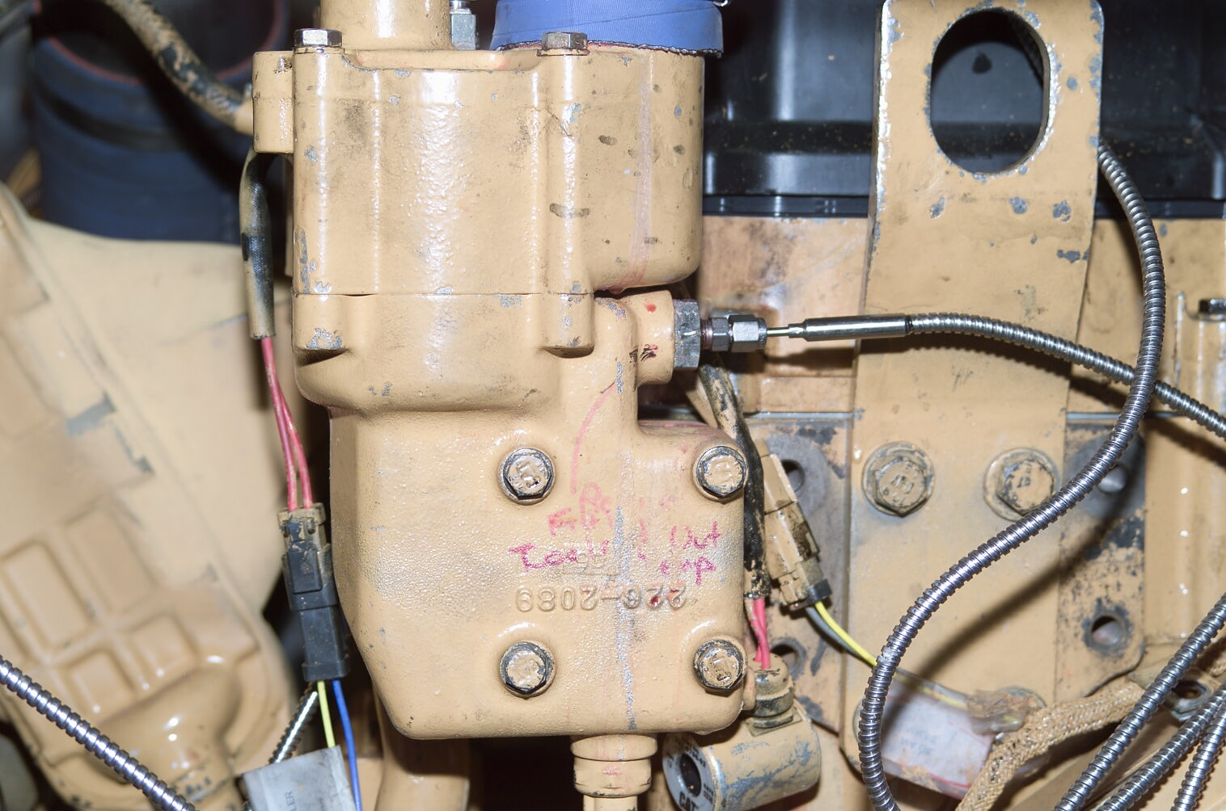
Coolant Out Temp

