Fig. A4.8
Crankcase Pressure Connection

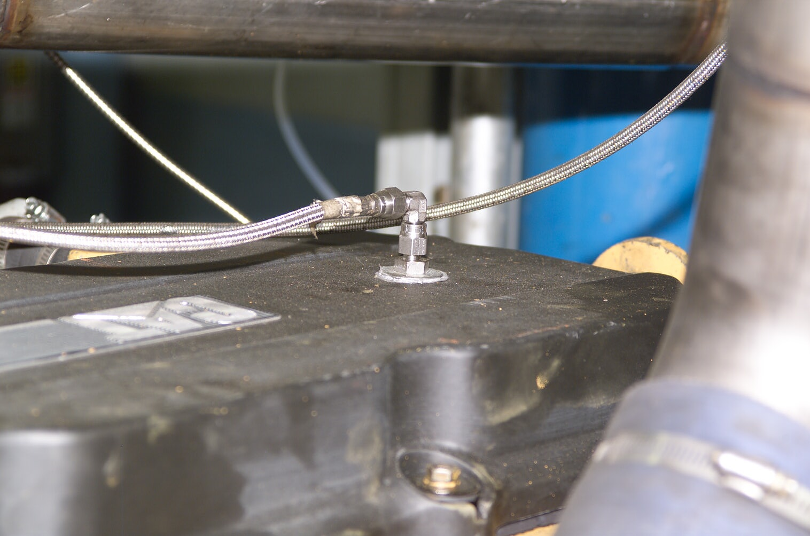
Bulkhead Fitting

