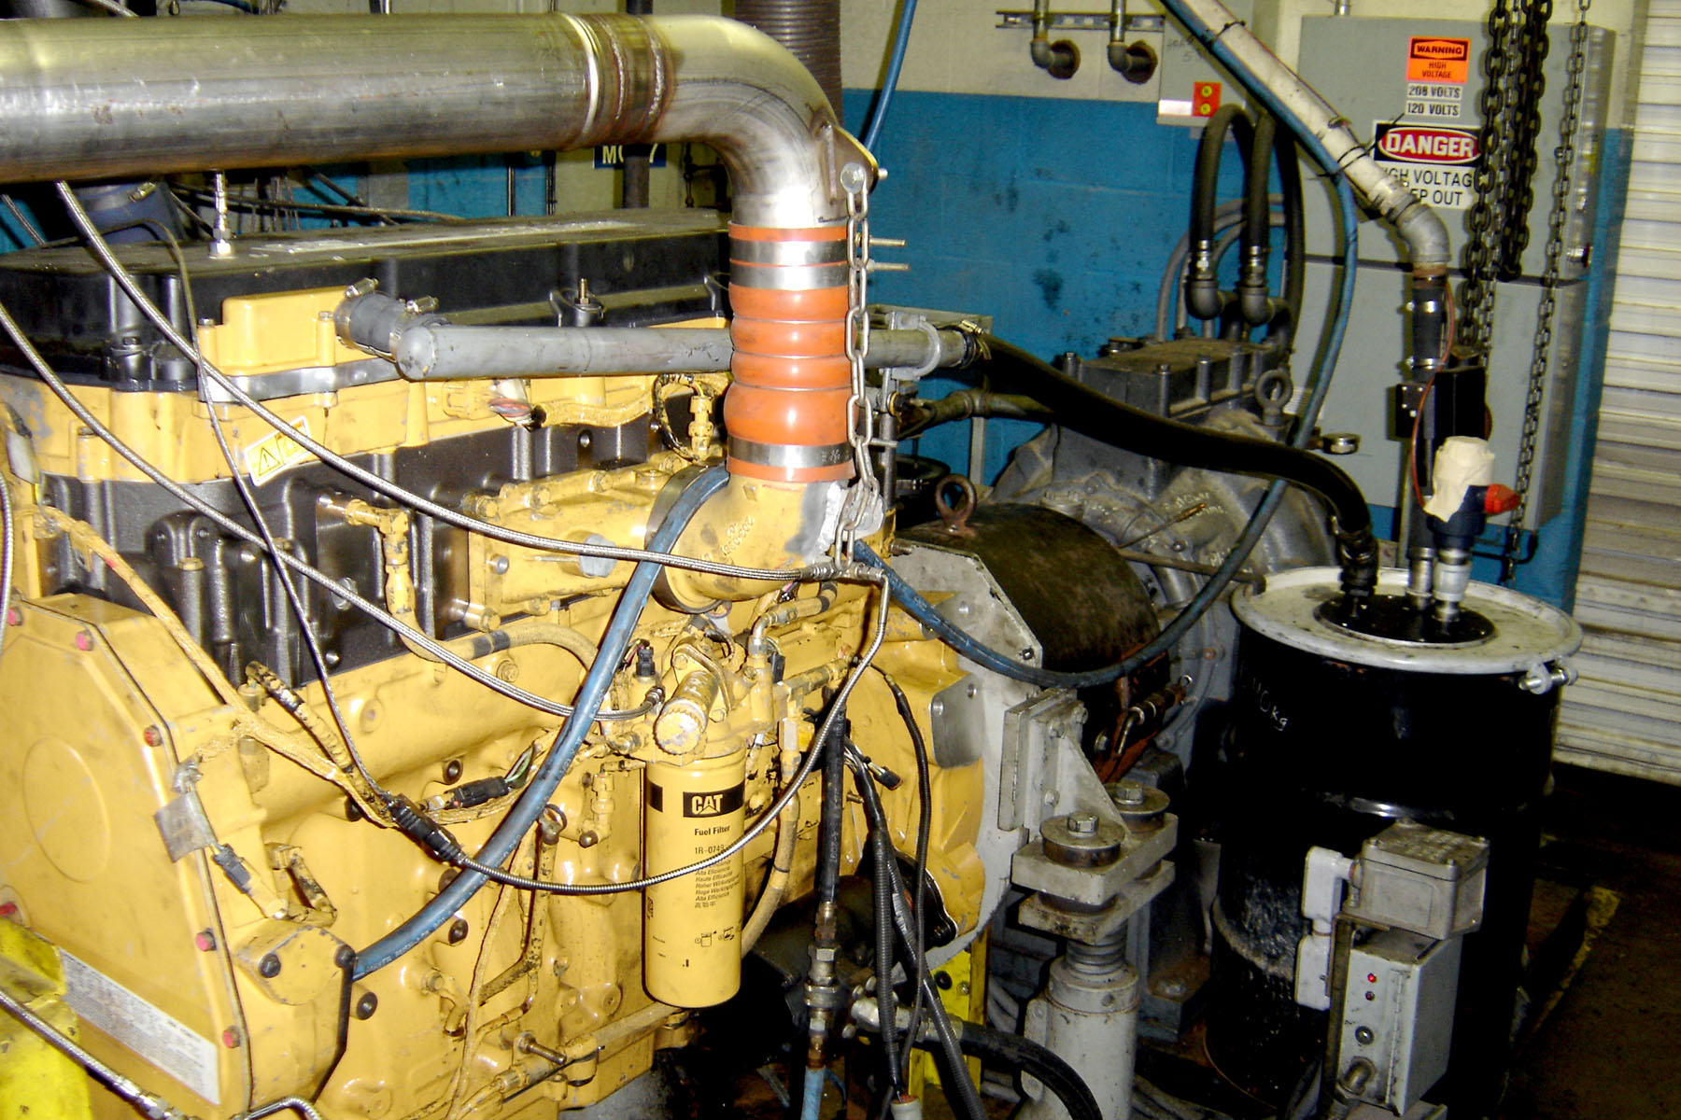
Figure A4.7 Crankcase Aspiration System
Spacer plate
Blowby filter
Blowby
Canister
To flow rate
Measurement
device

