Fig. A4.6
Oil Weight Cart

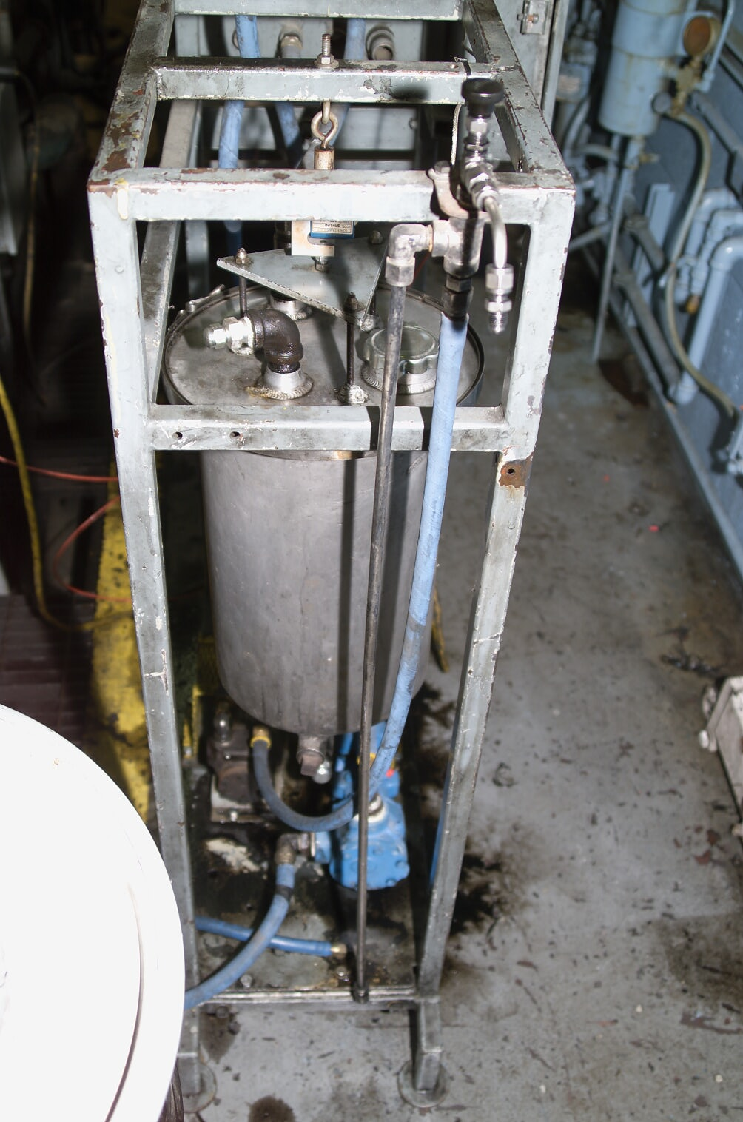
Sample Valve

