Fig. 4.5
Pressurized Oil Fill Port

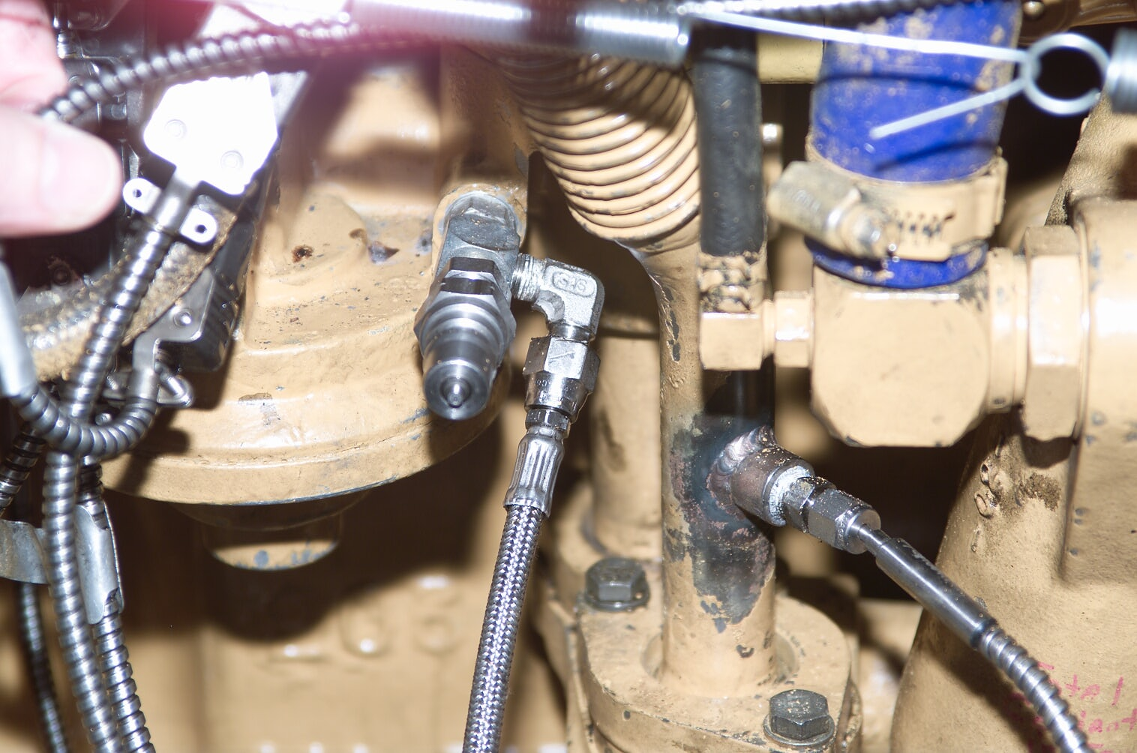
Oil Fill Quick Disconnect
Oil Filter Inlet Press

