Fig. A4.4
Exhaust Tube

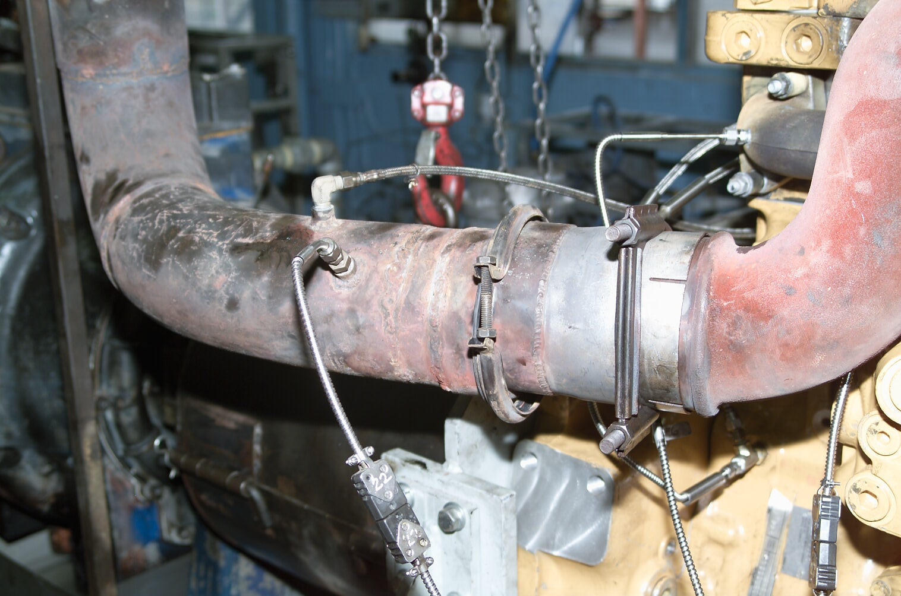
Exhaust Temp
Exhaust Pressure

