Fig. A4.3
Inlet Tube

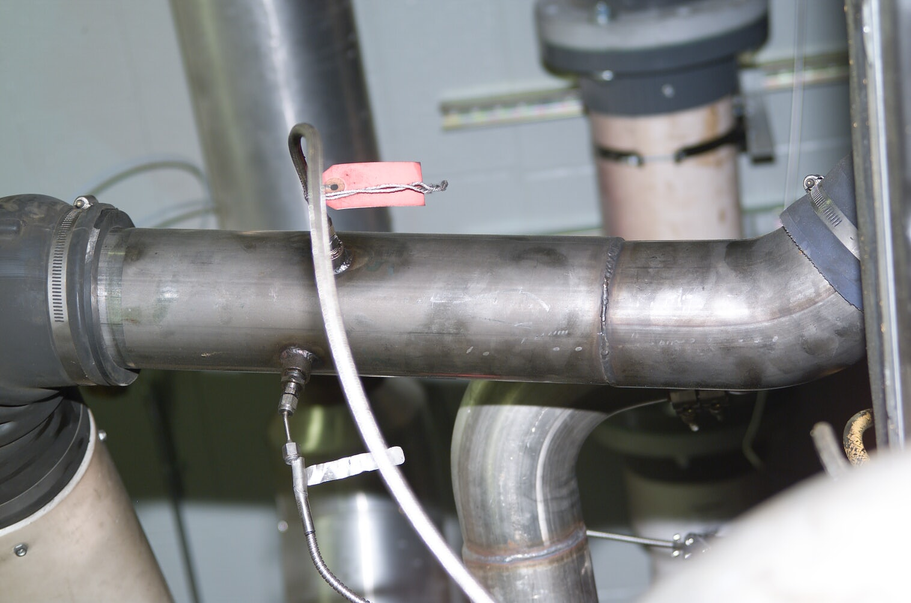
Inlet Air Temperature
Inlet Air Pressure
Air Flow

