Fig A4.2
Compressor Block off Plate and Crankcase Pressure Balance Connection

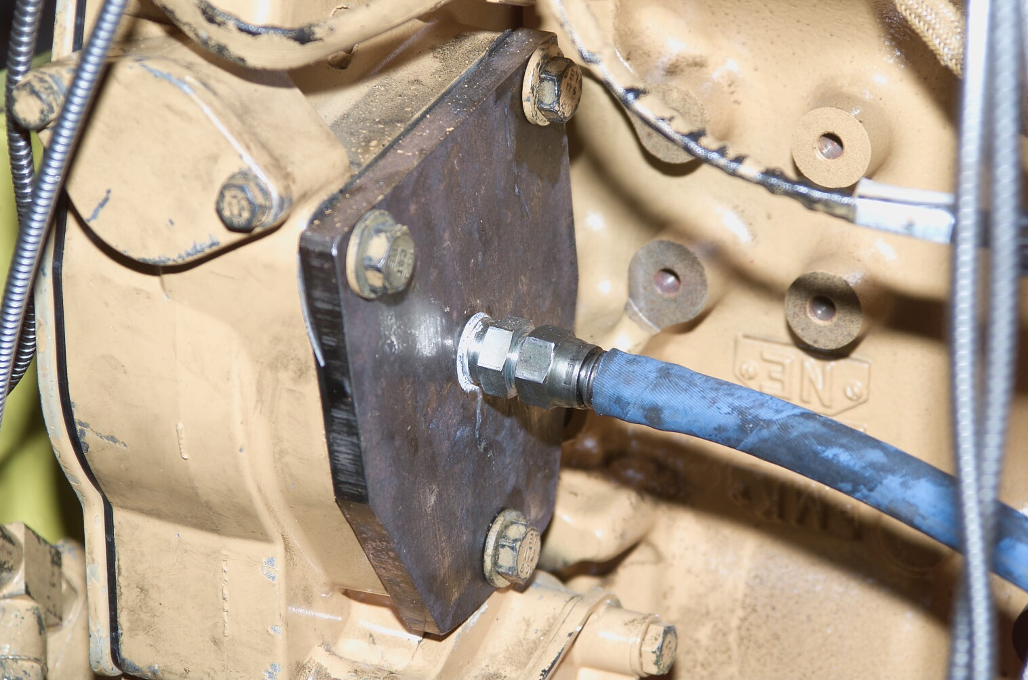
Block Off Plate

Crankcase Pressure Balance

