Fig. A4.19
Turbo Wastegate Control Cable

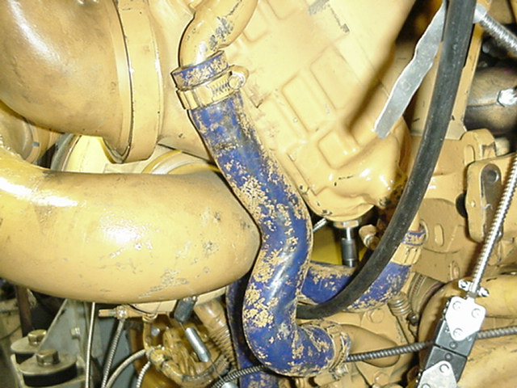
Operator Cable from Front of Engine

