Fig. A4.15
Cooling System Pressure

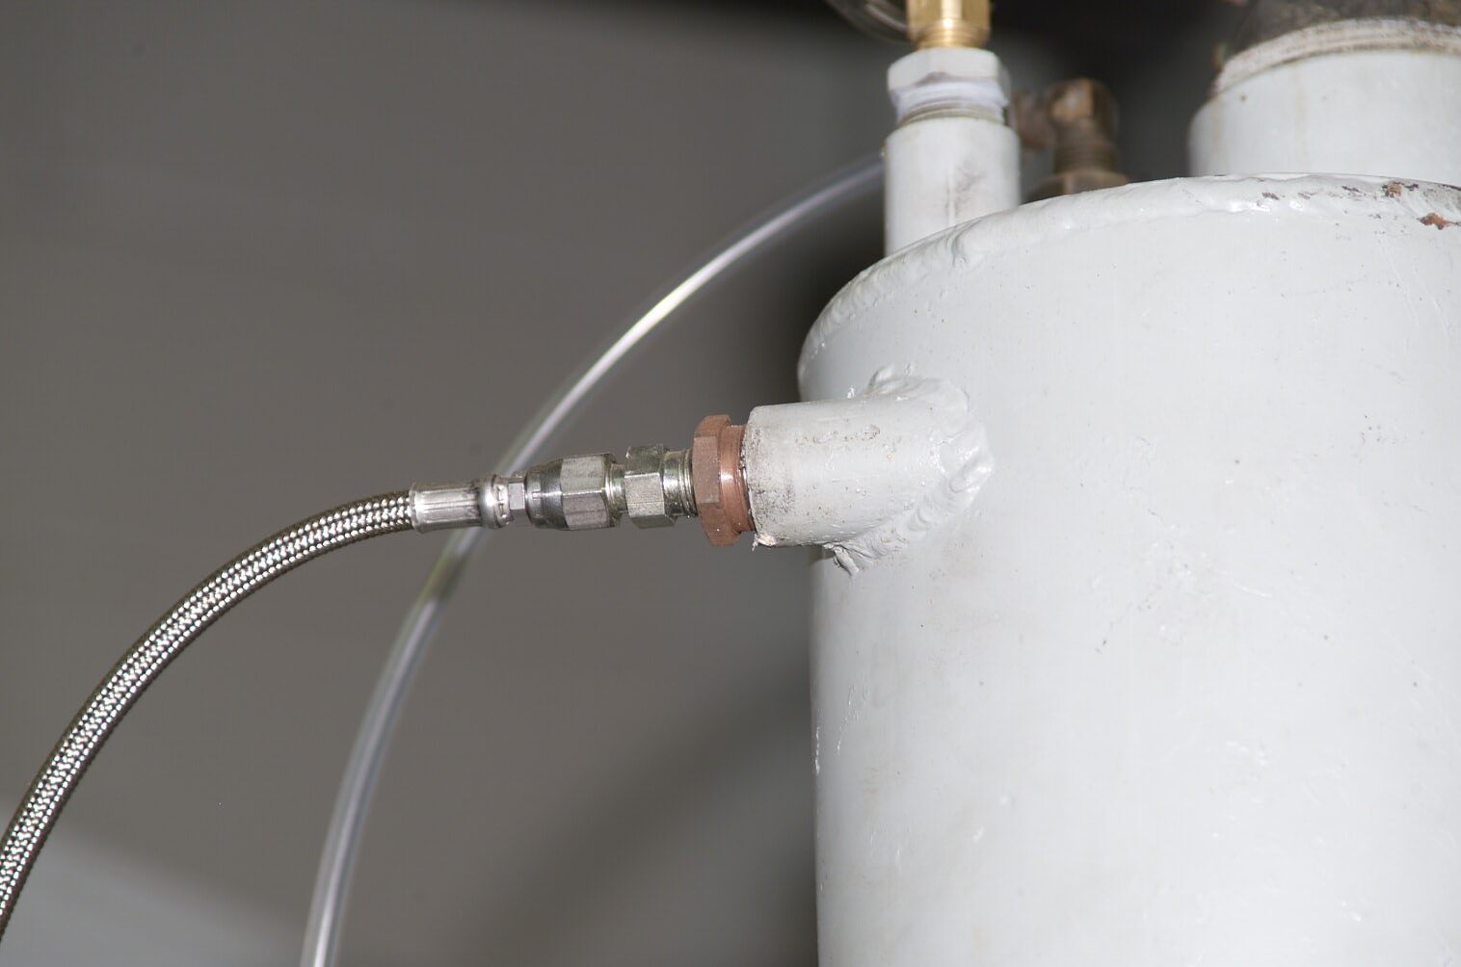
Pressure Tap
T-Stat Housing Air Purge
Expansion Tank

