Fig. A4.14
Oil Filter Out Pressure and Temperature

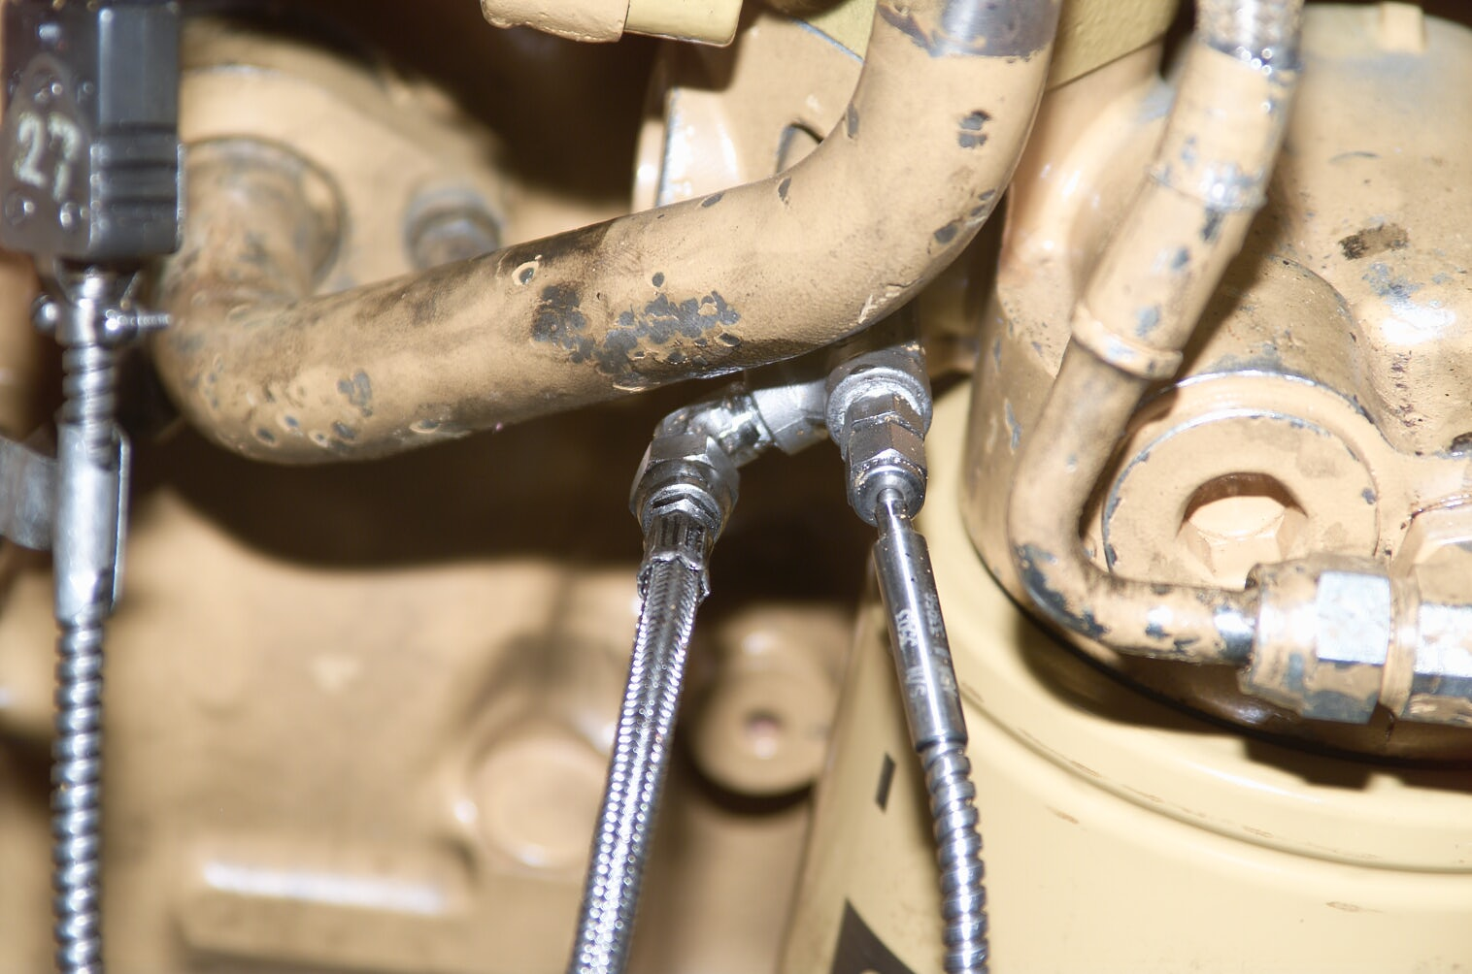
Oil Filter Manifold
Pressure Tap
Temperature Tap

