Fig. A4.13
Intake Manifold Pressure and Temperature

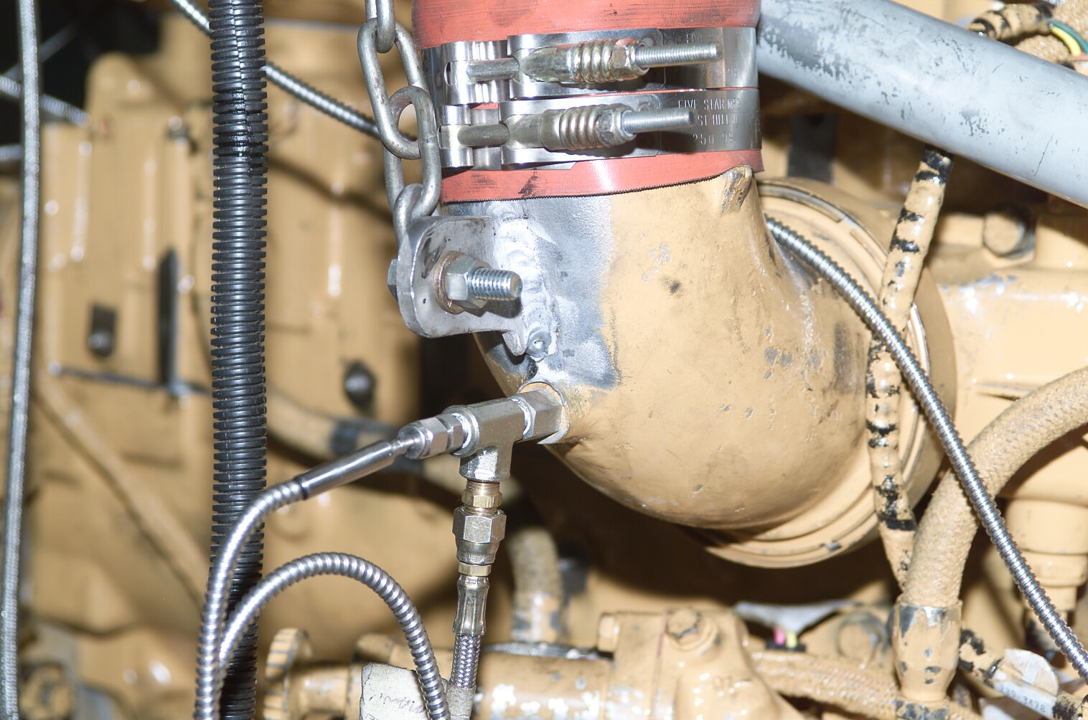
Intake Press
Intake Temp

