Fig. A4.12
Fuel to Engine Pressure and Temperature

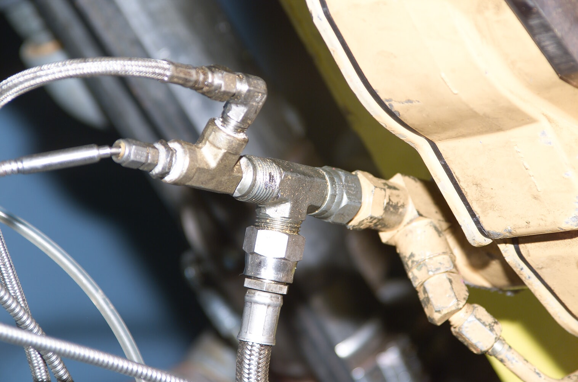
Fuel Supply
Fuel Temp
Fuel Press

