Fig. A4.11
Oil Gallery Pressure and Temperature

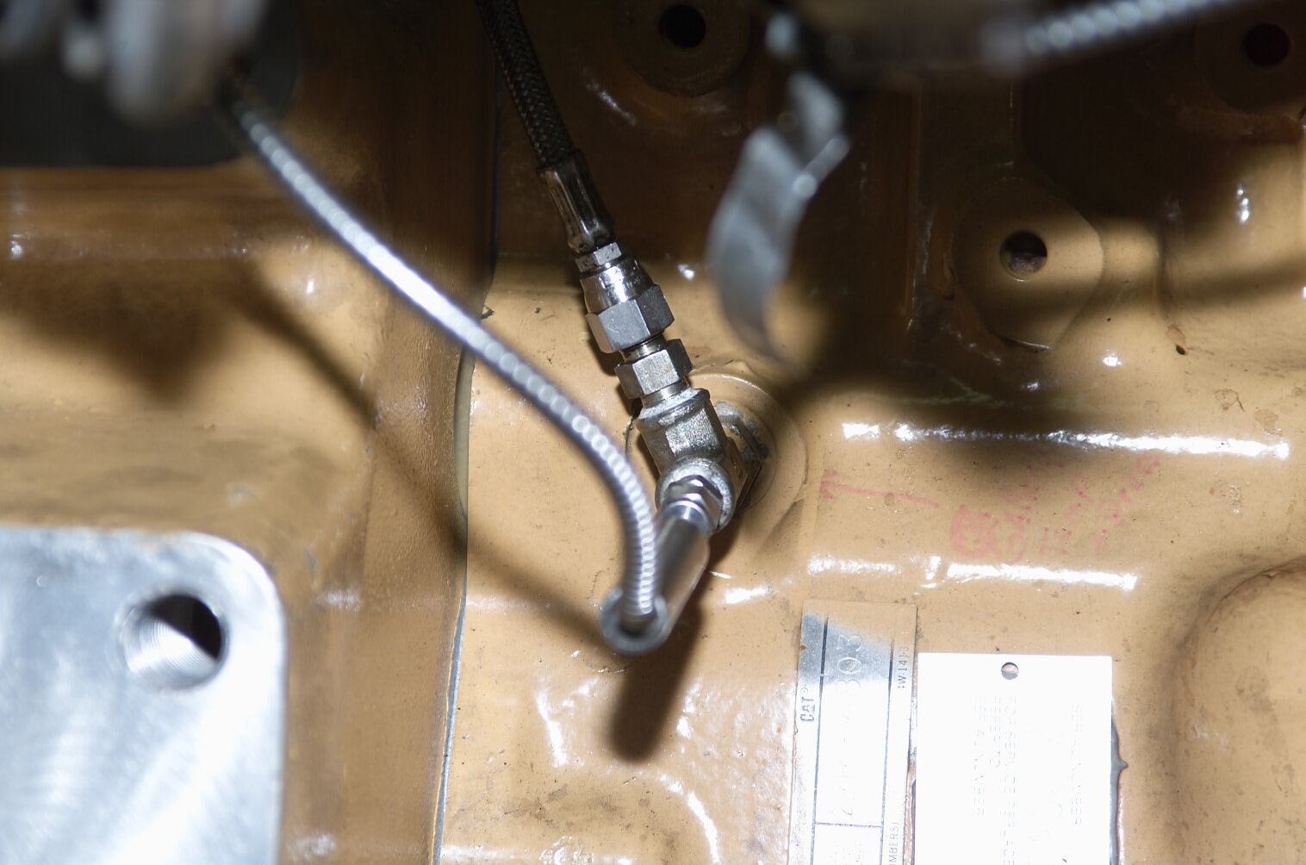
Oil Gallery Tap
Pressure Tap
Temperature Probe

