Fig. A4.10
Coolant to Engine

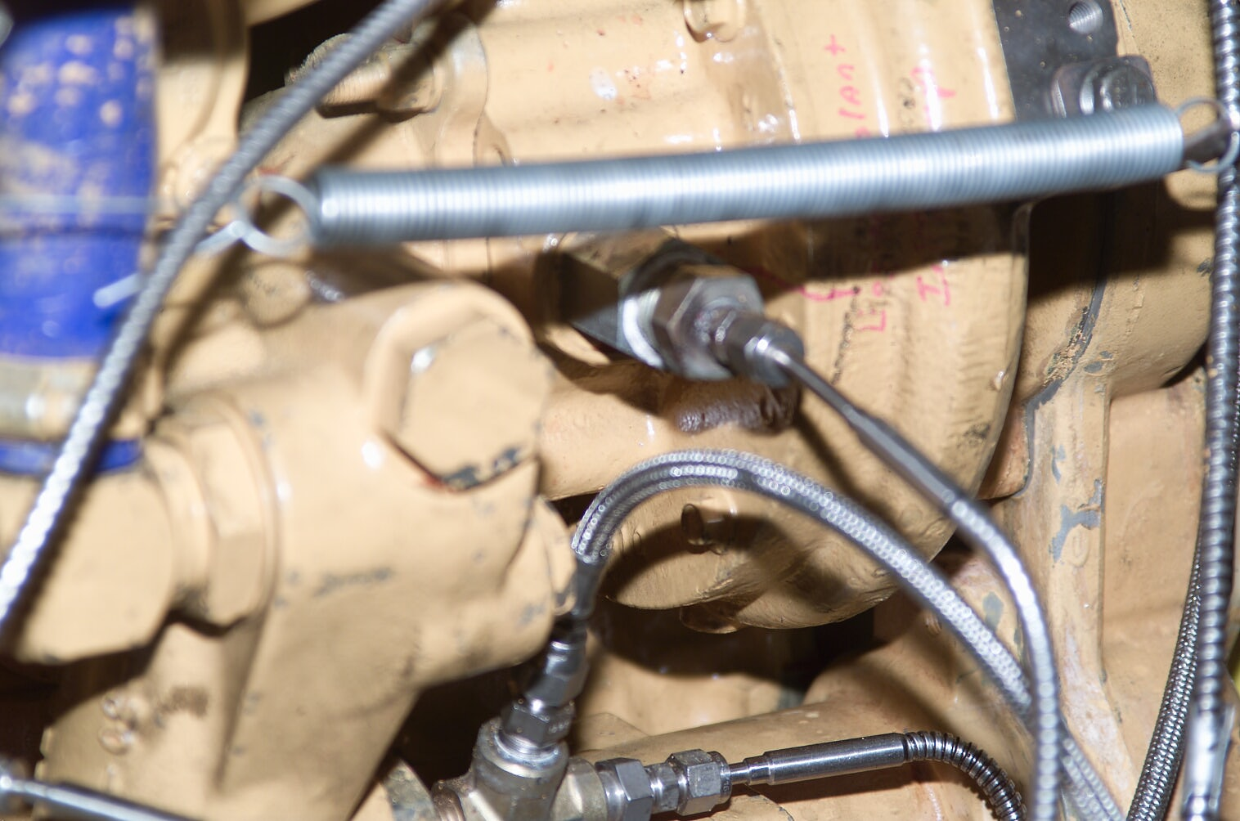
Coolant Inlet Temp
Engine Coolant Pump

