CATERPILLAR C13

ENGINE OIL AERATION TEST

**Draft B1- Released to the ASTM SUB B PC-11 2/26/2014**

This document is a draft procedure submitted for consideration by ASTM and the appropriate sub committees and groups for use in the development of a new ASTM standard. Modifications to this procedure will be made throughout development before being accepted.

Prepared by: Martin Thompson

Reviewed by:

Accepted by:

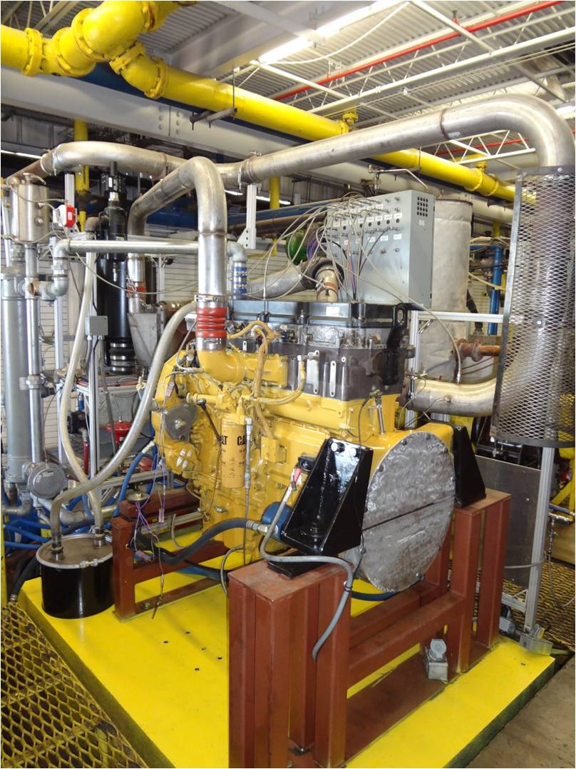

1. **Scope**

This test method is commonly referred to as the C13 EOAT. The test method defines a heavy-duty diesel engine test procedure conducted under high idle conditions to evaluate engine oil performance with regards to engine lubricant aeration.

1. **Reference Documents**

ASTM D7549 C13 Test Procedure

Additional references to be defined in a later draft

1. **Terminology**

To be defined in a later draft

1. **Summary of Test Method**

This test method uses a Caterpillar production C13 diesel engine (see ASTM D7549 C13 Test Procedure Annex A3 for ordering information and a list of engine build parts). The test operation involves two 30 minute flushes for each test, a 30 minute test warm-up, a 5 minute baseline density reference period and then a 50 hour test length at high engine speed. The aeration level of the engine oil is determined by using a Coriolis Density Meter to continuously monitor the density of a small portion of diverted gallery oil flow that has controlled pressure, temperature and flow rate. The density of this oil is used to calculate the percentage of total sample volume that is entrained air.

The engine and test stand are equipped with appropriate instrumentation to record and control various operating parameters.

1. **Significance and Use**

This test method assesses the performance of an engine oil with respect to entrained aeration under high speed operation of a turbocharged heavy-duty four stroke diesel engine.

The results from this test method may be compared against specification requirements to ascertain acceptance.

The design of the test engine used in this test method is representative of many, but not all, diesel engines. This factor, along with the unique operating conditions, needs to be considered when comparing the test results against specification requirements.

1. **Apparatus**

**Test Engine Configuration**

The test engine should be configured in accordance with the C13 Test Procedure D7549 Section 6 and the supporting Annex A3.

The test engine does not require a dynamometer or driveline for test operation. All items associated with the dynamometer and requirements in D7549 are not necessary.

The external oil system (D7549 6.2.8) is not used on the C13 EOAT test engine. Using an oil pan that is modified according to D7549 is acceptable however the added oil pan fittings must be capped.

The aeration measurement system is comprised primarily of a heated line, pressure control valve, coriolis density meter, variable speed pump, pressure transducers and thermocouples. This system should be assembled as shown in A?.?

1. **Engine Liquids and Cleaning Solvent**

Approximately 115 L of test oil is required to complete the test.

Approximately 490 L of Chevron Philips PC-10 ultra low sulfur diesel fuel is required to complete the test.

Prepare the engine coolant by mixing 50% volume of mineral free water with 50% volume of Caterpillar brand coolant concentrate. As an option, pre-mixed coolant is available and may be used directly. Table 2 shows Caterpillar part numbers for several sized containers of concentrate or premixed coolant.

The mineral-free water shall have a mineral content not exceeding 34.4 mg/kg of total dissolved solids.

The coolant mixture may be used for 6 test starts or up to 3400 h. The mixture shall remain at a 50/50 ratio during the course of the test. Verify by using either Caterpillar testers 5P3514 or 5P0957 or an equivalent tester. Keep the coolant mixture free from contamination.

Keep the total solids below 5000 mg/kg.

Maintain a correct additive level. Verify by checking the coolant using Caterpillar test kit P/N 8T5296.

Cleaning Solvent*—*Use a solvent that meets ASTM [D235](http://enterprise.astm.org/SUBSCRIPTION/NewValidateSubscription.cgi?D235-HTML), Type II, Class C requirements for aromatic content (0-2 % vol), flash point (61 °C, min), color (not darker that +25 Saybolt or 25 Pt-Co). Obtain a certificate of analysis for each batch of solvent from the supplier. (**Warning—**Combustible. Health Hazard. Use adequate safety precautions.)

1. **Preparation of Apparatus**

All engine assembly and cleaning of parts should be done in accordance with D7549 section 8. The rebuild of the test engine should be performed when operational conditions cannot be met or reference testing cannot meet acceptable limits.

(The rebuild interval may be revised at a later date)

All operational measurements including instrument calibration, temperature measurement locations, pressure measurement locations and flow rate measurement locations should be done in accordance with D7549 section 8.

Additionally, aerated oil sample temperature, pressure, flow rate and density are measured using the aeration system as shown in A?.?

The sample oil temperature value is an average of the Coriolis Meter inlet thermocouple and the Coriolis Meter outlet thermocouple. The sample oil temperature is a theoretical temperature at the midpoint of the Coriolis Meter.

The sample oil pressure value is an average of the Coriolis Meter inlet pressure transducer and the Coriolis Meter outlet pressure transducer. The sample oil pressure is a theoretical pressure at the midpoint of the Coriolis Meter.

1. **Engine/Stand Calibration and Non-Reference Oil Tests**

To be defined in a later draft

1. **Procedure**

Initial Engine Test Following Engine Rebuild:

Install the test engine into a test cell equipped for the operational conditions required by the C13 D7549 section 10.5 Break-In Conditions. A full load break-in using the C13 D7549 procedure is necessary to properly load engine. This test cell is not required to be used for the aeration testing. The Break-In oil must be Caterpillar branded DEO-ULS CJ-4 15W-40 or an equivalent Caterpillar certified CJ-4 15W-40 oil??

After the engine has performed a full break-in it can be transferred to the stand equipped with the aeration measurement system and instrumented according to this procedure. Alternatively, the engine can run both the break-in and the aeration testing on the same stand so long as it can meet the D7549 break-in procedure conditions and can also maintain the operation conditions defined in this procedure for aeration testing.

**Pre-Test Procedure:**

Install a new Caterpillar 1R-1808 oil filter.

Fill the engine with 32.2 L of test oil. Engine oil may either be pressure charged into the engine according to D7549 section 6.2.7 or manually filled through the engine oil add tube.

Start the engine, perform the warm-up (TABLE ??). After step 2 of the warm-up completes perform a 2 min cool down at idle conditions before stopping the engine.

Drain the engine of the initial oil charge while allowing the oil sampling circuit pump to run and drain. After the engine has been drained of oil, fill the engine with a new 32.2 L charge of test oil.

Repeat the warm-up. After step 2 of the warm-up completes perform a 2 min cool down at idle conditions before stopping the engine.

Drain the engine of the initial oil charge while allowing the oil sampling circuit pump to run and drain. After the engine has been drained of oil, fill the engine with a new 36 L charge of test oil. Record the oil weight and volume of this oil fill.

**Warm-up and Baseline Conditions**

**Parameter Unit Step 1 Step 2**

Stage Length min 5 30

Speed rpm 900 1800

Coolant Out Temp. A °C 90 90

Intake Air Temp. A  °C 25 25

Manifold Temp. A °C 40 40

Fuel Temp. A °C 40 40

Gallery Oil Temp. A °C 90 90

Sample Oil Temp. A °C 90 90

Sample Oil Flow A L/min 1.5 1.5

Sample Oil Pres A kPaA 150 150

Intake Air Pres A kPaA 93 93

Fuel Flow g/min Record Record

Blowby Flow L/min Record Record

Intake Manifold Pres. kPaG Record Record

Exhaust After Turbo Temp. °C Record Record

Fuel Pressure kPaG Record Record

Oil Gallery Pressure kPaG Record Record

Coolant System Pressure kPaG Record Record

Exhaust restriction kPaG Record Record

Crankcase Pressure kPaG Record Record

*A This is the control set-point. It can require up to 30 min of operation to achieve.*

**Shutdowns and Maintenance:**

The test may be shutdown at the discretion of the laboratory to perform repairs. However, the intent of this test method is to conduct the 50 h test procedure without shutdowns.

A normal shutdown is accomplished by ramping down to idle conditions and running for 2 minutes and then stopping the engine.

An emergency shutdown occurs when the normal shutdown cannot be completed, such as under an alarm condition. During an emergency shutdown ignition can be turned off immediately and the engine allowed to stop.

Maintenance can be performed on the engine components or stand support equipment at the discretion of the laboratory.

The limit for total downtime and number of shutdowns is not specified. Record all shutdowns, pertinent actions and total downtime during the 50h test procedure.

Each time the engine is re-started it must perform the warm-up (TABLE??) before proceeding onto test.

**Baseline Reference Procedure:**

After flushing the engine with the procedure above a new test must perform a complete warm-up and baseline reference step. This step is performed at the same operational conditions as standard warm-up and the 50 h test step, however there are multiple calculations and values determined during the step that are used throughout the 50 h test.

The thermal expansion coefficient is determined by calculating the linear slope of oil sample density versus oil sample temperature through a 10 degree oil sample temperature increase using the least squares method. This calculation will use all data points for density and the corresponding oil sample temperature between 80 and 90 degrees Celsius. This temperature window is typically seen during the last 10 minutes of warm-up step 2.

The test laboratory shall interpret the results and the accuracy of the correlation to determine if the thermal expansion coefficient is appropriate. Modifications to this coefficient calculation or data set must be supported with comments if the test laboratory calculates this value in any other manner.

After this warm-up is completed the thermal expansion coefficient is set and is not calculated again for subsequent restarts and warm-ups.

Immediately following step two of this warm-up, the engine is run for 5 minutes at stage 2 warm-up conditions to calculate the baseline un-aerated density. At this point all controlled parameters must be within limits and controlling well (define). The baseline oil density for use in calculating the test aeration is calculated during this step by averaging the oil sample density for the 5 minutes and. This value is set for the duration of the test and this step is not run again for subsequent restarts and warm-ups.

The test laboratory shall interpret the results and the accuracy of this step to determine if the baseline density is appropriate. Modifications to this coefficient calculation or data set must be supported with comments if the test laboratory calculates this value in any other manner.

**50 h Test Procedure:**

Take a 240 mL sample of the fresh oil from the original container.

The 50 hour on test step (Table??) is performed immediately after the baseline is run. The 50 hour test timer will accumulate continuously during this step but will stop immediately if a shutdown is initiated. The test timer shall resume when the test has returned to the test step conditions.

During this step the oil aeration and aeration averages are calculated continuously according to the test equations (Table??).

The calculation of oil aeration averages will not include any values obtained within 4 hours of on test time accumulation following an engine shutdown and restart.

Record all operational parameters shown in (Table??) along with the calculated values from (Table??) with automated data acquisition at a minimum frequency of once every 6 min. recorded values shall have a minimum resolution in accordance with (ANNEX??). Report this data on the appropriate form of the test report.

Oil samples and analysis are taken according to the schedule and methods shown in (ANNEX??)

After the 50 hour test has completed, perform a normal cool down. Drain and weigh the test oil charge with the oil sample circuit pump running and calculate the total oil consumed during the test.

**50 h Test Conditions**

**Parameter Unit Step 1**

Stage Length hours 50

Speed rpm 1800

Coolant Out Temp.  °C 90

Intake Air Temp.  °C 25

Manifold Temp. °C 40

Fuel Temp. °C 40

Gallery Oil Temp. °C 90

Sample Oil Temp. °C 90

Sample Oil Flow L/min 1.5

Sample Oil Pres kPaA 84

Intake Air Pres kPaA 93

Fuel Flow g/min Record

Blowby Flow L/min Record

Intake Manifold Pres. kPaG Record

Exhaust After Turbo Temp. °C Record

Fuel Pressure kPaG Record

Oil Gallery Pressure kPaG Record

Coolant System Pressure kPaG Record

Exhaust restriction kPaG Record

Crankcase Pressure kPaG Record

1. **Calculation, Test Validity and Test Results**

Oil samples and analysis are taken according to the schedule and methods shown in (ANNEX??)

Determine the oil aeration using the equations shown in (Table??)

The specified test result is the average aeration level from 30-50 hours. Additionally, the maximum aeration level and a plot of the aeration from 0-50 hours are reported. Report this data on the appropriate form of the test report.

**Test Equations and Aeration Variables**

**Parameter Unit Source**

Sample Oil Density g/cc Direct Measurement

Sample Oil Temperature °C $=AVERAGE(MM Inlet Temp, MM Outlet Temp)$

Sample Oil Pressure kPaA $=AVERAGE(MM Inlet Pres, MM Outlet Pres)$

Sample Oil Flow  L/min Direct Measurement

Ambient Pressure kPaA Direct Measurement

Air Density g/cc $=\frac{(Sample Oil Pressure)}{(287.003*(Sample Oil Temp +273.15)}$

Baseline Oil Density g/cc Average density during baseline step

Thermal Expansion Coef. g/cc°C Linear slope of density decrease from 80-90 °C during warmp

Temp. Corrected Density g/cc $=Sample Oil Density + \left(Thermal Coef. *\left(90-Sample Oil Temp\right)\right)$

Aeration % $=100*\frac{Baseline Oil Density-Temp Corrected Density}{Temp Corrected Density – Air Density}$

**Chem Analysis**

**Method Units BOT EOT 1, 5, 25**

Fuel Dilution D3524 Diesel wt. % No Yes No

Viscosity D445 100°C cSt Yes Yes Yes

Metals by ICP D5185 ppm Yes Yes Yes

|  |  |  |  |
| --- | --- | --- | --- |
| **Aeration Parts List (Order of Flow)** | | | |
| 1 | Heated Line | SII-B-8-060-S-E8-PPO-A-AK-D72-000 5 FT HEATED 1/2" STAINLESS LINE $1,935 | |
| 2 | Regulator | Research Valve ( 1/4", H, ATO), 2 Way, 1001GCN36SVOHLN36 | |
|  | Line | 1 FT 1/2" stainless line | |
| 4 | T and P | 4 way coupling with Thermocouple and Pressure line | |
| 5 | Micromotion | Elite Micromotion 025 | |
| 6 | T and P | 4 way coupling with Thermocouple and Pressure line | |
| 7 | Line | 4 FT 3/8" stainless line (SS-6BHT-48) | |
| 8 | Pump | S-74014-40 GEAR PUMP SYSTEM 115V 14.700 LBS 38 Days $ 1,917.37 | |
| 9 | Line | 4 FT 3/8" stainless line (SS-6BHT-48) | |
|  |  |  |  |
|  |  |  |  |
| **Aeration System Piping Orientation (Order of Flow)** | | | |
| Gallery Inlet | The system inlet will be plumbed to the lower left side drain plug with a 90deg NPT to #10 AN fitting (1/2") | | |
| Heated Line | A 5'x1/2" heated line will run under the engine and to the right side and connected to the regulator | | |
| SS Line | A 1'x1/2" (#10AN) SS PTFE line will run from the regulator to the temp/pressure coupling | | |
| 4 way coupling | A 4x1/2" coupling will be placed with the thermocouple fitting facing upwards and pressure line downwards | | |
| Micromotion | A CMF 025 Elite Micromotion will be oriented with the inlet centerline horizontal and the unit plane vertical | | |
| Mount | A height adjustable mount must be used for mounting the Micromotion. (9”+/- 2” in from oil pan gasket to MM centerline) | | |
| 4 way coupling | A 4x1/2" coupling will be placed with the thermocouple fitting facing upwards and pressure line downwards | | |
| SS Line | A 4'x3/8" (#6AN) SS PTFE line will run from the temp/pressure coupling to the Pump | | |
| Pump | The pump should be mounted with the inlet centerline horizontal and attached to the Mount | | |
| Sump Return | A 4'x3/8" (#6AN) SS PTFE line will run from the Pump to the lower right side drain plug | | |

**Diagram of Aeration system orientation compared to engine:**

