Meeting: Stats Group Support for ROBO
Date: June 7, 2018
Location: Webex

Actions:
- Justin Mills to send the following items to Jo Martinez for distribution: Presentation, TMC calibration requirements, Link to ROBO section on TMC’s website.
- Tom Scholfield and Justin Mills to develop ROBO test timeline with critical dates for the following: method changes, workshop dates, introduction of new reference oils, limit setting for reference oils

Executive Summary:
Justin Mills (ROBO SP Chair) and Tom Schofield (ASTM TMC) met with the ASTM’s Statistics Task Group to discuss the persistent mild trend that ROBO has experienced. The primary objectives of this meeting were the following:
- Provide an introduction into ROBO including test conditions and parameters, calibration requirements, and LTMS
- Review charter for stats group that was developed by ROBO’s surveillance panel
- Determine a path forward

Summary:
On June 7, 2018 Jo Martinez hosted a Webex to discuss a path forward for addressing the persistent mild trend that exists in the ROBO test. Participants included Justin Mills (ROBO SP chair), Tom Scholfield (ASTM TMC), and ASTM’s statistics group.
The following slides were shared during the Webex (and are attached for reference):
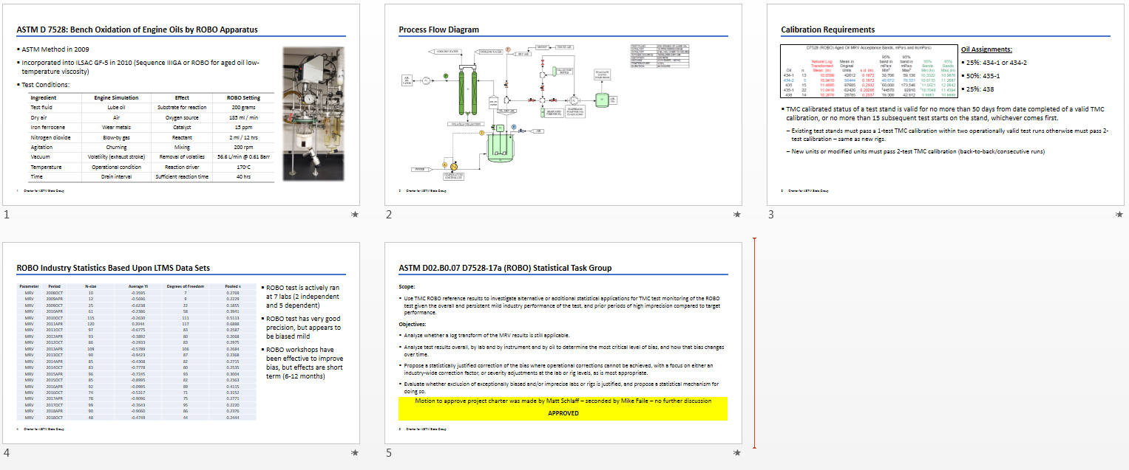

Over the course of the discussion the following topics and questions came up:
- ROBO Calibration
  - TMC calibrated status of a test stand is valid for no more than 50 days from date completed of a valid TMC calibration, or no more than 15 subsequent test starts on the stand, whichever comes first. Existing test stands must pass a 1-test TMC calibration within two operationally valid test runs otherwise must pass 2-test calibration – same as new rigs. New units or modified units must pass 2-test TMC calibration (back-to-back/consecutive runs). Modified units not bear a new name in the LTMS.
  - TMC monitoring is mandatory for the ROBO test. Reference data for the ROBO test is tracked in a LTMS on TMC’s website. Reported parameters include serial numbers for reaction flask and vacuum pump.
- ASTM D 7528 Test Method
  - The method has had a number of revisions since 2009, but majority of the revisions were related to housekeeping; conversion of units (metric), removing outdated tables. In terms of operation and procedure the method has not changed since 2009. The most significant change to the method was in 2017 when TMC monitoring became mandatory
  - ASTM D 7528 specifies critical parts including the reaction flask from ACE Glass. The vacuum pump is not explicitly specified; however it must be capable of delivering a specified flow rate and vacuum.
- Exclusion of “Bad” ROBO units
  - Within the group of TMC monitored ROBO stands, there are sometimes “bad” units. These are units that either fail to calibrate after multiple attempts or have poor precision, causing a negative impact to the test’s pooled s and average Yi. It was suggested that addressing this type of issue is out of the scope of the stats group. Instead this is more or less an administrative task. The surveillance panel can develop criteria to exclude this units from LTMS statistics.
    - It is important to note that ROBO’s calibration requirements are effective in keeping “bad” units out of service. The robust calibration requirements prevent these units from running candidate samples.
  - In an engine test, labs usually self-exclude “bad” engine stands due to the high cost of parts and fuel; however this does not occur in ROBO due to its low cost.
- Persistent Mild Trend
  - The ROBO test has experienced a mild trend since its origination, but the precision is typically on target. It was pointed out that precision will naturally improve as the test runs mild due to the logarithmic transform.
  - In the past ROBO workshops have led to an improvement in ROBO’s bias. At these workshops operators would share best practices including maintenance procedures. Labs would also agree on making a concerted effort to move units toward target performance/severity.
  - The ROBO SP is interested in investigating alternative measures (statistics) to correct the bias
- Statistical Analysis
  - The ROBO test is more complex than most other bench tests. As such, there are many more variables to consider when conducting a statistical analysis.
    - In addition to the operational variables, things such as workshops, method changes, reference oil changes, equipment changes may have an impact on the statistical analysis. An action was taken to develop a timeline of changes to the ROBO test.
  - It was pointed out that not all labs are reporting to the same number of significant figures. For example some labs report MRV as XX,XXX while others report as XX,X00. Also some labs are changing their naming nomenclature of reaction flasks or vacuum pumps between calibrations. It was suggested that reporting units and number of significant figures be harmonized in the reporting of results.
  - Currently TMC’s calibration requirements only address MRV viscosity and do not consider yield stress as a pass/fail criteria. MRV yield stress is reported and tracked on ROBO’s LTMS.
  - Before the stats group can move forward with an analysis the following information must be provided: Presentation, TMC calibration requirements, Link to ROBO section on TMC’s website, ROBO test timeline.
- Timeline
  - There is not an urgent need to address the mild trend in ROBO. The test is operational and “bad” units are being excluded from running candidate samples by TMC’s calibration requirements. With that said, the ROBO SP would still like a rough estimate on how long the analysis will take.

