LDEOC/EOEC SURVEILLANCE PANEL

An LDEOC/EOEC conference call was held on 3-26-24 @ 9 am Central Standard Time. The following esteemed members were on the call:

Mike Birke – SwRI

Olivia Schmitz - SwRI

Becky Grinfield – SwRI

Jared Cavaliere – SwRI

Vince Donndelinger - Lubrizol

Jennifer Walland - Lubrizol

Robert Stockwell – Oronite

Laura Birnbaumer - Oronite

Kimberly Gutierrez - Intertek

Joe Franklin – Intertek

Michael Shea – Exxon Mobil

Dennis Gaal – ExxonMobil

Jason Bowden – OHT

Maggie Smerdon – Savant

John Loop – TMC

Mike Deegan – Ford

Todd Dvorak – Infineum

Ron Shah – Infineum

Kaitlyn Gibson – Valvoline Global

The purpose of the review the GF7 round robin data generated from the following 4 elastomers:

* ACM-2
* AEM-2
* AEM-3
* FKM-3

The six labs listed below participated in the round robin.

1. Savant
2. Intertek
3. ISP
4. Lubrizol
5. Valvoline
6. SwRI

Each material was run 5 times with the SL107 reference oil. Todd Dvorak went over the statistical analysis (attached) of the data. The target summary along with standard deviations was presented for each of the materials and measured properties. In the summary review, it was brought to the panel’s attention that for the volume measurement with elastomer AEM3, Lab I, bath 2 appeared to exhibit a higher variability than the other labs. John Loop double checked with the lab to be certain the test was run properly and there were no errors in data submission. The lab insisted the data was correct, but on the recommendation of subject matter experts, the data was omitted from the statistics. Mike Birke brought up that the current limits are preliminary and will be revisited at a future date to determine if any adjustments need to be made to account for time and batch to batch variability. Continuing with the presentation, the same lab and bath generated hardness and tensile strength data on AEM3 and FKM3 which were also excluded from the statistics. Vince Donndelinger had a comment on the bimodal nature of the AEM3 hardness data. Todd Dvorak acknowledged the point but mentioned that the larger standard deviation should account for the two groups of data. Additionally, Mike Birke mentioned the limits will be revisited in the future after more data is generated. Mike Deegan of Ford had a question relating to Lab I bath 2 and how the data will be handled in the future. Joe Franklin said unless something changes the bath will not calibrate. Joe Franklin made a motion to accept the targets and limits as shown below with a second from Robert Stockwell. The motion passed with a resounding 100% affirmative vote.

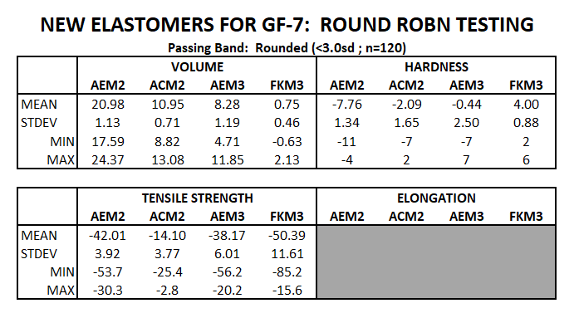

Jason Bowden presented the new OHT part number designations (attached). Coming up with new part numbers was a challenge since current OHT part numbers and J2643 can conflict at times. Joe Franklin mentioned the document also valuable for cross referencing the new and old part numbers. The group was also in favor of adding the part numbers to the D7216 procedure. Jason Bowden made a motion to approve the new part numbers with a second from Robert Stockwell. And once again, the motion passed with a resounding 100% affirmative vote. Jason also mentioned the elastomers are now available for purchase.

John Loop updated the panel on the status of the data dictionaries. The DDs have been released and TMC is working to get their system online to accept data as well as request CMIRS. During the interim, labs can request the materials in the comments section and data can be submitted as an Excel flat file in the same manner the labs used for the round robin.

There was no other new business and the highly successful call ended at 9:46 am.