LUBRICANT TEST MONITORING SYSTEM

Second Edition

#### Acknowledgment

The first version of the Lubricant Test Monitoring System (LTMS) was the result of efforts of the American Chemistry Council (ACC) Statistical Engine Test Work Group (SETWG) of the ACC Product Approval Protocol Task Group (PAPTG). The SETWG applied a logical and data based analytical approach to available ASTM (American Society for Testing and Materials) calibration test data in the development of the LTMS. This system of managing lubricant engine test severity (bias) and precision was presented to the ASTM Technical Guidance Committee of the Test Monitoring Board in October, 1991 by the ACC PAPTG. The LTMS was subsequently adopted for use by ASTM Surveillance Panels.

This Second Edition was initiated by the ASTM LTMS Task Force, and, specifically, the Statistics Task Group of the LTMS Task Force which included statisticians and others from the engine oil industry as well as representatives of independent laboratories and the ASTM Test Monitoring Center. Stakeholders provided input through various venues including Surveillance Panels and internal company communications.

#### Preface to the Second Edition

When SETWG created LTMS, they were not confident that they had solved the problems that triggered their efforts. They had consensus that they had laid the groundwork for a comprehensive approach toward “leveling the playing field” of engine lubricant specification testing. They knew that parts of the approach were wrong but that it was worth the penalties of minor inaccuracies to achieve the broader goal of a framework for conscientious businesses to have access to equitable measurement of lubricant performance.

The ASTM testing industry adopted LTMS intending to monitor effectiveness and accuracy of the system. Surveillance Panels and Test Development Task Forces were assisted in fine tuning adjustments over the years. But, until recently, there was little effort to follow up on the intention to consider revision of the basics of the system.

That the basic system still functions is an endorsement of its value and robustness. However, evolutions of engine technology, test development, business dynamics, economic factors, and laboratory strategies have consistently pushed toward fewer reference tests. Under this pressure, Surveillance Panels and Test Development Task Forces made changes often deviating from original guidelines and spirit of LTMS. Traditional Statistical Process Control (SPC) approaches might not have been appropriate with the advent of LTMS but with the current lack of data, appropriateness of the techniques in LTMS has become more questionable. It is time to rejuvenate the system recognizing current paucity of data and economic realities.

This version of LTMS delivers encompassing guidelines within which Surveillance Panels can adjust parameters for individual test types. Not following guidelines should be pursued only with knowledgeable endorsement by a consensus of shareholders.

Reference tests that improve quality and equity of testing should be considered for the value they deliver. This second edition is presented in the hope that it will provide value to the industry without partiality.

In the following document, “we” refers to the authors of this document – the LTMS Task Force Statistics Task Group:

Art Andrews, ExxonMobil

Doyle Boese, Infineum

Janet Buckingham, Southwest Research Institute

Martin Chadwick, Intertek

Jeff Clark, ASTM Test Monitoring Center

Todd Dvorak, Afton

Jo Martinez, Chevron Oronite

Bob Mason, Southwest Research Institute

Allison Rajakumar, Lubrizol

Jim Rutherford, Leader, Chevron Oronite

Phil Scinto, Lubrizol

Dan Worcester, Southwest Research Institute

Contents

Acknowledgment 2

Preface to the Second Edition 3

A. GOALS 5

B. THEORY 5

C. PRACTICAL CONSIDERATIONS 6

D. TEST DEVELOPMENT 6

E. UPDATE ANALYSES 8

F. SECOND EDITION CONTROL CHARTS 8

i. Reference Qualification 8

ii. Severity adjustment entity Charting and Actions 9

iii. Industry Charting and Actions 10

G. SURVEILLANCE PANEL GUIDELINES FOR IMPLEMENTING LTMS VERSION 2 11

i. Existing Tests 11

ii. Lab and industry level 2 Zi limits 11

iii. Prediction error monitoring parameters, severity adjustment parameters, and reference period adjustment parameters 12

iv. Annual review 13

v. LTMS documentation 14

H. REFERENCE OILS 14

I. ENGINEERING JUDGMENT AS APPLIED TO THE INTERPRETATION OF LTMS CONTROL CHARTS 15

J. GUIDELINES FOR NUMBERING OF NEW TEST STANDS 16

K. SURVEILLANCE PANEL GUIDELINES FOR REVISIONS TO THE LTMS 16

L. GUIDELINES FOR INTRODUCTION OF NEW PROCEDURES, HARDWARE, PARTS, AND/OR FUEL 17

M. REFERENCE TEST VALIDITY CODES AND CHARTABLE REFERENCES 18

APPENDIX A: APPLYING SEVERITY ADJUSTMENTS 20

APPENDIX B: TEMPLATES FOR VERSION 2 LABORATORY AND STAND BASED LTMS 21

*<Test Name>* LTMS Requirements(A Laboratory Based Severity Adjustment System) 21

TEST METHOD PORTION 21

TMC COMPENDIUM PORTION 26

*<Test Name>* LTMS Requirements (A Stand Based Severity Adjustment System) 28

TEST METHOD PORTION 28

TMC COMPENDIUM PORTION 33

APPENDIX C: DEVELOPMENT OF VARIANCE ESTIMATORS AND CHART LIMITS 35

APPENDIX D: FLOW CHARTS 37

APPENDIX E: DERIVATION OF Ee AND EZ LIMITS 45

APPENDIX F: REFERENCES 53

#### A. GOALS

The Lubricant Test Monitoring System (LTMS) is a tool used to identify differences among industry test results. The purpose of the LTMS is to assist the industry to level the playing field for non-reference testing. No matter where or when a non-reference is tested, the goal of LTMS is to bring all results to parity. Adjustments within the system attempt to ameliorate problems when the cause cannot be identified or physically corrected.

* LTMS, although applied to reference oil tests and results, is intended to enhance our ability to measure performance of non-reference oils.
* LTMS should treat large and small labs equitably.
* LTMS should strive for standardization across test types with guidelines and criteria defined for deviations.
* LTMS should encourage on target results and improved precision.
* LTMS should systemically eliminate incentives for inappropriate engineering judgments.
* LTMS should promote reliability, integrity, and efficiency of testing.

Actions in the revision of LTMS are motivated by two desires. First, we want severity adjustment entities (a severity adjustment entity is the entity to which severity adjustments are applied – it could be a laboratory, a stand, an engine, or other identified entities) to be near enough to each other on the performance scale that we believe they are measuring the same oil characteristics. Second, we need enough data from a severity adjustment entity so that we know where it is on the performance scale relative to the rest of the industry.

#### B. THEORY

LTMS is not SPC. It is something more like what Box1,2[1] called “Statistical Control by Monitoring and Adjustment” or “Statistical Process Monitoring and Feedback Adjustment”. But LTMS isn’t quite that because we don’t have sufficient data and we are not adjusting a process, we are just applying simple adjustments similar to Bisgaard’s “Using a Time Series Model for Process Adjustment and Control” 3. Since we are doing something completely different and we don’t have enough data, we need to keep it simple, draw from theoretical approaches as possible, and don’t make too many arbitrary rules.

Traditional SPC methods might not be adequate for determining LTMS parameters. There may be better approaches than estimating average run lengths even in the case of the usual assumptions (stationarity, etc). As we incorporate more realistic assumptions, evaluation of signaling power becomes very complicated.

When implementing LTMS Version 2 for existing tests, mock application to existing data can be illuminating but not definitive. LTMS Version 2 was not in place when the existing data were generated, so tests were not run as they would have been under Version 2.

#### C. PRACTICAL CONSIDERATIONS

Our approach to the new LTMS is suboptimal. The LTMS TF SS reached consensus that our best hope for quickly taking advantage of identified improvements would be to specify a simplistic, one-size-fits-all system for application across all test types. This is the default recommended system for every test type. Compelling presentation of data is necessary to justify making changes to the system. We make suggestions of where and how specific tuning could be developed.

The LTMS revision was developed with input from all stakeholders.  This includes customers, practitioners, statisticians, etc.  Any system that is “forced” onto the Surveillance Panels will not work.

There are many items that impact test results that are out of the labs’ control. These items should not adversely affect labs or test sponsors.

Especially for test types with little reference data, we could be stuck with an adjustment for a long time. Conversely, without adjustment, we could be getting spurious results for a long time.

#### D. TEST DEVELOPMENT

Before a new test enters the Lubricant Test Monitoring System a precision study is designed and analyzed by industry statisticians in collaboration with a Test Design Task Force, a Surveillance Panel, or other appropriate industry body of subject matter experts. The study investigates sources of variability and provides targets and estimates of precision for reference oils. The precision study is often supplemented by tests to address potential for base oil interchange and viscosity grade read across. Additional stands or laboratories might run tests concurrently to the precision study in the hopes of attaining reference status when LTMS is defined for the test.

We need data during test development from statistically designed experiments to:

* Establish precision and LTMS targets in current technology oils;
* Determine sources of variability which will help determine level of monitoring and control (lab, stand, engine); and
* Consider all important sources of variability pertinent to the test.

Guidelines for target development:

* Strive for a homogeneous dataset to set targets.
* A minimum of 10 tests per reference oil technology and 8 tests per reference oil should be used to set reference oil targets.
* Outliers should not be removed from the target dataset unless special cause can be identified. If the cause can be identified and removed from future testing, the outlier can be removed from the target dataset. If the cause can be identified and appropriate adjustment developed for all tests, then the outlier results may be adjusted.
* The target development dataset should be generated within as short a timeframe as possible.
* Targets should be developed using regression analysis considering all possible covariates (lab, stand, engine, test parts and fuel, run order, time, etc.).
* Issues involving oil by lab interactions should be resolved before final targets are set.

The industry statisticians have a fairly standard way of analyzing data from precision studies.

An analysis of the sources of variability must determine whether it is appropriate to reference stands, engines, laboratories, fuel, test part batches or any combination of sources. The severity adjustment entity is laboratory or stand and/or hardware. Data shortage will generally bias selection toward laboratory and we make laboratory the default severity adjustment entity. The following factors could persuade us to choose stand and/or hardware instead of the default.

* An engine is reused for testing with minimal rebuild,
* An engine is always associated with the same stand,
* Data analyses find engines or stands to provide significant predictive ability for test results,
* Fundamental mechanistic understanding of the performance measure compels belief in stand or engine effects, and/or,
* Data from a previous version of the test gave accepted evidence of a stand or engine effect.

Targets for reference oils are most appropriately based on least squares or predicted marginal means. If there are significant differences among severity adjustment entities (e.g., stands), reference oil targets could be weighted averages of the least squares means for the severity adjustment entity by oil interaction with weights based on the expected number of non-reference tests within each severity adjustment entity, or could be based on an accepted “correct” subset. The standard deviation for each test pass criterion is estimated by the appropriate model.

Because of the assumptions (homoscedasticity, normality, etc.) implicit in the tools used to determine calibration and severity adjustments, the statisticians will always strive to determine whether data transformation is appropriate. A basic and now easily applied tool to investigate transformations uses the Box-Cox algorithm. Other theoretical and analytical approaches to investigate transformations will also be used. Both statistical and engineering judgment should be exercised in determining transformations. Phenomena that are primarily driven by multiplicative factors (wear, for example), usually benefit from logarithmic transformation. Measurements related to spatial area (e.g., percent coverage), usually benefit from square root transformation. The inverse transformation should only be used when it makes theoretical sense such as when the true random variable is in the denominator as in fixed distance fuel economy testing reported as miles per gallon. Cleanliness rating scales from 0 to 10 have more variability in the middle and some form of a logistic transformation should be the first choice even if we don’t have data at the extremes. Transformations need to work across the entire useful scale of measurement including both reference oil and non-reference oil test data.

#### E. UPDATE ANALYSES

A surveillance panel has the discretion to update reference oil standard deviations at any time. At a minimum, standard deviations for each of the reference oils should be reviewed when 10, 20, and 30 tests have been completed. Standard deviations should be subsequently reviewed periodically to estimate current variability in addition to ASTM Test Monitoring Center (TMC) semiannual reports containing variability estimates. Test results in the reference oil data set should be severity adjusted prior to calculating standard deviations. Reference oil targets generally should not change assuming that severity adjustments account for location shifts.

Since we by default neither optimize LTMS parameters nor use theoretically rigorous estimates of prediction variability and severity adjustment accuracy, these should be reviewed at the same time that reference oil standard deviations are reviewed.

#### F. SECOND EDITION CONTROL CHARTS

##### i. Reference Qualification

For the sake of brevity and simplicity, we will assume in this section that the severity adjustment entity is a laboratory. If, as described above, a compelling case for other severity adjustment entity (e.g., engine) has been accepted, details of this section are slightly modified (see Appendix B).

With the default system, the first stand within a laboratory requires three reference tests for initial non-reference testing qualification. These reference tests are run consecutively, before non-references, and may include precision study oils as well as reference oils. Calibration status is not judged until the final reference test in the consecutive string is complete.

In order to remain qualified for non-reference oil testing, a test stand shall begin a reference oil test after no more than 18 valid non-reference oil tests in the stand or no later than 15 months following the completion of the stand’s previous qualifying reference oil test, whichever comes first. If more than 15 valid non-reference oil tests or more than 12 months are allowed in the standard reference period, then the laboratory is required to run 1 acceptable reference per six month interval. The time limits could be decreased if appropriate by the Surveillance Panel. These intervals might be reduced or increased as a function of monitoring. If reference period extensions push intervals over the 15 tests or 12 months limits, the requirement to run 1 acceptable reference per six month interval is **not** invoked.

If two full length reference oil tests are declared operationally invalid during the attempt to calibrate an existing stand, increases to the reference interval that would otherwise apply, will not occur in this situation.

##### ii. Severity adjustment entity Charting and Actions

For each severity adjustment entity, let

Xi = ith test result in original units in end of test order,

Ti = ith test result in appropriate units in end of test order,

(Ti=Xi unless a transformation is used in which case Ti=transformed (Xi))

Yi = ith standardized test result = (Ti – target) / (standard deviation),

(Target and standard deviation are as currently defined for the reference oil used in the reference test)

Zi = EWMA = λ Yi + (1- λ) Zi-1,

(By default, λ=0.2. With sufficient data and appropriate analyses, λ could be optimized by Box procedure minimizing sum of squares for prediction, , see Reference 1, pages 87-88.)

(Fast start is used, i.e., Z0=average of the three most recent non-capped Yi’s run to obtain reference entity calibration.)

and,

ei = prediction error from EWMA = Yi – Zi-1.

For each severity adjustment entity, chart Yi, Zi, and ei versus i. Zi is used as an adjustment chart to promote similar severity across severity adjustment entities. Shewhart charts of the ei’s indicate whether we know the relative performance of the severity adjustment entity well enough to adequately severity adjust using the Zi.

Level 1, 2, and 3 limits and their implications for prediction error monitoring are described in Appendix B. Suggested limits for prediction error monitoring are shown in the following table. Derivation of these limits is explained in Appendix C. As discussed, in Section G, it is each surveillance panel’s responsibility to select an appropriate set of limits for each of the prediction error monitoring parameters.

Shewhart Limits for Prediction Error Monitoring Parameters



Level 1 and 2 limits and their implications for severity monitoring and adjustment are described in Appendix B. The default recommendation for the level 1 limit for each severity adjustment parameter is zero. That is, continuous or no threshold severity adjustment is recommended. Selection of EWMA level 2 limits should be made by the surveillance panel in original engineering units as discussed in Section G.

##### iii. Industry Charting and Actions

For the entire testing industry, let

Xi = ith test result in original units in end of test order,

Ti = ith test result in appropriate units in end of test order,

(Ti=Xi unless a transformation is used in which case Ti=transformed (Xi))

Yi = ith standardized test result = Yi = (Ti – target) / (standard deviation),

(Target and standard deviation are as currently defined for the reference oil used in the reference test)

and,

Zi = EWMA = λ Yi + (1- λ) Zi-1.

(By default, λ=0.2. With sufficient data and appropriate analyses, λ could be optimized by Box procedure minimizing sum of squares for prediction, , see Reference 1, pages 87-88.)

(Fast start is used, i.e., Z0=average of Y1, Y2, and Y3.)

Industry Zi charts without application of severity adjustment can indicate when a change in testing has caused the entire industry to drift. Such drift would be captured by severity adjustments. However, the industry chart might alert faster than individual testing entities. It might also indicate when the entire industry has shifted to the extent that the originally intended engine oil performance characteristics can no longer be reliably measured.

TMC will maintain industry Zi charts and include them in semiannual reports. To enhance understanding of trends, individual reference entities will be indicated on the charts through color or symbols in coded form. Further, when the following limits are exceeded in absolute value, the TMC will take actions as indicated in Appendix B.

As described in Section G, the surveillance panel should determine level 2 limits based on mechanistic understanding of the test and discussed in engineering units. Suggested level 1 limits are shown in the following table.

Industry EWMA Limits for Severity Adjustment Parameters



#### G. SURVEILLANCE PANEL GUIDELINES FOR IMPLEMENTING LTMS VERSION 2

Surveillance panels have the ultimate responsibility and authority for test development, target creation, and implementation of LTMS. However, given the importance of LTMS to test definition, it is advisable to include industry statisticians early and throughout the test development process. LTMS implementation for a test typically includes an engagement of industry statisticians with the surveillance panel or test development task force. From analyses of precision study data and/or historical data, the statisticians will present a recommendation to the surveillance panel for most of the LTMS parameters. It is the responsibility of the surveillance panel to review and endorse or modify the proposed system parameters. Other system parameters should originate at the surveillance panel. Selection of these other parameters by the surveillance panel might be informed by data analyses; but, the criteria for selection should primarily be determined by subject matter experts.

##### i. Existing Tests

Using historical data from an existing test, potential parameters can be explored. The goal is not to determine exactly where each severity adjustment entity would start but to explore in a limited way whether various parameter settings might have more accurately compensated for past situations.

Each severity adjustment entity would begin its application of Version 2 LTMS with its first reference run in the new regime. It would be the decision of the surveillance panel whether all entities would start simultaneously with a reference test or with each entity’s next reference test. For example, if new hardware were being introduced, the surveillance panel might specify that each entity run a reference with new hardware before starting another non-reference test.

##### ii. Lab and industry level 2 Zi limits

Level 2 limits for severity adjustment entity Zi charts are intended to identify when a severity adjustment entity is so far from target that it cannot discriminate oil performance in the same manner as when testing is on target. This choice of limits is based on subject matter expertise related to the mechanism being evaluated. For example, when using a 0 to 10 cleanliness rating scale, if the target is 5 and a severity adjustment entity is obtaining results close to 10, then the entity will not likely be able to discriminate oil performance because all oils would be producing very clean results due to the severity of the entity. These limits must be determined for each parameter in original units. Limits need not be symmetric, i.e., severe and mild limits might not be the same distance from the target in any metric. Surveillance panels should consider that two labs could be farther apart than the difference between mild and severe limits; but, the non-reference tests would not be severity adjusted farther than those limits. The panel should consider Zi lag in setting limits.

One form of help in making these determinations could come from plotting original unit results (xi) versus deviation from target in standardized units (yi) for reference oil(s) and theoretical pass limit oil. It would also be very helpful for additive companies to bring input from formulators to the surveillance panel.

Level 2 limits for industry Zi charts are intended to mandate alert to the industry that something in the test appears to be causing a severity shift. At that point the industry must evaluate whether normal severity adjustments are adequate and also investigate whether the cause of the shift can be determined. Level 1 limits for industry Zi charts can trigger a TMC investigation with possible involvement by the surveillance panel. Level 2 triggers, however, require the immediate involvement by the surveillance panel.

##### iii. Prediction error monitoring parameters, severity adjustment parameters, and reference period adjustment parameters

When multiple pass / fail criteria are defined for a test, statisticians’ preparation for engagement would include evaluation of correlation among the criteria. It is generally detrimental to include redundant measures of oil performance. For purposes of LTMS, redundant measures bias ability of the system to detect appropriate signals. While all passing criteria should have severity adjustments in the system, it might reduce the effect of redundant criteria if test parameters of lesser importance or meaning are not included as prediction error monitoring parameters. These parameters would not be subject to the prediction error (ei) judgments of reference test acceptability. As part of the statisticians’ engagement, the surveillance panel should consider whether a subset of criteria should be designated as severity adjustment only parameters. Generally, this parameter bifurcation could be accomplished by declaring whether each parameter is ei only, Zi only, or both. However, if special circumstances justify it, designation of parameters for reference period adjustment might be different from designation of parameters for prediction error monitoring.

One of the severity adjustment parameters is the industry approved severity adjustment standard deviation. As part of the implementation engagement, statisticians will propose standard deviations appropriate at the pass limit for the criterion. The statistician will suggest transformations, if appropriate. It is hoped that transformations homogenize variability. If adequate transformations are not determined, statisticians and the surveillance panel need to consider how to deal with multiple pass limits such as when a test is used in multiple categories and whether the severity adjustment standard deviation remains appropriate when the test experiences large severity shifts.

After designating whether each pass / fail criterion is a prediction error monitoring parameter, severity adjustment parameter, and / or a reference period adjustment parameter, appropriate limits should be addressed. Unless there is justification for a difference, default limits should be used as shown in Section F. If a specific pass / fail criterion requires more severe or more lenient limits, suggestions for these limits are included in Section F.

The surveillance panel should decide whether time extensions should be included with test count extensions and, if they are to be included, whether the extensions should be sufficient time to allow extended test count or if the extensions should be percentage time extensions similar to test count extensions.

For tests with merit systems used in passing criteria, the potential impact of LTMS should also be considered. Unless there is clear evidence for the specific test that another approach is better, all of the parameters should be monitored and adjusted individually. Reference test disposition decisions should be made based on individual parameter monitoring. Total merits should also be monitored.

The surveillance panel should consider whether the system would allow reference acceptance based on test results that are not meaningful. The surveillance panel should determine whether ei limits stacked on top of Zi limits could mean a result outside a reasonable range could be acceptable.

When multiple parameters are included for reference interval extension and reference interval reduction criteria, the values of Ee and EZ might be adjusted. A detailed discussion of this topic is contained in Appendix E.

##### iv. Annual review

The Technical Guidance Committee (TGC) will organize and conduct annual reviews of the LTMS system in its entirety. Surveillance Panel chairmen are ex officio members of the TGC. The chairmen should prepare with their surveillance panel for these reviews. As part of this preparation, the surveillance panel together with the TMC will review data to determine if any laboratory or laboratories exhibit(s) unusual performance. Such unusual performance might include but not be limited to severity differences from other laboratories, poor relative precision, high invalid rates, and etcetera. Concerns identified in LTMS data and in the LTMS process should be brought forward to the TGC annual review meetings.

##### v. LTMS documentation

It is very desirable that we have consistent documentation of LTMS for individual test types. Someone needing this information should be able to find it in an analogous place regardless of test type.

Some aspects of LTMS are more permanent and more logically contained in the test method. As part of the test method, they are subject to revision by information letter. This includes definitions of new laboratories and new stands, specification of basic reference intervals, reference oil targets, and implications of exceeding LTMS limits.

Other parts of LTMS definition are more transient. They might be subject to periodic update or tunable during the annual review. Changes are suggested by data and analyses. They are subject to the consensus and timing guidelines as specified in section K, below. These latter aspects should be documented in a compendium of test type specific LTMS parameters maintained by the Test Monitoring Center. They include reference oil standard deviations, limits for ei and Zi monitoring, and lambdas for Zi calculations.

#### H. REFERENCE OILS

Reference Oils are requested and selected by the ASTM Surveillance Panel and Classification Panel. Reference oils should represent the majority of oils tested and demonstrate a test continues to discriminate around the current pass limits. At least two oils that can be discriminated by the test are recommended. This is necessary as it is possible for a shift to move the test to a severity level where discrimination around the pass limit is lost due to the size of applied adjustments and/or the nature of the measurement scale.

Guidelines for reference oil selection:

* Strive for reference oils that “mimic” non-reference oil behavior.
* Reference oils should meet the chemical and physical limits of the category.
* Reference oils should meet the chemical and physical limits of the pass limit. In other words, if a pass limit is tied to a particular viscosity grade, base oil type, chemical element, or other characteristic, the reference oil should meet those chemical and physical limits.
* Reference oils do not need to pass every parameter for the test, but they should be around various pass/fail limits.
* Adding new reference oils for an existing test should be done very cautiously.
* Reference oil performance should be similar across laboratories. If it is not similar, then one of the following are recommended:
  + Try to identify and fix the problem.
  + It may be appropriate to consider removing the reference oil from the test.
  + Do not incorporate bias due to interactions, such as between reference oil and laboratory, into LTMS targets.
* Reference oils should be blended to last the life of the test for the category.

Re-blended reference oil results should be subject to Level 1 ei alarms (See Appendix B) using original reference oil targets to determine reference acceptability The surveillance panel should decide whether results should be judged using Zi. When eight (8) references have been run on the oil, the data are examined and analyzed to determine if the mean performance of the oil has changed. (A change in the mean performance of the oil is DIFFERENT from a change in the engine test reflected in the oil performance.) If the oil performance has changed, then the oil re-blend may be attempted a second time, or, the oil may be assigned a different designation with new targets. If the mean performance of the oil has not changed, the targets established for the original blend of the reference oil should be used. Determination of a change in performance is made through statistical analyses considering all possible covariates.

When a new reference oil is introduced, monitoring and adjustment should not use reference results from the new oil until the test targets have been approved by the Surveillance Panel based on at least eight (8) tests.

Surveillance Panels are encouraged to accelerate data generation for new or re-blended reference oils through temporary modification of reference oil mix or flexible approaches to reference periods. They should also try to maintain inventories of heritage blends for comparison with new blends.

#### I. ENGINEERING JUDGMENT AS APPLIED TO THE INTERPRETATION OF LTMS CONTROL CHARTS

The Lubricant Test Monitoring System (LTMS), by design, will infrequently produce false indications of the severity and/or precision of a test result. These false indications can occur at the stand, laboratory, and/or industry levels. One type of false indication is an alarm that is not the result of a real problem but is, rather, an anomaly. A second type of false indication occurs when a real problem exists, yet the control charts remain within acceptable limits. On occasion, when sufficient technical information is available, either type of false indication can be identified as such. In these cases, the ASTM Test Monitoring Center (TMC), through the application of engineering judgment, may determine that a deviation from normal LTMS actions is warranted. The following points describe the process by which engineering judgment is applied by the TMC:

1. The TMC determines if the potential exists for the application of engineering judgment in the interpretation of control charts.

2. When it is determined that the potential exists for the application of engineering judgment, all subsequent investigation proceeds under the assumption that the current control chart indications are correct.

3. When an engineering investigation is commenced, it is incumbent on the affected lab(s) to prepare necessary technical information in concert with the TMC.

4. The ACC Monitoring Agency will be notified that an engineering investigation involving control chart interpretation has commenced.

5. The TMC may solicit relevant input from outside sources, such as the Test Developer, Surveillance Panel Chairman, O&H Subpanel Leader and the ACC Monitoring Agency. In all cases, the confidentially of the affected lab(s) will be appropriately maintained.

6. If, in the judgment of the TMC, a deviation from normal LTMS actions is warranted, then it will be documented in writing along with a summary of the relevant technical information considered in making the judgment. The affected lab(s) and the ACC Monitoring Agency will receive copies of this document.

7. If, in the judgment of the TMC, normal LTMS action should be followed by the affected lab(s), then no special documentation is required.

8. The application of engineering judgment in the interpretation of LTMS control charts is handled on a case-by-case basis. The TMC does not consider any prior judgment rendered to be precedent setting.

#### J. GUIDELINES FOR NUMBERING OF NEW TEST STANDS

Each new test stand entering the LTMS shall be assigned a coded apparatus number by the TMC. If the new stand was previously calibrated in the LTMS, the original coded apparatus number plus a letter suffix (i.e., A, B, C, etc.) shall be used each time the stand reenters the system.

The TMC will use engineering judgment regarding the renumbering of test stands on which lapses in calibration periods occur. In such cases, a stand will generally not be renumbered if a calibration test sequence is started (and maintained) within two years from the end of the previous period. However, if a review of the past and present configuration of the stand, tests conducted in between calibration periods (standardized or not), or any other pertinent information dictates, renumbering will be required.

#### K. SURVEILLANCE PANEL GUIDELINES FOR REVISIONS TO THE LTMS

The final authority for specifying the test-specific requirements of the LTMS resides with the surveillance panels of Subcommittee D02.B0.

1. Surveillance panels shall strive for unanimous approval of any revision to the LTMS.

2. Except in the case of an urgent target update, surveillance panel chairmen shall allow at least two weeks for review and possible panel discussion prior to the effective date of the LTMS revision.

3. To ensure the value of the two-week review, it is expected that each surveillance panel member will be responsible for representing their organization’s technical position.

4. In those instances when the panel vote on a proposed LTMS revision is not unanimous, all minority voters shall be given sufficient opportunity to present the technical basis for their votes.

The surveillance panel shall make every effort to resolve minority voter concerns in order for there to be a consensus on the proposed LTMS revision. In the event unanimity cannot be achieved, a minority vote can be ruled non-persuasive by majority vote.

#### L. GUIDELINES FOR INTRODUCTION OF NEW PROCEDURES, HARDWARE, PARTS, AND/OR FUEL

There may be occasion when a change is to be made to the defined, existing test in the form of a procedure change, hardware change, parts change and or fuel change. If the surveillance panel is concerned that such a change could affect the severity of the test, it is suggested that one of the approaches below be planned prior to testing. In all approaches, non-reference testing should not take place with the changed conditions prior to the completion of the approach.

Approach 1: Matrix or Round Robin

In this approach, a matrix or series of matrices is planned and run. The industry does not move forward with the changes until it has been shown that the changes either:

* do not affect the test, or
* can be corrected with an industry correction factor, or
* can be corrected with severity adjustments, or
* can be corrected with a combination of an industry correction factor and severity adjustments.

Once calibration is achieved, all future tests must be run with the change. Updated Zi apply to subsequent non-reference tests that incorporate the changes, but updated Zi does not apply to any non-reference tests that did not yet incorporate the changes. In the case that a non-reference test run without the changes finishes after the updated Zi based on the changes, the non-reference must be severity adjusted based on Zi prior to any changes.

Approach 2: Use of Level 1 ei

In this approach a reference entity may calibrate with the change, independent of the Industry, by running a reference test and meeting the Level 1 ei requirement. If Level 1 ei requirement is not met, then the reference entity simply needs to follow the guidelines of the LTMS document. Once calibration is achieved, all future tests on the reference entity must be run with the change. Updated Zi apply to subsequent non-reference tests that incorporate the changes, but updated Zi do not apply to any non-reference tests that did not yet incorporate the changes. In the case that a non-reference test run without the changes finishes after the updated Zi based on the changes, the non-reference must be severity adjusted based on Zi prior to any changes.

#### M. REFERENCE TEST VALIDITY CODES AND CHARTABLE REFERENCES

In the reference test datasets available on the TMC website (<http://www.astmtmc.cmu.edu/>), validity codes indicate the nature of outcome of each reference test. These codes consist of two letters representing validity designation and test designation as shown in the following chart.

Tests that are appropriate for control and monitoring charting are termed “chartable” and identified as such in the TMC datasets. Chartable tests usually have validity codes AC or OC although tests with other validity codes might be chartable.

|  |  |  |  |
| --- | --- | --- | --- |
| **Validity**  **Designation** | Definition | **Test**  **Designation** | Definition |
| **A** | acceptable for intended purpose | **C** | calibration test |
| **O** | operationally valid,  does not meet statistical criteria | **D** | double blind, for calibration |
| **R** | operationally invalid,  reported as valid by lab, not in stats | **E** | fuel run also for calibration |
| **X** | aborted, not in stats | **F** | fuel run for fuel approval only |
| **L** | operationally invalid  as determined by lab, not in stats | **G** | industry donated test, not for calibration |
| **N** | acceptable for intended purpose,  and not in stats | **H** | hardware run also for calibration |
| **M** | not acceptable for intended purpose, and not in stats | **I** | hardware run for hardware approval only |
| **P** | pending (not resolved), not in stats | **N** | non-blind, information |
| **T** | Temporary | **O** | calibration approval by sources other than TMC |
|  |  | **S** | discrimination test, not for calibration |

#### APPENDIX A: APPLYING SEVERITY ADJUSTMENTS

In order to adjust non-reference oil test results for laboratory or stand and/or hardware severity, an exponentially weighted, moving average technique (EWMA) is applied to standardized calibration test results.

Severity Adjustment Calculation Procedure:

Round Zi to three decimal places.

If a Severity Adjustment (SA) applies, calculate it as follows:

SA = -1 x (Zi) x sSA

where sSA = industry approved severity adjustment standard deviation for each parameter as shown in each test area section.

Round the SA value, using the method specified in ASTM Practice E 29, to the precision level specified in the test area data dictionary. Add the SA to the test result in the appropriate Units of Measure.

Contact the TMC for assistance with, or questions about, applying severity adjustments.

#### APPENDIX B: TEMPLATES FOR VERSION 2 LABORATORY AND STAND BASED LTMS

##### *<Test Name>* LTMS Requirements(A Laboratory Based Severity Adjustment System)

###### TEST METHOD PORTION

The following are the specific *<Test Name>* calibration test requirements.

A. Reference Oils and Parameters

The prediction error monitoring parameter is Parameter 1 and the severity adjustment only parameter is Parameter 2. The reference oils required for test stand and test laboratory calibration are reference oils accepted by the ASTM *<Test Name>* Surveillance Panel. The targets for the current reference oils for each parameter are presented below.

PARAMETER 1

Unit of Measure: *units(including transform if any)*

PREDICTION ERROR MONITORING PARAMETER

|  |  |
| --- | --- |
| Reference Oil | Target |
|  |  |
|  |  |
|  |  |

PARAMETER 2

Unit of Measure: *units(including transform if any)*

SEVERITY ADJUSTMENT ONLY PARAMETER

|  |  |
| --- | --- |
| Reference Oil | Target |
|  |  |
|  |  |
|  |  |

B. Acceptance Criteria

1. New test labs [It is preferred that the definition of a new laboratory appears in the test method. But if it doesn’t or requires clarification, it should be done here.]
   1. A minimum of three (3) operationally valid reference and/or matrix tests with no level 3 ei alarms must be run on the first test stand in a new laboratory.

* Note that industry matrix runs may be included, as well as reference runs, at the discretion of the surveillance panel.
  1. Following the necessary tests, check the status of the control charts and follow the prescribed actions.
  2. If two full length reference oil tests are declared operationally invalid during the attempt to calibrate a stand, then an increase in the reference interval per section 4.d may not be granted.

2. Existing Test Lab

1. New test stands in an existing lab, and test stands in an existing test lab that have not run an acceptable reference in the past two years, may calibrate with one test provided Level 1 limit requirement is met. Otherwise a second test is required for calibration.
2. For an existing test stand in an existing lab run one test
3. Following an operationally valid reference oil calibration test, check the status of the control charts and follow the prescribed actions.
4. If two full length reference oil tests are declared operationally invalid during the attempt to calibrate a stand, then an increase in the reference interval per section 4.d may not be granted.

3. Reference Oil Assignment

Once a test stand has been accepted into the system, the TMC will assign reference oils for continuing calibration according to the following reference oil mix:

* 100% of the scheduled calibration tests should be conducted on reference oils <*Oil XXX*>, <*Oil YYY*>, and <*Oil ZZZ*> or subsequent approved reblends.

4. Chart Status

The following are the steps that must be taken in the case of exceeding chart limits. The steps are listed in order of priority, although charts should be studied simultaneously to determine the cause(s) of a problem. In the case of multiple alarms, contact the TMC for guidance. The laboratory always has the option of removing any stand from the system.

1. Shewhart Chart of Prediction Error (ei) for **prediction error monitoring parameters only**

• Level 3

– Immediately conduct one additional reference test in the stand that triggered the alarm. Do not update the control charts for the lab until the follow up reference test is completed and the ExI analysis, per Section 4.c (below), has been performed.

• Level 2

– Reduce the number of tests allowed in the calibration period in the stand that triggered the alarm to [enter number of tests representing 80% of the standard calibration period].

• Level 1

* + The level 1 limit applies in situations that have been pre-determined by the surveillance panel to have a potential impact on test results. These situations may include the introduction of new critical parts, fuel batches, reference oil reblends, or other test components. When these conditions have been met and a level 1 alarm is triggered, immediately conduct one additional reference test in the stand that triggered the alarm.
  + The level 1 limit also applies to a stand in an existing test lab that has not run an acceptable reference in the past two years. The stand can calibrate with one test if the level 1 limits are not exceeded. Otherwise, immediately conduct another reference test in the stand.

b. Reference entity EWMA of Standardized Test Result (Zi) for **all parameters**

• Level 2

* Immediately conduct one additional reference test either
  + in the stand that triggered the alarm, or
  + in the stand that is next due for calibration.
    - The stand that triggered the alarm is not calibrated for non-reference testing without further reference testing.

• Level 1

* The level 1 limit applies to all reference tests that are control charted, even when other alarms have been triggered. Level 1 uses Zi to determine the laboratory severity adjustment (SA). Calculate the laboratory SA for each parameter as follows and confirm the calculation with the TMC:

SA = -Zi x sSA

where sSA =industry approved severity adjustment standard deviation

c. Excessive influence (ExI) Analysis for **prediction error monitoring parameters only**

* The ExI analysis is performed anytime that a lab ei level 3 alarm is triggered. As prescribed in Section 4.a, Level 3, a follow up reference test is run. The following comparisons then determine whether the value of Yi is modified to limit its influence on LTMS. Yi+1 is the next completed reference in the laboratory after the level 3 alarm

1. If |Yi – Yi+1| ≤ ei level 3 limit, then Yi is equal to the value originally determined.
2. If Yi > Zi-1 and Yi-Yi+1 > ei level 3 limit, then let

Yi = ei level 3 limit + Zi-1.

1. If Yi ≤ Zi-1 and Yi-Yi+1 < -ei level 3 limit, then let

Yi = -ei level 3 limit + Zi-1.

1. If none of i), ii), or iii) is true, then Yi is equal to the value originally determined.

Where: i = test that originally triggered level 3 alarm,

i-1 = test prior to alarm trigger, and

i+1 = test immediately following alarm trigger.

Once the proper Yi value has been determined, update the charts. Confirm calculations with the TMC. The laboratory and the TMC maintain a record of the modification.

d. Increase in the Number of Tests for the Stand Calibration Period

• The number of tests allowed in a stand calibration period, for existing stands only, may be increased if the previous test was an acceptable reference based upon the chart results for all prediction error monitoring parameters as follows:

* + If |ei| ≤ Ee, then the number of tests allowed for that calibration period may be increased by [insert number of tests representing 20% of the standard calibration period], [if surveillance panel opts to include “, and the time between references may be increased by” insert time extension required to extend number of tests or time period representing 20% of the standard period ], or
  + If |ei| ≤ Ee and |Zi|≤ EZ, then the number of tests allowed for that calibration period may be increased by [insert number of tests representing 40% of the standard calibration period] [if surveillance panel opts to include “,and the time between references may be increased by” insert time extension required to extend number of tests or time period representing 40% of the standard period “.

Confirm calculations with the TMC.

• If two full length reference oil tests are declared operationally invalid during the calibration sequence in the same stand, then the increase in calibration period will not be granted

e. Industry EWMA of Standardized Test Result (Zi) for **all parameters**

• Level 2

* + TMC informs the surveillance panel that the limit has been exceeded. The surveillance panel then investigates and pursues resolution of the alarm.

• Level 1

* + The TMC investigates whether severity adjustments are adequately addressing the trend, investigates the possible causes, and communicates as appropriate with industry.

###### TMC COMPENDIUM PORTION

The following are the specific *<Test Name>* calibration test requirements.

A. Reference Oils and Parameters

The prediction error monitoring parameter is Parameter 1 and the severity adjustment only parameter is Parameter 2. The reference oils required for test stand and test laboratory calibration are reference oils accepted by the ASTM *<Test Name>* Surveillance Panel. The standard deviations for the current reference oils for each parameter are presented below.

PARAMETER 1

Unit of Measure: *units(including transform if any)*

PREDICTION ERROR MONITORING PARAMETER

|  |  |
| --- | --- |
| Reference Oil | Standard Deviation |
|  |  |
|  |  |
|  |  |

PARAMETER 2

Unit of Measure: *units(including transform if any)*

SEVERITY ADJUSTMENT ONLY PARAMETER

|  |  |
| --- | --- |
| Reference Oil | Standard Deviation |
|  |  |
|  |  |
|  |  |

B. Monitoring and Adjustment Parameters

The constants used for the construction of the control charts for the <*Test Name*>, and the adjustment and monitoring chart limits, are shown below.

Laboratory Shewhart Limits for Prediction Error Monitoring Parameters

|  |  |
| --- | --- |
| Shewhart Chart of Prediction Error ei = Yi – Zi-1 | |
| Limit Type | Limit* |
| Level 3 | TBD |
| Level 2 | TBD |
| Level 1 | TBD |

Laboratory EWMA Limits for Each Severity Adjustment Parameter

|  |  |  |
| --- | --- | --- |
| EWMA of Standardized Test Result Zi = λ(Yi) + (1 – λ)Zi-1 | | |
| Limit Type | λ | Limit |
| Level 2  Upper Limit | 0.2 | TBD by SP Input |
| Level 2  Lower Limit | 0.2 | TBD by SP Input |
| Level 1 | 0.2 | 0 |

Severity Adjustment Standard Deviation for Each Severity Adjustment Parameter

|  |  |
| --- | --- |
| Severity Adjustment Parameter | Severity Adjustment Standard Deviation: sSA |
|  |  |
|  |  |
|  |  |

Laboratory Prediction Error and EWMA Reference Period Extension Limits for Each Reference Period Adjustment Parameter

|  |  |
| --- | --- |
| Limit Type | Limit |
| Ee | 1.05 |
| EZ | 0.66 |

Industry EWMA Limits for Each Severity Adjustment Parameter

|  |  |  |
| --- | --- | --- |
| EWMA of Standardized Test Result Zi = λ(Yi) + (1 – λ)Zi-1 | | |
| Limit Type | λ | Limit |
| Level 2  Upper Limit | 0.2 | TBD by SP Input |
| Level 2  Lower Limit | 0.2 | TBD by SP Input |
| Level 1 | 0.2 | TBD |

##### *<Test Name>* LTMS Requirements (A Stand Based Severity Adjustment System)

###### TEST METHOD PORTION

The following are the specific <Test Name> calibration test requirements. For brevity, “stand” as used in this section refers to severity adjustment entity which might be a stand and/or engine or hardware.

A. Reference Oils and Parameters

The prediction error monitoring parameter is Parameter 1 and the severity adjustment only parameter is Parameter 2. The reference oils required for test stand calibration are reference oils accepted by the ASTM *<Test Name>* Surveillance Panel. The targets for the current reference oils for each parameter are presented below.

PARAMETER 1

Unit of Measure: *units(including transform if any)*

PREDICTION ERROR MONITORING PARAMETER

|  |  |
| --- | --- |
| Reference Oil | Target |
|  |  |
|  |  |
|  |  |

PARAMETER 2

Unit of Measure: *units(including transform if any)*

SEVERITY ADJUSTMENT ONLY PARAMETER

|  |  |
| --- | --- |
| Reference Oil | Target |
|  |  |
|  |  |
|  |  |

B. Acceptance Criteria

1. New test stands. [It is preferred that the definition of a new laboratory appears in the test method. But if it doesn’t or requires clarification, it should be done here.]
   1. A minimum of three (3) operationally valid reference and/or matrix tests with no level 3 ei alarms must be run on each test stand before calibration is considered.

* Note that industry matrix runs may be included, as well as reference runs, at the discretion of the surveillance panel.
  1. Following the necessary tests, check the status of the control charts and follow the prescribed actions.
  2. If two full length reference oil tests are declared operationally invalid during the attempt to calibrate a stand, then an increase in the reference interval per section 4.d may not be granted.

2. Existing Test Stand

1. For an existing test stand, run one test.
2. Following an operationally valid reference oil calibration test, check the status of the control charts and follow the prescribed actions.
3. If two full length reference oil tests are declared operationally invalid during the attempt to calibrate a stand, then an increase in the reference interval per section 4.d may not be granted.

3. Reference Oil Assignment

Once a test stand has been accepted into the system, the TMC will assign reference oils for continuing calibration according to the following reference oil mix:

* 100% of the scheduled calibration tests should be conducted on reference oils <*Oil XXX*>, <*Oil YYY*>, and <*Oil ZZZ*> or subsequent approved reblends.

4. Chart Status

The following are the steps that must be taken in the case of exceeding chart limits. The steps are listed in order of priority, although charts should be studied simultaneously to determine the cause(s) of a problem. In the case of multiple alarms, contact the TMC for guidance. The laboratory always has the option of removing any stand from the system.

1. Shewhart Chart of Prediction Error (ei) for **prediction error monitoring parameters only**

• Level 3

– Immediately conduct one additional reference test in the stand that triggered the alarm. Do not update the control charts until the follow up reference test is completed and the ExI analysis, per Section 4c (below), has been performed.

• Level 2

– Reduce the number of tests allowed in the calibration period in the stand that triggered the alarm to [enter number of tests representing 80% of the standard calibration period].

• Level 1

* + The level 1 limit applies in situations that have been pre-determined by the surveillance panel to have a potential impact on test results. These situations may include the introduction of new critical parts, fuel batches, reference oil reblends, or other test components. When these conditions have been met and a level 1 alarm is triggered, immediately conduct one additional reference test in the stand that triggered the alarm.
  + The level 1 limit also applies to a stand in an existing test stand that has not run an acceptable reference in the past two years. The stand can calibrate with one test if the level 1 limits are not exceeded. Otherwise, immediately conduct another reference test in the stand.

b. Reference entity EWMA of Standardized Test Result (Zi) for **all parameters**

• Level 2

* Immediately conduct one additional reference test in the stand that triggered the alarm.

• Level 1

* The level 1 limit applies to all reference tests that are control charted, even when other alarms have been triggered. Level 1 uses Zi to determine the stand severity adjustment (SA). Calculate the stand SA for each parameter as follows and confirm the calculation with the TMC:

SA = -Zi x sSA

where sSA =industry approved severity adjustment standard deviation

c. Excessive influence (ExI) Analysis for **prediction error monitoring parameters only**

* The ExI analysis is performed anytime that a stand ei level 3 alarm is triggered. As prescribed in Section 4.a, Level 3, a follow up reference test is run. The following comparisons then determine whether the value of Yi is modified to limit its influence on LTMS. Yi+1 is the next completed reference in the stand after the level 3 alarm

1. If |Yi – Yi+1| ≤ ei level 3 limit, then Yi is equal to the value originally determined.
2. If Yi > Zi-1 and Yi-Yi+1 > ei level 3 limit, then let

Yi = ei level 3 limit + Zi-1.

1. If Yi ≤ Zi-1 and Yi-Yi+1 < -ei level 3 limit, then let

Yi = -ei level 3 limit + Zi-1.

1. If none of i), ii), or iii) is true, then Yi is equal to the value originally determined.

Where: i = test that originally triggered level 3 alarm,

i-1 = test prior to alarm trigger, and

i+1 = test immediately following alarm trigger.

Once the proper Yi value has been determined, update the charts. Confirm calculations with the TMC. The laboratory and the TMC maintain a record of the modification.

d. Increase in the Number of Tests for the Stand Calibration Period

• The number of tests allowed in a stand calibration period, for existing stands only, may be increased if the previous test was an acceptable reference based upon the chart results for all prediction error monitoring parameters as follows:

* + If |ei| ≤ Ee, then the number of tests allowed for that calibration period may be increased by [insert number of tests representing 20% of the standard calibration period], [if surveillance panel opts to include “, and the time between references may be increased by” insert time extension required to extend number of tests or time period representing 20% of the standard period ], or
  + If |ei| ≤ Ee and |Zi|≤ EZ, then the number of tests allowed for that calibration period may be increased by [insert number of tests representing 40% of the standard calibration period] [if surveillance panel opts to include “,and the time between references may be increased by” insert time extension required to extend number of tests or time period representing 40% of the standard period “.

Confirm calculations with the TMC.

• If two full length reference oil tests are declared operationally invalid during the calibration sequence, then the increase in calibration period will not be granted

e. Industry EWMA of Standardized Test Result (Zi) for **all parameters**

• Level 2

* + TMC informs the surveillance panel that the limit has been exceeded. The surveillance panel then investigates and pursues resolution of the alarm.

• Level 1

* + The TMC investigates whether severity adjustments are adequately addressing the trend, investigates the possible causes, and communicates as appropriate with industry.

###### TMC COMPENDIUM PORTION

The following are the specific *<Test Name>* calibration test requirements.

A. Reference Oils and Parameters

The prediction error monitoring parameter is Parameter 1 and the severity adjustment only parameter is Parameter 2. The reference oils required for test stand calibration are reference oils accepted by the ASTM *<Test Name>* Surveillance Panel. The standard deviations for the current reference oils for each parameter are presented below.

PARAMETER 1

Unit of Measure: *units(including transform if any)*

PREDICTION ERROR MONITORING PARAMETER

|  |  |
| --- | --- |
| Reference Oil | Standard Deviation |
|  |  |
|  |  |
|  |  |

PARAMETER 2

Unit of Measure: *units(including transform if any)*

SEVERITY ADJUSTMENT ONLY PARAMETER

|  |  |
| --- | --- |
| Reference Oil | Standard Deviation |
|  |  |
|  |  |
|  |  |

B. Monitoring and Adjustment Parameters

The constants used for the construction of the control charts for the <*Test Name*>, and the adjustment and monitoring chart limits, are shown below.

Stand Shewhart Limits for Prediction Error Monitoring Parameters

|  |  |
| --- | --- |
| Shewhart Chart of Prediction Error ei = Yi – Zi-1 | |
| Limit Type | Limit* |
| Level 3 | TBD |
| Level 2 | TBD |
| Level 1 | TBD |

Stand EWMA Limits for Each Severity Adjustment Parameter

|  |  |  |
| --- | --- | --- |
| EWMA of Standardized Test Result Zi = λ(Yi) + (1 – λ)Zi-1 | | |
| Limit Type | λ | Limit |
| Level 2  Upper Limit | 0.2 | TBD by SP Input |
| Level 2  Lower Limit | 0.2 | TBD by SP Input |
| Level 1 | 0.2 | 0 |

Severity Adjustment Standard Deviation for Each Severity Adjustment Parameter

|  |  |
| --- | --- |
| Severity Adjustment Parameter | Severity Adjustment Standard Deviation: sSA |
|  |  |
|  |  |
|  |  |

Stand Prediction Error and EWMA Reference Period Extension Limits for Each Reference Period Adjustment Parameter

|  |  |
| --- | --- |
| Limit Type | Limit |
| Ee | 1.05 |
| EZ | 0.66 |

Industry EWMA Limits for Each Severity Adjustment Parameter

|  |  |  |
| --- | --- | --- |
| EWMA of Standardized Test Result Zi = λ(Yi) + (1 – λ)Zi-1 | | |
| Limit Type | λ | Limit |
| Level 2  Upper Limit | 0.2 | TBD by SP Input |
| Level 2  Lower Limit | 0.2 | TBD by SP Input |
| Level 1 | 0.2 | TBD |

#### APPENDIX C: DEVELOPMENT OF VARIANCE ESTIMATORS AND CHART LIMITS

If we assume (as we assumed for creation of the original LTMS in accord with traditional Statistical Process Control) the Yi to be independent and identically distributed, the variance for the EWMA can be estimated by

 for i=0,1,2,3, …

As i increases, the first bracketed factor decreases and we might approximate the variance of the EWMA as



Then, if we assume normalization makes Yi ~N(0,1), we might further simplify to



And limits for the EWMA chart for monitoring severity (Zi plotted against completion date order) might be expressed as

$$0±c\sqrt{\frac{λ}{2-λ}}$$

Similarly, the variance of ei might then be approximately estimated by



And limits for Shewhart charts of the ei’s might be expressed as



In traditional SPC, the constants, c, are typically selected with false alarm error rates and average run lengths in mind. Under the assumptions for traditional SPC, these false alarm error rates and run lengths have been well studied and documented through application of probability theory or simulation. In fact, we believe the Yi to be non-stationary (i.e., there is not a constant mean) and to frequently exhibit autocorrelation. Limits in version 2 of LTMS (which is a system for monitoring and adjustment rather than traditional SPC) do not have the same meaning and the probability theory and simulations are not applicable.

IF the EWMA or, equivalently ARIMA(0,1,1), adequately models the data such that the residuals from the model are approximately independent and identically distributed as N(0,) and  could be estimated as the mean squared error from the EWMA prediction, then we would use  to estimate $σ_{e_{i}}^{2}$. However, we suggest the following approach to start LTMS for a test unless adequate data and analyses have been done to implement the more rigorous approach. Residuals from the EWMA and alternate models should be reviewed along with regular review of reference oil variances.

The default approach is then to use the above along with the following table of constants to determine limits for a test. The resulting limits are shown in Section F. Surveillance panels should judge whether each pass criterion should be judged as for ei, Zi, or both and, if judged for that chart, whether the default, tightened, or loosened limits should be used.

Laboratory Shewhart Constants for Prediction Error Monitoring Parameters



Industry EWMA Constants for Severity Adjustment Parameters



#### APPENDIX D: FLOW CHARTS

**High-Level LTMS 2nd Edition Flowchart**

Report a valid reference to TMC

Does the difference (ei) between current test severity (Yi) and the historical severity of the adjusted entity (Zi-1) indicate this test may not be representative of the entity?

No

Does the current severity of the adjusted entity (Zi) indicate the entity continues to measure the selected parameter in a manner that is representative of the physical mechanisms the test is intended to measure and does the LTMS continue to interpret results in the manner originally intended?

Reference is acceptable

Yes

No

Conduct another reference immediately and perform excessive influence analysis.

Yes

Evaluate appropriate interval for next reference

Conduct another reference immediately.

*Note operation at this severity level indicates a sustained trend of producing results that significantly deviate from target and a thorough investigation of the reference entity should be conducted before resuming referencing.*











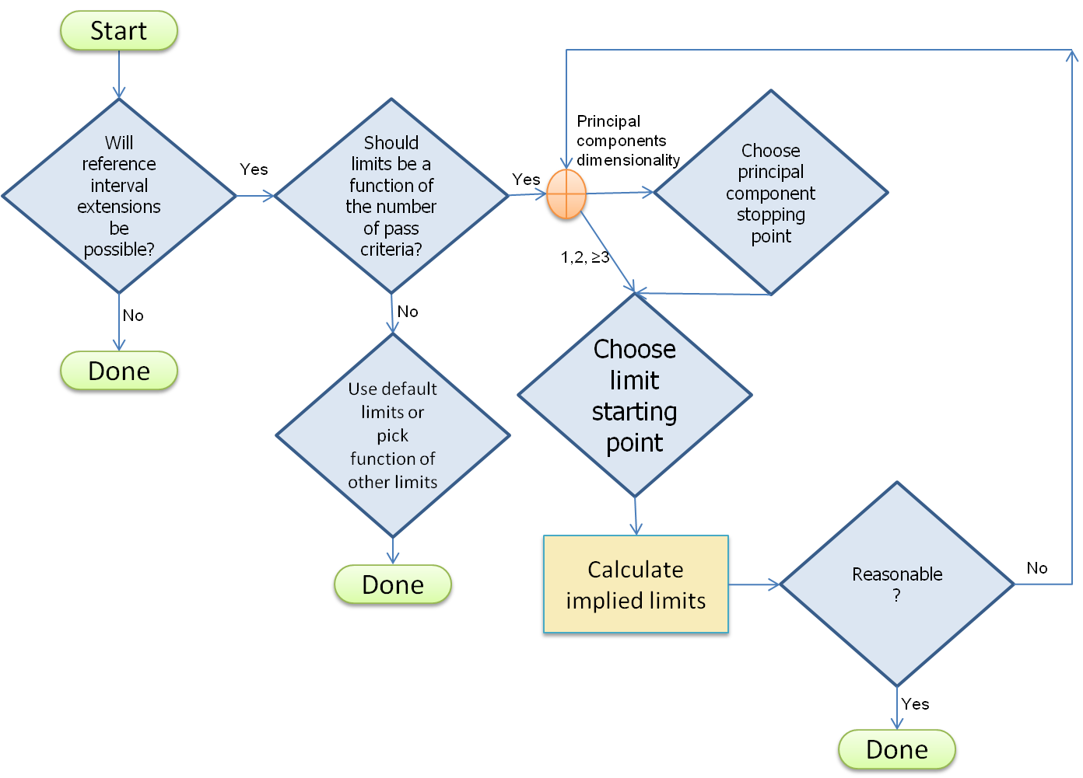



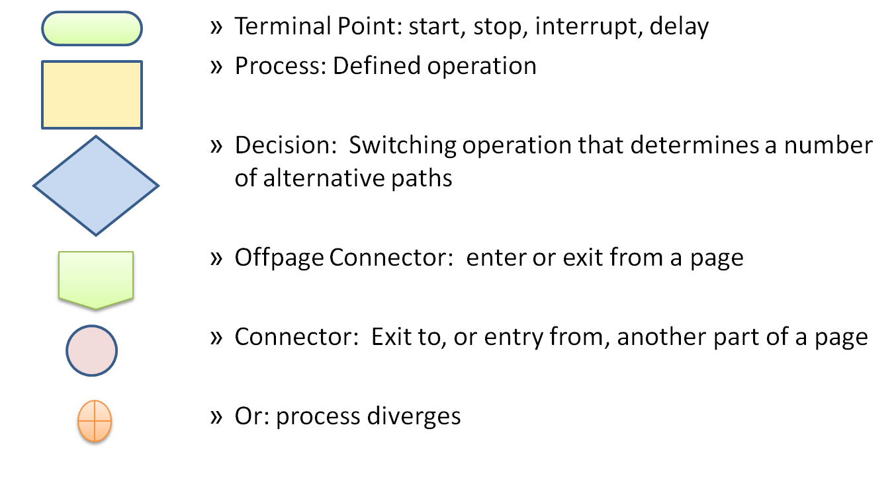

#### APPENDIX E: DERIVATION OF Ee AND EZ LIMITS

Application of LTMS Version 2 reference period extensions requires several decisions. This appendix addresses those decisions in a sequential manner. The sequence is logical but the surveillance panel might want to consider the decisions in a different order if they find some issues more controversial or compelling.

We begin with listing and elucidation of the primary decisions to be addressed followed by a brief discussion of implementation, three examples, and a flowchart.

**1. Will reference period extensions be included?**

The use of Ee and EZ limits as detailed in this document is strongly encouraged. LTMS Version 2 was designed as a total system. While each surveillance panel has the authority to choose various portions of the system, the value of the system as a whole has been balanced in the best practice form defined in this document. The effect on the value of the whole system of deviating from best practices should be evaluated.

Of course, the simplest route open to a surveillance panel would be to decide not to allow extensions to reference intervals. The panel would not then need to deal with added complexity in the system and could dispense with the rest of this appendix that details how to determine limits for extensions. Aside from the holistic reasoning above for adopting all parts of the system, this eliminates a positive incentive to the laboratory for being consistent and on target. If the panel decides not to use extensions, they could still use reductions. While this is only a disincentive for inconsistency, it is better than completely abandoning the opportunity for the system to adapt to a laboratory’s performance by adjusting toward the right amount of reference testing.

**2. Should limits be a function of the number of reference period extension parameters?**

If a surveillance panel wisely chooses to implement reference period extensions, further decisions must be made to determine limits. One school of thought considers that the more hurdles applied in terms of the number of parameters judged for extensions, the more chances there are to stumble. Some would argue that the chance of failing to obtain extension should be independent of, or at least not so severely hampered by, the number of extension parameters. The contrary argument is that each of the pass criteria for a test must be measured with accuracy and precision. The quality of a test is only as good as the least credible criterion.

**3. If limits are to be adjusted for the number of parameters, how will they be adjusted?**

We won’t describe here the theory or details of principal components analysis. Sufficient for this discussion, we will say it is a well established statistical method for extracting and compressing the information content from a set of inter-correlated variables. It is used in the context of setting limits for reference period extensions as a means of determining the independent dimensionality of the parameters. If this sounds too weird, another suggested approach is to designate one set of limits to apply if there is one parameter, a second set of limits for two parameters, and a third set of limits for three or more parameters. This would eliminate the need for the principal components analysis. But it would also ignore information about correlation structures in the data. As will be seen below, when adjusting for more than three parameters, the difference in limits is smaller at each step. The biggest change is from one to two parameters. The next biggest change is from two to three parameters. And the change keeps shrinking.

**3a. If the principal components dimensionality is used, what is the cutoff?**

Is it 75% or 90% of variance / inertia accounted for? Should we Look for less than x% inertia? What is the pattern of the eigenvalues? Should eigenvalues be bigger than one? The various approaches to this question are detailed in the examples.

There is some concern that for large numbers of pass criteria, adjusting for the number of parameters could lead to reference period extension limits that do not make sense relative to the level one, two, or three limits for ei or Zi. For example, with some combinations of limits, we might have the situation that another reference test is required or the reference period is extended – the basic reference period might be eliminated. This situation could occur with various approaches to setting limits. All limits and the entire LTMS for a test should be reviewed for reasonableness.

**4. Whether or not the limits are to be adjusted for the number of parameters, what is the starting point?**

One approach to deriving reference extension limits would be to base them on the other monitoring and control limits for ei and Zi. If we use level one ei limits to judge whether a known change requires additional references, is it reasonable to conclude that when no change is suspected and level one ei criteria are met then there is confidence the Zi is “correct”? Since the Zi level two limits are to be established based on an understanding of the test, is it reasonable to conclude that operating at some percentage of that band represents on target performance?

The two questions of reasonableness above could be answered negatively in the belief that the extension limits address different questions than level one ei limits and level two Zi limits.

**Implementation**

The above are four or five of the primary questions to be resolved when implementing limits for reference period extensions.

Should the panel decide not to adjust for the number of parameters, it remains only to choose one set of limits. The default limits suggested by the LTMS TF STG are shown in the following table. These limits were derived as consensus reasonable limits for the Cummins ISB test. These default limits could be used if they are not adjusted for the number of parameters or they could be used as the starting point for adjustable limits in the case of two parameters or even in the case of dimensionality two as discussed below.

Laboratory Prediction Error and EWMA Reference Period Extension Limits

for Each Reference Period Adjustment Parameter

|  |  |
| --- | --- |
| Limit Type | Limit |
| Ee | 1.05 |
| EZ | 0.66 |

If the panel would like to adjust for the number of pass criteria or parameters, decisions must be made about how to count the parameters, how many components to count if principal components are used, and the starting point or a set of limits for one number of parameters. These issues will be illustrated in the following three examples.

**Example 1: Cummins ISB**

There are two pass criteria for the Cummins ISB - average cam shaft wear and average tappet weight loss. Both are considered reference test extension parameters. If we don’t adjust for the number of parameters, the default limits above could be used for both and we would be done. The LTMS TF STG considered these limits in a look at historical data and reached consensus that they yielded reasonable results along with the rest of the system as the surveillance panel has defined it for Version 2.

We investigated the dimensionality of the two parameters in the ISB. We fit two models using all 38 chartable tests in the LTMS dataset with cam wear and tappet wear as the two results and with laboratory, oil code, and the interaction between laboratory and oil code as predictors. We then ran principal components analysis with the residuals from the two models as variables.





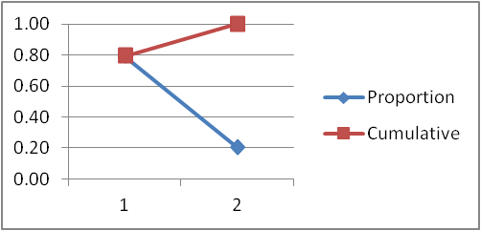

Although various techniques have been used to determine the number of components to include to describe a multi-collinear system, all are either subjective, arbitrary, or both. For example, some say that when analyzing the correlation matrix (as done here) since the average eigenvalue is one, we should only keep components with eigenvalues greater than one. This is clearly too arbitrary and simplistic. Some authors advocate the scree elbow test. This doesn’t work with two components. It will be discussed in later examples. Statisticians often look at proportion of variability in the system described by the component. The described variability is sometimes called the inertia of the component. We might include only the number of components necessary to account for 75, 80, or 90% of the inertia. But which percentage should we choose? In this example, if we require 80% or higher cumulative inertia, we need both components and the dimensionality remains two.

**Example 2: Mack T-12**

The passing criterion for the Mack T-12 is Mack Merits. Merits are calculated from five results from a test and all five results were either monitored, adjusted, or both in the original version of LTMS. It is possible that all five will be reference interval extension parameters in LTMS Version 2. The five variables are cylinder liner wear, top ring weight loss, oil consumption, ΔPb at end of test, and ΔPb from 250 to 300 hours. We use natural logarithm transformations for the last three variables.

We investigated the dimensionality of the five parameters in the T-12. We fit five models using all 61 chartable tests in the LTMS dataset with cylinder liner wear, top ring weight loss, ln(oil consumption),ln(ΔPb at end of test), and ln(ΔPb from 250 to 300 hours) as the five results and with laboratory, oil code, and the interaction between laboratory and oil code as predictors. We then ran principal components analysis with the residuals from the five models as variables.





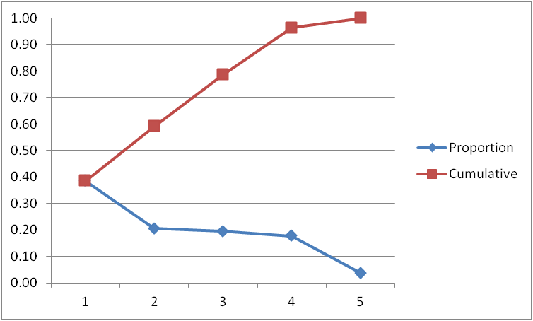

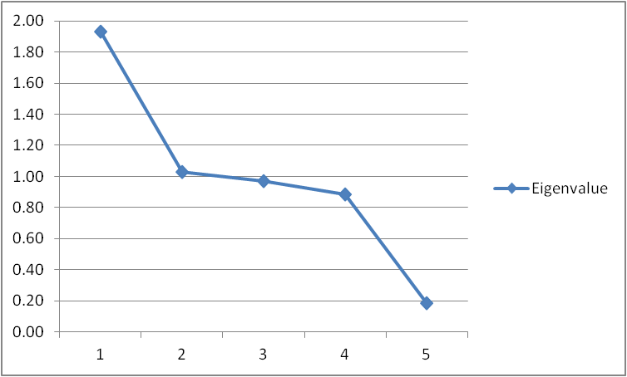

The scree elbow mentioned in the previous example advises to plot eigenvalues (or inertia of each component that is the same plot with a different vertical scale) in decreasing size as in the immediately preceding plot. ‘Scree’ is the accumulation of rocks at the base of a cliff. Look for an elbow where the line changes from steep to flat and keep only the components before the elbow. In this case, we would keep one component. However, the first component accounts for only 39% of the variability in the system. Components 2, 3, and 4 have similar sized eigenvalues, similar percent inertia, and are close to the average eigenvalue so we can’t really distinguish among their relative contributions. If we include the first four components, we account for 96% of the variability in the system.

If we start with our default limits associated with dimensionality of two, we calculate the following tables based on the Šidák inequality.





We might then call the dimensionality of this system four and determine Ee and EZ to be 1.430 and 0.752, respectively.

**Example 3: Sequence VG**

The passing criteria for the Sequence VG are average engine sludge, average rocker cover sludge, average engine varnish, average piston varnish, oil screen clogging, and number of hot stuck rings. For the purposes of this example we will assume that the reference period extension parameters are average engine sludge, average rocker cover sludge, average engine varnish, average piston varnish, and the natural logarithm of oil screen clogging plus one.

We fit five models using all 304 chartable tests in the LTMS dataset with the assumed reference period adjustment parameters as the five results and with laboratory, oil code, and the interaction between laboratory and oil code as predictors. We then ran principal components analysis with the residuals from the five models as variables.





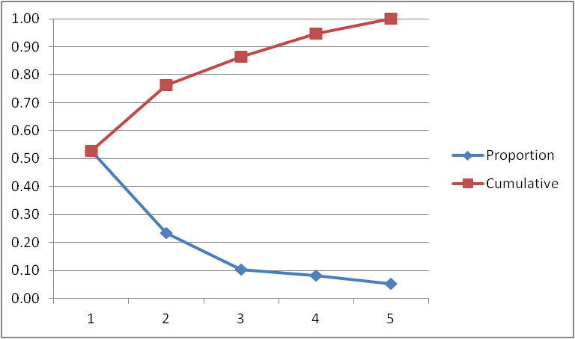

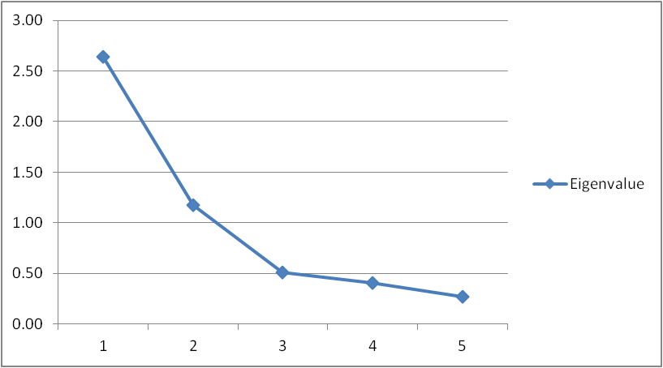

In this example, the scree elbow could be interpreted as telling us to use two or three components. Components three and four have similar small percentage of inertia. Over 75% of inertia is capture in the first two components. We probably would settle on dimensionality of two and select 1.050 for Ee and 0.660 for EZ.

#### APPENDIX F: REFERENCES

1. Box, G. E. P., Luceño, A., and Paniagua-Quiñones, M. d. C (2009), *Statistical Control by Monitoring and Adjustment, Second Edition*, New Jersey: Wiley.
2. Box, G. and Kramer, T (1992), “Statistical Process Monitoring and Feedback Adjustment – A Discussion,” *Technometrics*, 34, 251-267.
3. Bisgaard, S. and Kulahci, M (2008), “Using a Time Series Model for Process Adjustment and Control,” *Quality Engineering*, 20:134-141.

1. References are shown in Appendix F.